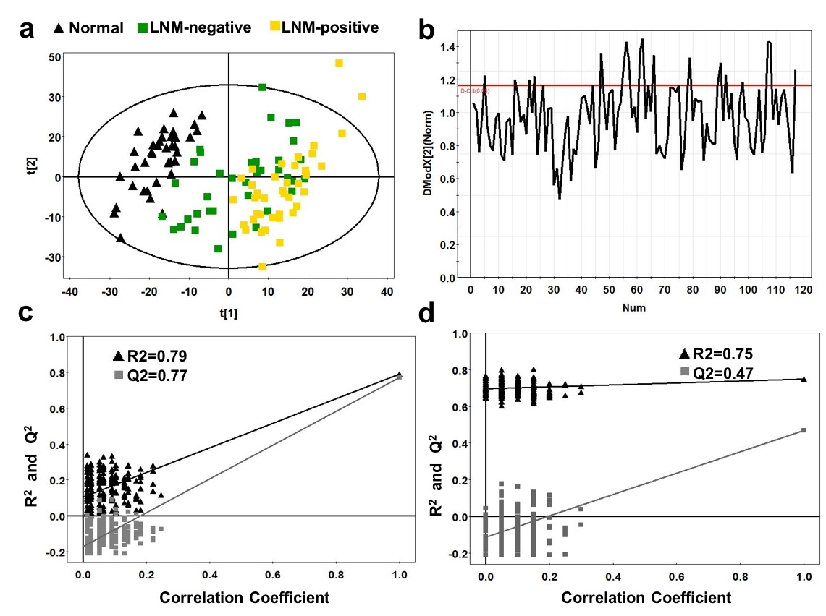

Fig. S1 Metabolic profiling between GC tissues and normal controls. a PCA scores plot between the GC tissues and normal controls. b The distance to PCA model showing any outlier. c Statistical validation of the corresponding PLS-DA model using permutation analysis (200 times). R² is the explained variance, and Q² is the predictive ability of the model. d Statistical validation of the corresponding PLS-DA model using permutation analysis (200 times). R² is the explained variance, and Q² is the predictive ability of the model.

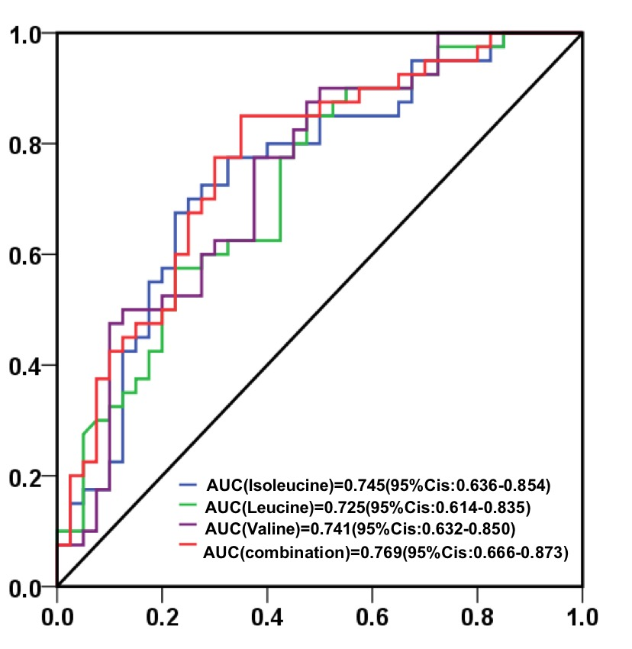
Fig. S2 Receiver operating characteristic (ROC) curve analysis of BCAAs between GC patients with LNM or not. Combination represents isoleucine, leucine and valine.

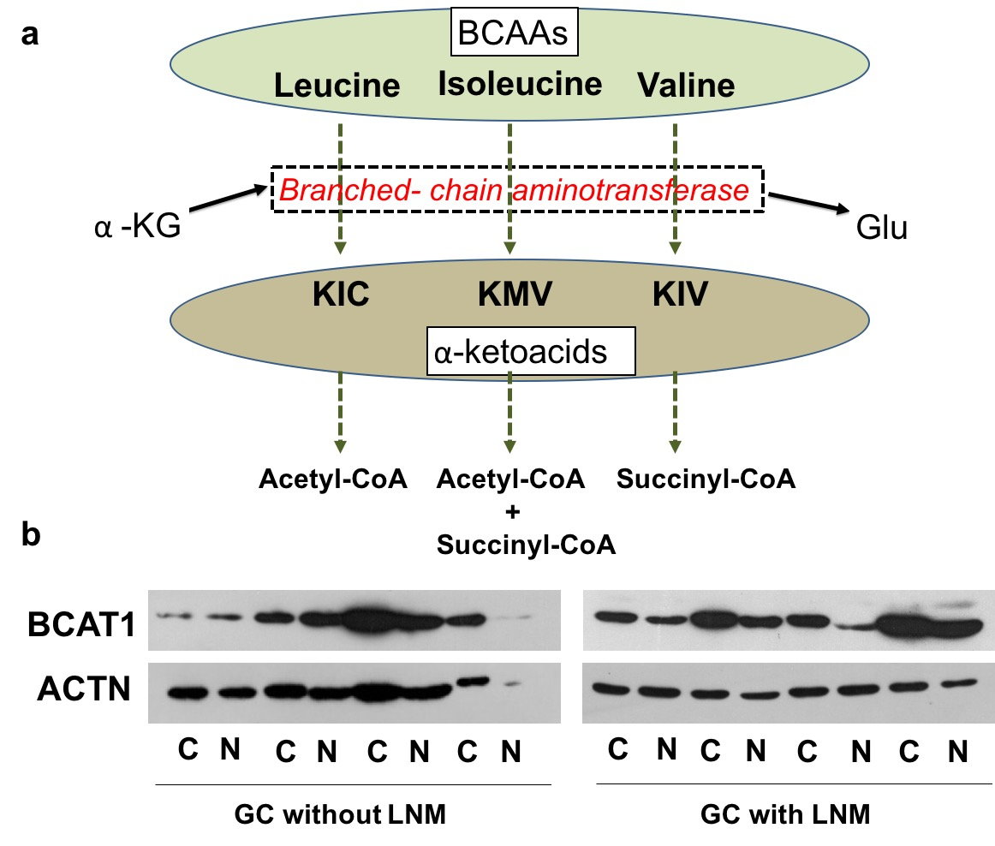
Fig. S3 a BCAAs catabolism schematics of the reaction catalysed by BCAT. 𝛼-KG, 𝛼-ketoglutarate; KIC, 𝛼-ketoisocaproic acid; KMV, 𝛼-keto-𝛽-methylvaleric acid; KIV, 𝛼-ketoisovaleric acid. b The expression level of BCAT1 in GC tissues by Western blot. BCAT1, branched-chain aminotransferase; C, cancer; N, normal.

