Supplemental Content
Metabolite and transcript profiling of Guinea grass (Panicum maximum Jacq) response to elevated [CO₂] and temperature
Metabolomics
Jessica M. Wedow, Craig R. Yendrek, Tathyana R. Mello, Silvana Creste, Carlos A. Martinez, Elizabeth A. Ainsworth^{1,2*}

¹ Department of Plant Biology & Carl R. Woese Institute for Genomic Biology, University of Illinois at Urbana-Champaign
² USDA Agricultural Research Service, Global Change and Photosynthesis Research Unit, Urbana, IL

*Corresponding Author: Elizabeth A. Ainsworth, 1201 W. Gregory Drive, 147 ERML, Urbana, IL 61801 USA, lisa.ainsworth@ars.usda.gov

Supplemental File 1. Differentially expressed genes (DEG) within each weighted gene correlations network analysis (WGCNA) module for time point A. Values show the elevated CO₂ and elevated temperature (eCeT) treatment compared to ambient control (C) based on LIMMA analysis.

Supplemental File 2: Differentially expressed genes (DEGs) in combined elevated CO₂ and elevated temperature (eCeT) treatments from time points A and B. The log2 fold change (log2FC) is shown along with statistical analysis of differential gene expression.

Supplemental File 3: Linear correlation coefficient (r) and significance (Adj.P) of linear relationships between metabolites and transcripts sampled at Time Point B.

Supplemental Table 1: Weighted gene correlation network analysis (WGCNA) signed network statistics for time point A with GO-term enrichment analysis. Minimum module size was 75 genes. The genes contained within a module were used to identify significantly increased GO-Enrichment biological process terms (P<0.01). Metabolites listed were significantly correlated with the corresponding module (P<0.05, |r| ≥ 0.75). Module: WGCNA gene grouping, Number of Genes: total number of genes within each module, Number of DEG: total number of differentially expressed genes within each module, Metabolite (P,r): Linear correlation between module eigengen based connectivity and gene significance for metabolite (p value and correlation coefficient), GO-term enrichment: gene ontology enrichment of total number of genes within the module.
Module | Number  of Genes | Number  of DEG | Metabolite  (P, r) | GO-term Enrichment  (GO-term ID; Fold Enrichment)
1 | 1719 | 2 | - | Phosphate-containing compound metabolic process  (GO:0006796; 1.67)
2 | 1260 | 9 | - | Gibberellin biosynthetic process  (GO:0009686; 12.82)  Cell surface receptor signaling  (GO:0007166; 3.81)  Protein phosphorylation  (GO:0006468; 2.74)
3 | 948 | 84 | Melibiose  (5.8e-04, -0.76) | Defense response to oomycetes  (GO:0002229; 12.7)  Transmembrane receptor protein tyrosine kinase signaling  (GO:0007169; 6.94)  Response to bacterium  (GO:0009617; 6.94)
4 | 536 | 2 | - | Protein phosphorylation  (GO:0006468; 2.71)  Defense response  (GO:0006952; 2.19)
5 | 484 | 35 | - | Oxylipin biosynthesis  (GO:0031408; 17.06)  Terpenoid biosynthesis  (GO:0046246; 9.22)  Response to wounding  (GO:0009611; 5.03)  Hormone biosynthesis  (GO:0042446; 4.24)  Secondary metabolite biosynthesis  (GO:0044550; 3.85)  Defense response to other organisms  (GO:0098542; 2.28)  Oxidation-reduction process  (GO:0055114; 2.23)
6 | 444 | 2 | - | Response to wounding  (GO:0009611; 6.20)

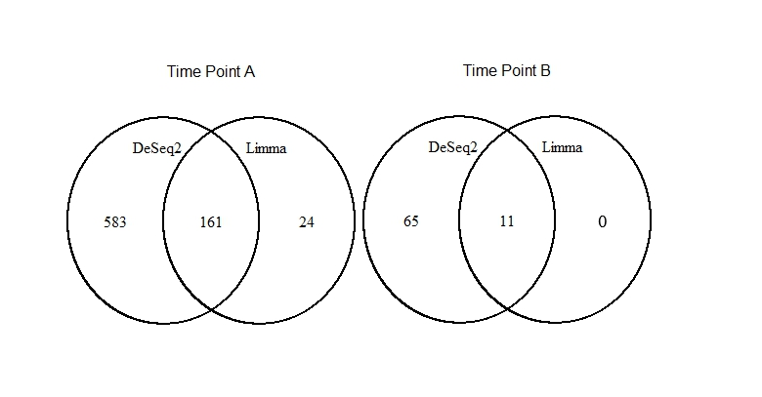

Supplemental Figure 1. Comparison of statistical methods for RNAseq. Venn diagram of differentially expressed genes (p<0.05) in the combined elevated [CO₂], elevated temperature treatment comparing LIMMA and DESeq2 analyses for time points A and time point B.

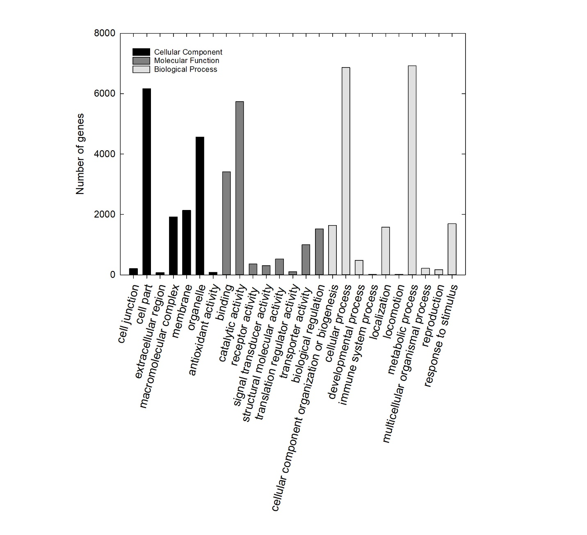
Supplemental Figure 2: Gene ontology ‘slim’ classification of the Panicum maximum transcriptome. The number of unigenes assigned to each GO slim terms in the P. maximum transcriptome is shown in the bar chart. Transcripts were classified into three categories: cellular components, molecular functions and biological processes. 11,538 total classified unigenes. False discovery rate of 0.05 was applied and categories with less than 10 genes were removed.

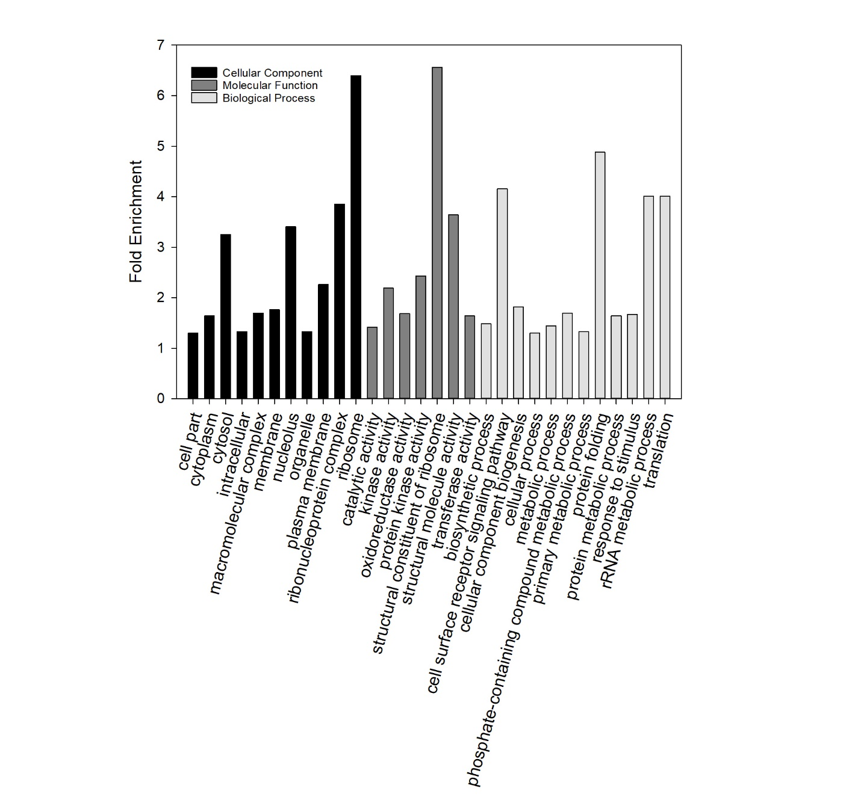
Supplemental Figure 3: Gene ontology ‘slim’ classification of differently expressed genes (DEG) in plants grown in the combined elevated [CO₂], elevated temperature treatment in time point A. The average fold enrichment for groups of transcripts assigned to each GO slim term is shown. Transcripts were classified into three categories: cellular components, molecular functions and biological processes. 666 total genes were classified. A false discovery rate of 0.05 was applied.

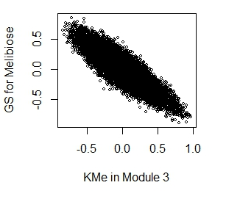

Supplemental Figure 4: Correlation between module membership in Module 3 and gene significance (GS) for melibiose. Eigengen based connectivity of module membership measure is plotted on the x axis (KMe). Correlation coefficient -0.87 and p<0.0001.

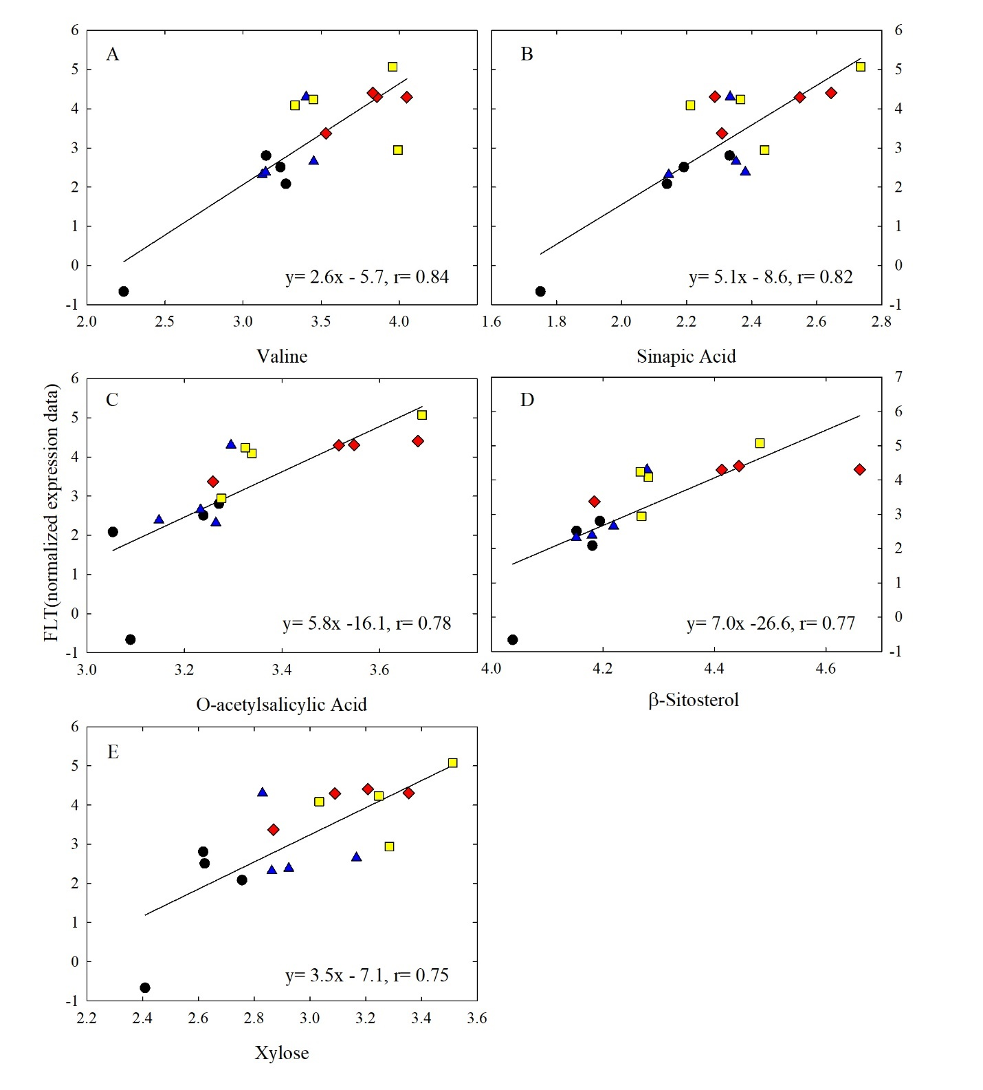
Supplemental Figure 5: Linear correlations, from Time Point B, with Flowering Locus T and metabolite content. ‘At1g65480’ FLT (normalized expression level) correlation with metabolite [Log₁₀ (relative concentration/ 100mg DW)] (A) Valine, (B) Sinapic acid, (C) O-acetylsalicylic acid, (D) β- Sitosterol, (E) Xylose. Ambient (black, circle), elevated [CO₂] (blue, triangle), elevated temperature (red, diamond), combination (yellow, square). Linear regression equation and correlation coefficient are denoted on each panel.

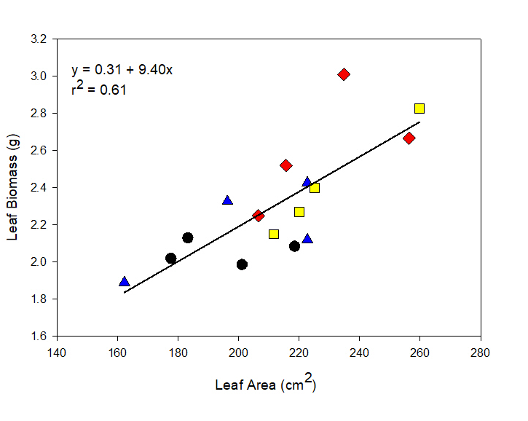

Supplemental Figure 6: Relationship between individual leaf biomass and leaf area. The linear correlation of Guinea grass individual leaf area and leaf biomass measured on Aug 22-29, 2014. Ambient [CO₂] and temperature (black, circle), Elevated [CO₂], ambient temperature (blue, triangle), Ambient [CO₂], Elevated temperature (red, diamond), Elevated [CO₂] and temperature (yellow, square).

