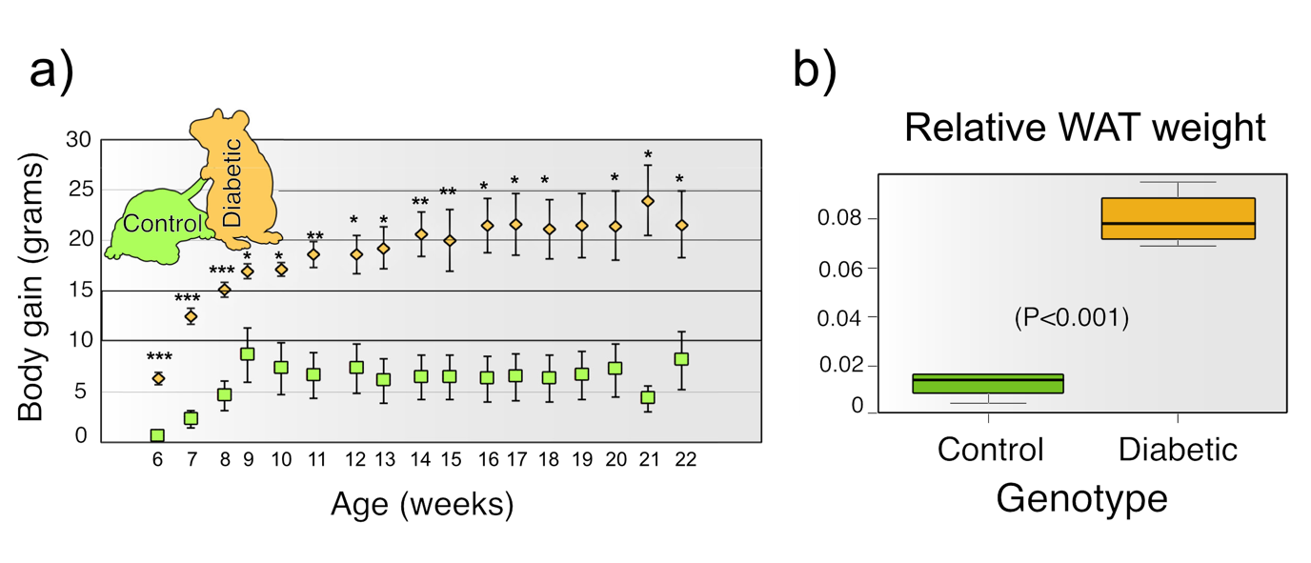
S2_Fig 1: Body weight gain in diabetic and control groups. a: A One-way ANOVA (n=12) showed that differences between body weight gain (W) of diabetic individuals (orange) and control ones (green) was statistically significant (p<0.01). b: Relative WAT weight was statistically higher in diabetic individuals than in controls (p<0.001).

