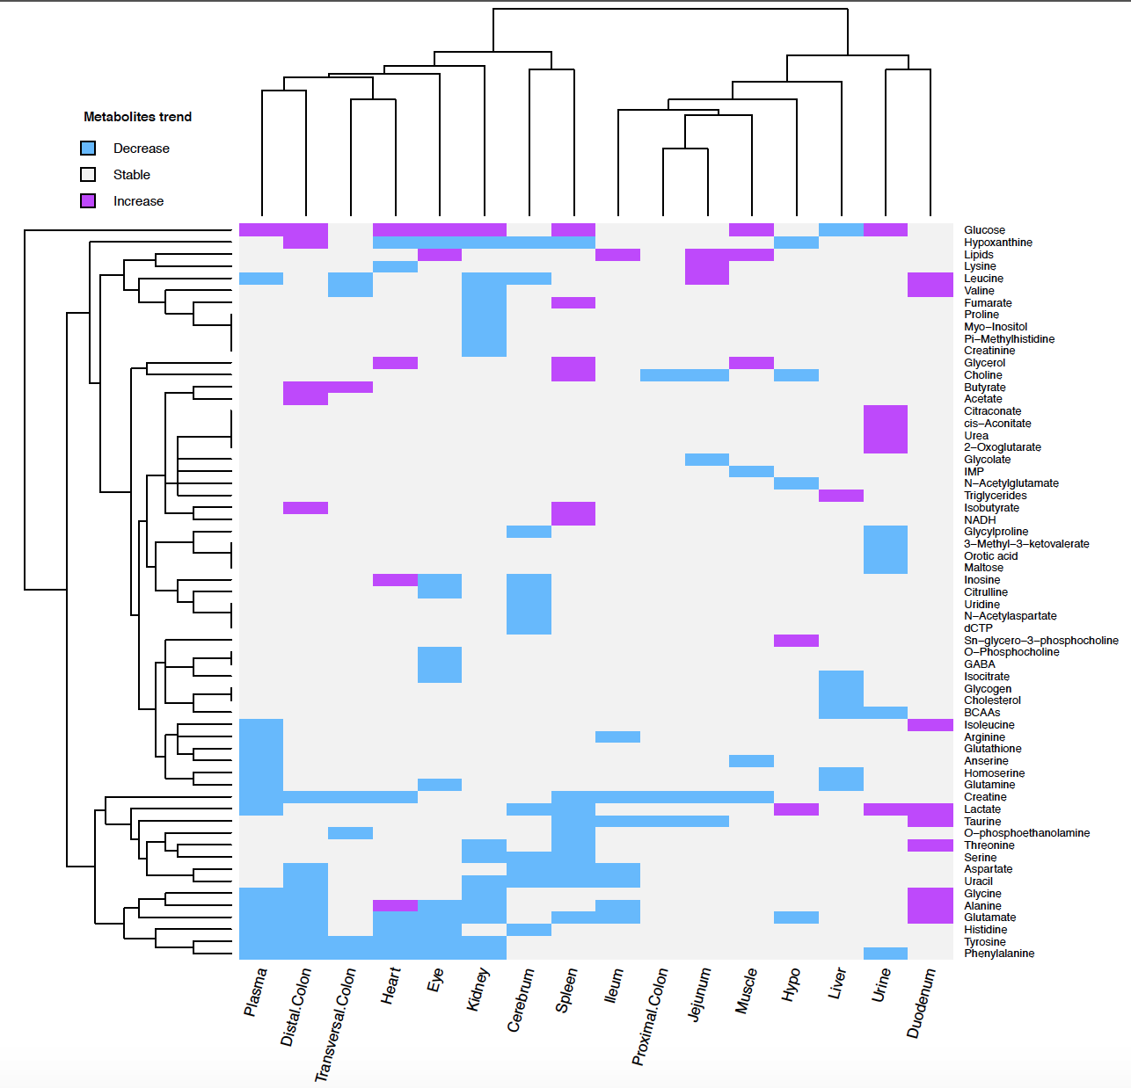
S6_Fig 1: Heat-map showing clusters of matrices and metabolites. Purple colour indicates an increase of the metabolite and blue colour a decrease of the metabolite in diabetic individuals compared to control ones.

