SUPPLEMENTARY IINFORMATION

Metabolic characterisation of THP-1 macrophage polarisation using LC-MS-based metabolite profiling

Alaa Abuawad^{1, 2}, Chidimma Mbadugha³, Amir M. Ghaemmaghami³, Dong-Hyun Kim^{1*}
¹Centre for Analytical Bioscience, Division of Advanced Materials and Healthcare Technologies, School of Pharmacy, University of Nottingham, UK
²Department of Pharmaceutical Sciences and Pharmaceutics, Faculty of Pharmacy, Applied Science Private University, Amman, Jordan.
³Division of Immunology, School of Life Sciences, Faculty of Medicine and Health Sciences, University of Nottingham, Nottingham, UK

*Correspondence to: Email: dong-hyun.kim@nottingham.ac.uk Tel: +44 1157484697

Characterization of macrophages polarization
DAPI
Phalloidin

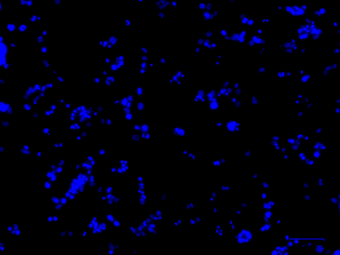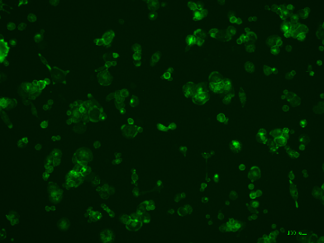
M0
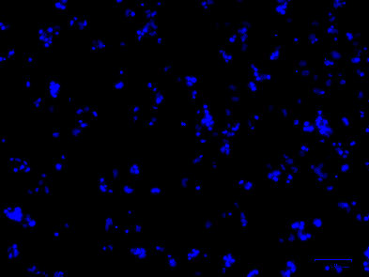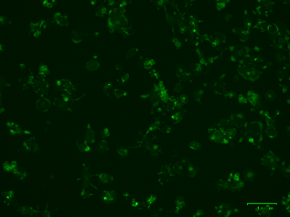
M1 c10
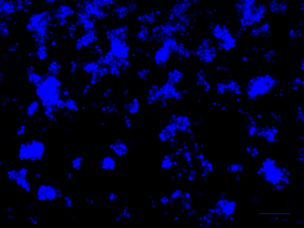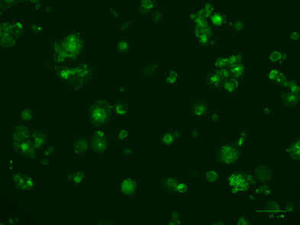
M2 c10

Supplementary 1 Figure 1: Morphology of cytokine polarised THP-1 cells. Cells were stained with phalloidin (green) and DAPI (blue) for the visualization of cytoskeleton. Images were taken at 10x magnification; scale bar = 100μm.

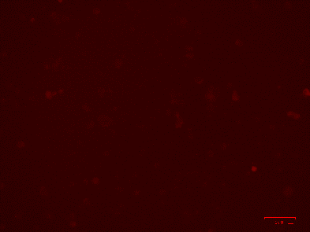
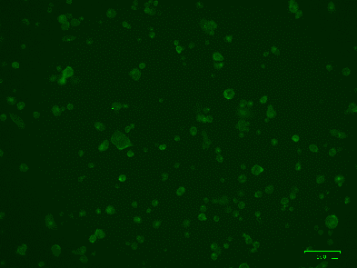
M0
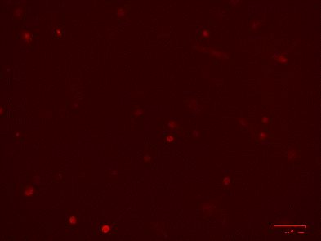
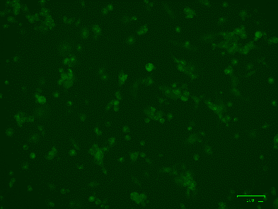
M1
M2


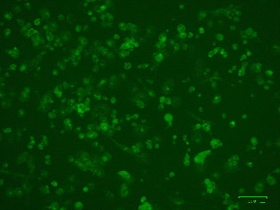
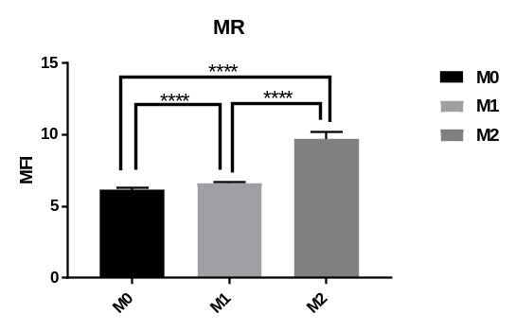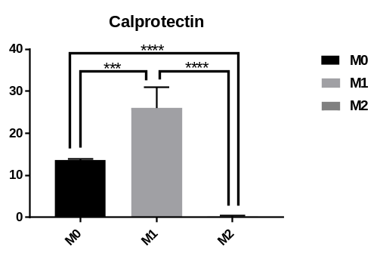
B
Supplementary 1 Figure 2: Expression of surface markers by cytokine polarized THP-1 macrophages. A) Immunofluorescent images of showing mannose receptor (green) and calprotectin (red) expression; nuclei were stained with DAPI (blue). B) Mean fluorescent intensities of M1, M2 and M0 cells.

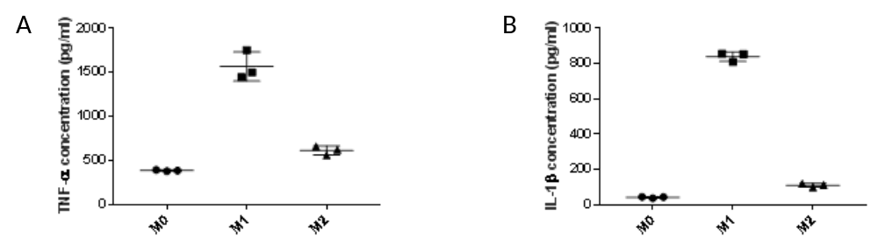
Supplementary 1 Figure 3: Cytokine expression by macrophages. Following 6 h PMA activation, cells were treated with GM-CSF (50ng/ml), LPS (100 ng/mL) and IFN-γ (20 ng/mL) or M-CSF (50 ng/mL) and IL-4 (20 ng/mL) for up to 72 h to generate M1 or M2 polarised cells, respectively. A) TNF-α B) IL-1β expression. Data is presented as mean ± SD (n=3).

