Supplementary Information: Metabolic characterization of colorectal cancer cells harbouring different KRAS mutations in codon 12, 13, 61 and 146 using human SW48 isogenic cell lines

Authors: Dorna Varshaviª, Dorsa Varshaviª, Nicola McCarthy^{b}, Kirill Veselkov^{c}, Hector C Keun^{d} and Jeremy R. Everett^{a*}
ª Medway Metabonomics Research Group,
University of Greenwich,
Chatham Maritime,
Kent,
ME4 4TB
United Kingdom

^{b} Horizon Discovery Ltd.,
Cambridge Research Park,
8100 Beach Dr, Waterbeach,
Cambridge,
CB25 9TL
United Kingdom

^{c} Department of Surgery and Cancer,
Faculty of Medicine,
Imperial College,
London,
SW7 2AZ
United Kingdom

^{d} Department of Surgery and Cancer,
Imperial College London,
Hammersmith Hospital Campus,
London,
W12 ONN UK
United Kingdom

* Author for Correspondence
ORCID: 0000-0003-1550-4482
Telephone: +44 (0)208 331 8323
Email: j.r.everett@greenwich.ac.uk

Supplementary Table 1. Data acquisition and processing parameters for 2D NMR spectra of SW48 KRAS ^{G13D/+}
Parameter | JRES | COSY | HSQC | HMBC
F2 spectral width in Hz | 10,026.7 | 7,211 | 7,211 | 9,615
F1 spectral width in Hz | 78.0 | 7,211 | 28,678 | 34,716
data points in t2 | 8,192 | 4,096 | 2,048 | 2,048
spectral size in F2 | 1,638 |  | 4,096 | 2,048
increments in t1 | 40 | 256 | 400 | 256
spectral size in F1 | 256 | 2,048 | 1,024 | 1,024
number of scans | 16 | 32 | 128 | 50
relaxation delay in seconds | 2.00 | 2.00 | 3.00 | 3.00
apodisation | sine bell in t1 and t2 with first point correction in t1 | sine bell squared in t2, sine square with first point correction in t1 | sine bell squared in t2, sine square with first point correction in t1 | sine bell in t1 and t2 with first point correction in t1
Bruker pulse sequence | jresgpprqf | Cosygpprqf | hsqcetgpprsisp 2.2.be | hmbcgplpndprqf
notes | the spectrum was tilted by 45⁰ and symmetrised | t1 noise reduction was applied to the spectrum

Supplementary Table 2. Data acquisition and processing parameters for 2D NMR spectra of media of SW48 KRAS ^{+/+}
Parameter | JRES | COSY | HSQC
F2 spectral width in Hz | 10,026.7 | 9,578 | 9,578
F1 spectral width in Hz | 78.0 | 9,578 | 34,720
data points in t2 | 8,192 | 8,192 | 3,072
spectral size in F2 | 1,638 | 8,192 | 4,096
increments in t1 | 40 | 512 | 800
spectral size in F1 | 256 | 2,048 | 1,024
number of scans | 8 | 12 | 20
relaxation delay in seconds | 2.00 | 2.00 | 3.00
apodisation | sine bell in t1 and t2 with first point correction in t1 | sine bell squared in t2, sine square with first point correction in t1 | sine bell squared in t2, sine square with first point correction in t1
Bruker pulse sequence code | jresgpprqf | Cosygpprqf | hsqcetgpprsisp 2.2.be
notes | the spectrum was tilted by 45⁰ and symmetrised | t1 noise reduction was applied to the spectrum

Supplementary Figure 1. a) The aliphatic region of the 600 MHz ¹H NMR spectra from SW48 KRAS ^{G13D/+,} KRAS ^{+/+,} KRAS ^{G12D/+} extracts. Numbers indicate signals corresponding to individual metabolites.1.isoleucine; 2. leucine; 3.valine; 4. lactate; 5. alanine; 6. acetate; 7.glutamate; 8. UDP-N-acetylglucosamine;9. UDP-N-acetylgalactosamine; 10.glutamine; 11. glutathione; 12.succinate; 13. aspartate; 14.creatine; 15. creatine phosphate; 16. choline; 17. phosphorylcholine; 18. glycerophosphocholine; 19. betaine; 20.taurine; 21. myo-inositol; 22.glycine; 23.glucose
Supplementary Figure 1. b) The aromatic region of the 600 MHz ¹H NMR spectra from SW48 KRAS ^{G13D/+,} KRAS ^{+/+,} KRAS ^{G12D/+} extracts. Numbers indicate signals corresponding to individual metabolites. 8. UDP-N-acetylglucosamine; 9. UDP-N-acetylgalactosamine; 23. glucose; 24. inosine; 25. NAD; 26. UDP-glucose; 27. AMP; 28. tyrosine; 29. phenylalanine; 30. uridine; 31. ATP
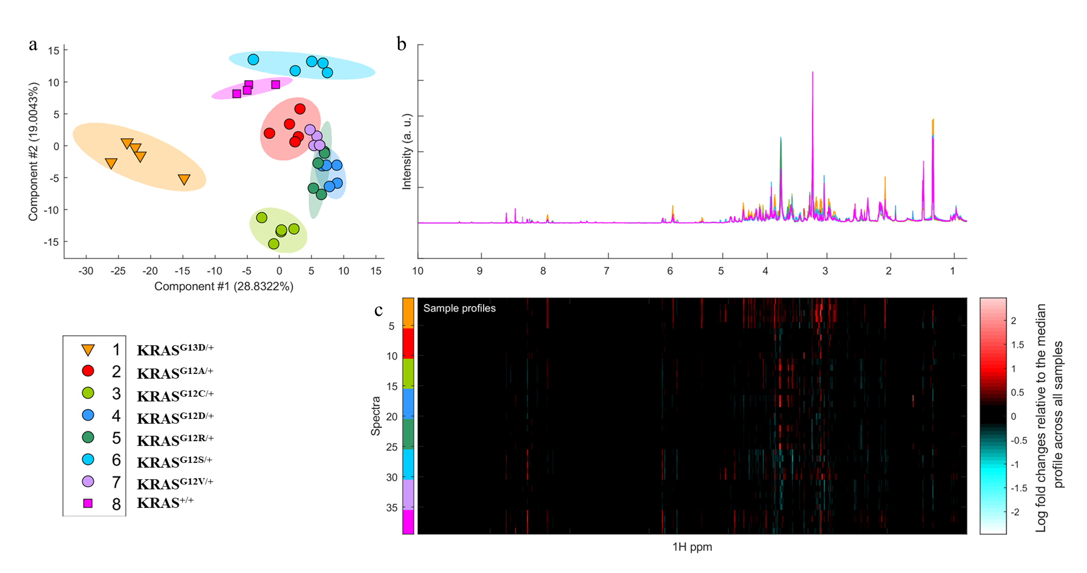
Supplementary Figure 2. a) MMC score plot of the 600MHz ¹NMR spectra of extracts of SW48 cells with KRAS mutations in codons 12 and 13 and their wild type counterpart, b) superimposed NMR spectra of SW48 cells, with the same colour coding as in the MMC plot; c) the corresponding ‘heat map display of the 600 MHz ¹H NMR spectra of SW48 cell lines from 0.8 to 10.0 ppm. Red and blue elements in the spectra indicate NMR signals that are more intense, or less intense, respectively, than the median signal intensity for all the samples.
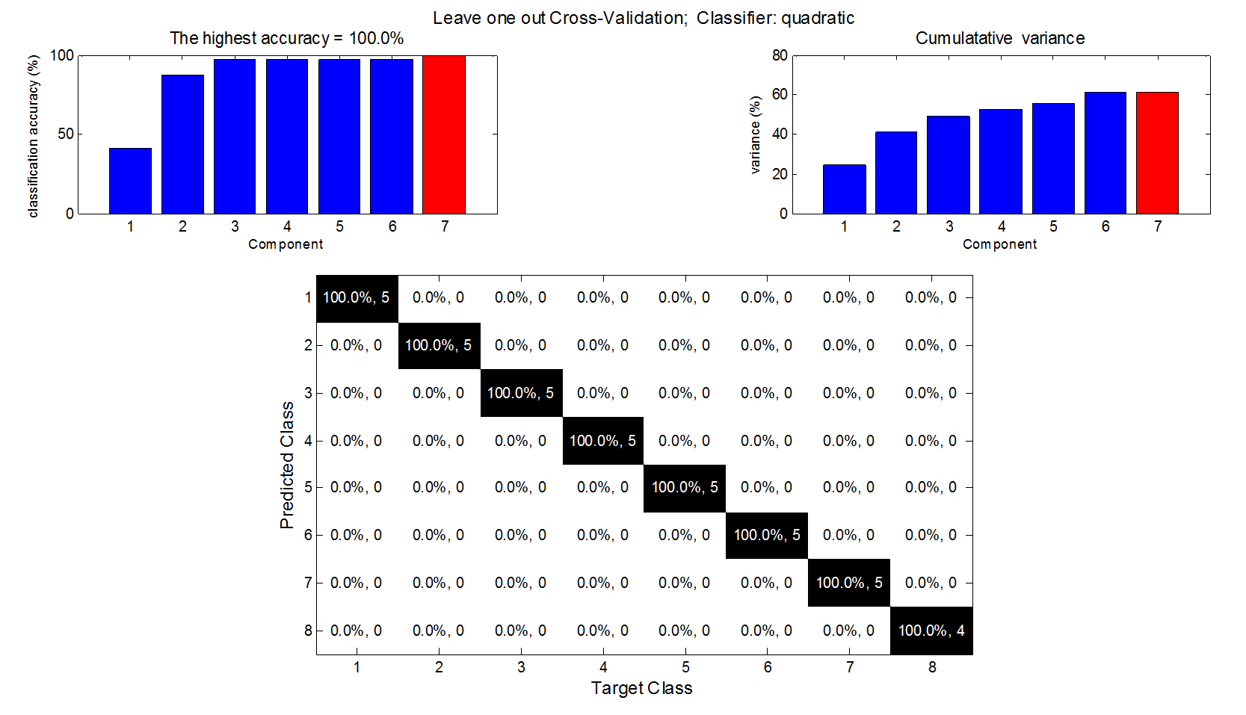
Supplementary Figure 3. Leave one out cross validation of the 600 MHz ¹H NMR spectra from extracts of SW48 cells with KRAS mutation at codon 12 and 13 using the quadratic as a classifier; The upper left and upper right diagnostic plots indicate the changes in the percentage of correct classification and the variation related to discrimination as a function of the number of discriminating components respectively. The red color-bar highlights the optimum number of discriminating components. The diagonal of each confusion matrix shows the percentage of samples that are correctly predicted in each class by colouring each box in confusion matrices, black to white with descending predictivity. The off-diagonal boxes represent the percentage of samples in one class being incorrectly predicted into other classes.

Supplementary Figure 4. At bottom a ‘heat map display of the 600 MHz ¹H NMR spectra of KRAS ^{G12S/+} (top 5 strips) vs the corresponding spectra of parental cell line (KRAS^{+/+}) extracts (bottom 4 strips). Red and blue elements in the spectra indicate NMR signals that are more intense, or less intense, respectively, than the median signal intensity for the whole samples. At top, the corresponding ANOVA plot, showing positive peaks for those intracellular metabolite signals that are more intense in KRAS ^{G12S/+}, and negative peaks for those metabolite signals that are less intense. The signals are colour coded by the p value adjusted for an FDR of 0.1
Supplementary Figure 5. At bottom a ‘heat map display of the 600 MHz ¹H NMR spectra of KRAS ^{G12A/+} (top 5 strips) vs the corresponding spectra of KRAS^{+/+} extracts (bottom 5 strips). Red and blue elements in the spectra indicate NMR signals that are more intense, or less intense, respectively, than the median signal intensity for the whole samples. At top, the corresponding ANOVA plot, showing positive peaks for those intracellular metabolite signals that are more intense in KRAS ^{G12A/+}, and negative peaks for those metabolite signals that are less intense. The signals are colour coded by the p value adjusted for an FDR of 0.1.
Supplementary Figure 6. At bottom a ‘heat map display of the 600 MHz ¹H NMR spectra of KRAS ^{G12C/+} (top 5 strips) vs the corresponding spectra of parental cell line (KRAS^{+/+}) extracts (bottom 4 strips). Red and blue elements in the spectra indicate NMR signals that are more intense, or less intense, respectively, than the median signal intensity for the whole samples. At top, the corresponding ANOVA plot, showing positive peaks for those intracellular metabolite signals that are more intense in KRAS ^{G12C/+}, and negative peaks for those metabolite signals that are less intense. The signals are colour coded by the p value adjusted for an FDR of 0.1.
Supplementary Figure 7. At bottom a ‘heat map display of the 600 MHz ¹H NMR spectra of KRAS ^{G12D/+} (top 5 strips) vs the corresponding spectra of parental cell line (KRAS^{+/+}) extracts (bottom 4 strips). Red and blue elements in the spectra indicate NMR signals that are more intense, or less intense, respectively, than the median signal intensity for the whole samples. At top, the corresponding ANOVA plot, showing positive peaks for those intracellular metabolite signals that are more intense in KRAS ^{G12D/+}, and negative peaks for those metabolite signals that are less intense. The signals are colour coded by the p value adjusted for an FDR of 0.1.
Supplementary Figure 8. At bottom a ‘heat map display of the 600 MHz ¹H NMR spectra of KRAS ^{G12V/+} (top 5 strips) vs the corresponding spectra of parental cell line (KRAS^{+/+}) extracts (bottom 4 strips). Red and blue elements in the spectra indicate NMR signals that are more intense, or less intense, respectively, than the median signal intensity for the whole samples. At top, the corresponding ANOVA plot, showing positive peaks for those intracellular metabolite signals that are more intense in KRAS ^{G12V/+}, and negative peaks for those metabolite signals that are less intense. The signals are colour coded by the p value adjusted for an FDR of 0.1.
Supplementary Figure 9. At bottom a ‘heat map display of the 600 MHz ¹H NMR spectra of KRAS ^{G12R/+} (top 5 strips) vs the corresponding spectra of parental cell line (KRAS^{+/+}) extracts (bottom 4 strips). Red and blue elements in the spectra indicate NMR signals that are more intense, or less intense, respectively, than the median signal intensity for the whole samples. At top, the corresponding ANOVA plot, showing positive peaks for those intracellular metabolite signals that are more intense in KRAS ^{G12R/+}, and negative peaks for those metabolite signals that are less intense. The signals are colour coded by the p value adjusted for an FDR of 0.1.
Supplementary Table 3. Intracellular metabolites discriminating between KRAS^{G12S/+} and KRAS^{+/+}

Metabolite | ppm | p-values | q-values | Log2 FC¹
glutamate | 2.341 | 2.62E-03 | 6.25E-02 | -0.708
glutamine | 2.454 | 4.13E-03 | 8.21E-02 | -0.570
aspartate | 2.705 | 1.50E-03 | 4.57E-02 | -0.365
phosphocholine | 3.224 | 5.43E-03 | 9.75E-02 | -0.697
myo-inositol | 4.067 | 2.57E-03 | 6.18E-02 | -0.629
glucose | 5.235 | 4.93E-02 | 1.00E+00 | 0.515
UDP-N-acetylglucosamine | 5.513 | 1.78E-05 | 3.69E-03 | -0.479
UDP-N-acetylgalactosamine | 5.546 | 6.43E-05 | 6.94E-03 | -0.197
GTP | 8.14 | 2.40E-04 | 1.63E-02 | -0.231
1. FC: fold change

Supplementary Table 4. Intracellular metabolites discriminating between KRAS ^{G12A/+} and KRAS^{+/+}

Metabolite | ppm | p-values | q-values | Log 2 FC¹
leucine | 0.966 | 3.70E-04 | 1.62E-02 | -0.538
isoleucine | 1.009 | 2.24E-03 | 4.62E-02 | -0.475
valine | 1.040 | 1.56E-03 | 3.77E-02 | -0.495
threonine | 1.328 | 3.17E-03 | 5.77E-02 | -0.351
glutamine | 2.440 | 3.73E-03 | 6.41E-02 | -0.572
aspartate | 2.704 | 2.33E-03 | 4.72E-02 | -0.370
UDP-N-acetylglucosamine | 5.512 | 3.88E-05 | 5.99E-03 | -0.424
UDP-N-acetylgalactosamine | 5.546 | 4.49E-04 | 1.79E-02 | -0.165
uridine | 5.900 | 7.48E-04 | 2.42E-02 | 0.464
tyrosine | 6.899 | 4.14E-03 | 6.84E-02 | -0.172
phenylalanine | 7.329 | 3.74E-04 | 1.63E-02 | -0.268
inosine | 8.349 | 3.15E-06 | 2.65E-03 | 1.783
ATP | 8.537 | 2.03E-03 | 4.39E-02 | -0.297
AMP | 8.605 | 1.70E-04 | 1.10E-02 | -1.399
- FC: fold change

Supplementary Table 5. Intracellular metabolites discriminating between KRAS ^{G12C/+} and KRAS^{+/+}
Metabolite | ppm | p-values | q-values | Log2 FC¹
leucine | 0.966 | 5.75E-04 | 7.62E-03 | -0.518
isoleucine | 1.009 | 1.60E-03 | 1.60E-02 | -0.462
valine | 1.041 | 1.82E-03 | 1.76E-02 | -0.468
threonine | 1.329 | 6.31E-04 | 8.12E-03 | -0.451
alanine | 1.479 | 5.07E-03 | 3.71E-02 | -0.700
glutamate | 2.341 | 1.09E-02 | 6.43E-02 | -0.360
succinate | 2.406 | 8.40E-04 | 1.00E-02 | -0.902
glutamine | 2.44 | 2.86E-05 | 1.11E-03 | -1.215
glutathione | 2.545 | 1.90E-02 | 9.54E-02 | -0.332
aspartate | 2.705 | 4.55E-03 | 3.43E-02 | 0.408
choline | 3.208 | 2.78E-03 | 2.39E-02 | 0.406
glycerophosphocholine | 3.234 | 4.49E-04 | 6.47E-03 | -0.719
myo-inositol | 4.067 | 2.44E-05 | 1.01E-03 | 1.047
uridine | 5.9 | 1.19E-06 | 2.06E-04 | 1.107
fumarate | 6.521 | 7.06E-03 | 4.71E-02 | 0.221
tyrosine | 6.899 | 1.03E-02 | 6.15E-02 | -0.127
phenylalanine | 7.329 | 1.35E-03 | 1.40E-02 | -0.210
UMP | 8.105 | 9.27E-06 | 6.03E-04 | -0.977
GTP | 8.14 | 3.66E-05 | 1.28E-03 | -0.328
inosine | 8.349 | 2.79E-07 | 1.09E-04 | 1.716
ATP | 8.537 | 2.60E-05 | 1.05E-03 | -0.574
AMP | 8.606 | 1.80E-07 | 9.45E-05 | -2.852
1. FC: fold change

Supplementary Table 6. Intracellular metabolites discriminating between KRAS ^{G12D/+} and KRAS^{+/+}
Metabolite | ppm | p-values | q-values | Log2 FC¹
leucine | 0.966 | 5.86E-03 | 5.39E-02 | -0.405
isoleucine | 1.010 | 1.08E-02 | 8.05E-02 | -0.197
valine | 1.041 | 8.57E-03 | 6.93E-02 | -0.412
lactate | 1.325 | 6.46E-03 | 5.74E-02 | -0.711
threonine | 1.329 | 1.04E-02 | 7.88E-02 | -0.380
succinate | 2.406 | 7.69E-05 | 3.04E-03 | -0.978
glutamine | 2.44 | 1.23E-02 | 8.81E-02 | -0.275
aspartate | 2.705 | 1.64E-03 | 2.24E-02 | 0.553
creatine phosphate | 3.045 | 9.02E-04 | 1.51E-02 | 0.973
glycerophosphocholine | 3.234 | 1.00E-03 | 1.62E-02 | -0.717
taurine | 3.428 | 4.51E-03 | 4.51E-02 | 0.445
UDP-N-acetylglucosamine | 5.513 | 3.68E-05 | 1.95E-03 | -0.463
UDP-N-acetylgalactosamine | 5.546 | 2.68E-04 | 6.62E-03 | -0.180
Uridine | 5.9 | 8.28E-05 | 3.20E-03 | 0.779
NAD | 6.05 | 4.35E-03 | 4.40E-02 | -0.168
tyrosine | 6.899 | 1.16E-02 | 8.44E-02 | -0.140
phenylalanine | 7.329 | 6.29E-03 | 5.64E-02 | -0.191
UMP | 8.105 | 6.37E-05 | 2.68E-03 | -0.816
GTP | 8.14 | 1.55E-04 | 4.73E-03 | -0.260
inosine | 8.349 | 8.90E-07 | 2.59E-04 | 1.853
ATP | 8.537 | 1.38E-04 | 4.37E-03 | -0.479
AMP | 8.606 | 3.27E-07 | 1.82E-04 | -2.610
1. FC: fold change

Supplementary Table 7. Intracellular metabolites discriminating between KRAS ^{G12V/+} and KRAS^{+/+}
Metabolite | ppm | p-values | q-values | Log2 FC¹
leucine | 0.966 | 7.70E-05 | 3.09E-03 | -0.687
isoleucine | 1.009 | 6.02E-04 | 8.89E-03 | -0.565
valine | 1.041 | 3.32E-04 | 6.47E-03 | -0.631
lactate | 1.325 | 1.03E-03 | 1.22E-02 | -0.997
threonine | 1.329 | 1.96E-05 | 1.58E-03 | -0.886
alanine | 1.479 | 2.48E-03 | 2.14E-02 | -0.816
glutamate | 2.341 | 1.20E-03 | 1.35E-02 | -0.677
succinate | 2.406 | 1.99E-05 | 1.59E-03 | -1.297
glutamine | 2.44 | 2.86E-03 | 2.34E-02 | -0.567
glutathione | 2.545 | 5.64E-04 | 8.60E-03 | -0.572
creatine | 3.040 | 3.13E-04 | 6.25E-03 | -1.240
choline | 3.208 | 2.57E-03 | 2.19E-02 | -0.410
glycerophosphocholine | 3.234 | 7.12E-03 | 4.25E-02 | -0.411
taurine | 3.428 | 1.73E-02 | 7.77E-02 | -0.412
UDP-N-acetylglucosamine | 5.513 | 4.93E-04 | 7.92E-03 | -0.318
UDP-N-acetylgalactosamine | 5.546 | 8.84E-03 | 4.92E-02 | -0.094
uridine | 5.9 | 3.26E-05 | 2.06E-03 | 0.542
NAD | 6.05 | 2.32E-02 | 9.46E-02 | -0.128
tyrosine | 6.899 | 6.80E-04 | 9.53E-03 | -0.270
phenylalanine | 7.329 | 1.08E-04 | 3.77E-03 | -0.303
UMP | 8.105 | 3.61E-04 | 6.72E-03 | -0.623
GTP | 8.14 | 5.17E-03 | 3.44E-02 | -0.161
inosine | 8.349 | 2.87E-05 | 1.92E-03 | 1.566
ATP | 8.537 | 1.91E-04 | 4.98E-03 | -0.423
AMP | 8.606 | 2.42E-06 | 5.77E-04 | -2.253
1. FC: fold change
Supplementary Table 8. Intracellular metabolites discriminating between KRAS ^{G12R/+} and KRAS^{+/+}
Metabolite | ppm | p-values | q-values | Log2 FC¹
glutamine | 2.44 | 8.43E-05 | 2.77E-03 | -1.132
aspartate | 2.705 | 1.16E-03 | 1.84E-02 | 0.428
creatine phosphate | 3.045 | 2.62E-06 | 5.76E-04 | -1.619
choline | 3.208 | 9.33E-03 | 8.30E-02 | 0.344
phosphocholine | 3.225 | 4.00E-03 | 4.50E-02 | -0.459
glycerophosphocholine | 3.234 | 1.59E-05 | 1.08E-03 | -1.115
taurine | 3.428 | 9.47E-03 | 8.36E-02 | 0.295
UDP-N-acetylglucosamine | 5.513 | 1.77E-05 | 1.14E-03 | -0.483
UDP-N-acetylgalactosamine | 5.546 | 5.35E-05 | 2.10E-03 | -0.181
uridine | 5.9 | 2.05E-07 | 2.02E-04 | 0.554
GTP | 8.14 | 8.07E-05 | 2.71E-03 | -0.281
inosine | 8.349 | 1.41E-07 | 1.80E-04 | 1.178
AMP | 8.606 | 2.01E-05 | 1.22E-03 | -1.850
1. FC: fold change
a b

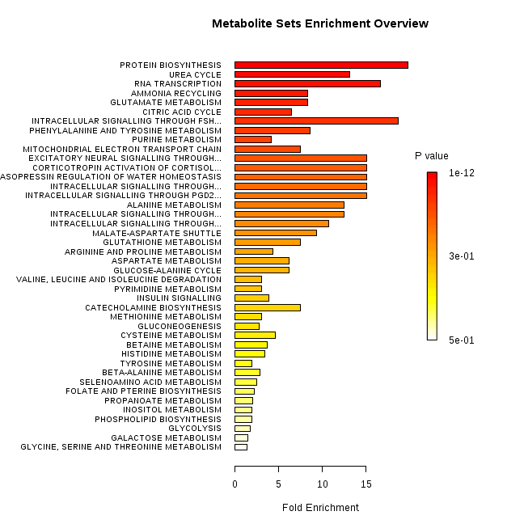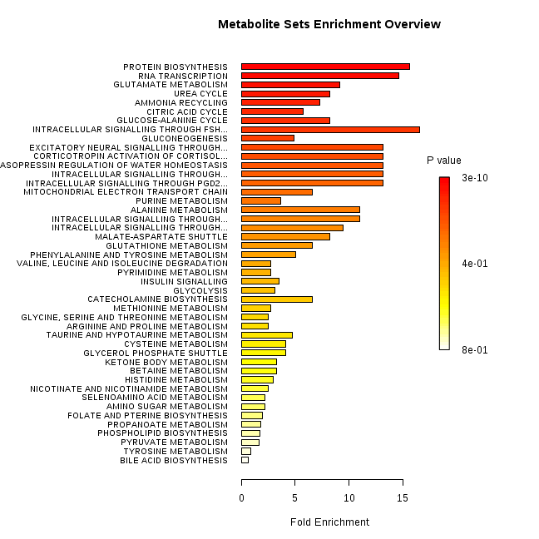
Supplementary Figure 10. Metabolic pathway analyses for metabolites discriminating between: a) KRAS ^{G12C/+}and KRAS^{+/+} b) KRAS ^{G12V/+}and KRAS^{+/+}. The horizontal bars summarize the main metabolite sets identified in this analysis; the bars are coloured based on their p-values and the length is based on the fold enrichment

a b
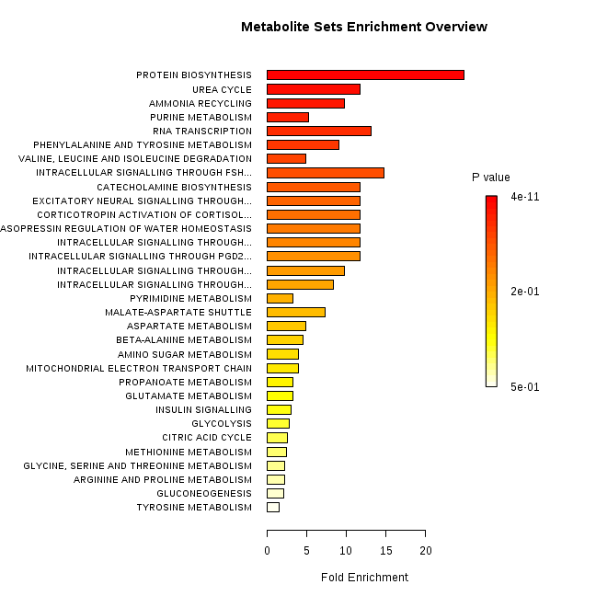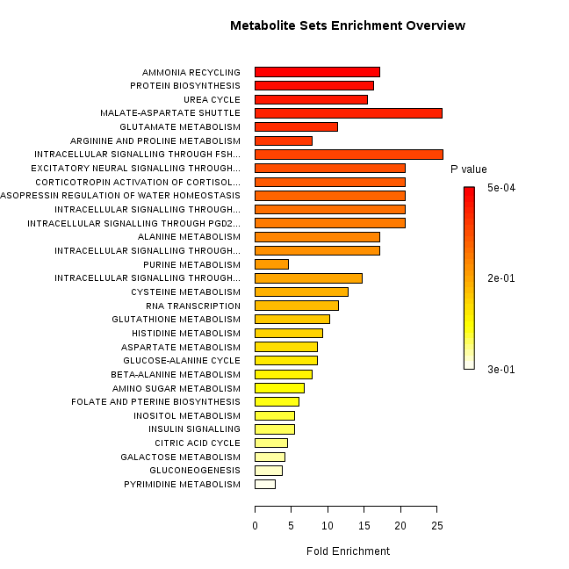
Supplementary Figure 11. Metabolic pathway analyses for metabolites discriminating between: a) KRAS ^{G12A/+}and KRAS^{+/+} b) KRAS ^{G12S/+}and KRAS^{+/+} . The horizontal bars summarize the main metabolite sets identified in this analysis; the bars are coloured based on their p-values and the length is based on the fold enrichment

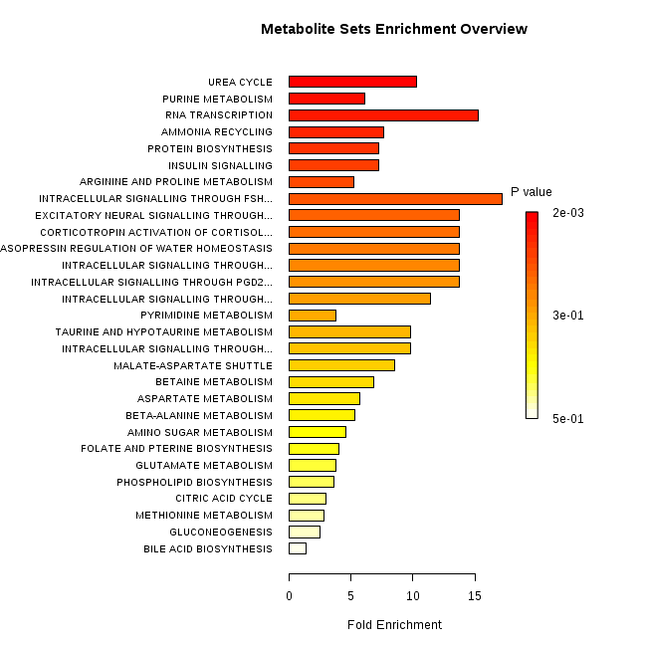

Supplementary Figure 12. Metabolic pathway analyses for metabolites discriminating between KRAS ^{G12R/+}and KRAS^{+/+}. The horizontal bars summarize the main metabolite sets identified in this analysis; the bars are coloured based on their p-values and the length is based on the fold enrichment

Supplementary Table 9. Changes in intracellular amino acids involved in protein synthesis
Metabolite | Chemical shift (ppm) |  | G12S/+  vs +/+ | G12A/+  vs +/+ | G12C/+  vs +/+ | G12D/+  vs +/+ | G12V/+  vs +/+ | G12R/+  vs +/+
  G13D/+
  vs +/+
isoleucine | 0.943 |  | - |  |  |  |  | -
leucine | 0.961 |  | - |  |  |  |  | -
valine | 0.996 |  | - |  |  |  |  | -
threonine | 1.335 | - | - | - |  |  |  | -
 | 1.484 | - | - | - |  | - |  | -
  alanine
glutamate | 2.059 |  |  | - |  | - |  | -
glutamine | 2.145 | -
aspartate | 2.684 |  |  |  |  |  | -
tyrosine | 6.910 |  | - |  |  |  |  | -
phenyl-alanine | 7.340 |  | - |  |  |  |  | -
Supplementary Figure 13. a) The aliphatic region of the 600 MHz ¹H NMR spectra from SW48 KRAS ^{G13D/+,} KRAS ^{+/+,} KRAS ^{G12D/+} media. Numbers indicate signals corresponding to individual metabolites. 1. isoleucine; 2. leucine; 3. valine;4. lactate; 5. alanine; 6. L-alanyl-L-glutamine; 7. acetate; 8. glutamine; 9. pyruvate; 10. glucose; 11. threonine

Supplementary Figure 13. b) The aromatic region of the 600 MHz ¹H NMR spectra from SW48 KRAS ^{G13D/+,} KRAS ^{+/+,} KRAS ^{G12D/+} media. Numbers indicate signals corresponding to individual metabolites. 12. tyrosine; 13. histidine; 14. tryptophan; 15. phenylalanine; 16. formate

Supplementary Figure 14. a) PCA score plot of the 600MHz ¹H NMR spectra from media of SW48 cell lines with KRAS mutations in codons 12 and 13 and their wild type counterpart, b) superimposed NMR spectra of cell’s media, with the same colour coding as in the PCA plot part a); c) ‘the corresponding heat map display of the 600 MHz ¹H NMR spectra from 0.8 to 10.0 ppm of media of SW48 cell lines. Red and blue elements in the spectra indicate NMR signals that are more intense, or less intense, respectively, than the median signal intensity for all the samples.

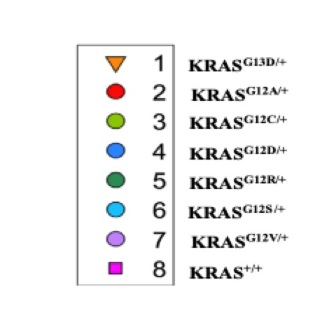
Supplementary Figure 15. a) MMC score plot of the 600 MHz ¹H NMR spectra from media of SW48 cell lines with KRAS mutations in codons 12 and 13 and their wild type counterpart, b) superimposed NMR spectra of SW48 cell media, with the same colour coding as in the MMC plot; c) the corresponding ‘heat map display of the 600 MHz ¹H NMR spectra of Red and blue elements in the spectra indicate NMR signals that are more intense, or less intense, respectively, than the median signal intensity for all the samples.

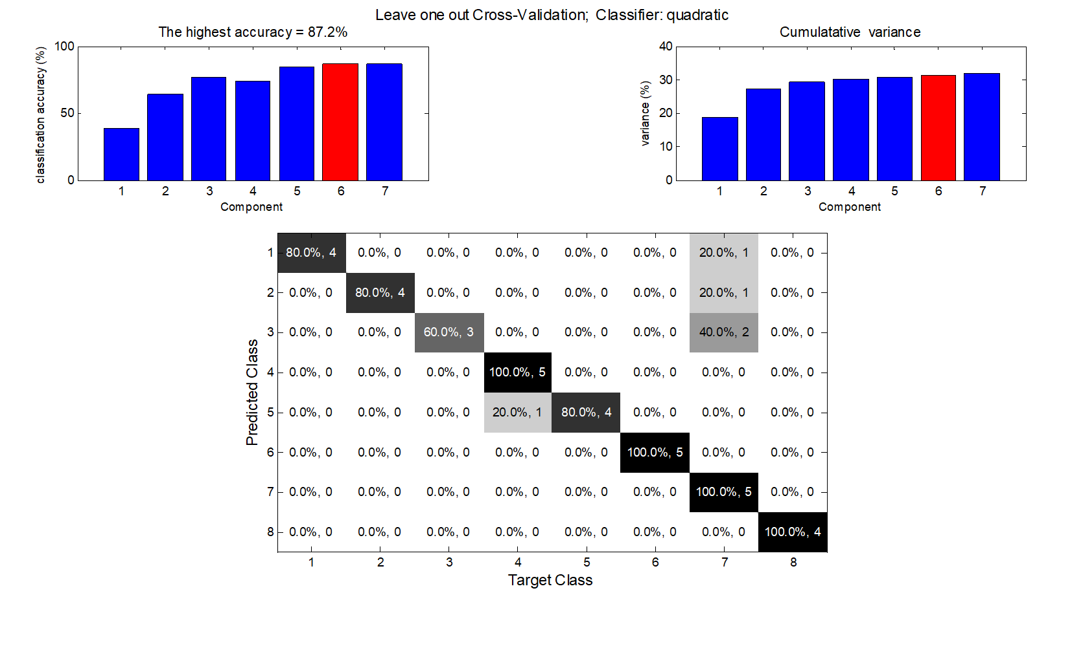
Supplementary Figure 16. Leave one out cross validation of the MMC model made from 600 MHz ¹H NMR spectra of the media of SW48 cell lines with KRAS mutation at codon 12 and 13 using the quadratic as a classifier; The upper left and upper right diagnostic plots indicate the changes in the percentage of correct and the variation related to discrimination as a function of the number of discriminating components respectively. The red color-bar highlights the optimum number of discriminating components. The diagonal of each confusion matrix shows the percentage of samples that are correctly predicted in each class by colouring each box in confusion matrices, black to white with a descending predictivity. The off-diagonal boxes represent the percentage of samples in one class being incorrectly predicted into other classes.
Supplementary Figure 17. At bottom a ‘heat map display of the 600 MHz ¹H NMR spectra from media of KRAS ^{G13D/+} (top 5 strips) vs the corresponding spectra from media of KRAS^{+/+} (bottom 4 strips). Red and blue elements in the spectra indicate NMR signals that are more intense, or less intense, respectively, than the median signal intensity for the whole samples. At top, the corresponding ANOVA plot, showing positive peaks for those metabolite signals that are more intense in media of KRAS ^{G13D/+}, and negative peaks for those metabolite signals that are less intense. The signals are colour coded by the p value adjusted for FDR of 0.1.
Supplementary Figure 18. At bottom a ‘heat map display of the 600 MHz ¹H NMR spectra from media of KRAS ^{G12S/+} (top 5 strips) vs the corresponding spectra from media of KRAS^{+/+} (bottom 4 strips). Red and blue elements in the spectra indicate NMR signals that are more intense, or less intense, respectively, than the median signal intensity for the whole samples. At top, the corresponding ANOVA plot, showing positive peaks for those metabolite signals that are more intense in media of KRAS ^{G12S/+}, and negative peaks for those metabolite signals that are less intense. The signals are colour coded by the p value adjusted for FDR of 0.1.
Supplementary Figure 19. At bottom a ‘heat map display of the 600 MHz ¹H NMR spectra from media of KRAS ^{G12A/+} (top 5 strips) vs the corresponding spectra from media of KRAS^{+/+} (bottom 4 strips). Red and blue elements in the spectra indicate NMR signals that are more intense, or less intense, respectively, than the median signal intensity for the whole samples. At top, the corresponding ANOVA plot, showing positive peaks for those metabolite signals that are more intense in media of KRAS ^{G12A/+}, and negative peaks for those metabolite signals that are less intense. The signals are colour coded by the p value adjusted for FDR of 0.1.
Supplementary Figure 20. At bottom a ‘heat map display of the 600 MHz ¹H NMR spectra from media of KRAS ^{G12C/+} (top 5 strips) vs the corresponding spectra from media of KRAS^{+/+} (bottom 4 strips). Red and blue elements in the spectra indicate NMR signals that are more intense, or less intense, respectively, than the median signal intensity for the whole samples. At top, the corresponding ANOVA plot, showing positive peaks for those metabolite signals that are more intense in media of KRAS ^{G12C/+}, and negative peaks for those metabolite signals that are less intense. The signals are colour coded by the p value adjusted for FDR of 0.1.
Supplementary Figure 21. At bottom a ‘heat map display of the 600 MHz ¹H NMR spectra from media of KRAS ^{G12D/+} (top 5 strips) vs the corresponding spectra from media of KRAS^{+/+} (bottom 4 strips). Red and blue elements in the spectra indicate NMR signals that are more intense, or less intense, respectively, than the median signal intensity for the whole samples. At top, the corresponding ANOVA plot, showing positive peaks for those metabolite signals that are more intense in KRAS ^{G12D/+}, and negative peaks for those metabolite signals that are less intense. The signals are colour coded by the p value adjusted for FDR of 0.1.
Supplementary Figure 22. At bottom a ‘heat map display of the 600 MHz ¹H NMR spectra from media of KRAS ^{G12V/+} (top 5 strips) vs the corresponding spectra from media of KRAS^{+/+}(bottom 4 strips). Red and blue elements in the spectra indicate NMR signals that are more intense, or less intense, respectively, than the median signal intensity for the whole samples. At top, the corresponding ANOVA plot, showing positive peaks for those metabolite signals that are more intense in KRAS ^{G12V/+}, and negative peaks for those metabolite signals that are less intense. The signals are colour coded by the p value adjusted for FDR of 0.1.
Supplementary Figure 23. At bottom a ‘heat map display of the 600 MHz ¹H NMR spectra from media of KRAS ^{G12R/+} (top 5 strips) vs the corresponding spectra from media of KRAS^{+/+} (bottom 4 strips). Red and blue elements in the spectra indicate NMR signals that are more intense, or less intense, respectively, than the median signal intensity for the whole samples. At top, the corresponding ANOVA plot, showing positive peaks for those metabolite signals that are more intense in KRAS ^{G12R/+}, and negative peaks for those metabolite signals that are less intense. The signals are colour coded by the p value adjusted for FDR of 0.1.
Extracellular Metabolite Profile Differences between KRAS Mutants.
The media metabolic profile (exometabolome) of KRAS ^{G13D/+} showed decreased levels of 3-methyl-2-oxovaleric acid, 2-oxoisovaleric acid, lactate, threonine, L-alanyl-L-glutamine, methionine, ketoleucine, phenylalanine, tryptophan and increased levels of glutamate and acetate (Supplementary Table 10).
Compared to KRAS WT, exometabolome of KRAS G12S was characterised by decreased levels of lactate, alanine, glutamine, methionine and increased levels of L-alanyl-L-glutamine and acetate (Supplementary Table 11).
In KRAS G12A decreased levels of L-alanyl-L-glutamine, methionine, ketoleucine, glucose, tryptophan and increased concentrations of lactate and acetate was observed in comparison to parental cell line (Supplementary Table 12).
KRAS G12C displayed decreased levels of isoleucine, leucine, valine, acetate, methionine, glucose, phenylalanine, tryptophan and higher levels of 3-methyl-2-oxovaleric acid and lactate relative to KRAS WT (Supplementary Table 13).
Compared to WT, KRAS G12D showed decreased levels of L-alanyl-L-glutamine and increased concentrations of alanine, glutamine, pyruvate (Supplementary Table 14).
KRAS G12V exhibited decreased levels of 3-methyl-2-oxovaleric acid, 2-oxoisovaleric acid, L-alanyl-L-glutamine, methionine, ketoleucine, glucose, phenylalanine and formate and increased levels of lactate, alanine, glutamate, pyruvate compared to KRAS WT (Supplementary Table 15).
In KRAS G12R, decreased levels of isoleucine, leucine, valine, L-alanyl-L-glutamine, acetate, methionine, aspartate, histidine, glucose, tyrosine, phenylalanine, tryptophan, formate and increased levels of 3-methyl-2-oxovaleric acid, 2-oxoisovaleric acid, lactate and glutamate were observed in comparison to KRAS WT (Supplementary Table 16).

Supplementary Table 10. Extracellular metabolites discriminating between KRAS^{G13D/+} and KRAS^{+/+}

Metabolite | ppm | p-values | q-values | Log 2 FC¹
3-methyl-2-oxovaleric acid | 1.108 | 1.02E-04 | 2.83E-03 | -0.565
2-oxoisovaleric acid | 1.121 | 6.28E-05 | 2.13E-03 | -0.516
threonine | 1.330 | 6.33E-03 | 5.06E-02 | -0.324
lactate | 1.338 | 7.30E-04 | 1.06E-02 | -0.220
L-alanyl-L-glutamine | 1.550 | 1.18E-05 | 1.05E-03 | -1.018
acetate | 1.923 | 4.27E-03 | 3.74E-02 | 0.188
glutamate | 2.065 | 4.27E-05 | 1.71E-03 | 0.497
ketoleucine | 2.611 | 4.49E-05 | 1.76E-03 | -0.477
methionine | 2.648 | 9.08E-05 | 2.67E-03 | -0.241
Phenylalanine | 7.342 | 1.03E-02 | 7.20E-02 | -0.106
tryptophan | 7.749 | 6.47E-04 | 9.69E-03 | -0.208
1. FC: fold change
Supplementary Table 11. Extracellular metabolites discriminating between KRAS^{G12S/+} and KRAS^{+/+}
Metabolite | ppm | p-values | q-values | Log 2 FC¹
lactate | 1.338 | 9.59E-04 | 1.76E-02 | -0.732
alanine | 1.491 | 2.29E-03 | 2.96E-02 | -0.659
L-alanyl-L-glutamine | 1.550 | 8.51E-06 | 2.96E-03 | 1.837
acetate | 1.923 | 2.92E-05 | 2.37E-03 | 0.557
glutamine | 2.453 | 2.90E-03 | 3.43E-02 | -0.661
methionine | 2.648 | 2.16E-03 | 2.86E-02 | -0.134
1. FC: fold change
Supplementary Table 12. Extracellular metabolites discriminating between KRAS^{G12A/+} and KRAS^{+/+}

Metabolite | ppm | p-values | q-values | Log 2 FC¹
lactate | 1.338 | 1.49E-04 | 3.46E-03 | 0.740
L-alanyl-L-glutamine | 1.550 | 1.13E-03 | 1.34E-02 | -2.490
acetate | 1.923 | 3.27E-03 | 2.92E-02 | 0.308
ketoleucine | 2.611 | 9.09E-03 | 6.23E-02 | -0.253
methionine | 2.648 | 2.24E-03 | 2.20E-02 | -0.259
glucose | 5.242 | 1.75E-03 | 1.84E-02 | -0.225
tryptophan | 7.749 | 6.26E-05 | 2.15E-03 | -0.513
1. FC: fold change

Supplementary Table 13. Extracellular metabolites discriminating between KRAS^{G12C/+} and KRAS^{+/+}

Metabolite | ppm | p-values | q-values | Log 2 FC¹
leucine | 0.965 | 1.19E-02 | 9.82E-02 | -0.110
isoleucine | 1.007 | 3.08E-03 | 3.71E-02 | -0.175
valine | 1.039 | 1.53E-03 | 2.26E-02 | -0.182
3-methyl-2-oxovaleric acid | 1.108 | 9.23E-04 | 1.56E-02 | 0.301
acetate | 1.923 | 7.75E-05 | 3.70E-03 | -0.616
lactate | 1.338 | 6.14E-03 | 6.11E-02 | 0.474
methionine | 2.648 | 2.03E-03 | 2.76E-02 | -0.157
glucose | 5.242 | 1.24E-03 | 1.94E-02 | -0.148
phenylalanine | 7.342 | 2.87E-03 | 3.54E-02 | -0.116
tryptophan | 7.749 | 7.01E-03 | 6.73E-02 | -0.152
1. FC: fold change

Supplementary Table 14. Extracellular metabolites discriminating between KRAS^{G12D/+} and KRAS^{+/+}

Metabolite | ppm | p-values | q-values | Log 2 FC¹
alanine | 1.491 | 3.39E-03 | 7.13E-02 | 0.194
L-alanyl-L-glutamine | 1.550 | 1.28E-03 | 3.87E-02 | -2.680
pyruvate | 2.378 | 2.96E-03 | 6.61E-02 | 0.246
glutamine | 2.453 | 4.90E-03 | 8.98E-02 | 0.176
1. FC: fold change
Supplementary Table 15. Extracellular metabolites discriminating between KRAS^{G12V/+} and KRAS^{+/+}

Metabolite | ppm | p-values | q-values | Log 2 FC¹
3-methyl-2-oxovaleric acid | 1.108 | 1.36E-03 | 1.19E-02 | -0.245
2-oxoisovaleric acid | 1.121 | 1.41E-02 | 7.58E-02 | -0.250
lactate | 1.338 | 1.57E-02 | 8.25E-02 | 0.214
alanine | 1.491 | 1.12E-03 | 1.02E-02 | 0.152
L-alanyl-L-glutamine | 1.550 | 8.99E-04 | 8.57E-03 | -1.204
glutamate | 2.065 | 1.49E-03 | 1.28E-02 | 0.182
pyruvate | 2.378 | 2.39E-03 | 1.85E-02 | 0.358
ketoleucine | 2.611 | 3.40E-03 | 2.45E-02 | -0.232
methionine | 2.648 | 3.85E-05 | 7.54E-04 | -0.194
glucose | 5.242 | 7.23E-04 | 7.34E-03 | -0.094
phenylalanine | 7.342 | 1.34E-03 | 1.17E-02 | -0.098
formate | 8.461 | 7.86E-03 | 4.77E-02 | -0.272
1. FC: fold change

Supplementary Table 16. Extracellular metabolites discriminating between KRAS^{G12R/+} and KRAS^{+/+}

Metabolite | ppm | p-values | q-values | Log 2 FC¹
leucine | 0.965 | 5.59E-04 | 1.17E-02 | -0.191
isoleucine | 1.007 | 1.44E-03 | 1.71E-02 | -0.256
valine | 1.039 | 1.51E-03 | 1.74E-02 | -0.263
3-methyl-2-oxovaleric acid | 1.108 | 1.36E-03 | 1.68E-02 | 0.381
2-oxoisovaleric acid | 1.121 | 2.95E-03 | 2.56E-02 | 0.429
lactate | 1.338 | 5.55E-04 | 1.17E-02 | 0.502
L-alanyl-L-glutamine | 1.550 | 9.31E-03 | 5.36E-02 | -1.323
acetate | 1.923 | 1.51E-05 | 3.49E-03 | -0.645
glutamate | 2.065 | 9.73E-03 | 5.51E-02 | 0.167
methionine | 2.648 | 7.29E-04 | 1.32E-02 | -0.253
aspartate | 2.795 | 1.03E-03 | 1.54E-02 | -0.515
glucose | 5.242 | 2.55E-04 | 8.03E-03 | -0.207
tyrosine | 6.903 | 3.09E-03 | 2.63E-02 | -0.150
histidine | 7.117 | 5.19E-04 | 1.13E-02 | -0.086
Phenylalanine | 7.342 | 1.14E-03 | 1.59E-02 | -0.150
tryptophan | 7.749 | 2.14E-02 | 9.81E-02 | -0.213
formate | 8.461 | 7.27E-04 | 1.32E-02 | -0.449
1. FC: fold change

Supplementary Figure 24. a) The aliphatic region of ¹HNMR spectra from SW48 KRAS ^{+/+,} KRAS ^{Q61H/+}, KRAS ^{A146T/+} intracellular extract. Numbers indicate signals corresponding to individual metabolites. 1. 1.isoleucine; 2. leucine; 3.valine; 4. lactate; 5. alanine; 6. acetate; 7.glutamate; 8.glutamine; 9. glutathione; 10. N-acetylglutamate; 11.succinate; 12. aspartate; 13.creatine; 14. choline; 15. phosphorylcholine; 16. glycerophosphocholine; 17. betaine; 18.taurine; 19. myo-inositol; 20.glycine; 22.glucose
Supplementary Figure 24. b) The aromatic region of ¹H NMR spectra from SW48 KRAS ^{+/+,} KRAS ^{Q61H/+}, KRAS ^{A146T/+} extract. Numbers indicate signals corresponding to individual metabolites. 22. glucose; 23. UDP-N-acetylglucosamine; 24. UDP-N-acetylgalactosamine; 25. NAD; 26. AMP; 27. tyrosine; 28. phenylalanine; 29. ATP
Supplementary Figure 25. a) PCA score plot of the 600MHz ¹H NMR spectra from extracts of SW48 cell lines with KRAS mutations in codons 16 and 146 and their wild type counterpart, b) superimposed NMR spectra of cell lines with the same colour coding as in the PCA plot part a); c) ‘the corresponding heat map display of the 600 MHz ¹H NMR spectra from 0.8 to 10.0 ppm of SW48 cell lines. Red and blue elements in the spectra indicate NMR signals that are more intense, or less intense, respectively, than the median signal intensity for all the samples. Supplementary Figure 26. a). MMC score plot of the 600MHz ¹NMR spectra from extracts of SW48 cells with KRAS mutations in codons 61 and 146 and their wild type counterpart, b) superimposed NMR spectra of SW48 cells, with the same colour coding as in the MMC plot; c) the corresponding ‘heat map display of the 600 MHz ¹H NMR spectra of Red and blue elements in the spectra indicate NMR signals that are more intense, or less intense, respectively, than the median signal intensity for all the samples.
Supplementary Figure 27. Leave one out cross validation of the 600 MHz ¹H NMR spectra from extracts of SW48 cell lines with KRAS mutations in codons 61 and 146 using the quadratic as a classifier; The upper left and upper right diagnostic plots indicate the changes in the percentage of correct and the variation related to discrimination as a function of the number of discriminating components respectively. The red color-bar highlights the optimum number of discriminating components. The diagonal of each confusion matrix shows the percentage of samples that are correctly predicted in each class by colouring each box in confusion matrices, black to white with a descending predictivity. The off-diagonal boxes represent the percentage of samples in one class being incorrectly predicted into other classes.
Supplementary Figure 28. At bottom a ‘heat map display of the 600 MHz ¹H NMR spectra of KRAS ^{A146T/+} (top 5 strips) vs the corresponding spectra of KRAS^{+/+} (bottom 4 strips). Red and blue elements in the spectra indicate NMR signals that are more intense, or less intense, respectively, than the median signal intensity for the whole samples. At top, the corresponding ANOVA plot, showing positive peaks for those metabolite signals that are more intense in KRAS ^{A146T/+}, and negative peaks for those metabolite signals that are less intense. The signals are colour coded by the p value adjusted for an FDR of 0.1.
Supplementary Figure 29. At bottom a ‘heat map display of the 600 MHz ¹H NMR spectra of KRAS ^{Q61H/+} (top 5 strips) vs the corresponding spectra of KRAS^{+/+} (bottom 4 strips). Red and blue elements in the spectra indicate NMR signals that are more intense, or less intense, respectively, than the median signal intensity for the whole samples. At top, the corresponding ANOVA plot, showing positive peaks for those metabolite signals that are more intense in KRAS ^{Q61H/+}, and negative peaks for those metabolite signals that are less intense. The signals are colour coded by the p value adjusted for an FDR of 0.1.
Supplementary Figure 30. At bottom a ‘heat map display of the 600 MHz ¹H NMR spectra of KRAS ^{A146T/+} (top 5 strips) vs the corresponding spectra of KRAS^{Q61H/+} (bottom 5 strips). Red and blue elements in the spectra indicate NMR signals that are more intense, or less intense, respectively, than the median signal intensity for the whole samples. At top, the corresponding ANOVA plot, showing positive peaks for those metabolite signals that are more intense in KRAS ^{A146T/+}, and negative peaks for those metabolite signals that are less intense. The signals are colour coded by the p value adjusted for an FDR of 0.1.
Supplementary Table 17. Summary of the most significant metabolites differentiating between SW48 cells with KRAS mutations in codons 61 and 146 and their wild type counterpart
Metabolite | Chemical shift | KRAS A146T/+ vs KRAS+/+ | KRAS Q61H/+ vs KRAS+/+ | KRAS A146T/+ vs KRAS Q61H/+
isoleucine | 0.943 (t), 1.01 (d), 3.675 (d) |  |  | -
leucine | 0.961 (d), 0.972 (d), 1.691 (m), 1.720 (m), 1.748 (m) , 3.737 (dd) |  |  | -
valine | 0.996 (d), 1.046 (d), 3.615 (d) |  |  | -
lactate | 1.331 (d), 4.113 (q) | -
threonine | 1.335 (d), 3.591 (d) | -
alanine | 1.48 (d), 3.787 (q) |  |  | -
acetate | 1.919 (s) |  | - | -
glutamate | 2.059 (m), 2.140 (m), 2.355 (m), 3.761 (dd) | - | - | -
UDP-N-acetylglucosamine | 2.084 (s), 4.295 (m), 4.36 (m), 5.523 (dd), 5.97 (d), 5.991 (d), 7.96 (d) |  |  | -
glutamine | 2.145 (m), 2.46 (m), 3.783 (t) |  |  | -
glutathione | 2.171 (m), 2.560 (m),  2.935 (dd), 2.980 (dd),  3.782 (m), 4.572 (dd) |  |  | -
succinate | 2.406 (s) | - |  | -
aspartate | 2.684 (dd), 2.816 (dd), 3.902 (dd) |  | -
creatine phosphate | 3.045 (s), 3.95 (s)
choline | 3.205 (s)
phosphocholine | 3.224 (s), 3.597 (s), 4.17 (m) | -
glycerophosphocholine | 3.234 (s), 4.33 (m) |  |  | -
taurine | 3.27 (t), 3.425 (t) |  | -
myo-inositol | 3.284 (t), 3.54 (dd), 3.62 (dd), 4.067 (t) |  | -
glucose | 4.65(d),5.2(d) |  |  | -
GTP | 5.945 (d), 8.14 (s) |  | -
UMP | 5.97 (d), 8.11 (d) |  |  | -
NAD | 6.044 (d), 6.09 (d), 8.429 (s), 9.15, 9.34 | -
fumarate | 6.521 (s) |  | - | -
tyrosine | 6.91 (m), 7.20 (m) |  |  | -
phenylalanine | 7.34 (d), 7.381 (m), 7.43 (m)
AMP | 8.273 (s), 8.614 (s) | - |  | -
ATP | 8.275 (s), 8.538 (s)

a b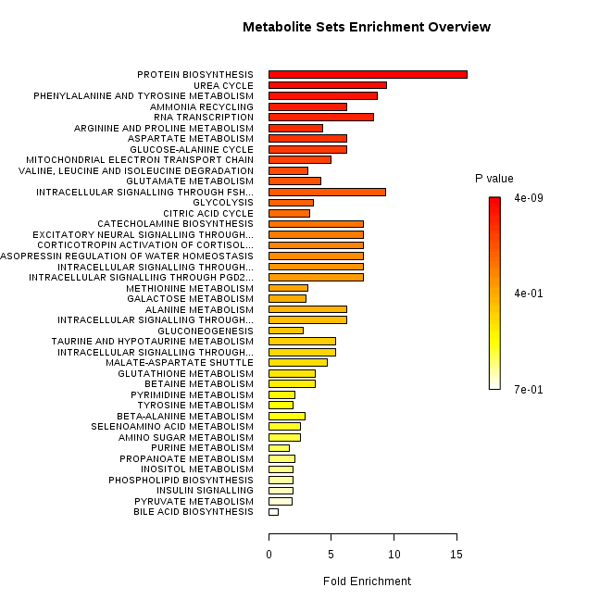 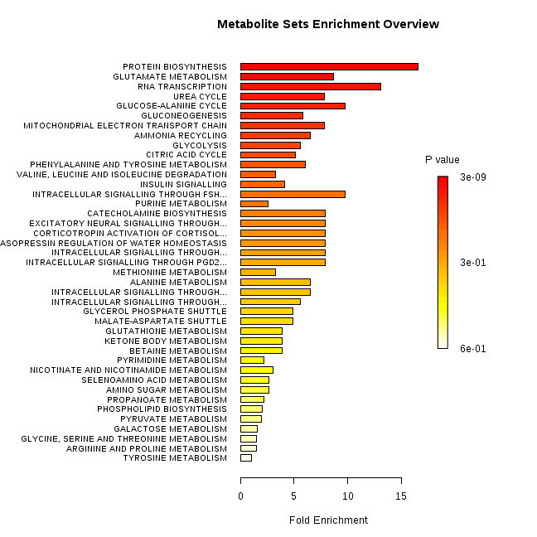
Supplementary Figure 31. Metabolic pathway analyses related to the metabolites that were discriminating between a) KRAS ^{A146T/+}and KRAS^{+/+} ; b) KRAS ^{Q61H/+}and KRAS^{+/+}. The horizontal bars summarize the main metabolite sets identified in this analysis; the bars are coloured based on their p-values and the length is based on the fold enrichment

Metabolite | ppm | p-values | q-values | log2 FC¹
leucine | 0.966 | 1.45E-03 | 1.06E-02 | -0.341
isoleucine | 1.009 | 1.23E-02 | 5.05E-02 | -0.250
valine | 1.041 | 6.87E-03 | 3.18E-02 | -0.253
alanine | 1.478 | 6.17E-05 | 1.60E-03 | -0.883
acetate | 1.920 | 1.79E-03 | 1.23E-02 | -0.425
glutamine | 2.440 | 6.76E-06 | 3.73E-04 | -1.260
glutathione | 2.544 | 1.31E-02 | 5.28E-02 | -0.189
aspartate | 2.704 | 2.51E-04 | 3.90E-03 | -0.382
creatine phosphate | 3.045 | 1.40E-02 | 5.59E-02 | 0.539
choline | 3.207 | 2.23E-06 | 2.30E-04 | -0.531
glycerophosphocholine | 3.233 | 2.18E-07 | 7.64E-05 | -1.368
taurine | 3.428 | 4.66E-04 | 5.62E-03 | 0.675
myo-inositol | 4.067 | 6.72E-04 | 6.87E-03 | 0.439
glucose | 5.235 | 9.50E-05 | 2.11E-03 | -0.324
UDP-N-acetylglucosamine | 5.513 | 3.24E-06 | 2.65E-04 | -0.214
fumarate | 6.521 | 1.43E-02 | 5.68E-02 | 0.152
tyrosine | 6.914 | 3.47E-03 | 1.89E-02 | -0.087
phenylalanine | 7.329 | 1.21E-03 | 9.58E-03 | -0.155
UMP | 8.105 | 3.74E-03 | 2.00E-02 | -0.193
GTP | 8.139 | 2.29E-03 | 1.44E-02 | 0.107
ATP | 8.537 | 2.06E-03 | 1.34E-02 | 0.242
Supplementary Table 18. Intracellular metabolites discriminating between KRAS^{A146T /+} and KRAS^{+/+}

1. FC: fold change

Supplementary Table 19. Intracellular metabolites discriminating between KRAS ^{Q61H/+} and KRAS^{+/+}
Metabolite | ppm | p-values | q-values | log 2 FC¹
leucine | 0.966 | 1.00E-06 | 1.95E-04 | -0.582
isoleucine | 1.009 | 3.66E-05 | 1.37E-03 | -0.441
valine | 1.041 | 6.05E-06 | 4.74E-04 | -0.464
lactate | 1.325 | 6.01E-05 | 1.83E-03 | -1.148
threonine | 1.329 | 5.74E-06 | 4.62E-04 | -0.542
alanine | 1.479 | 4.53E-05 | 1.56E-03 | -0.939
succinate | 2.406 | 7.29E-06 | 5.25E-04 | -0.875
glutamine | 2.44 | 1.03E-07 | 9.11E-05 | -1.175
glutathione | 2.544 | 1.67E-04 | 3.72E-03 | -0.186
creatine phosphate | 3.045 | 3.46E-05 | 1.34E-03 | -0.713
choline | 3.208 | 1.97E-02 | 8.16E-02 | -0.185
phosphocholine | 3.225 | 3.00E-03 | 2.41E-02 | -0.229
glycerophosphocholine | 3.234 | 1.81E-07 | 9.76E-05 | -1.360
glucose | 5.235 | 2.35E-04 | 4.72E-03 | -0.291
UDP-N-acetylglucosamine | 5.513 | 2.87E-05 | 1.19E-03 | -0.223
NAD | 6.050 | 5.69E-03 | 3.53E-02 | -0.103
tyrosine | 6.914 | 1.26E-05 | 7.01E-04 | -0.196
phenylalanine | 7.329 | 2.94E-04 | 5.46E-03 | -0.248
UMP | 8.105 | 4.04E-04 | 6.81E-03 | -0.219
ATP | 8.537 | 1.28E-02 | 5.97E-02 | -0.141
AMP | 8.605 | 4.52E-03 | 3.08E-02 | -0.301
1. FC: fold change

Supplementary Information References
Arena, S., Pisacane, A., Mazzone, M., Comoglio, P. M. & Bardelli, A. (2007) Genetic targeting of the kinase activity of the Met receptor in cancer cells. Proceedings of the National Academy of Sciences of the United States of America, 104(27), 11412-11417.
Benjamini, Y. (2010) Discovering the false discovery rate. Journal of the Royal Statistical Society Series B-Statistical Methodology, 72, 405-416.
Dieterle, F., Ross, A., Schlotterbeck, G. & Senn, H. (2006) Probabilistic quotient normalization as robust method to account for dilution of complex biological mixtures. Application in 1H NMR metabonomics. Anal Chem, 78(13), 4281-90.
Han, B., Kang, H. M. & Eskin, E. (2009) Rapid and Accurate Multiple Testing Correction and Power Estimation for Millions of Correlated Markers. PLoS Genetics, 5(4), e1000456.
Varshavi, D., Scott, F. H., Varshavi, D., Veeravalli, S., Phillips, I. R., Veselkov, K., Strittmatter, N., Takats, Z., Shephard, E. A. & Everett, J. R. (2018) Metabolic Biomarkers of Ageing in C57BL/6J Wild-Type and Flavin-Containing Monooxygenase 5 (FMO5)-Knockout Mice. Frontiers in Molecular Biosciences, 5, 28.
Vartanian, S., Bentley, C., Brauer, M. J., Li, L., Shirasawa, S., Sasazuki, T., Kim, J.-S., Haverty, P., Stawiski, E., Modrusan, Z., Waldman, T. & Stokoe, D. (2013) Identification of Mutant K-Ras-dependent Phenotypes Using a Panel of Isogenic Cell Lines. Journal of Biological Chemistry, 288(4), 2403-2413.
Veselkov, K. A., Mirnezami, R., Strittmatter, N., Goldin, R. D., Kinross, J., Speller, A. V. M., Abramov, T., Jones, E. A., Darzi, A., Holmes, E., Nicholson, J. K. & Takats, Z. (2014) Chemo-informatic strategy for imaging mass spectrometry-based hyperspectral profiling of lipid signatures in colorectal cancer. Proceedings of the National Academy of Sciences of the United States of America, 111(3), 1216-1221.
Veselkov, K. A., Vingara, L. K., Masson, P., Robinette, S. L., Want, E., Li, J. V., Barton, R. H., Boursier-Neyret, C., Walther, B., Ebbels, T. M., Pelczer, I., Holmes, E., Lindon, J. C. & Nicholson, J. K. (2011) Optimized preprocessing of ultra-performance liquid chromatography/mass spectrometry urinary metabolic profiles for improved information recovery. Anal Chem, 83(15), 5864-72.

