Metabolomics Journal
Glycerophospholipid and Detoxification Pathways Associated with Small for Gestation Age Pathophysiology: Discovery Metabolomics Analysis in the SCOPE Cohort.
Aude-Claire Morillon^{1,2}; Debora F. B. Leite^{3,4}; Shirish Yakkundi^{1,2}; Lee A Gethings^{5,6}; Gregoire Thomas⁷; Philip N. Baker⁸; Louise C. Kenny⁹; Jane A. English^{1,10,#}; Fergus P. McCarthy^{1,2, #}*
¹ INFANT Research Centre, Cork, Ireland;
² Department of Obstetrics and Gynecology, University College Cork, Cork, Ireland;
³ Federal University of Pernambuco, Pernambuco, Brazil;
⁴ Department of Tocogynecology, Campinas’s State University, Sao Paulo, Brazil;
⁵ Waters Corporation, Wimslow, UK;
⁶ Manchester Institute of Biotechnology, Division of Infection and Respiratory Medicine, Faculty of Biology, Medicine and Health, University of Manchester, Manchester, UK;
⁷ SQU4RE, 8800 Roeselare, Belgium;
⁸ College of Life Sciences, University of Leicester, Leicester, UK;
⁹ Department of Women’s and Children’s Health, Institute of Translational Medicine, University of Liverpool, Liverpool, UK
¹⁰ Department of Anatomy and Neuroscience, University College Cork, Cork, Ireland.

#Authors contributed equally.
*Corresponding Author: Fergus P. McCarthy, INFANT Research Centre, Cork University Hospital,
Wilton, Cork, Ireland. Email: Fergus.mccarthy@ucc.ie; Tel: +353 (0)21 4205082

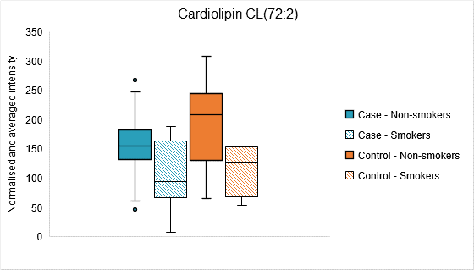
Online Resource 2 Box plot showing the normalised and averaged intensity of cardiolipin CL(72:2) in four groups from untargeted UPLC-MS analysis of SCOPE Cork plasma samples. Cases are small for gestational age (SGA, customised birthweight ≤10th centile). Blue box: case non- smokers (n=28), Blue pattern box: case smokers (n=12), Orange box: control non-smoker (n=36), and Orange pattern box: control smokers (n=4).

