SUPPORTING INFORMATION
Isolated murine skeletal muscles utilize pyruvate over glucose for oxidation
Ram B. Khattri¹, Jason Puglise¹, Terence E. Ryan^{1,4,5}, Walter, A. Glenn^{3,4}, Matthew E. Merritt², Elisabeth Barton^{1,4,5}
¹Department of Applied Physiology and Kinesiology;
²Department of Biochemistry and Molecular Biology;
³Department of Physiology and Functional Genomics;
⁴Myology Institute;
⁵Center for Exercise Science, University of Florida, Gainesville, FL, USA
Key words: Glucose metabolism, nuclear magnetic resonance (NMR), skeletal muscle metabolism, metabolic tracer, substrate specificity
Running Title: C-13 isopotomer analysis of skeletal muscle substrate utilization
Corresponding Author
Elisabeth R. Barton, PhD
Applied Physiology & Kinesiology
College of Health & Human Performance
University of Florida
124 Florida Gym | 1864 Stadium Road
Gainesville, FL 32611 UNITED STATES
tel 352-294-1714 | fax 352-392-5262 | erbarton@ufl.edu
Supporting Table ST1. NMR parameters for different experiments
S.No. | Experiment | Spectrometer Frequency (MHz) | Spectral width (Hz) | Relaxation delay (d1) | Acquisition time (s) | Number of scans | Measuring Pulse (in degree) | Repetition time (s) | Acquiring Temperature (ºC) | Decoupler/Presaturation
1 | First slice of a NOESY pulse sequence | 600 MHz Bruker with TCl CryoProbe | 7211.54 | 1 | 4 | 64 | 90 | 5.2 | 25 | Presaturation pulse
2 | ¹³C decoupling ON/OFF ¹H experiment | 600 MHz Bruker with TCl CryoProbe | 7142.9 | 2.85 | 1.15 | 128 | 90 | 4.0 | 25 | WALTZ-16
3 | Conventional ¹H decoupled ¹³C experiment | 600 MHz Agilent with 1.5 mmm superconducting (HTS) probe | 36764.7 | 1.5 | 1.5 | ~30K | 45 | 3.0 | 30 | WALTZ-16

Supporting Table ST2. Concentrations of branched chain amino acids, glycolytic, and TCA metabolites along with taurine and creatine in EDL muscle sample incubated in Ringer and MEM media (using [U- ¹³C₆] glucose as a substrate), separately via 1D ¹H NMR. Red = Branched chain amino acids (BCAA). “n” represents the biological replicates utilized in the study and each NMR sample consisted of pooled extracts of four individual muscles.
Metabolites | EDL_ Ringer (mM) | EDL_MEM (mM) ±S.D. | Soleus_Ringer (mM) | Soleus_MEM (mM) ± S.D.
Glutamate | 0.58 | 1.01±0.48 | 1.96 | 3.77±1.76
Lactate | 35.41 | 49.84±27.24 | 15.81 | 25.26±20.15
Alanine | 2.0 | 2.44±1.12 | 2.30 | 3.69±1.79
Leucine | 0.10 | 1.40±1.02 | 0.12 | 1.42±1.01
Isoleucine | 0.05 | 0.83±0.54 | 0.09 | 0.97±0.73
Valine | 0.12 | 0.87±0.53 | 0.12 | 0.90±0.64
Aspartate | 0.52 | 2.24±1.69 | 0.94 | 3.24±1.90
Taurine | 48.19 | 56.86±24.08 | 44.45 | 62.46±29.56
Creatine | 29.06 | 36.92±16.52 | 18.31 | 28.22±15.11
Lactate/Alanine | 17.72 | 19.40±2.99 | 6.87 | 5.88±2.03
Taurine/Creatine | 1.66 | 1.57±0.17 | 2.43 | 2.31±0.03

Supporting Table ST3. Fractional enrichment (%) ± S.D. in ringer and MEM media, in different skeletal muscle systems treated with either ¹³C₆ glucose or ¹³C₃ pyruvate. “n” represents the biological replicates utilized in the study and each NMR sample consisted of pooled extracts of four individual muscles.
 | Fractional Enrichment (%)
Media | MEM |  |  |  | Ringers
Substrate | [U- ¹³C₆] glucose |  | [U-¹³C₃] pyruvate |  | [U-¹³C₆] glucose |  | [U-¹³C₃] pyruvate
Metabolite | Alanine (n=3) | Lactate (n=3) | Alanine (n=2) | Lactate (n=2) | Alanine (n=1) | Lactate (n=1) | Alanine (n=1) | Lactate(n=1)
EDL | 21.42 ± 10.82 | 6.01 ± 0.33 | 66.18 ± 7.22 | 14.73 ± 4.87 | 25.04 | 5.31 | 66.99 | 11.94
Soleus | 27.62 ± 9.28 | 15.09 ± 1.25 | 61.81 ± 6.76 | 25.42 ± 4.17 | 27.70 | 17.67 | 67.46 | 24.37

Supporting Table ST4. Fraction of [1,2 ¹³C₂] enriched acetyl-CoA (Fc3) and anaplerotic flux (C4/C3) values in ringer and MEM media, in different skeletal muscle systems treated with either ¹³C₆ glucose or ¹³C₃ pyruvate
 | MEM |  | Ringers
Substrate & Muscle | Fc3 value | C4/C3 | Fc3 value | C4/C3
Glucose Soleus | NA | 2.59±0.10 | NA | 2.12
Glucose EDL | NA | 1.43±0.19 | NA | 1.55
Pyruvate Soleus | 0.39±0.03 | 1.36±0.24 | 0.44 | 0.97
Pyruvate EDL | 0.30±0.02 | 0.83±0.02 | 0.76 | 1.04

Supporting Table ST5. Fraction of [1,2 ¹³C₂] enriched acetyl-CoA (Fc3) and anaplerotic flux (C4/C3) values in different skeletal muscle systems in without and with pre-incubation with unlabeled pyruvate prior to labeled ¹³C₆ glucose. “n” represents the biological replicates utilized in the study and each NMR sample consisted of pooled extracts of four individual muscles.
 | No Pyruvate Pre-incubation |  | Pyruvate Pre-incubation
Muscle | Enriched  acetyl-CoA  Fc3 (n=3) | Anaplerotic flux C4/C3 (n=3) | Enriched  acetyl-CoA  Fc3 (n=1) | Anaplerotic flux C4/C3 (n=1)
EDL | NA | 1.43±0.19 | NA | 3.602
Sol. | NA | 2.59±0.10 | 0.245 | 4.066

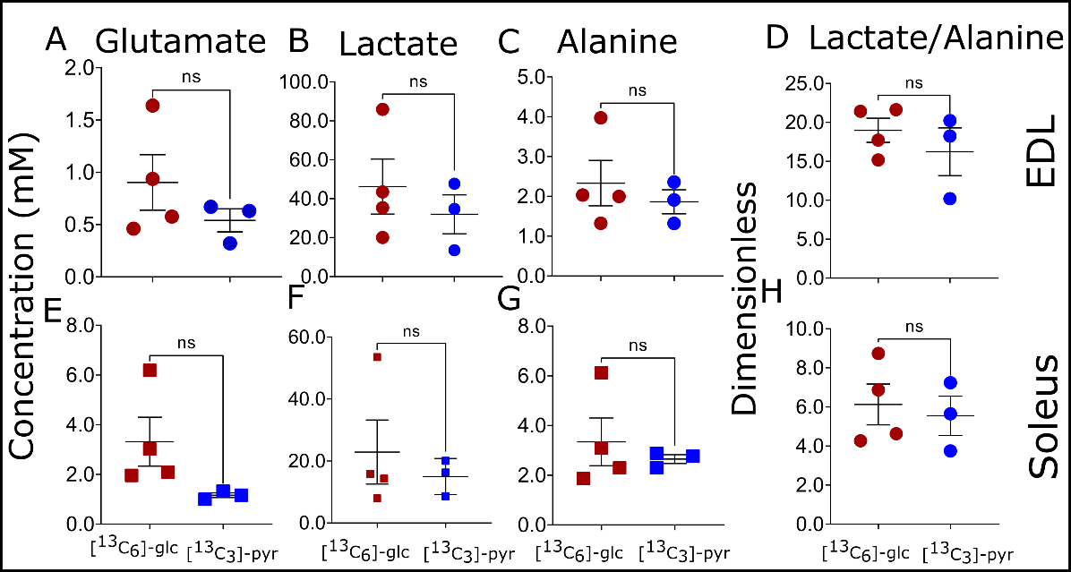
Figure S1. Comparison of concentrations of key TCA and glycolytic metabolites including lactate to alanine ratio in ¹³C labeled [U- ¹³C₆] glucose and [U-¹³C₃] pyruvate treated samples for isolated soleus and EDL muscles. Concentrations were determined using Chenomx NMR Suite 8.2 software, with ¹³C decoupling ON 1D ¹H spectra. Each NMR sample is the extract of either four EDL or soleus muscles. Four biological replicates were used for [U- ¹³C₆] glucose treated samples, and three biological replicates were used for [U-¹³C₃] pyruvate treated samples. Each biological replicate was a pool of 4 individual muscles. Statistical significance was determined using unpaired t-tests via GraphPad Prism with p < 0.05 considered significant.

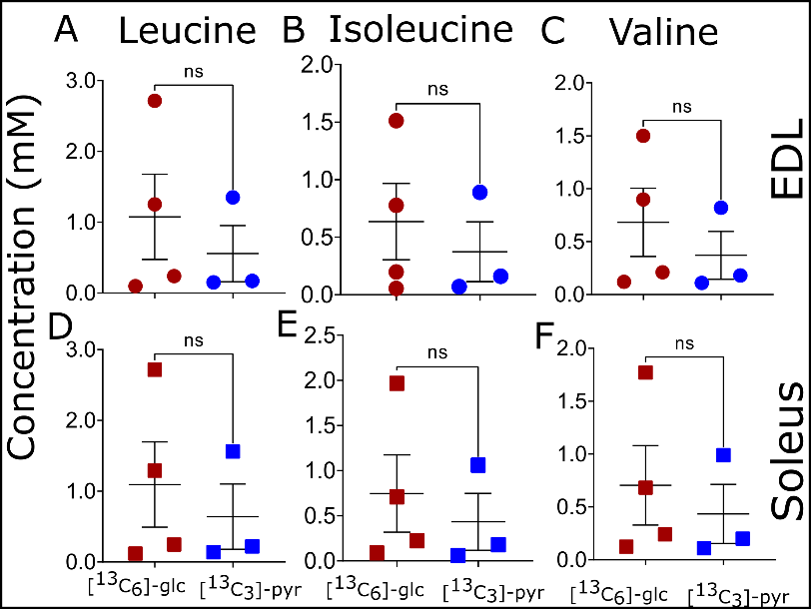
Figure S2. Comparison of concentrations of branched-chain amino acids in ¹³C labeled [U- ¹³C₆] glucose and [U-¹³C₃] pyruvate treated samples for isolated soleus and EDL muscles. Concentrations were determined using Chenomx NMR Suite 8.2 software, with ¹³C decoupling ON 1D ¹H spectra. Each NMR sample is the extract of either four EDL or soleus muscles. Four biological replicates were used for [U- ¹³C₆] glucose treated samples, and three biological replicates were used for [U-¹³C₃] pyruvate treated samples. Each biological replicate was a pool of 4 individual muscles. Statistical significance was determined using unpaired t-tests via GraphPad Prism with p < 0.05 considered significant.

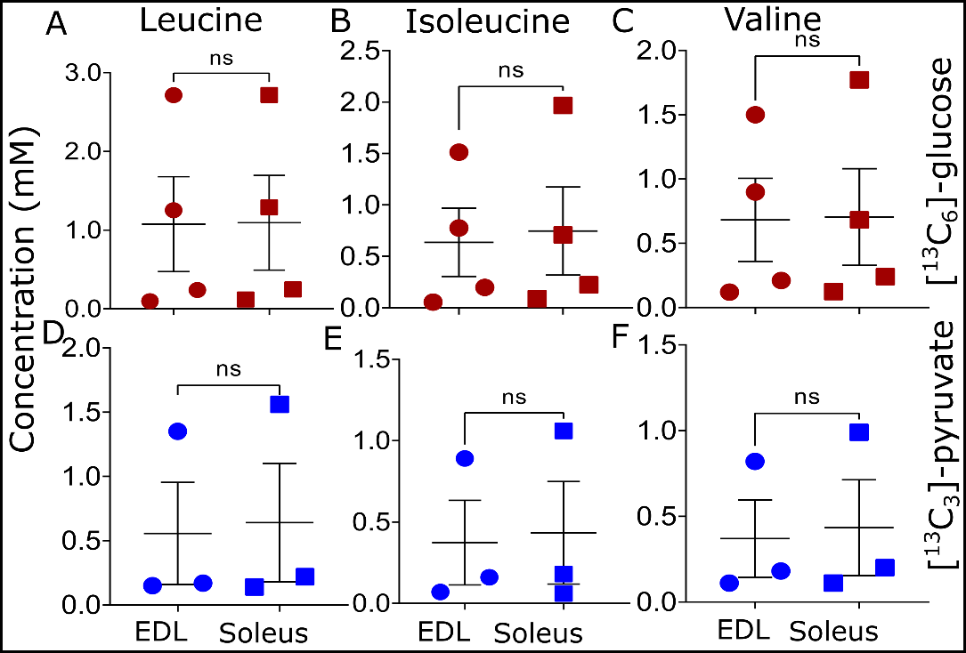
Figure S3. Comparison of concentrations of branched-chain amino acids in between soleus and EDL tissue samples incubated with ¹³C labeled [U- ¹³C₆] glucose and [U-¹³C₃] pyruvate. Concentrations were determined using Chenomx NMR Suite 8.2 software, with ¹³C decoupling ON 1D ¹H spectra. Each NMR sample is the extract of either four EDL or soleus muscles. Four biological replicates were used for [U- ¹³C₆] glucose treated samples, and three biological replicates were used for [U-¹³C₃] pyruvate treated samples. Each biological replicate was a pool of 4 individual muscles. Statistical significance was determined using unpaired t-tests via GraphPad Prism with p < 0.05 considered significant.

