Supplementary Materials
ReCIVA and CASPER breath collection, paired background sampling, TD-GC-MS analysis, and the feature extraction method are collectively known as the ‘OMNI’ method. More details into the OMNI settings are contained here.
Breath sample collection settings
Parameter | Value
Breath collection software and version | Breath Sample Collect (BSC) (version 3.4.0)
Number of tubes per pump | 2
Flow rate per tube (mL/min) | 250
Sampled volume (mL) per tube | 1250
Breath fraction sampled | Lower airways
Blank fraction sampled | Continuous
Supplementary Table 1: ReCIVA Breath Sampler collection settings. The table shows the various settings used with the ReCIVA Breath Sampler device utilized as part of the OMNI method used during this study.
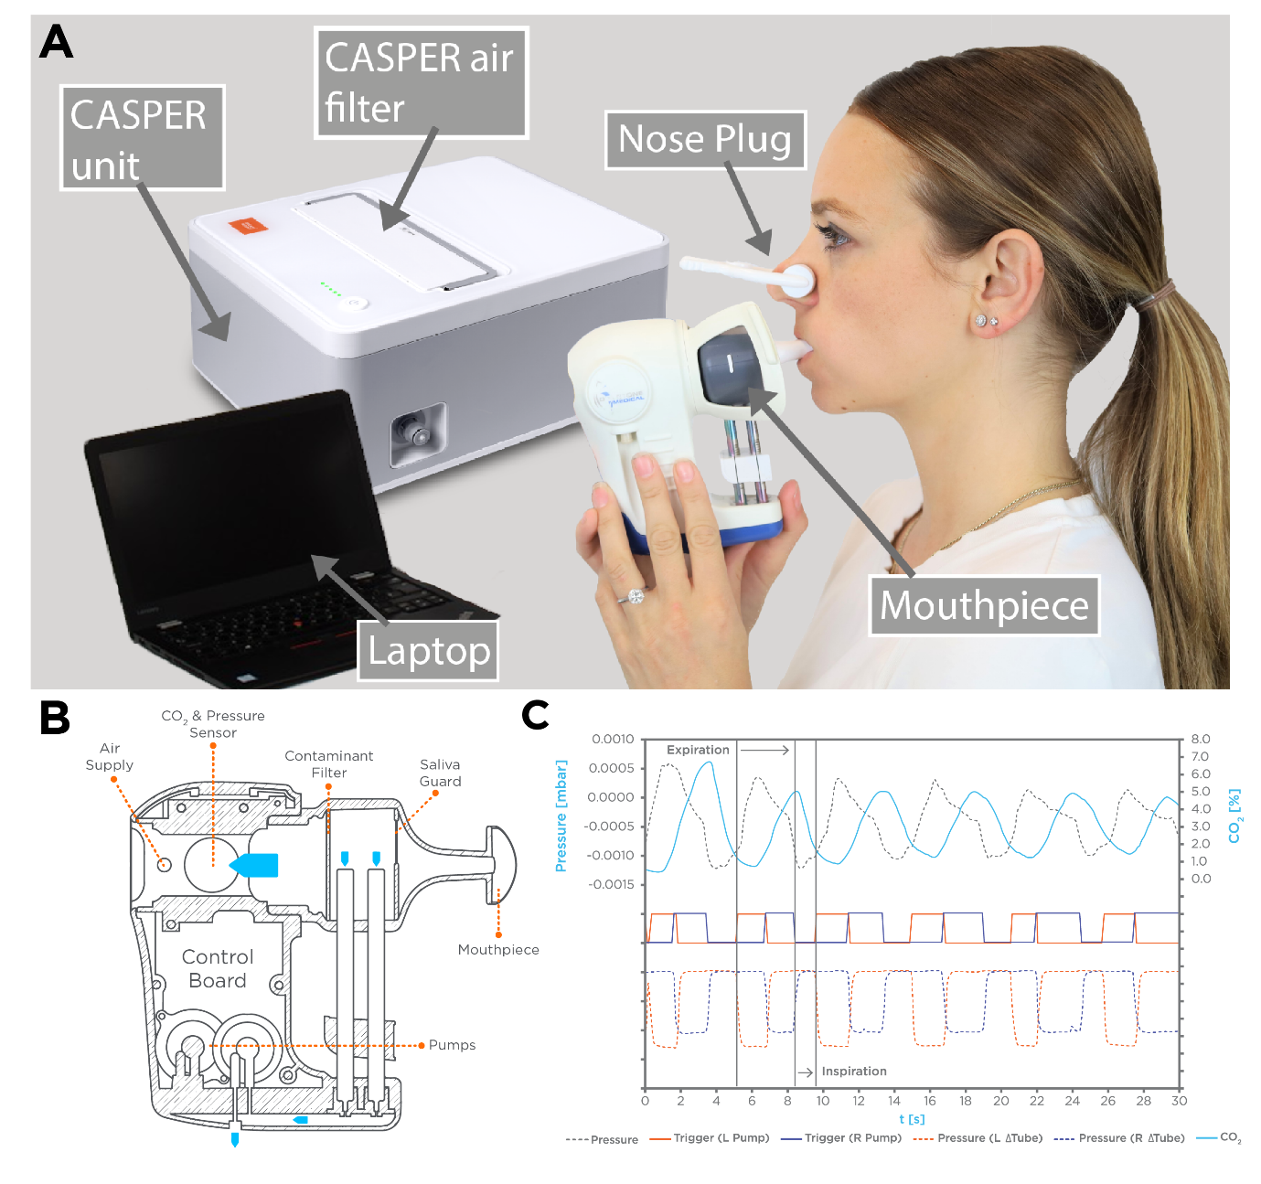
Supplementary Figure 1: A – an overview of the breath collection hardware used in the OMNI method in this study. The ReCIVA Breath Sampler was used with a mouthpiece and connected to the CASPER clean air supply. The subjects breathed normally into the device and inhaled air from the device originating from the CAPSER. B – A schematic of the ReCIVA Breath Sampler is shown. The ReCIVA has inbuilt CO₂ and pressure sensors that can be used to specifically activate the pumps to draw specific breath factions (i.e. end-tidal breath). C – An example of the CO₂ and pressure values across normal breathing. The sensors can trigger the pumps to draw breath into the adsorbent tubes to specifically collect VOCs from the end-tidal breath fraction.

Internal Standards
Compound Name | InChI Key | Class | Subclass
Hexane-D14 | VLKZOEOYAKHREP-ZLKPZJALSA-N | Saturated hydrocarbons | Alkanes
2-Butanone-1,1,1,3,3-D5 | ZWEHNKRNPOVVGH-PDWRLMEDSA-N | Organooxygen compounds | Carbonyl compounds
Heptane-D16 | IMNFDUFMRHMDMM-NEBSKJCTSA-N | Saturated hydrocarbons | Alkanes
2-Pentanone-1,1,1,3,3-D5 | XNLICIUVMPYHGG-PVGOWFQYSA-N | Organooxygen compounds | Carbonyl compounds
Octane-D18 | TVMXDCGIABBOFY-VAZJTQEUSA-N | Saturated hydrocarbons | Alkanes
Decane-D22 | DIOQZVSQGTUSAI-DNYWURFXSA-N | Saturated hydrocarbons | Alkanes
Dodecane-D26 | SNRUBQQJIBEYMU-DWXHPOBZSA-N | Saturated hydrocarbons | Alkanes
Hexane-D14 | VLKZOEOYAKHREP-ZLKPZJALSA-N | Saturated hydrocarbons | Alkanes
Supplementary Table 2: The identifiers (name and InChI key) and chemical class for each of the eight deuterated internal standard compounds liquid injected onto all samples, prior to analysis.

TD-GC-MS method settings
TD
Tube desorption temperature (°C) | 240
Tube desorption time (min) | 5
Trap desorb flow (mL/min) | 50
Trap low temperature (°C) | 5
Trap heat rate (°C/s) | 40
Trap high temperature (°C) | 270
Trap desorption time (min) | 10
GC
Column chemistry | TraceGOLDTM-624SilMS (6% cyanopropylphenyl-94% dimethylpolysiloxane), 0.25 mm (D) x 1.4 µm (Film thickness) x 30 m (L)
Oven temperature profile | Hold at 37°C (4 min), 5°C/min ramp to 150°C, 20°C/min ramp to 300°C and hold (10.9 min)
Carrier gas flow (mL/min) | 2
Aux heater 1 & 2 temperature (°C) | 300
MS
Scan type | Full
Scan range (m/z) | 30-450
Ionization mode | Positive
Electron energy (eV) | 35
Transfer line temperature (°C) | 300
Ion source temperature (°C) | 280
Supplementary Table 3: TD-GC-MS method settings. The table shows the various settings used for Thermal Desorption (TD), Gas Chromatography (GC), and Mass Spectrometry (MS) in the OMNI method.

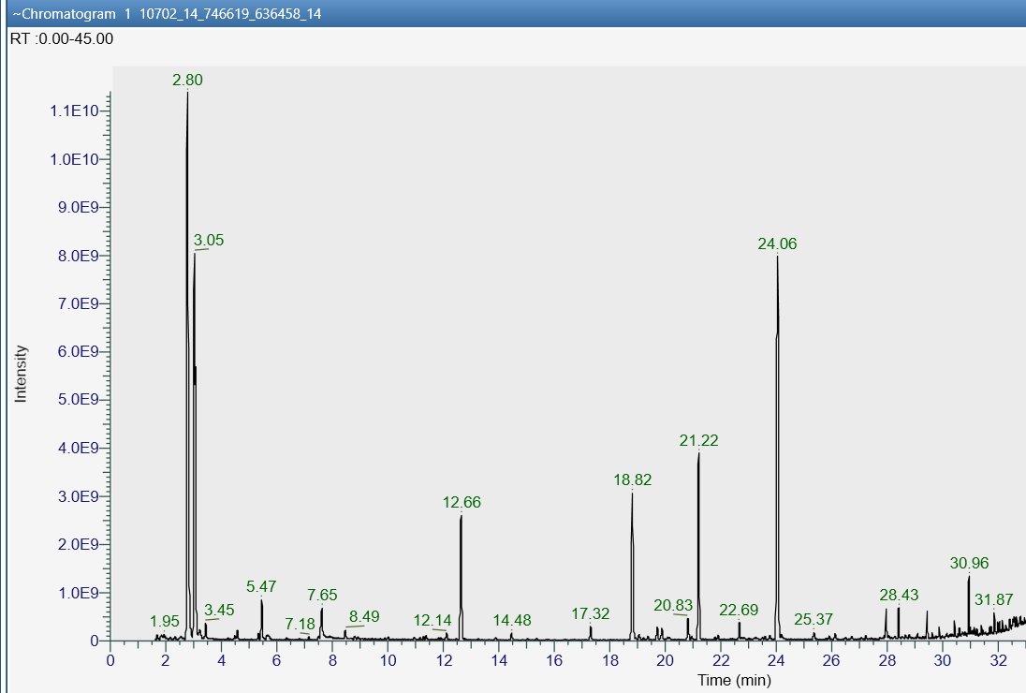
Supplementary Figure 2: A total ion chromatogram (TIC) from a breath sample. Retention time (min) is shown on the x-axis and peak area intensity on the y-axis.

Peak detection
Mass tolerance (ppm) | 5
Spectral S/N threshold | 3
Peak S/N threshold | 3
TIC threshold | 150,000
Ion overlap window (%) | 98
Group Compounds
RT tolerance (s) | 7
Dot product threshold | 500
Composition threshold (%) | 35

Supplementary Table 4: Feature extraction method parameters. The table shows the various settings used for peak detections and group compounds in the OMNI method.

