Supplementary Information
___________________________________________________________
EMBL-MCF 2.0: LC-MS/MS library for high-confidence targeted and untargeted metabolomics using low-adsorption HILIC
chromatography

Svitlana Dekina, Theodore Alexandrov, Bernhard Drotleff

Metabolomics Core Facility, European Molecular Biological Laboratory, Heidelberg 69117, Germany
Structural and Computational Biology Unit, European Molecular Biology Laboratory (EMBL), Heidelberg, Germany
Molecular Medicine Partnership Unit, EMBL and Heidelberg University, Heidelberg, Germany
Bio Studio, BioInnovation Institute, Copenhagen, Denmark

Contents

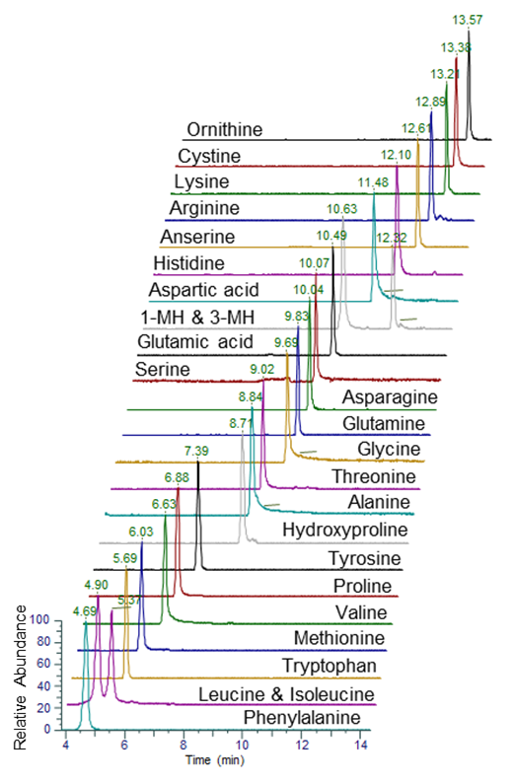

Figure S1. BEH Z-HILIC chromatograms of 25 amino acids. 1-MH: 1-Methylhistidine, 3-MH: 3-Methylhistidine

Table S5. Repeatability of retention times for an Amino Acid Standard mix (Sigma) used as system suitability check (n = 7), max RT variation of 4 s

Analyte | CV [%]
Cystine | 0.23
Lys | 0.24
Arg | 0.27
His | 0.34
Asp | 0.28
Glu | 0.21
Ser | 0.27
Asn | 0.30
Gln | 0.24
Gly | 0.22
Thr | 0.32
Ala | 0.28
Tyr | 0.34
Pro | 0.37
Val | 0.46
Met | 0.42
Trp | 0.46
Leu | 0.61
Ile | 0.75
Phe | 0.71

The CV values are based on results acquired for seven individual preparations of mobile phase. Inter-batch variation between columns was not investigated.

Table S6. Isomeric compounds covered in the library
Compound Name | Chemical Formula | Polarity | RT
2-Deoxyguanosine | C10H13N5O4 | - | 4.67
Adenosine | C10H13N5O4 | - | 2.35
Adenosine monophosphate | C10H14N5O7P | - | 11.20
Deoxyguanosine monophosphate | C10H14N5O7P | - | 12.42
Adenosine triphosphate | C10H16N5O13P3 | - | 14.23
Deoxyguanosine triphosphate | C10H16N5O13P3 | - | 15.73
Dihydroxyacetone | C3H6O3 | - | 2.49
Glyceraldehyde | C3H6O3 | - | 6.31
Hydroxypropionic acid | C3H6O3 | - | 7.51
Lactic Acid | C3H6O3 | - | 5.86
Alanine | C3H7NO2 | - | 8.82
Beta-Alanine | C3H7NO2 | - | 9.66
Sarcosine | C3H7NO2 | - | 8.22
Dihydroxyacetone_phosphate | C3H7O6P | - | 12.07
Glyceraldehyde 3-phosphate | C3H7O6P | - | 12.68
Fumaric acid | C4H4O4 | - | 12.95
Maleic acid | C4H4O4 | - | 2.62
2-Ketobutyric acid | C4H6O3 | - | 2.83
Acetoacetic acid | C4H6O3 | - | 5.01
Methylmalonic acid | C4H6O4 | - | 7.88
Succinic acid | C4H6O4 | - | 11.80
Butyric acid | C4H8O2 | - | 2.80
Isobutyric acid | C4H8O2 | - | 2.48
Homoserine | C4H9NO3 | - | 9.33
Threonine | C4H9NO3 | - | 8.95
5-Aminovaleric acid | C5H11NO2 | - | 10.28
Valine | C5H11NO2 | - | 6.71
Citraconic acid | C5H6O4 | - | 2.69
Itaconic acid | C5H6O4 | - | 10.76
Aminolevulinic acid | C5H9NO3 | - | 10.37
Hydroxyproline | C5H9NO3 | - | 8.70
N-Acetylalanine | C5H9NO3 | - | 6.05
Isoleucine | C6H13NO2 | -  - | 5.49
Leucine | C6H13NO2 | -  - | 5.04
Fructose-1,6-diphosphate | C6H14O12P2 | - | 16.53
Glucose 1,6-diphosphate | C6H14O12P2 | - | 16.21
cis-Aconitic acid | C6H6O6 | - | 12.89
trans-Aconitic acid | C6H6O6 | - | 14.95
N-Acetylgalactosamine | C8H15NO6 | - | 5.28
N-acetylmannosamine | C8H15NO6 | - | 5.70
p-Coumaric acid | C9H8O3 | - | 4.42
Phenylpyruvic acid | C9H8O3 | - | 1.70
Cotinine | C10H12N2O | + | 1.05
Serotonin | C10H12N2O | + | 5.29
Adenosine | C10H13N5O4 | + | 2.44
Deoxyguanosine | C10H13N5O4 | + | 4.70
Adenosine monophosphate | C10H14N5O7P | + | 10.60
Deoxyguanosine monophosphate dGMP | C10H14N5O7P | + | 12.51
2-Aminobutanoic acid | C4H9NO2 | + | 7.74
N,N-Dimethylglycine | C4H9NO2 | + | 6.60
Homoserine | C4H9NO3 | + | 9.39
Threonine | C4H9NO3 | + | 9.01
5-Aminovaleric acid | C5H11NO2 | + | 6.14
Betaine | C5H11NO2 | + | 5.78
Valine | C5H11NO2 | + | 6.62
Aminolevulinic acid | C5H9NO3 | + | 7.66
Hydroxyproline | C5H9NO3 | + | 8.72
N-Acetylalanine | C5H9NO3 | + | 2.34
Glutamic acid | C5H9NO4 | + | 10.50
O-Acetylserine | C5H9NO4 | + | 6.79
Isoleucine | C6H13NO2 | + | 5.37
Leucine | C6H13NO2 | + | 4.91

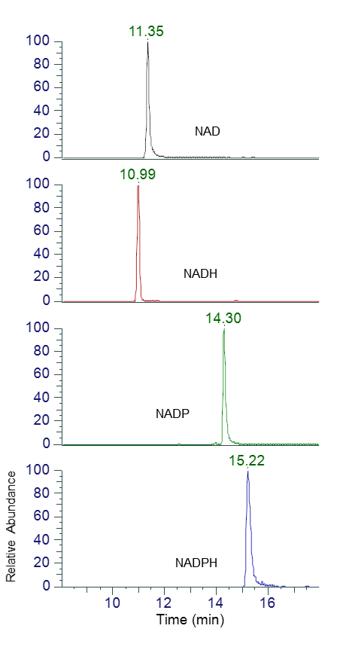
Figure S2. BEH Z-HILIC chromatograms of NAD, NADH, NADP and NADPH in ESI-.

Table S7. Favorable mode for plasma metabolites detected in both modes for high resolution data (based on precursor ions)
Metabolite name | Ratio Pos/Neg Area | Ratio Pos/Neg Height | Precision CV [%] |  | Favorable mode
Metabolite name | Ratio Pos/Neg Area | Ratio Pos/Neg Height | pos | neg | Favorable mode
2-Deoxycytidine | 0.79 | 0.66 | 4.57 | 4.55 | neg
Adenosine | 10.33 | 9.28 | 1.82 | 9.92 | pos
Adenosine monophosphate | 0.89 | 0.67 | 9.72 | 5.21 | neg
Alanine | 3.76 | 2.61 | 5.50 | 5.07 | pos
Anserine | 3.97 | 4.53 | 5.16 | 5.06 | pos
Arginine | 5.61 | 12.55 | 2.07 | 3.71 | pos
Asparagine | 0.87 | 1.49 | 5.15 | 4.64 | pos
Aspartic acid | 0.23 | 0.35 | 0.71 | 2.67 | neg
Bilirubin | 0.05 | 0.04 | 10.57 | 15.10 | neg
Carnitine | 497.21 | 511.79 | 12.18 | 2.85 | pos
Citrulline | 1.49 | 1.95 | 2.75 | 6.24 | pos
Cytidine | 0.62 | 0.45 | 2.10 | 3.51 | neg
Deoxyinosine | 4.66 | 6.00 | 2.68 | 1.46 | pos
Glutamic acid | 0.62 | 0.60 | 6.61 | 7.47 | neg
Glutamine | 1.15 | 1.30 | 2.53 | 1.23 | pos
Glutathione (GSH) | 0.58 | 0.70 | 1.24 | 2.57 | neg
Glutathione (GSSG) | 1.59 | 1.59 | 17.01 | 14.59 | pos
Glycerol 3-Phosphate | 0.04 | 0.03 | 11.13 | 10.55 | neg
Glycine | 0.39 | 0.3 | 10.22 | 4.44 | neg
Guanosine | 0.68 | 0.67 | 5.20 | 4.63 | neg
Histidine | 0.14 | 0.20 | 5.10 | 7.73 | pos
Hydroxyproline | 312.72 | 349.07 | 4.65 | 12.75 | pos
Hypoxanthine | 1.35 | 1.3 | 9.06 | 18.50 | neg
Inosine | 0.21 | 0.24 | 1.12 | 4.30 | neg
Inosinic acid | 0.71 | 0.56 | 4.81 | 2.73 | neg
Isoleucine | 3.55 | 4.16 | 11.52 | 12.41 | pos
Kynurenic acid | 0.55 | 0.49 | 3.92 | 1.90 | neg
Leucine | 3.36 | 3.28 | 5.79 | 4.18 | pos
Lysine | 4.61 | 7.78 | 2.71 | 2.33 | pos
Methionine | 2.49 | 3.13 | 2.10 | 4.99 | pos
N-Acetylglutamine | 0.29 | 0.33 | 3.29 | 3.34 | neg
N-Acetylphenylalanine | 0.05 | 0.09 | 2.12 | 7.19 | neg
Ornithine | 250.35 | 235.15 | 6.63 | 1.23 | pos
Pantothenic acid | 0.91 | 2.38 | 1.79 | 21.52 | pos
Phenylalanine | 0.01 | 0.01 | 2.84 | 3.85 | neg
Phosphocreatine | 2.95 | 0.66 | 6.29 | 2.00 | neg
Phosphoethanolamine | 0.82 | 0.48 | 14.25 | 4.11 | neg
Pipecolic acid | 12.87 | 12.16 | 12.21 | 7.05 | pos
Proline | 22.19 | 29.38 | 4.52 | 4.16 | pos
Pyroglutamic acid | 0.05 | 0.08 | 2.81 | 4.62 | neg
S-Sulfocysteine | 0.41 | 0.60 | 4.84 | 5.70 | neg
Serine | 0.19 | 0.25 | 4.06 | 2.96 | neg
Taurine | 0.97 | 0.94 | 3.55 | 4.59 | pos
Taurocholic acid | 0.02 | 0.01 | 1.83 | 2.69 | neg
Threonine | 0.83 | 1.49 | 4.79 | 1.12 | pos
Thymidine | 0.07 | 0.08 | 4.40 | 1.90 | neg
Tryptophan | 1.25 | 1.63 | 10.38 | 3.07 | pos
Uric Acid | 0.01 | 0.01 | 1.26 | 2.58 | neg
Valine | 2.12 | 2.25 | 6.09 | 2.92 | pos
Xanthine | 0.01 | 0.01 | 2.63 | 3.21 | neg

- Parameters for MS-DIAL ver. 4.9.221218

#Project
MS1 Data type Profile
MS2 Data type Profile
Ion mode Negative
Target Metabolomics
Mode ddMSMS

#Data collection parameters
Retention time begin 0.5 min
Retention time end 18 min
Mass range begin [m/z] 60
Mass range end [m/z] 900
MS2 mass range begin [m/z] 40
MS2 mass range end [m/z] 950

#Centroid parameters
MS1 tolerance [m/z] 0.01
MS2 tolerance [m/z] 0.02

#Isotope recognition
Maximum charged number ±2

#Peak detection parameters
Smoothing method LinearWeightedMovingAverage
Smoothing level 3
Minimum peak width 10
Minimum peak height 30000

#Peak spotting parameters
Mass slice width 0.05

#Deconvolution parameters
Sigma window value 0.5
MS2Dec amplitude cut off 0
Exclude after precursor TRUE
Keep isotope until 0.5
Keep original precursor isotopes FALSE

#MSP file and MS/MS identification setting
Retention time tolerance 1 min
Mass tolerance (MS1) [m/z] 0.005
Mass tolerance (MS2) [m/z] 0.02
Identification score cut off 80
Using retention time for scoring TRUE
Using retention time for filtering TRUE

#Alignment parameters setting
Retention time tolerance 0.1 min
MS1 tolerance [m/z] 0.005
Retention time factor 0.5
MS1 factor 0.5
Peak count filter 0
N% detected in at least one group 50
Remove feature based on peak height fold-change
TRUE
Sample max / blank average 5
Sample average / blank average 5

Ratio experimental samples : QCs 5:1

- Dwell volume and extracolumn volume of the Thermo Vanquish Horizon UHPLC system connected to an Orbitrap Exploris 240

Gradient delay volume:
- Binary Pump H - Dwell volume: 35 μL
- Split Sampler HT - Dwell volume: 110 μL (including 25 μL loop)
- Fluidic connections: Viper MP35N, 0.100 m x 150 mm - Dwell volume: 4.71 μL

Extracolumn volume:
- Fluidic connections: Viper MP35N, 0.100 m x 250 mm - Dwell volume: 7.85 μL
- HESI needle: 3.14 μL

