Supplemental Information

Differential Metabolic Profiles by Hispanic Ethnicity Among Male Tucson Firefighters

Tuo Liu¹, Melissa A. Furlong¹, Justin M. Snider², Malak M. Tfaily³, Christian Itson³, Shawn Beitel¹, John J. Gulotta⁴, Krishna Parsawar^{5, 6}, Kristen Keck^{5, 6}, James Galligan⁷, Douglas I. Walker⁸, Jefferey L. Burgess¹

¹University of Arizona Mel and Enid Zuckerman College of Public Health, Environmental Health Sciences
²University of Arizona School of Nutritional Sciences and Wellness
³University of Arizona Department of Environmental Science
⁴Tucson Fire Department
⁵University of Arizona Cancer Center
⁶University of Arizona Analytical and Biological Mass Spectrometry Core
⁷University of Arizona College of Pharmacy
⁸Gangarosa Department of Environmental Medicine, Rollins School of Public Health, Atlanta, GA
Corresponding author tuoooliu@arizona.edu, 1295 N Martin Ave, Tucson AZ 85724

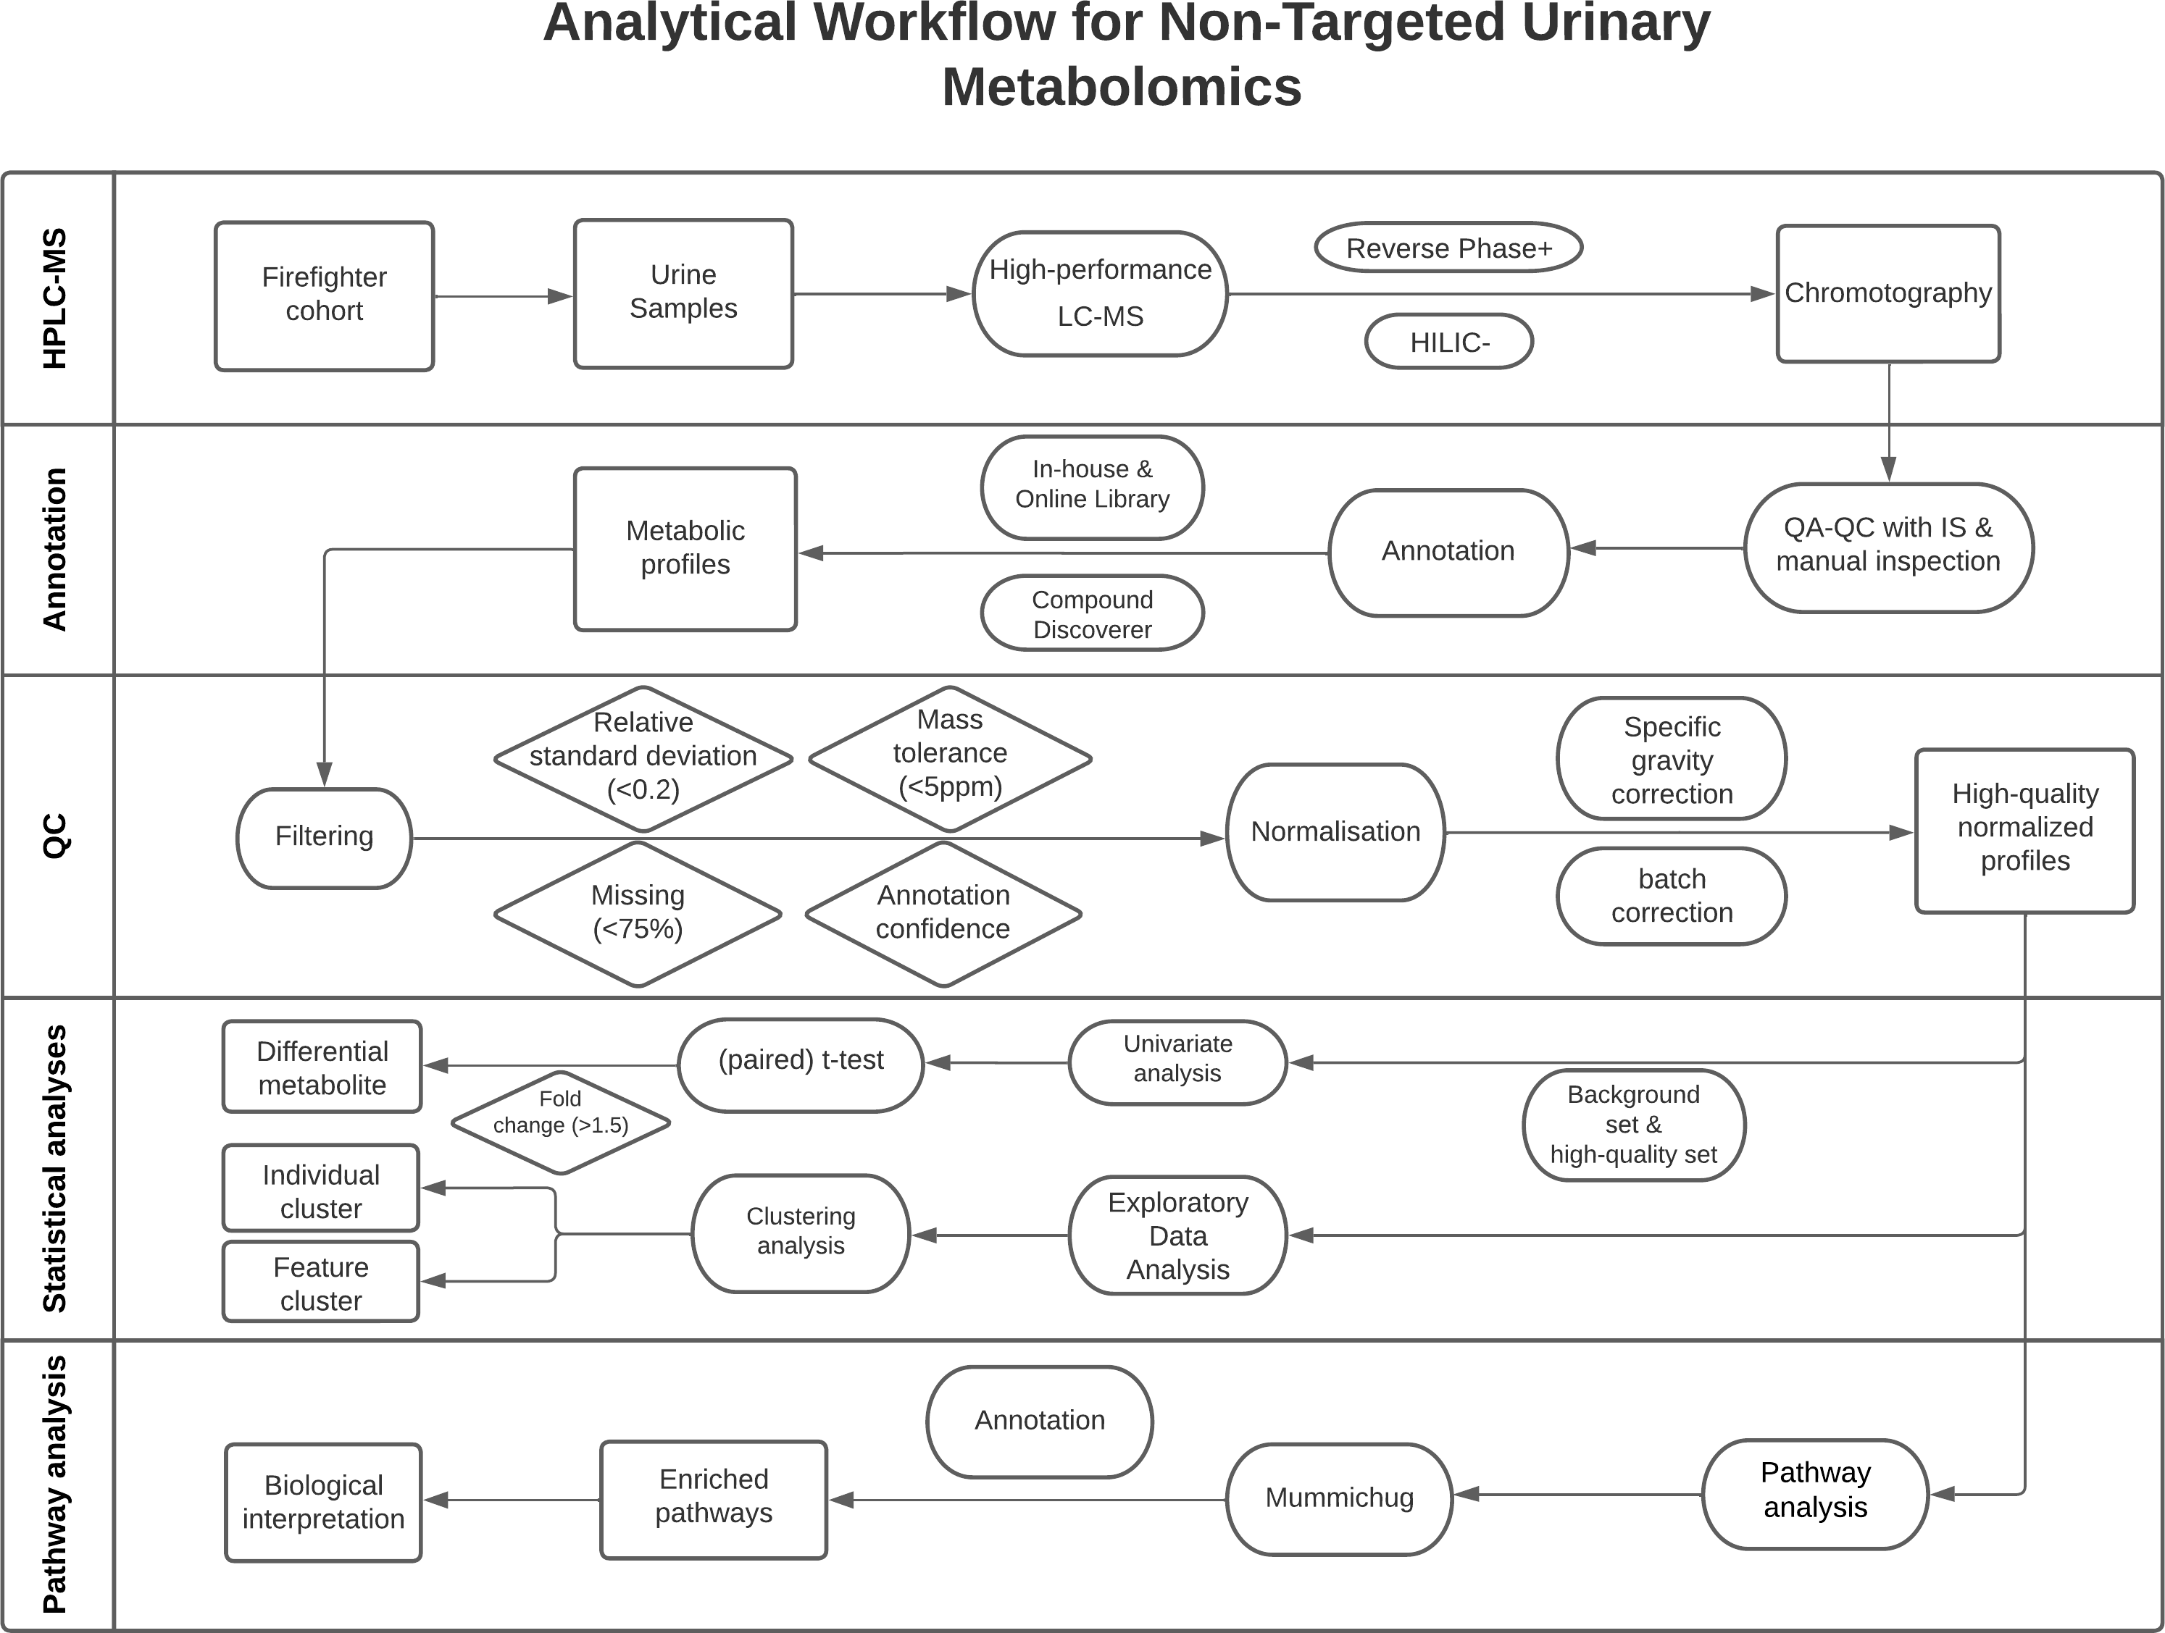
Supplemental Fig.5: Analytical diagram for urinary metabolomics analysis among firefighters.

The analytical pipeline followed in this study was sketched in the Supplemental Fig. 5 where five components were involved: HPLC-MS, annotation, quality control (QC), statistical analyses, and pathway analysis. At the Analytical and Biological Mass Spectrometry Core, University of Arizona, HPLC-MS was input with pretreated urine sample from the FFCCS cohort and analyzed the samples in two separation-ESI modes: HILIC (-) and RP (+). The output MS files were then manually inspected against lab standards to ensure data quality and sent to Compound Discoverer for annotation against both in-house and online libraries afterwards. The pipeline incorporates a filtering process that incorporates relative standard deviation, annotation mass difference, missing value percentage, and annotation confidence, to remove low-quality signals from further analyses. Specific gravity correction was applied to remove unwanted variation introduced by individual hydration level and batch correction was applied to further remove batch-wise variation. Remaining urinary features were input into differential analysis and exploratory analysis to identify differential hits and patterns that would help discern overall differential responses to the exposure variables among our samples. Pathway analysis took the complete set of urinary features as the reference set and the differential hits as the sample set to complete the overrepresentation analysis, and enrichment patterns were the output.
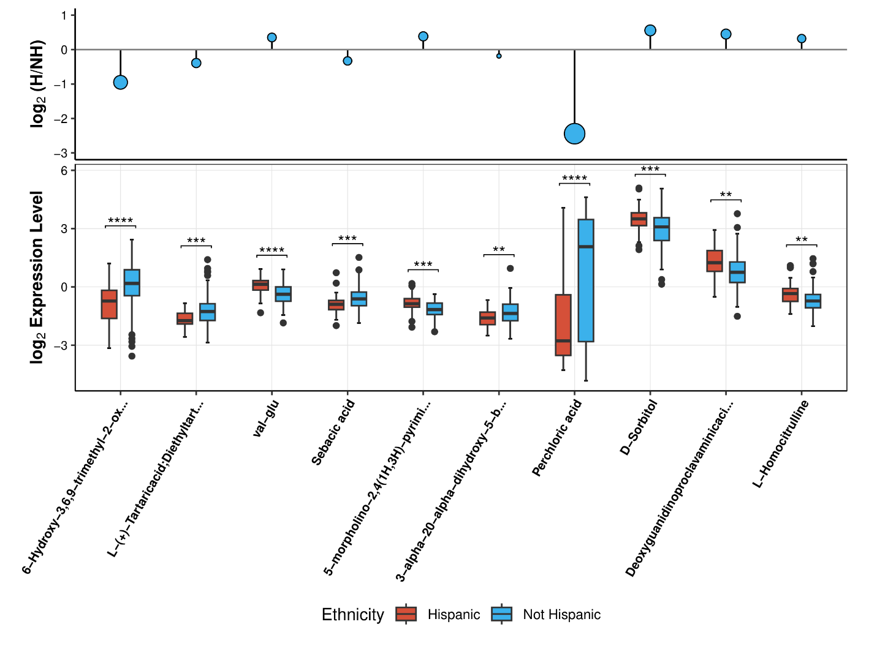
Supplemental Fig.6: Combo plot for model coefficients and expression level comparison for HILIC (-) differential metabolites with FDR < 0.05 & absolute slope >= 0.5. Top) Lollipop plot for model coefficients’ size and direction comparing Hispanic samples to non-Hispanics where negative and positive y values indicated downregulation and upregulation, respectively; Bottom) Hispanic group was colored in red and non- Hispanic group was colored in blue. Asterisks indicated statistical significance as determined by the Wilcox test for two sample mean comparison; black dots indicated potential outliers.
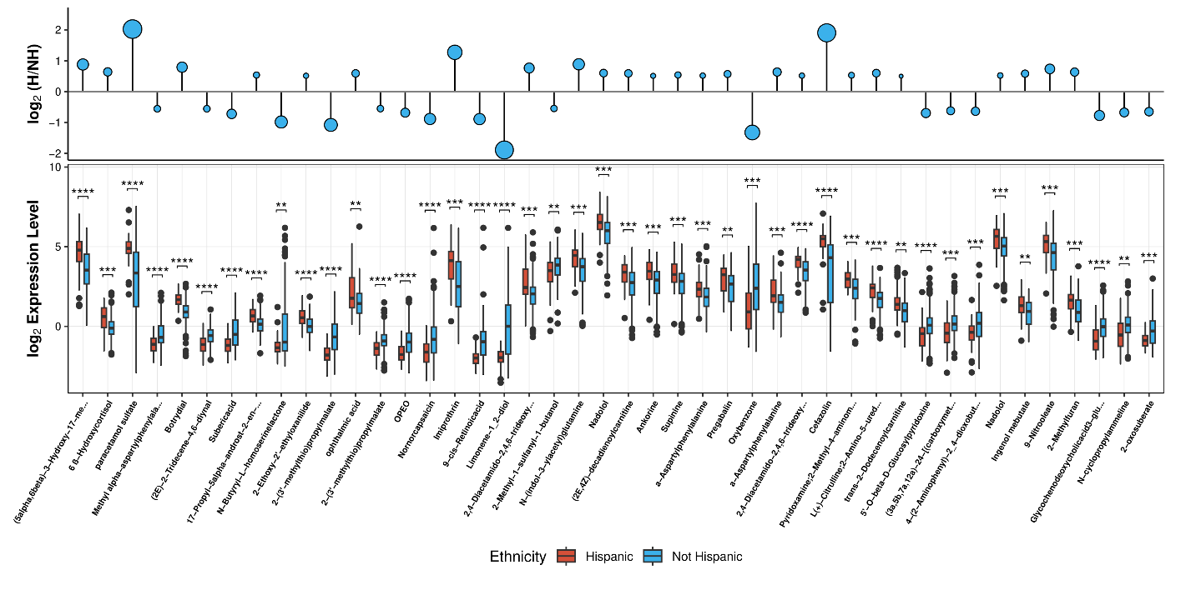
Supplemental Fig.7: Combo plot for model coefficients and expression level comparison for RP (+) differential metabolites with FDR < 0.05 & absolute slope >= 0.5. Top) Lollipop plot for model coefficients’ size and direction comparing Hispanic samples to non-Hispanics where negative and positive y values indicated downregulation and upregulation, respectively; Bottom) Hispanic group was colored in red and non-Hispanic group was colored in blue. Asterisks indicated statistical significance as determined by the Wilcox test for two sample mean comparison; black dots indicated potential outliers.
Supplemental Fig.6 and Fig.7 showcase the directionality and statistical magnitudes of the top differential urinary features from HILIC (-) mode. The Top figure demonstrates the results from the main model after adjusting for possible confounders, including age, BMI, and so on, whereas the Bottom figure was a raw comparison between two ethnic groups. For example, D-Sorbitol was reported to have statistically higher levels in Hispanic firefighter than non-Hispanic firefighters from the Bottom figure. The top figure reported the same direction of change for D-Sorbitol in Hispanics. This plot adds to our confidence towards the main model and overall analytical process.

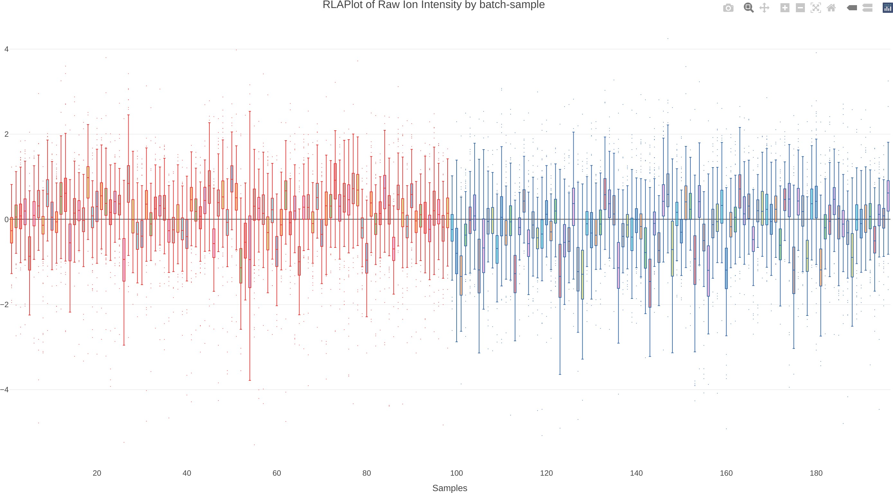
Supplemental Fig.8: Sample-wise total abundance by injection order in HILIC(-) mode. Abundance was standardized and the set colored in red marks the sample set analyzed in May and the set colored in blue in August. Although random fluctuations were observed within sets, there were no clear patterns of fluctuation in the total abundance across sets.
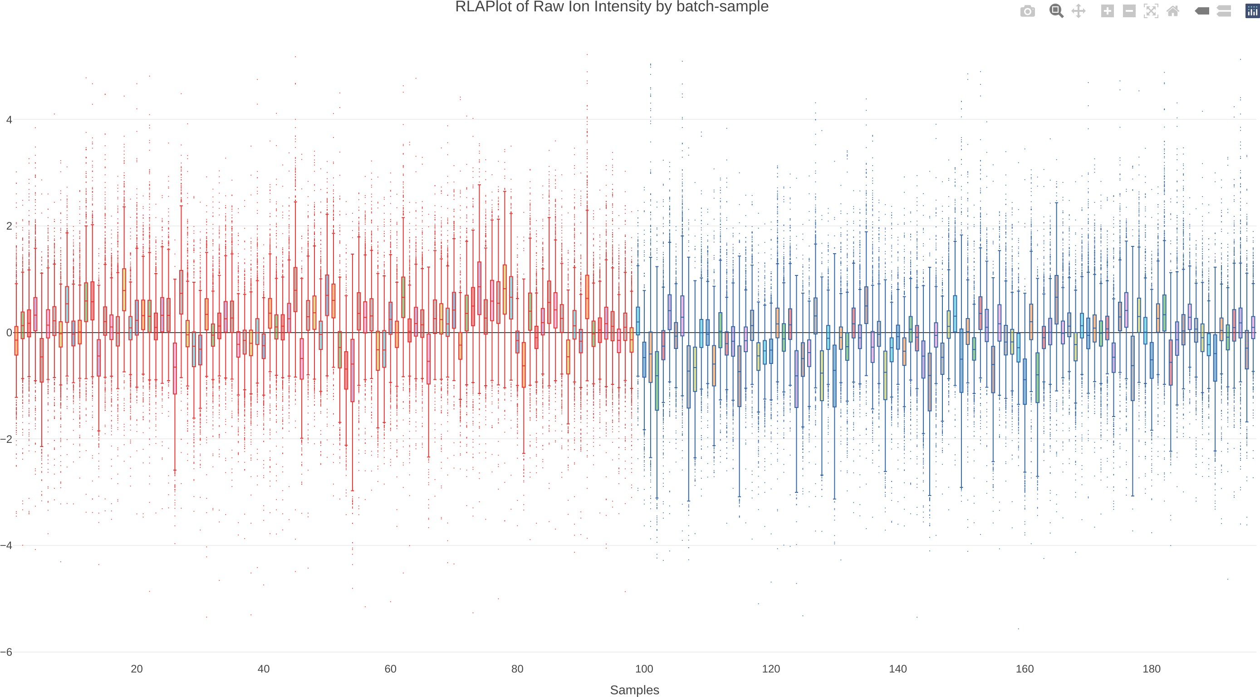
Supplemental Fig.9: Sample-wise abundance plot by injection order in RP(+) mode. Abundance was standardized and the set colored in red marks the sample set analyzed in May and the set colored in blue in August. Although random fluctuations were observed within sets, there were no clear patterns of fluctuation in the total abundance across sets.
Supplemental Fig.8 and Fig.9 present the set-wise variation of HILIC(-) and RP(+) by sample injection order. We ran our urine samples in two sets of batches in two separate months, May and August, due to maintenance needs of the LC-MS platform. No unacceptable set-by-set variations were observed which guaranteed data quality.

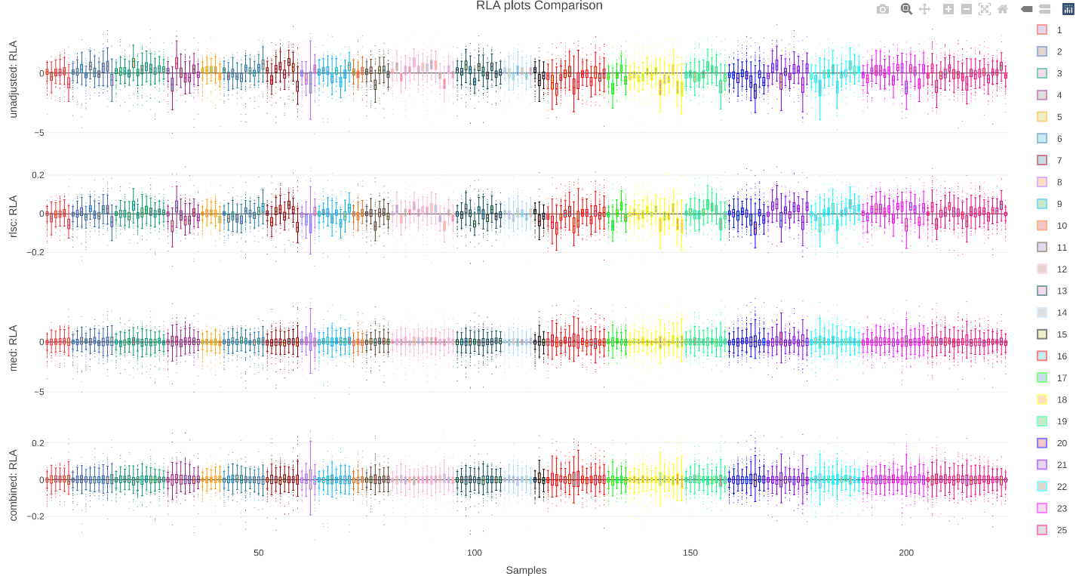
Supplemental Fig.10: Relative abundance plot in HILIC(-) mode for the comparison of normalization effects from various techniques. Normalized techniques applied included (from top to bottom) raw, quality control–based robust LOESS signal correction (rlsc), median scaling (med), combination of rlsc and median scaling. We observed inner- and inter-batch fluctuations. The method rlsc alone did not achieve satisfying variability stabilization. Median scaling and a combination of rlsc and median scaling resulted in similar stabilizing effects.
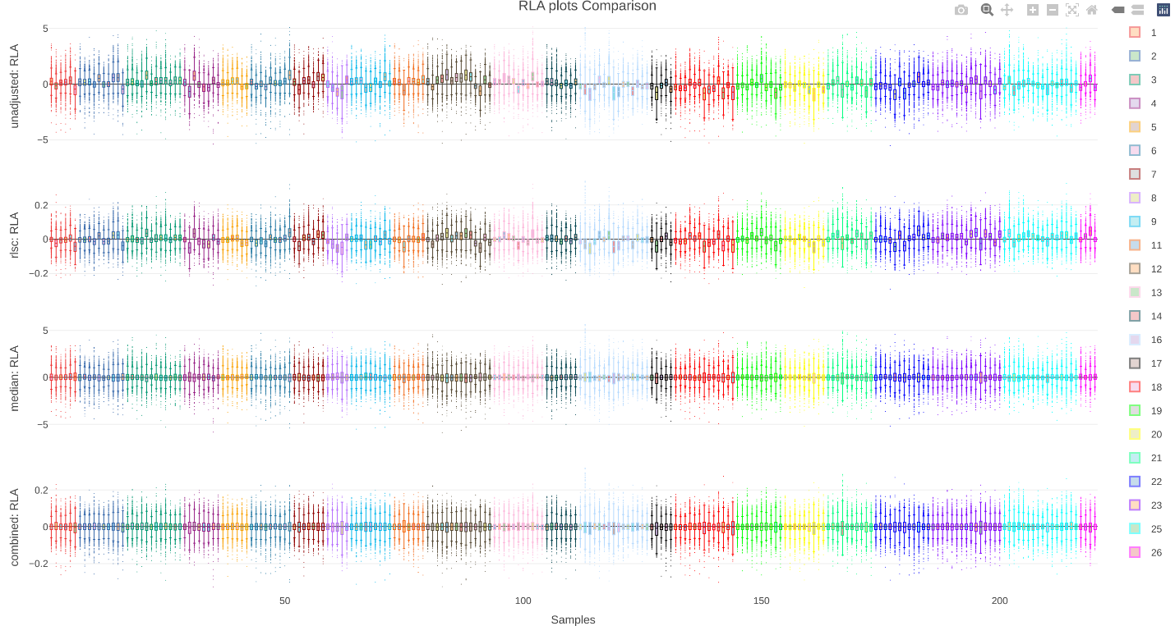
Supplemental Fig.11: Relative abundance plot in RP(+) mode for the comparison of normalization effects from various techniques. Normalized techniques applied included (from top to bottom) raw, quality control–based robust LOESS signal correction (rlsc), median scaling (med), combination of rlsc and median scaling. We observed inner- and inter-batch fluctuations. The method rlsc alone did not achieve satisfying variability stabilization. Median scaling and a combination of rlsc and median scaling resulted in similar stabilizing effects.
Supplemental Fig.10 and Fig.11 present the batch-wise variation of HILIC(-) and RP(+) samples by injection order. Prior to normalization, there were mild batch-wise variations observed, and different normalization methods were applied for variation stabilization purposes, including RLSC, median scaling, and the combination of both. The median scaling approach yielded similar results as the combination approach in terms of batch-wise and within-batch variation. We, thus, believed that median scaling was sufficient for normalization purposes.
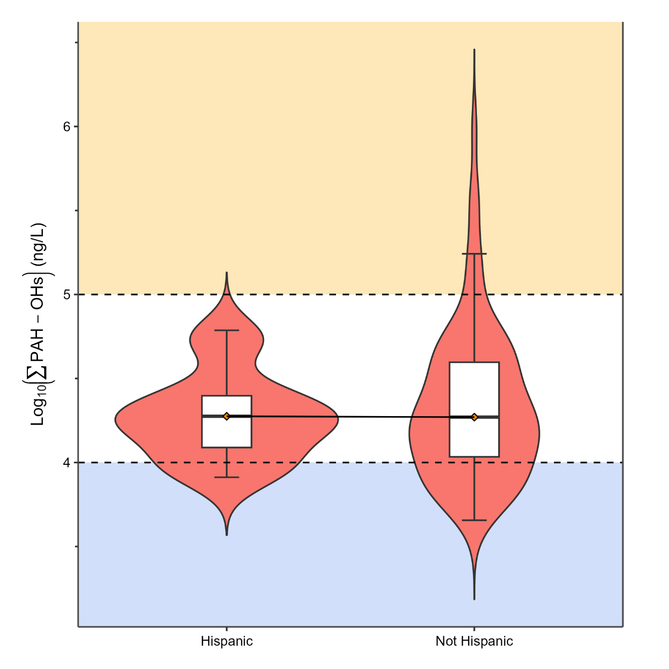
Supplemental Fig.12: Violin plot comparing the sum of PAH-OH metabolites in the urine of Hispanic (N=19) to non-Hispanic (N=81) participants after logarithmic transformed in male firefighters (N=100), after fire exposure. The adjusted FDR p-value thresholds were set as follows: * for p < 0.05, ** for p < 0.01, and *** for p < 0.001. Unmarked indicates non-significant results.

