Wall Shear Stress Modulates Metabolic Pathways in Endothelial Cells
Rita Simões-Faria ¹, Margo Daems², Hanna M Peacock², Mathias Declercq^{4,5}, Anton Willems¹, Elizabeth AV Jones², Bart Ghesquière^{*1}

¹Metabolomics Core Facility Leuven, Center for Cancer Biology, VIB, Leuven, Belgium; Laboratory of Applied Mass Spectrometry, Department of Cellular and Molecular Medicine, KU Leuven, Leuven, Belgium.
²Department of Cardiovascular Sciences, Centre for Molecular and Vascular Biology, KU Leuven, 3000 Leuven, Belgium.
³Department of Development and Regeneration, CF Centre, Woman and Child, KU Leuven, Leuven, Belgium.
⁴Laboratory of Angiogenesis and Vascular Metabolism, VIB Center for Cancer Biology (VIB-CCB), Department of Oncology, Leuven, Belgium.
*Corresponding author: Bart Ghesquière. Email: bart.ghesquiere@kuleuven.be

Supplementary Figures

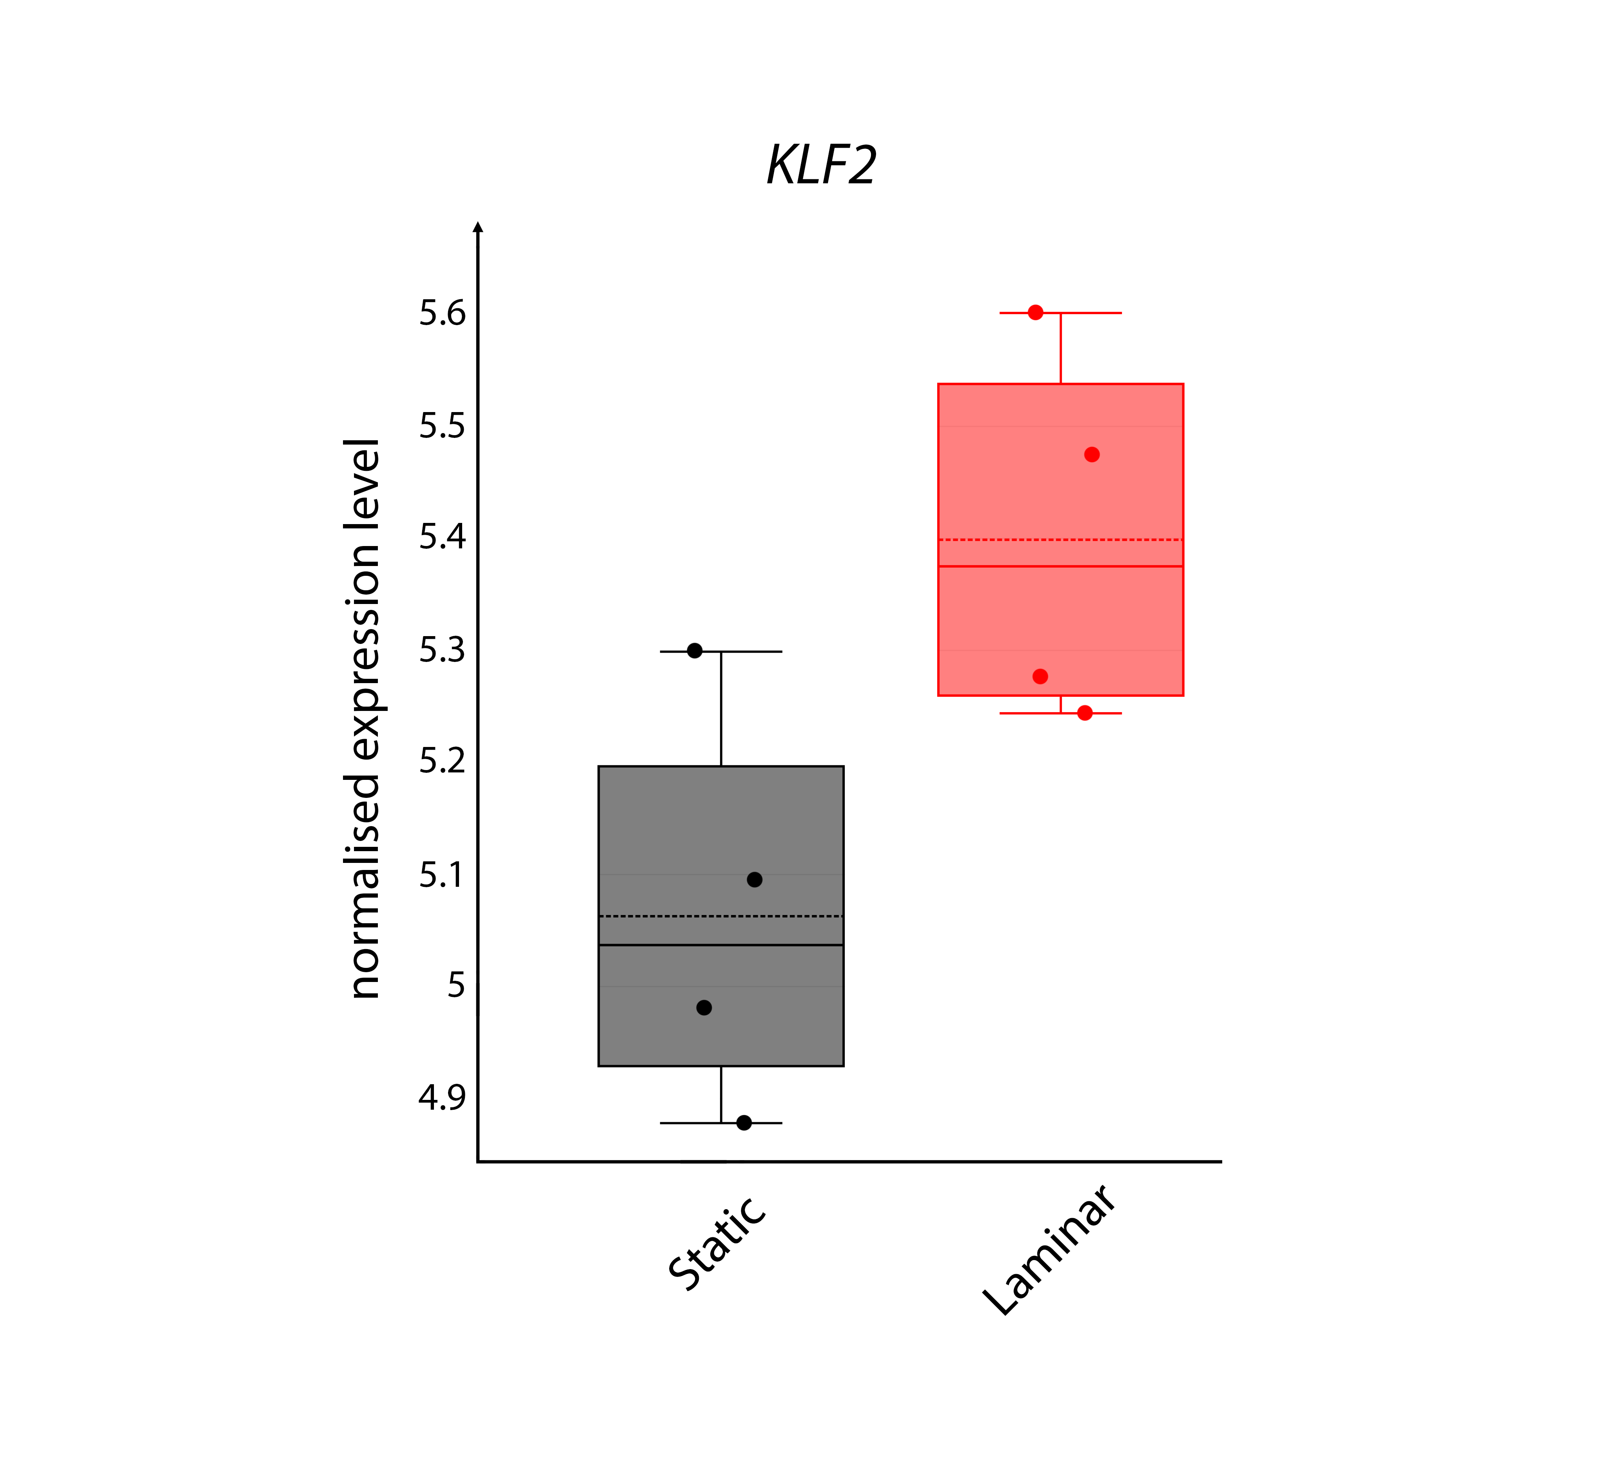
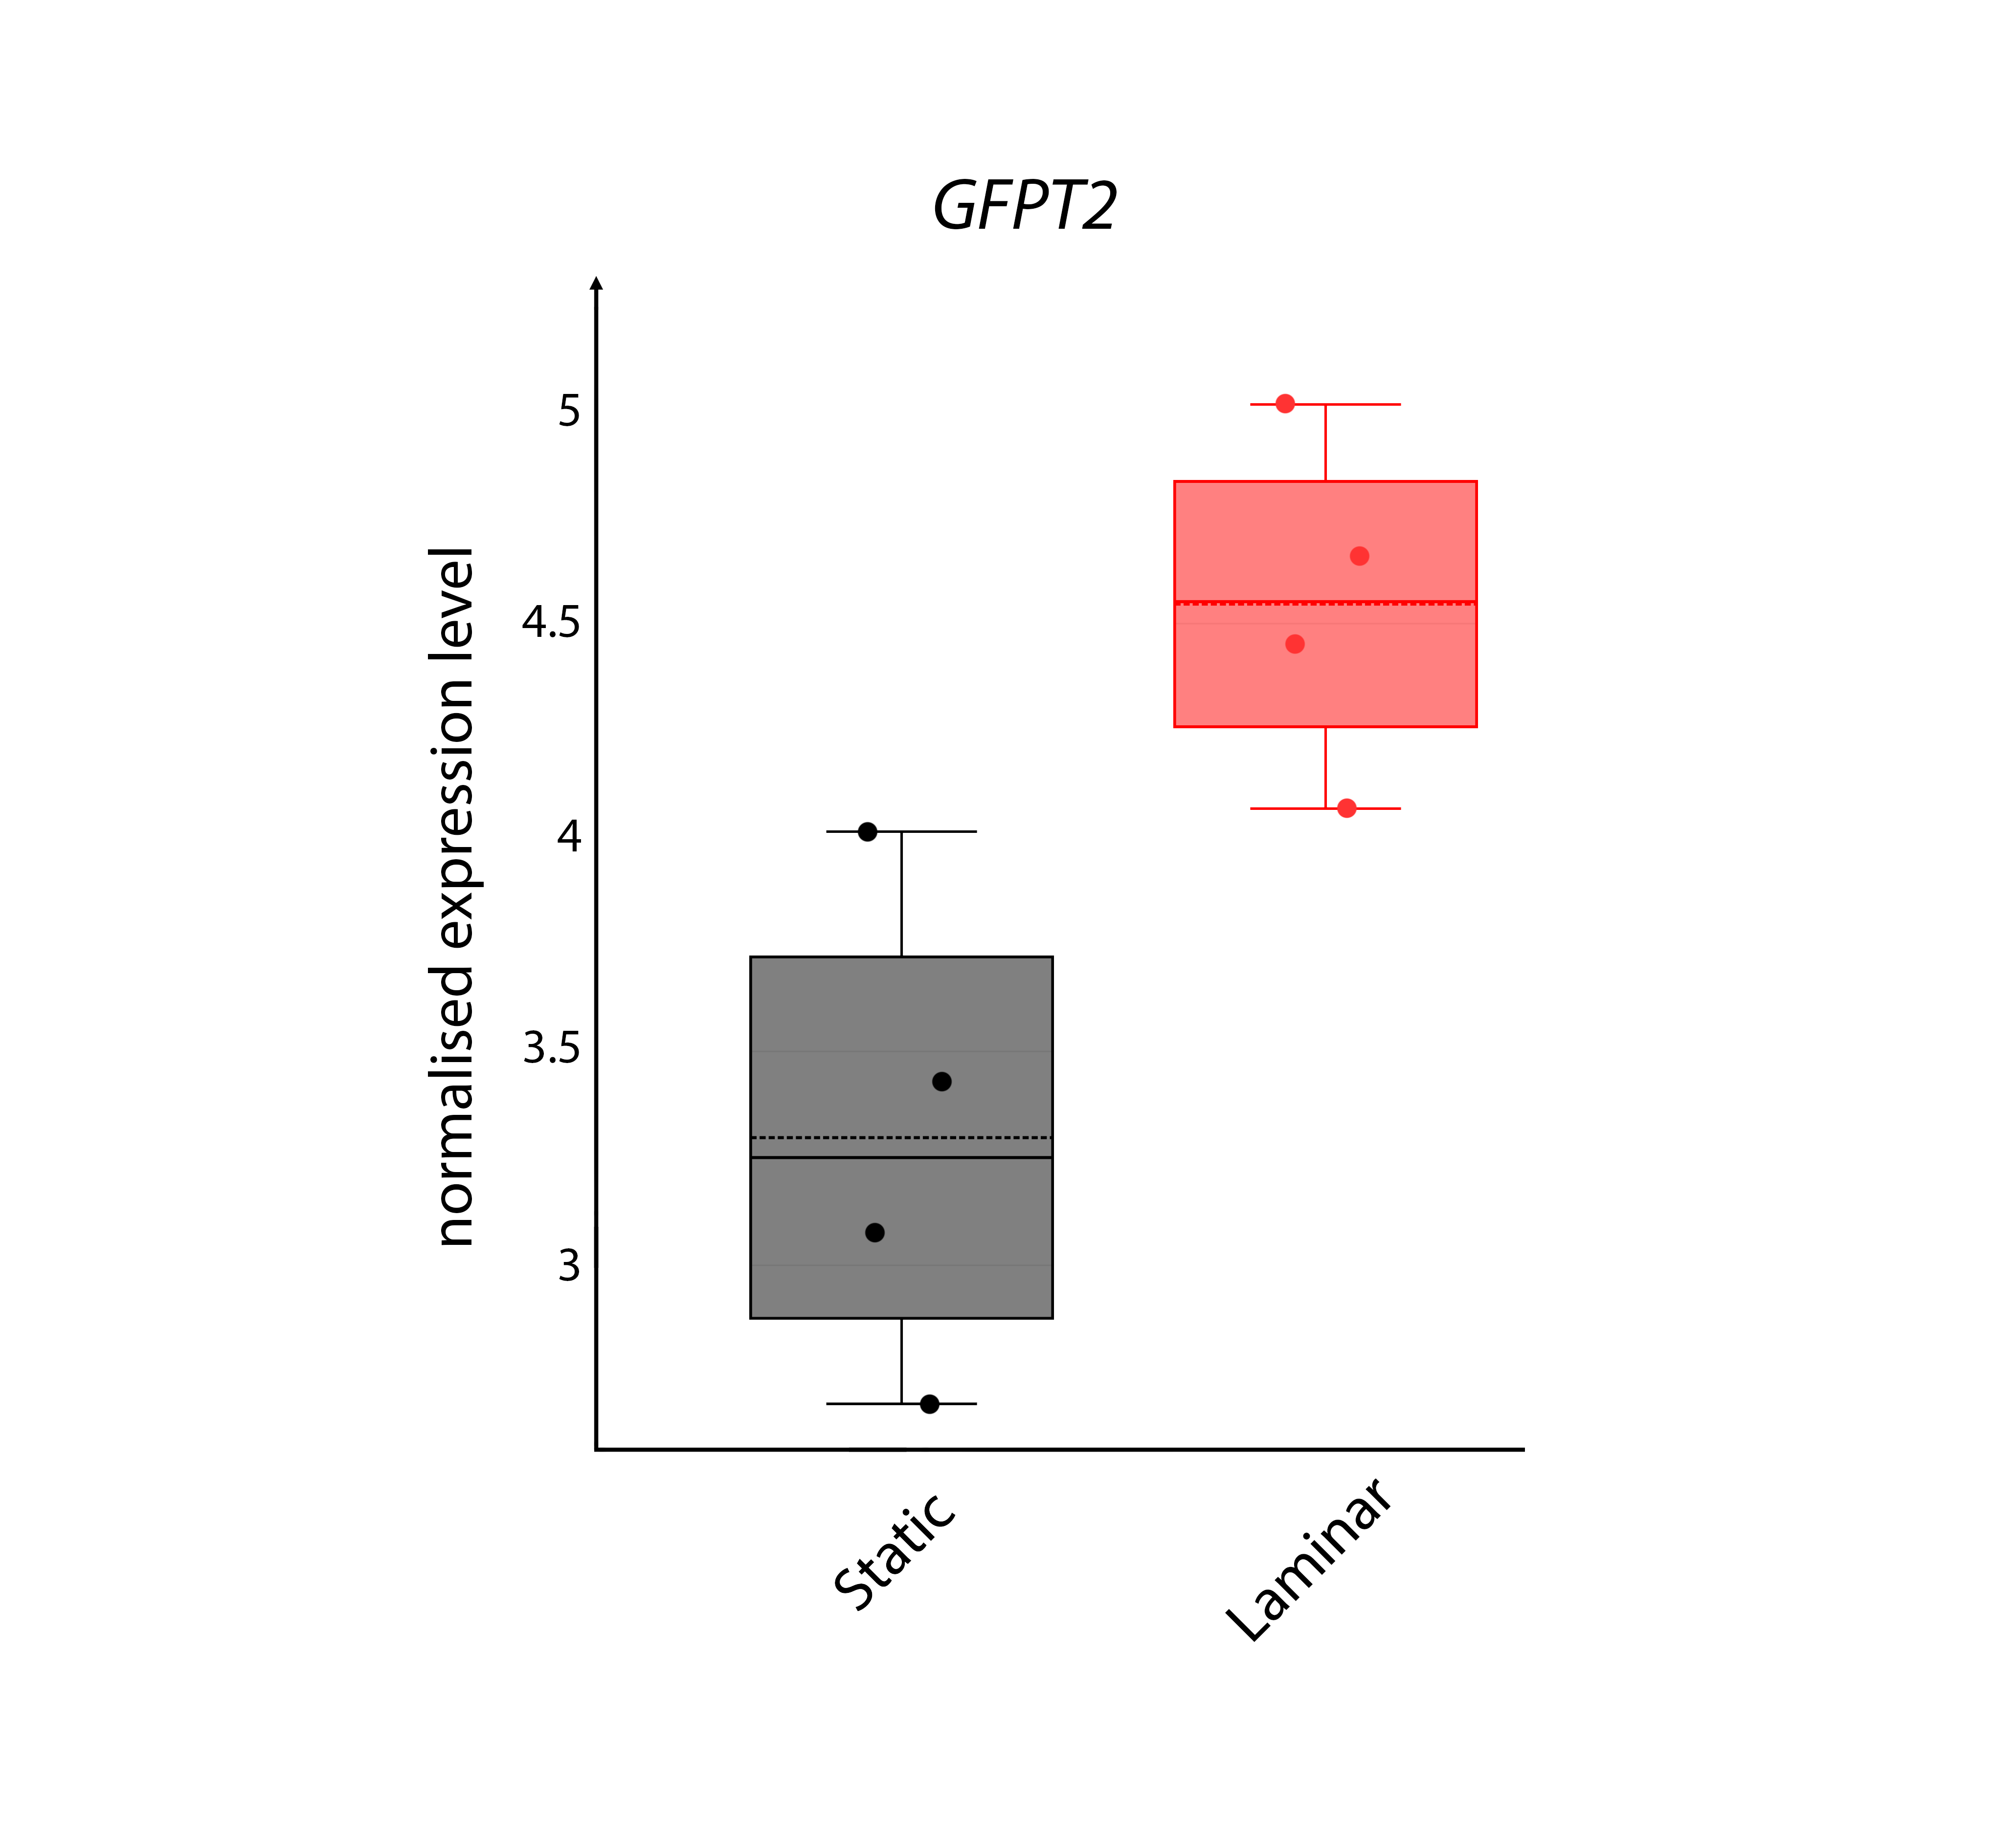
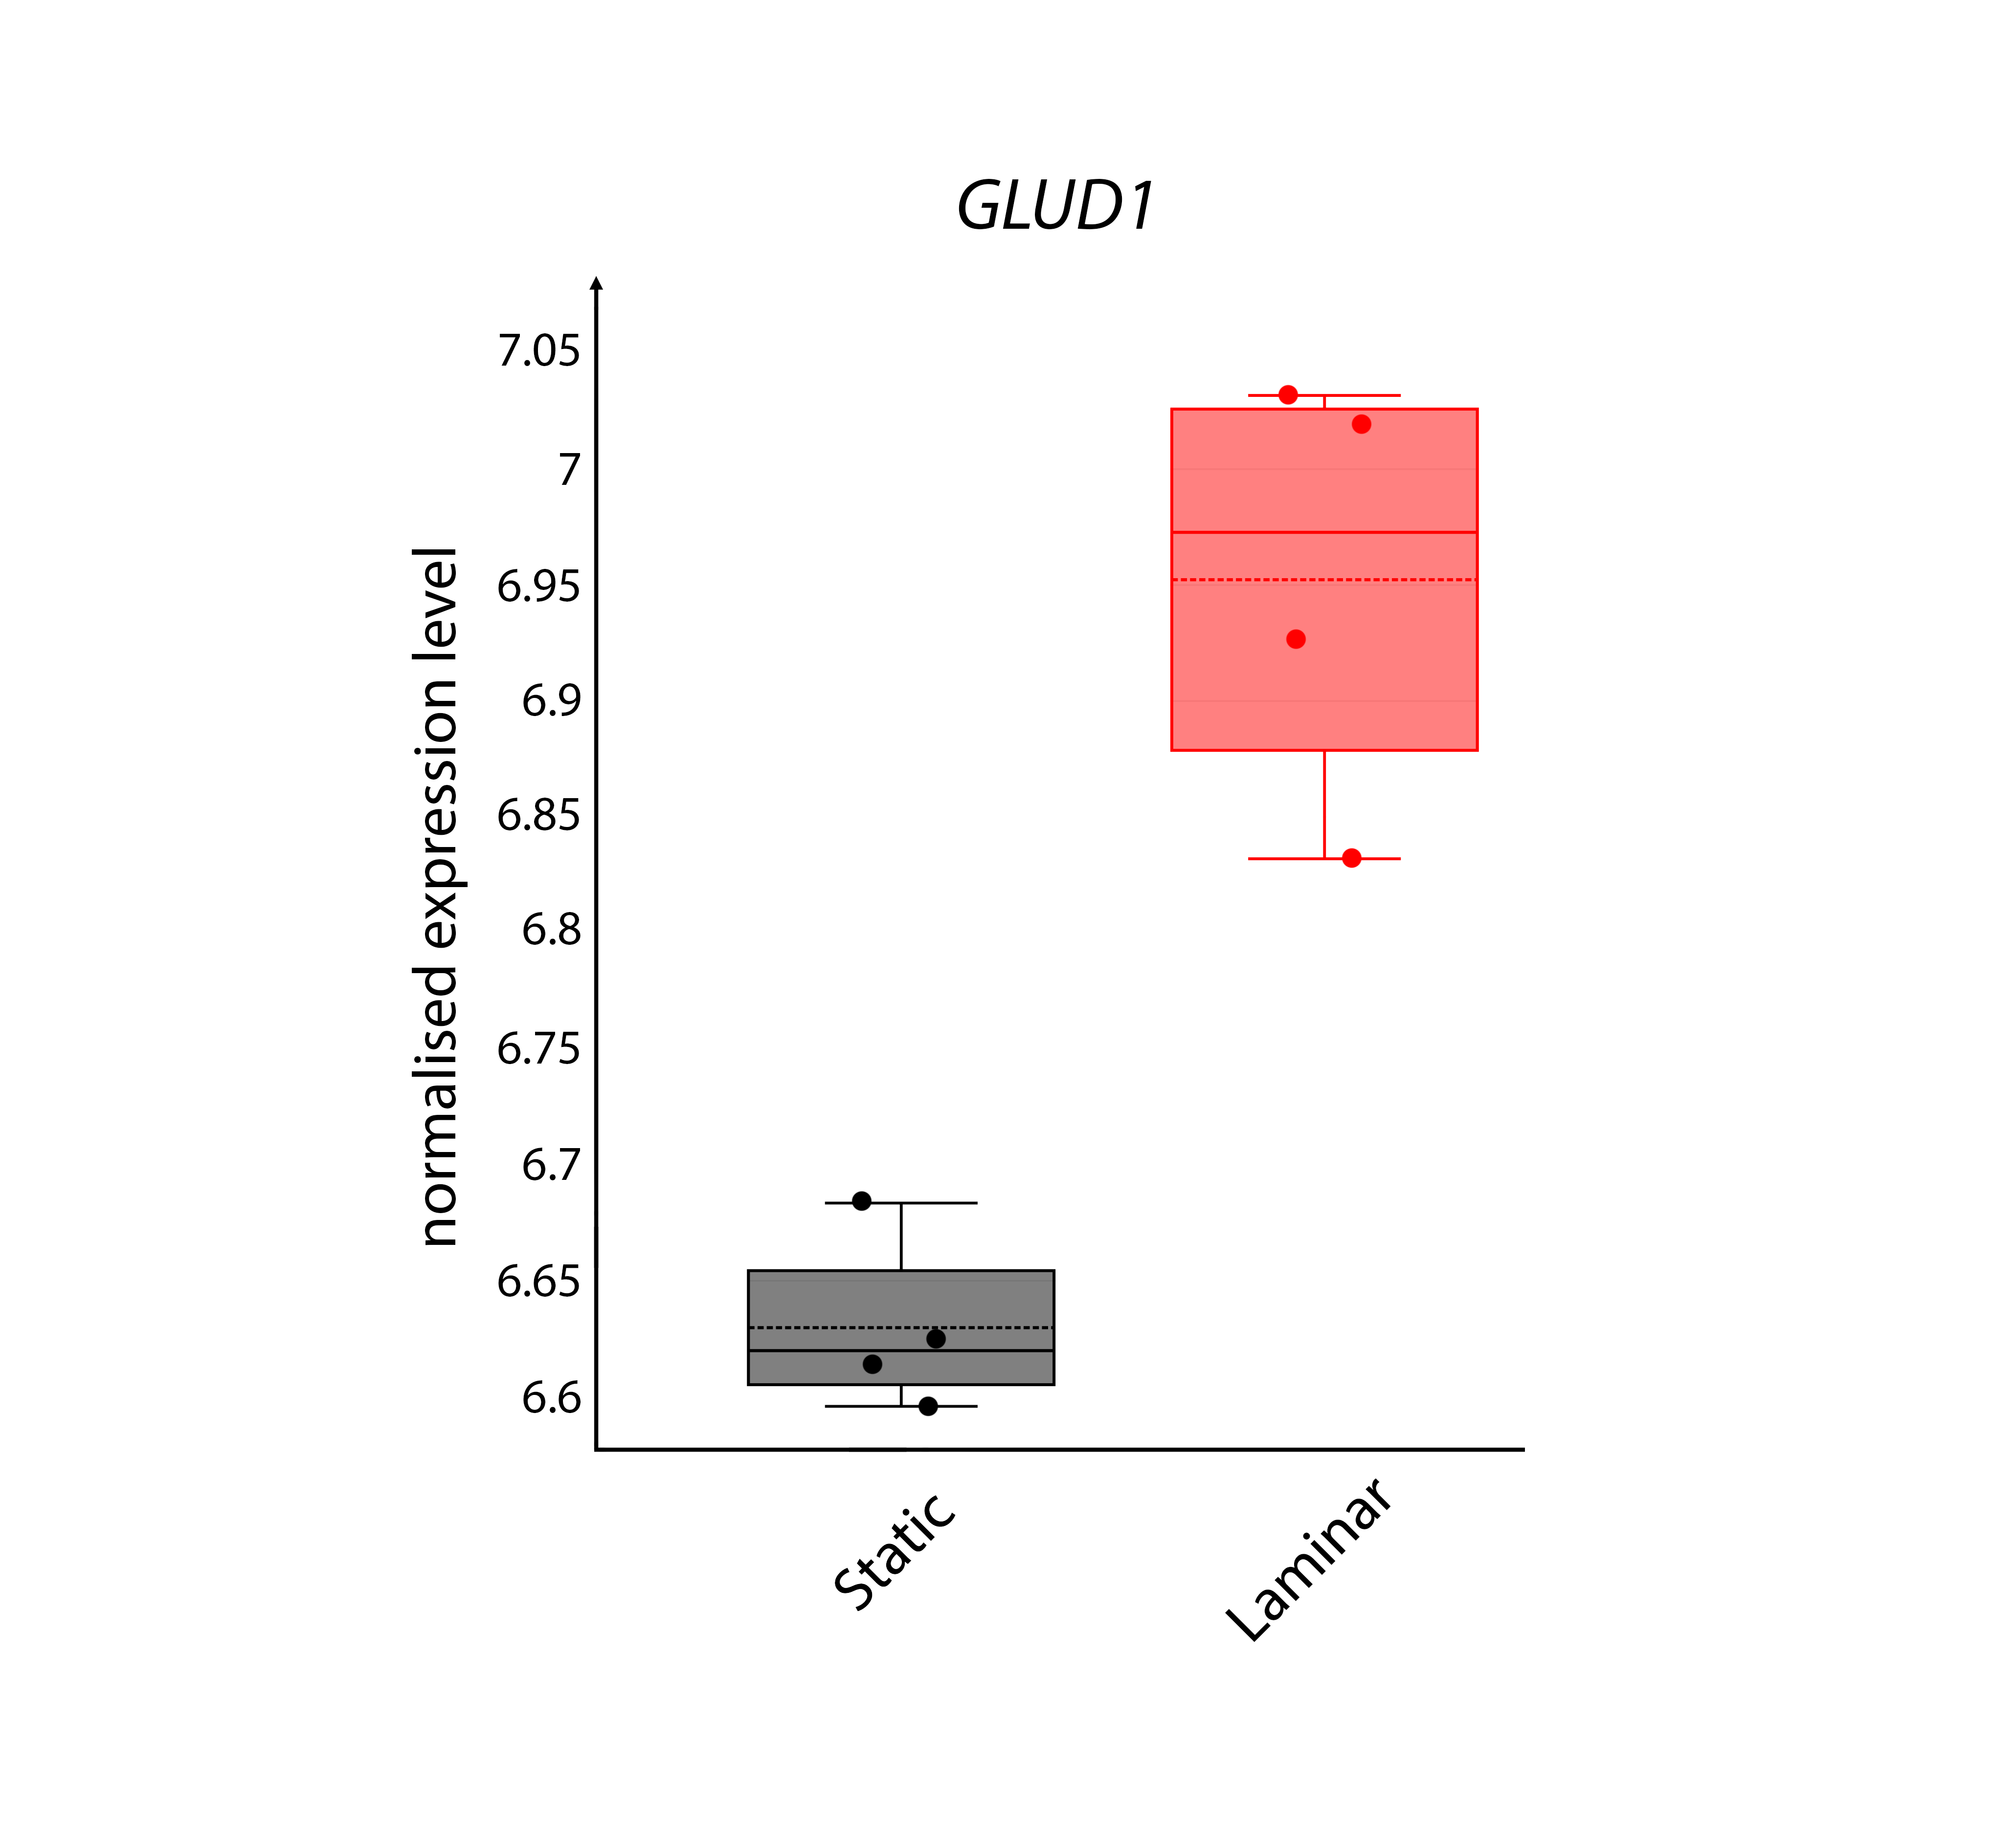
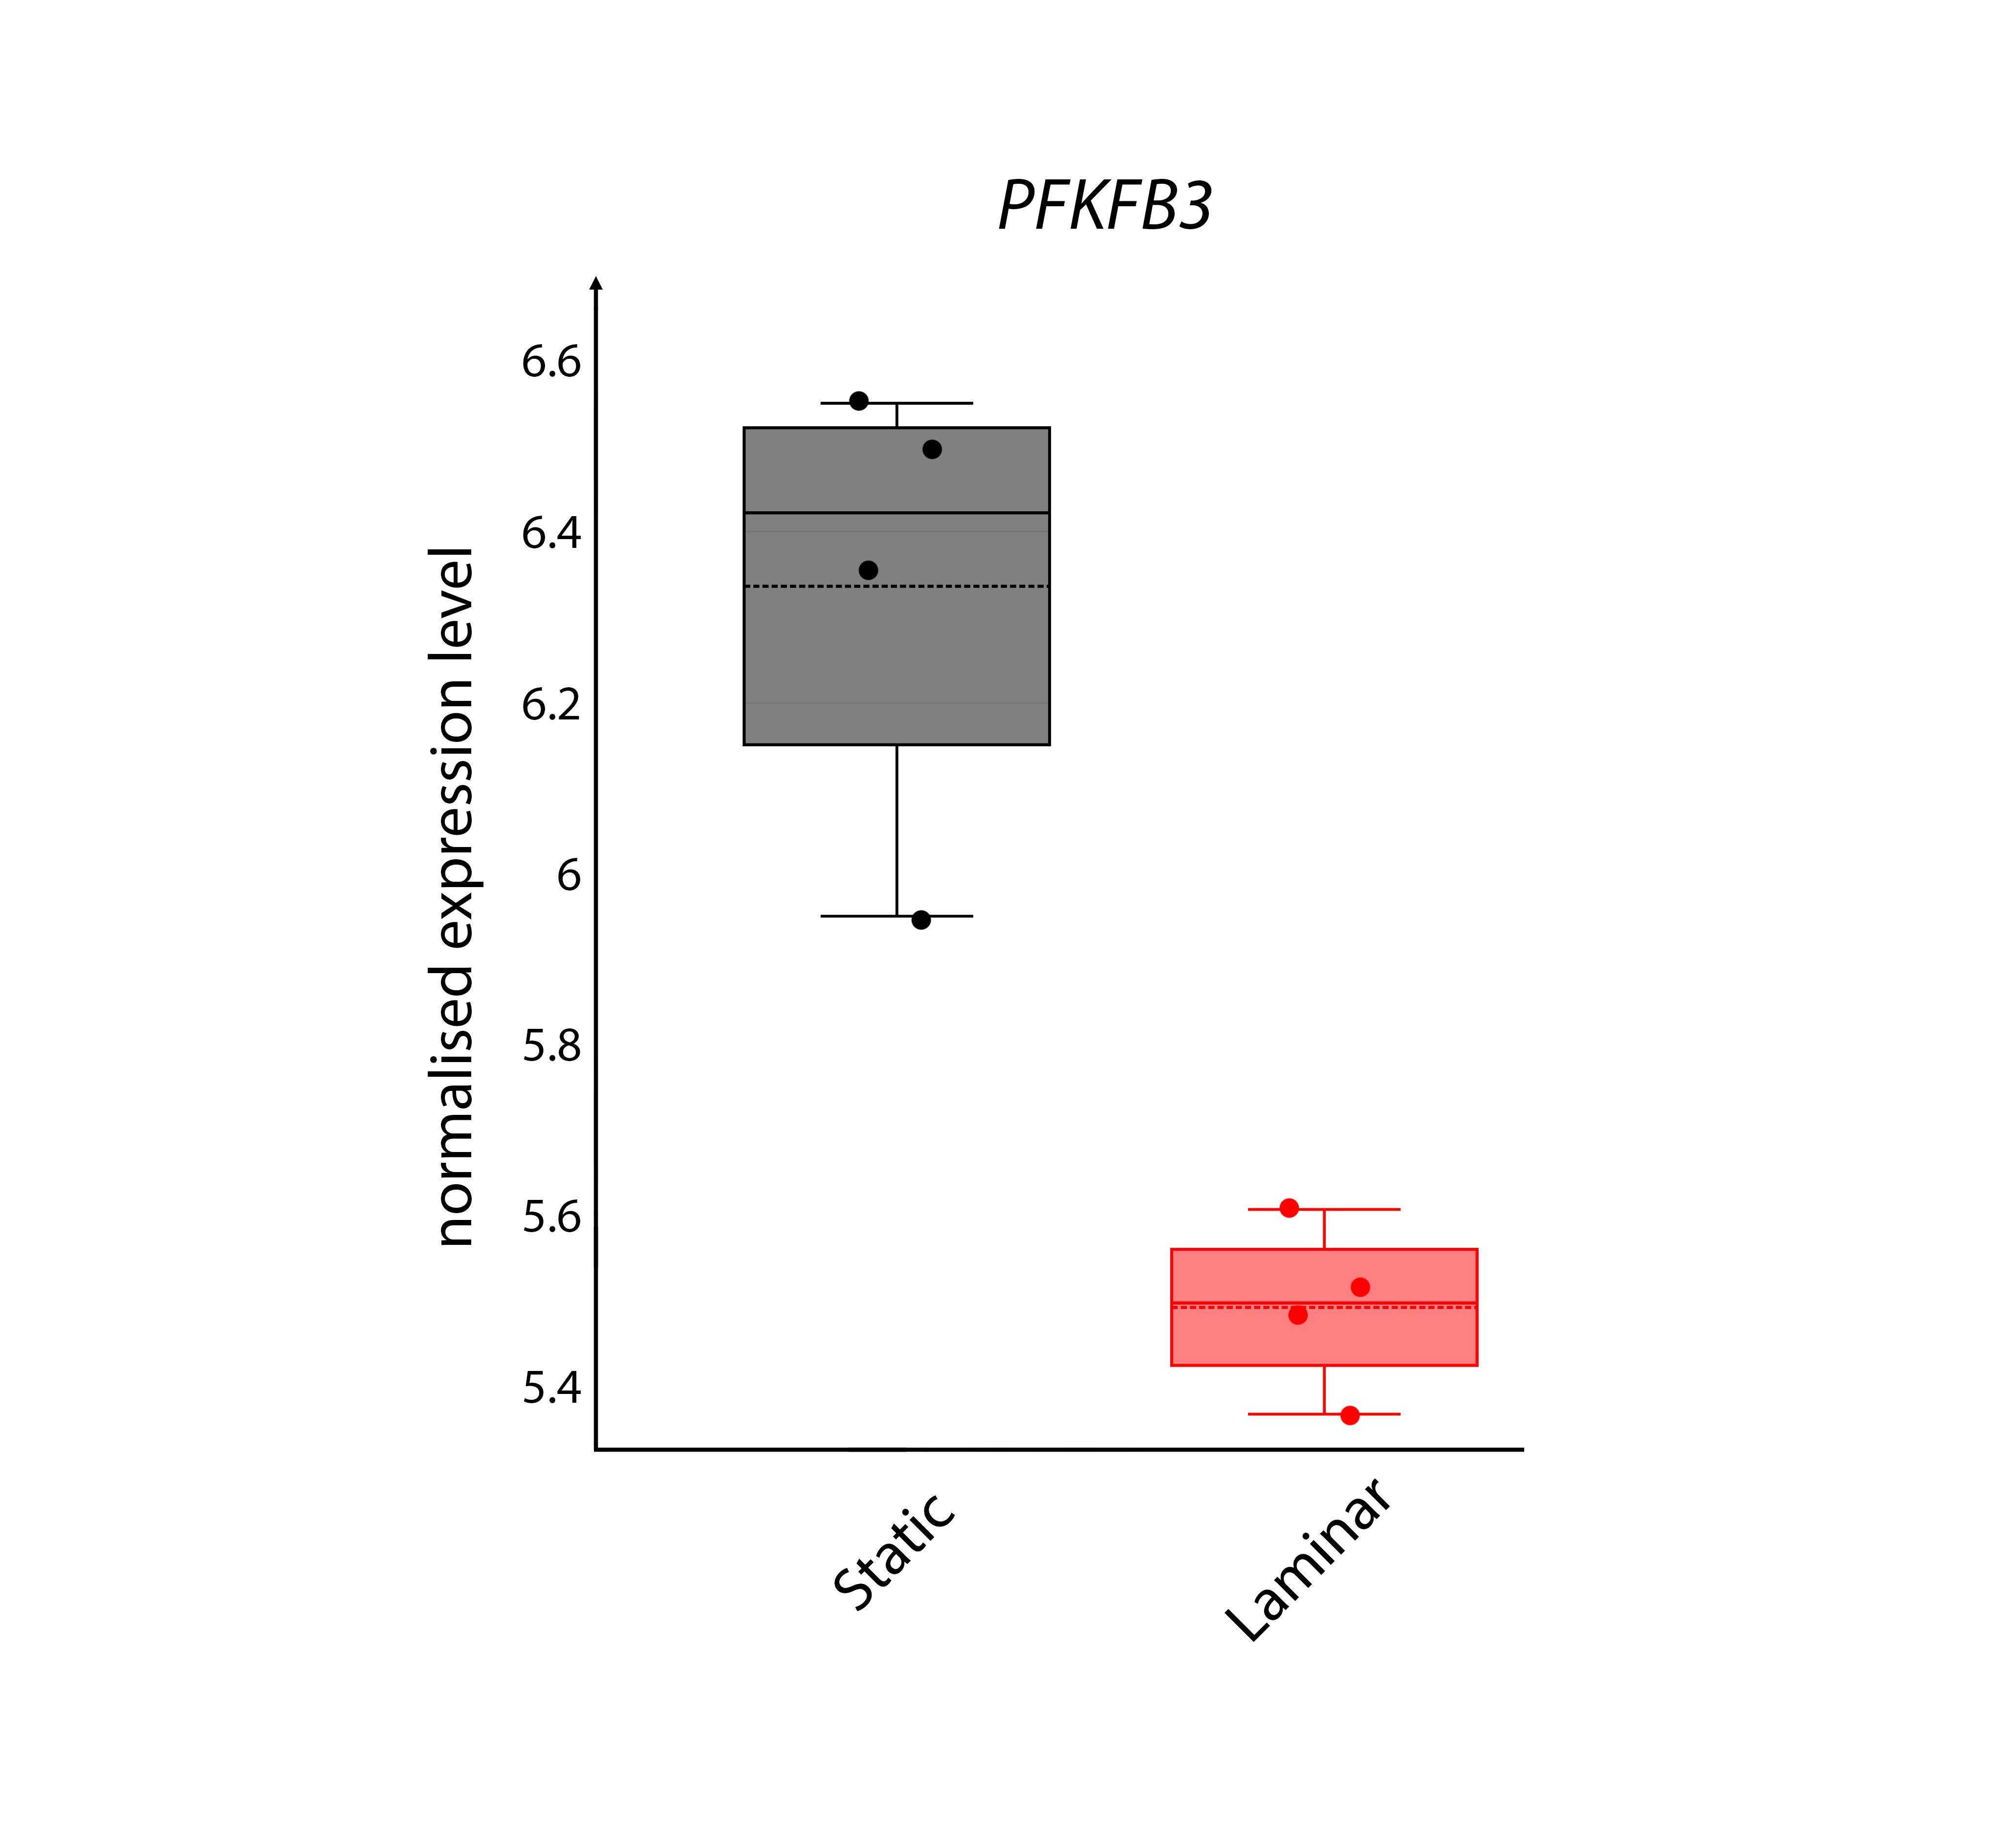
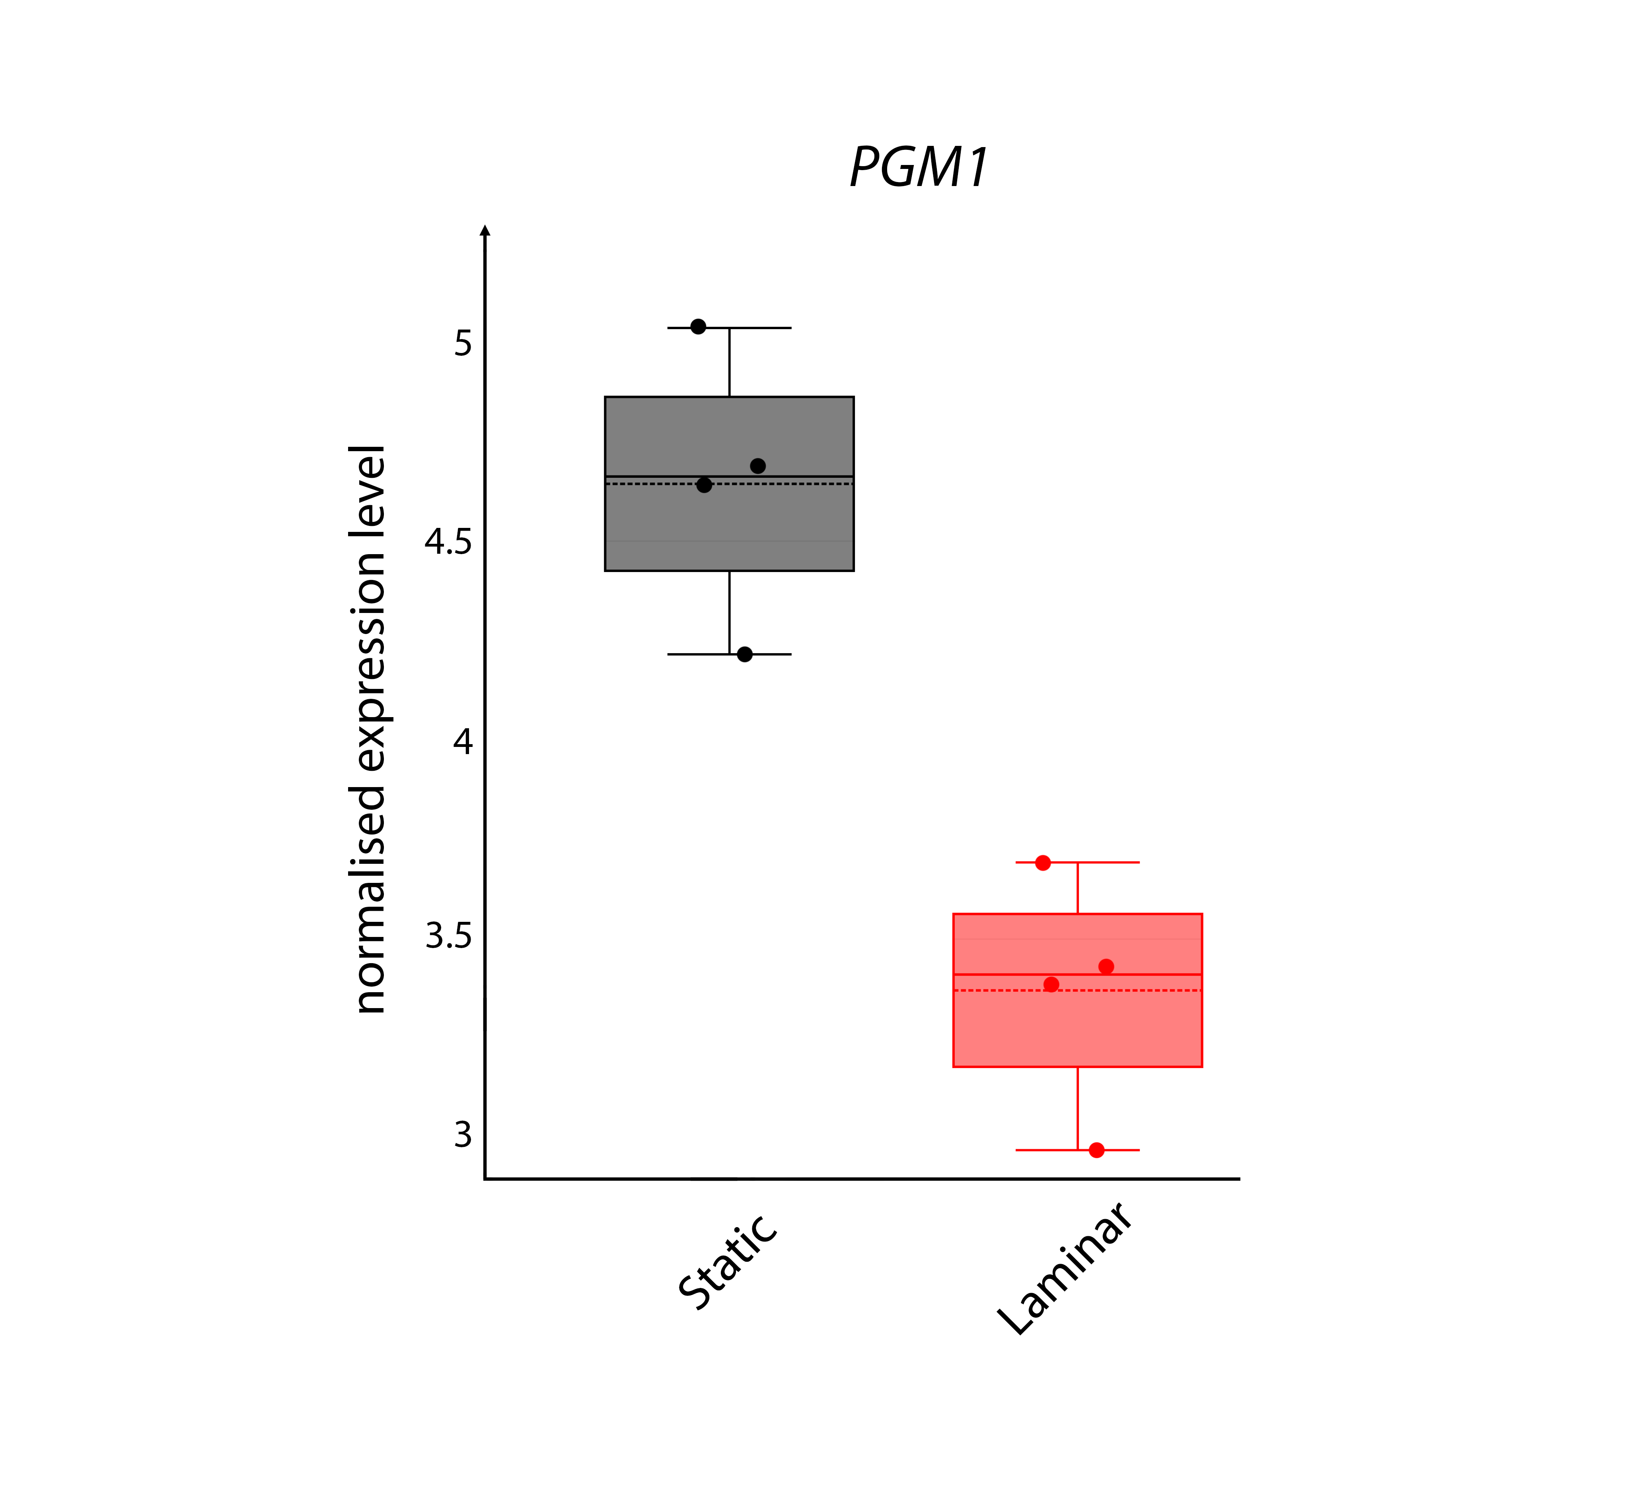
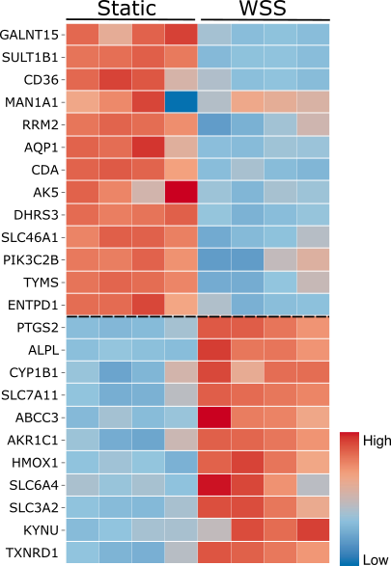
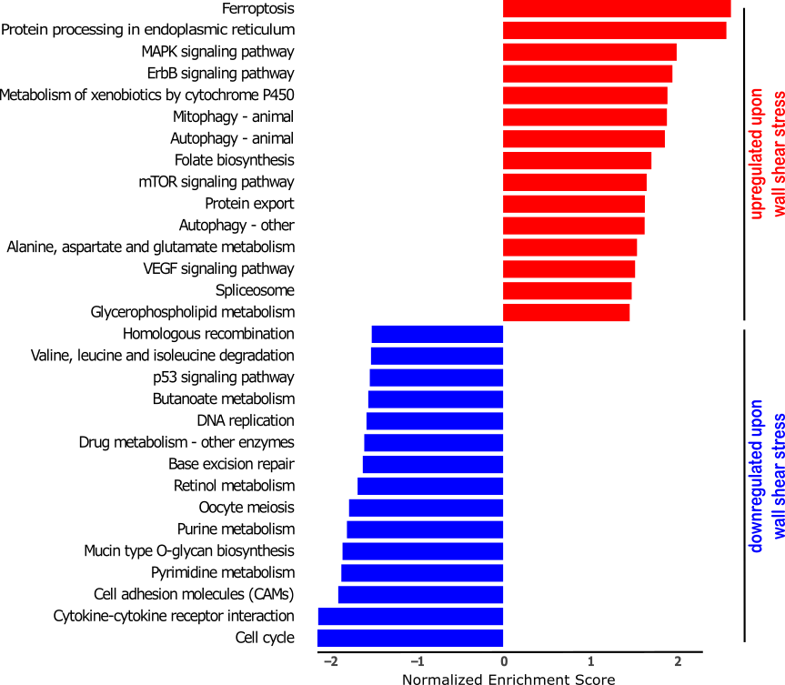
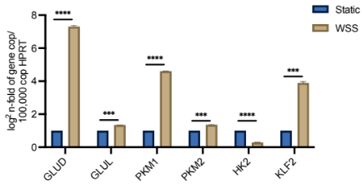
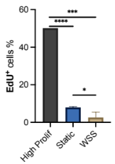
Figure S1: A) Boxplots showing normalized expression levels of PGM1, PFKFB3, GLUD1, KLF2, GFPT2 in ECs under static (Ctrl) or WSS cultures. n=4; B) qRT-PCR analysis of GLUD, GLUL, PKM1, PKM2, HK2 and KLF2 expression levels in ECs under static (Ctrl) or WSS cultures. n=3; ***p<0.001; ****p<0.0001 by multiple unpaired t-test. C) Barplots representing the top deregulated gene sets (with a significant adjusted p-value) ranked based on their normalized enrichment score. Upregulated gene sets induced upon WSS are shown in red; downregulated genes sets are in blue. D) Heatmap showing the expression levels of top ranked differentially expressed genes between ECs under static (Ctrl) or WSS cultures. Selected genes have adjusted p-values<0.05. E) EdU incorporation into DNA (proliferation assay) in ECs under static (Ctrl) or WSS cultures. (n=3). Mean + SEM; *p<0.05; ***p<0.001; ****p<0.0001 by multiple unpaired t-test.
Supplementary Figure S1
A
E
B
C
D
Static
WSS
Static
WSS
Static
WSS
Static
WSS
Static
WSS
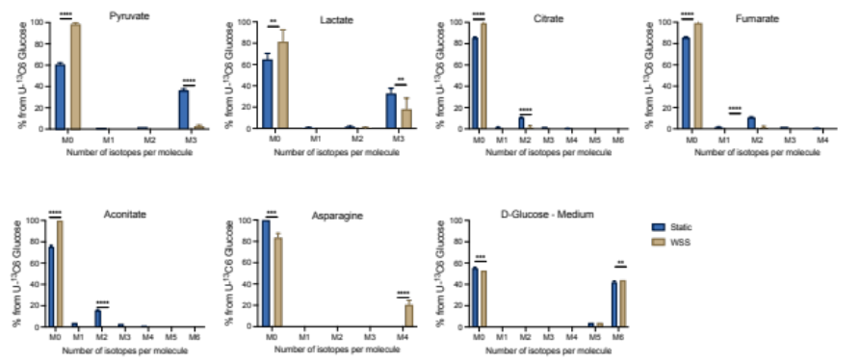
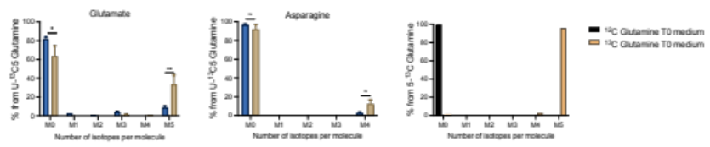
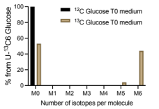
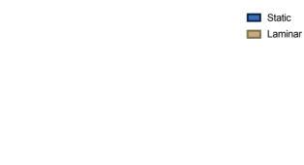
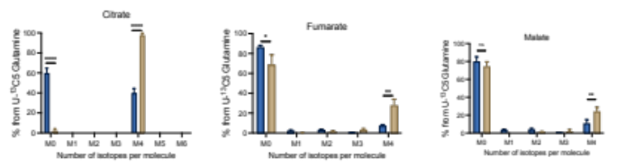
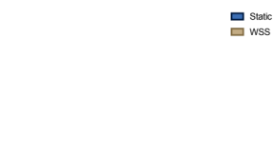
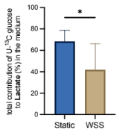
Supplementary Figure S2
F
G
H
I
K
L
J
D
C
B
A

O
N
M
E
Figure S2: A) Total contribution of [U-13C] glucose carbons to lactate in ECs under static (Ctrl) or WSS cultures. (n=3). *p<0.05; by unpaired t-test. B)-F) Mass distribution analysis of labeled intermediates (from [U-13C] glutamine) in ECs under static (Ctrl) or WSS cultures. (n=3). ns = nor significant, p>0.05; *p<0.05; **p<0.01; ****p<0.0001 by multiple unpaired t-test. G) Mass distribution comparison of labeled carbons of D-glucose present in the medium containing [U-13C] glutamine vs [U-12C] glutamine. (n=3). H)-M) Mass distribution analysis of labeled carbons (from [U-13C] glucose) of different metabolites in ECs under static (Ctrl) or WSS cultures. (n=3). **p<0.01; ***p<0.001; ****p<0.0001 by multiple unpaired t-test. N) Mass distribution analysis of labeled carbons (from [U-13C] glucose) of D-glucose present in the medium of ECs under static (Ctrl) or WSS cultures. (n=3). **p<0.01; ***p<0.001; by multiple unpaired t-test. O) Mass distribution comparison of labeled carbons of D-glucose present in the medium containing [U-13C] glucose vs [U-12C] glucose. (n=3).

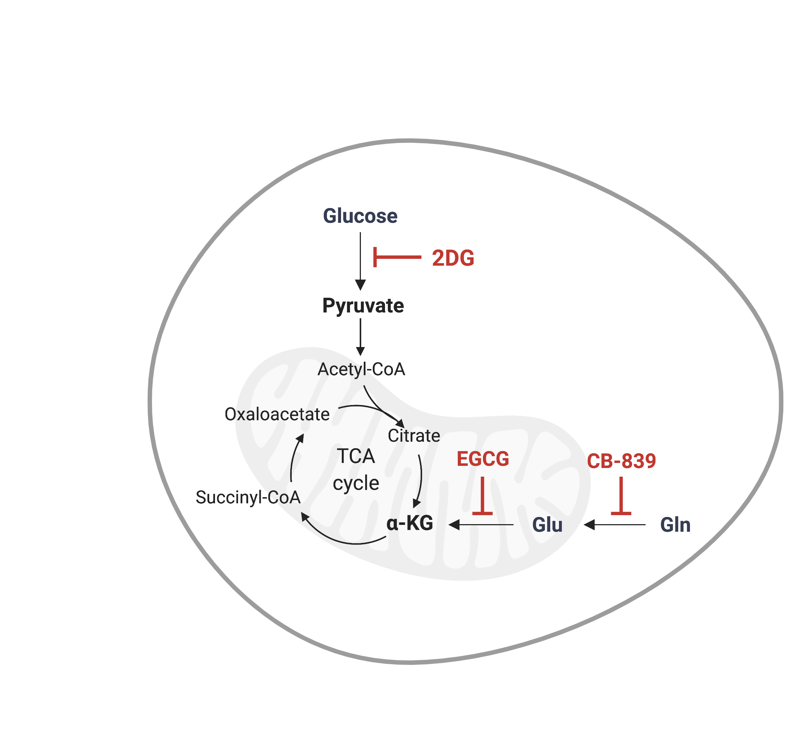
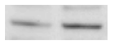
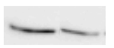
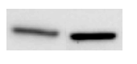
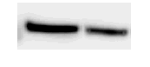
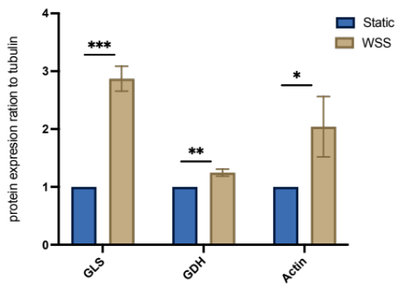
Supplementary Figure S3
C
B
A
- 65kDa
- 61kDa
- 42kDa
- 55kDa
β-Tubulin
β-Actin
GLS
GDH
Static
WSS
Figure S3: A) Schematic representation of the molecular pathway target of the drugs in test (EGCG (10μM), CB-839 (1μM) or 2DG (1mM)). Created with BioRender.com. B) Densitometric quantification of protein levels of GLS, GDH and beta actin normalized to tubulin between ECs under static (Ctrl) or WSS cultures. (n=3). *p<0.05; **p<0.01; ***p<0.001; by multiple unpaired t-test. C) Protein levels of GLS, GDH and beta actin in ECs under static (Ctrl) or WSS cultures. Tubulin is shown as loading control.
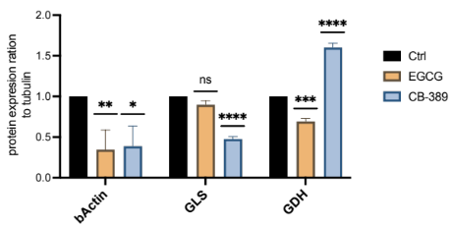
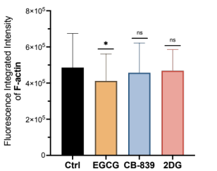
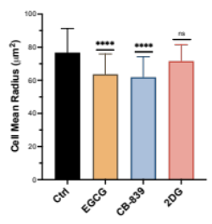
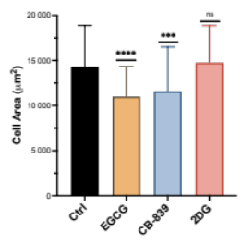
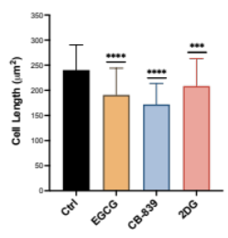
Figure S4: A) B) C) Cell morphology quantification of ECs under WSS in alternative media formulations (EGCG (10μM), CB-839 (1μM) or 2DG (1mM)). The diagram shows a quantitative analysis of (b) cell length (c) cell mean radius and (d) cell area. Parameters were calculated using image processing software (MetaMorph) and were determined for 50 cells in each group in test. (n=3). ns = nor significant, p>0.05; ***p<0.001; ****p<0.0001; by multiple unpaired t test. D) Fluorescence integrated intensity of F-actin of ECs under WSS cultures treated with EGCG, CB-839 or 2DG. (n=3). ns = nor significant, p>0.05; *p<0.05; by multiple unpaired t-test. E) Densitometric quantification of protein levels of beta actin, GLS and GDH normalized to tubulin between ECs under WSS cultures treated with EGCG, CB-839 or 2DG. (n=3). ns = nor significant, p>0.05; *p<0.05; ***p<0.001; ****p<0.0001; by multiple unpaired t-test. F) Protein levels of GDH, GLS and beta actin of ECs under WSS cultures treated with EGCG, CB-839 or 2DG. (n=3). Tubulin is shown as loading control.
Supplementary Figure S4
D
E
- 65kDa
- 61kDa
- 42kDa
- 55kDa
β-Tubulin
β-Actin
GLS
GDH
Ctrl
EGCG
CB-389
F
A
B
C

