Supplementary Material 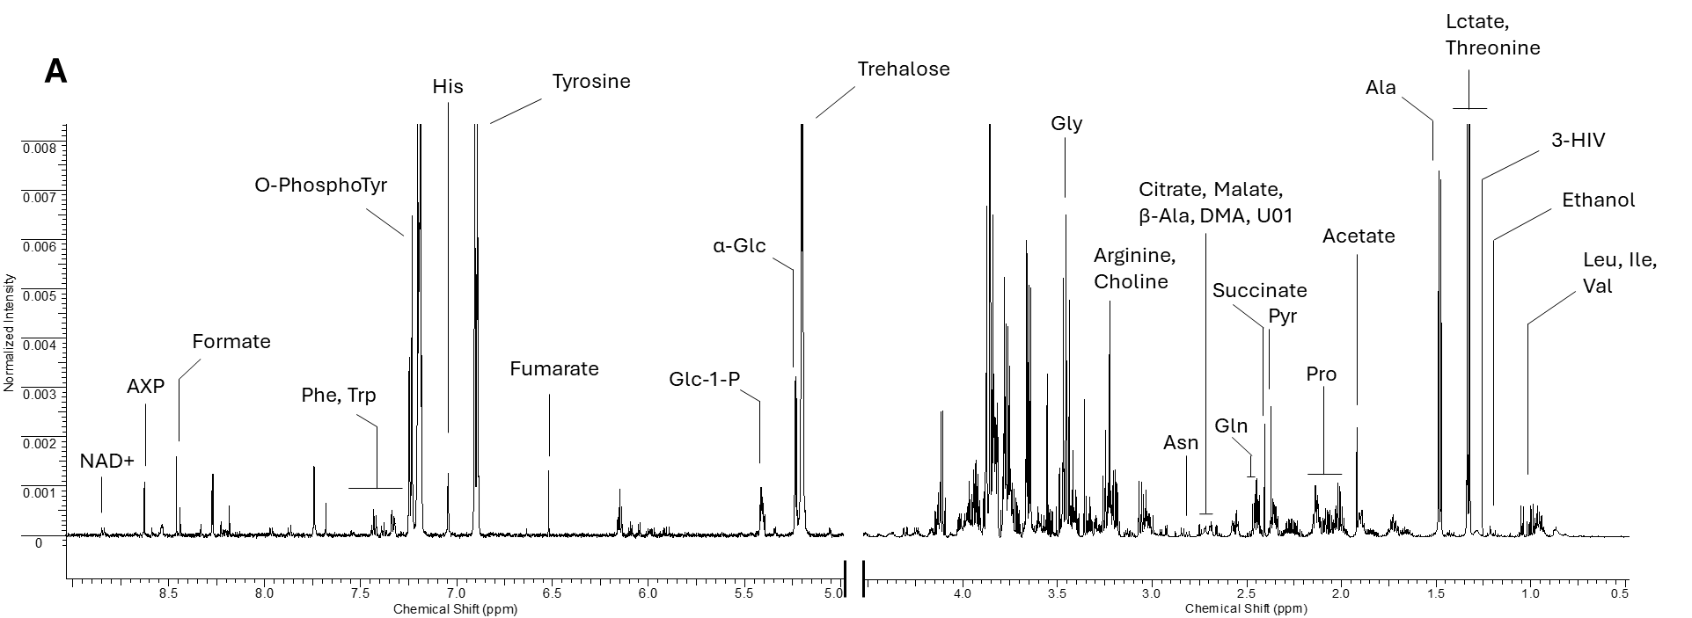
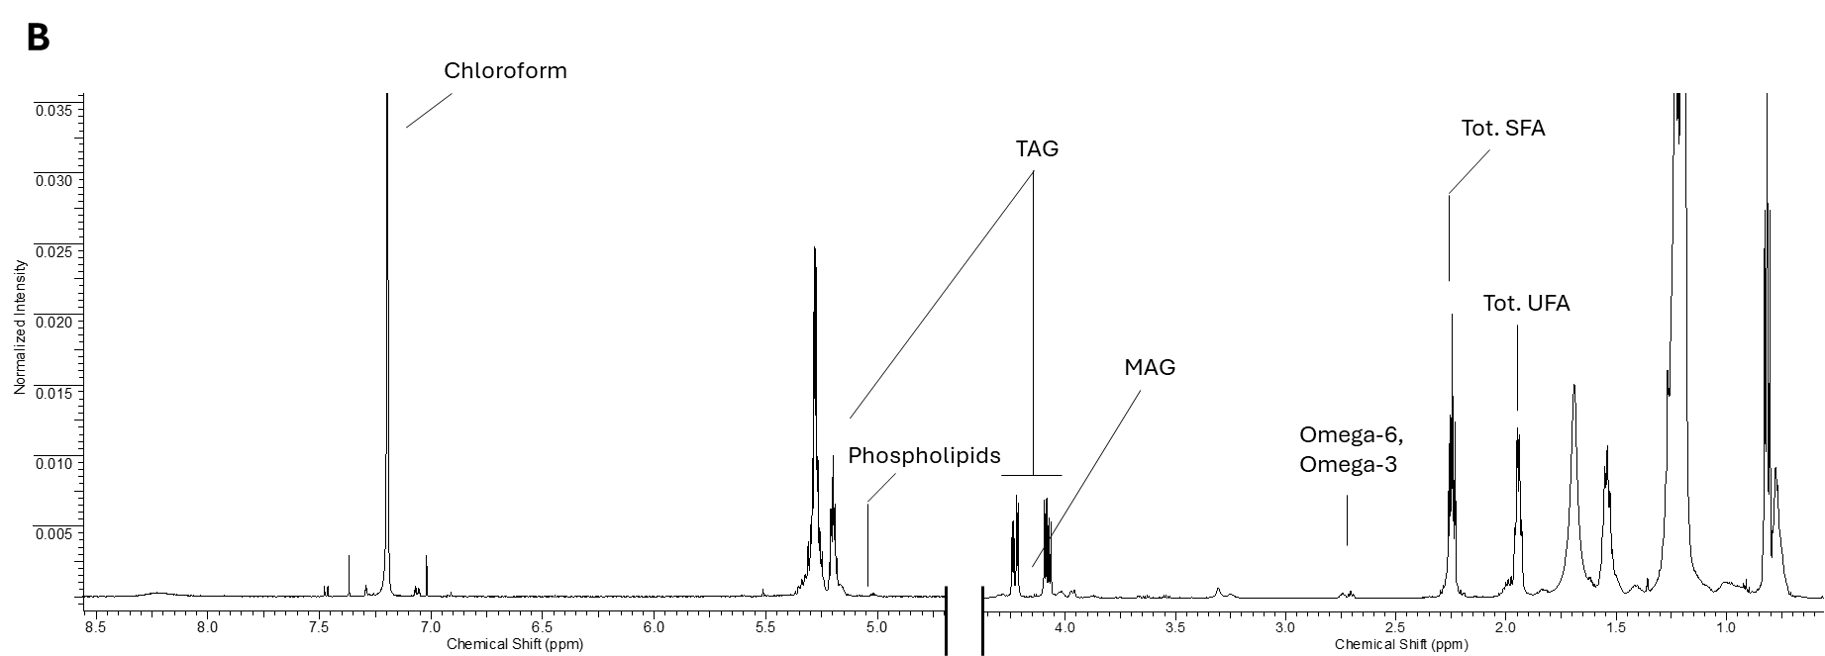
Figure S1. Representative spectra of both aqueous (A) and organic (B) fraction.

Figure S2. Permutation test performed on three main validation parameters. The continuous lines represent the value of index in the real data, while the histograms show the distribution of each parameter across permutations. On the top are reported the relative p-values for statistical significance.

Compound | Assignmentª | ¹H (ppm) | Multiplicity^{b}
Valine (Val) | α -CH  β-CH  γ-CH₃  γ’-CH₃ | 3,62  2,29  1,05  1,00 | m  m  d  d
Isoleucine (Ile) | α -CH  β-CH  γ-CH  γ'-CH  δ-CH₃  δ’-CH₃ | 3,69  1,99  1,25  1,49  1,01  0,95 | m  m  m  m  d  t
Leucine (Leu) | α -CH  β-CH₂  γ-CH₃  δ -CH₃  δ’-CH₃ | 3,74  1,73  1,69  0,97  0,96 | m  m  m  d  d
Ethanol | CH₂  CH₃ | 3,66  1,19 | q  t
3-Hydroxyisovalerate (3-HIV) | α-CH₂  β-CH₃, β-CH₃’ | 1.26  2.35 | s  s
Alanine (Ala) | α-CH  β-CH₃ | 3,77  1,49 | q  d
Threonine (Thr) | α-CH  β-CH  γ-CH₃ | 3,57  4,24  1,33 | d  m  d
Acetate | CH₃ | 1,93 | s
Proline (Pro) | ϒ-CH2  β’-CH  β-CH  δ’-CH  δ-CH  α-CH | 2.06  2.11  2.36  3.36  3.42  4.14 | m  m  m  m  m  m
Pyruvate (Pyr) | CH₃ | 2.46 | s
Succinate | α,β-CH₂ | 2,41 | s
Glutamine (Gln) | α-CH  β-CH₂  γ-CH₂ | 3,76  2,11  2,45 | t  dt  t
β-Alanine (β -Ala) | CH2  CH2 | 2.55  3.17 | t  t
Dimethylamine (DMA) | CH3, CH3’ | 2.75 | s
Asparagine (Asn) | α-CH  β-CH  β'-CH | 3,99  2,71  2,82 | dd  dd  dd
U01 | - | 2.89 | s
Choline | CH3, CH3’, CH3’’ | 3.20 | s
Arginine (Arg) | α-CH  β-CH₂  γ-CH₂  δ-CH₂ | 3,76  1,92  1,69  3,25 | m  m  m  t
Glycine (Gly) | α-CH₂ | 3,69 | s
Lactate | α-CH  β-CH | 4,12  1,37 | q  d
Malate | 3-CH₂  3-CH₂  2-CH | 2.35  2.66  4.29 | dd  dd  dd
Trehalose | CH-1,1’  CH-2,2’  CH-3,3’  CH-4,4’  CH-5,5’  CH₂-6,6’ | 5,19  3,64  3,76  3,44  3,82  3,79 – 3,88 | d  m  m  m  m  m
α-Glucose | CH-1  CH-2  CH-3  CH-4  CH-5  CH₂-6 | 5,23  3,55  3,72  3,42  3,84  3,73 – 3,90 | d  m  m  m  m  m
Glucose-1-Phosphate (Glc-1-P) | α-CH | 5.42 | d
Fumarate | α,β-CH=CH | 6,51 | s
Tyrosine (Tyr) | α-CH  β-CH  β'-CH  C2,6H-ring  C3,5H-ring | 3,93  3,15  3,05  7,20  6,90 | dd  dd  dd  d  d
Histidine (His) | C2H ring  C5H ring | 7.13  8.02 | s  s
O-PhosphoTyrosine (O-PhsphoTyr) | α-CH  β-CH  β'-CH  C5H-ring  C3H-ring  C6H-ring  C2H-ring | 3.08  3.17  3.98  6.78  6.94  7.13  7.19 | dd  dd  t  ddd  ddd  ddd  ddd
Phenylalanine (Phe) | C2,6H-ring  CH-4 ring  C3,5H-ring | 7,33  7,39  7,42 | m  m  m
Triptophan (Trp) | CH-5 ring  CH-6 ring  CH-7 ring  CH-4 ring | 7,20  7,27  7,54  7,74 | t  t  d  d
Formate | CH | 8,46 | s
Adenosine Phosphate (AXP) | C2H ring Ade  C8H ring Ade | 8,23  8,58 | s  s
NAD | C2H Nam  C4H Nam  C5H Nam  C6H Nam | 9,34  8,84  8,29  9,15 | s  m  m  m
Tot. Fatty Acids | α-CH₂ | 2.3 | m
Tot. Unsatured Fatty Acids | allilic-CH₂ | 2.02 | m
Omega-6 | homoallilic-CH₂ | 2.75 | m
Omega-3 | homoallilic-CH₂,CH₂’ | 2.80 | m
MAG | CH (glycerol-mojety) | 3.60 | dd
TAG | CH (glycerol-mojety) | 4.30 | dd
Phopholipids | CH (glycerol-mojety) | 5.20 | dd

Table S1. ¹H Resonances Assignment
ª specific resonance signal used for quantization are reported in bold.
^{b} s: singlet; d: doublet; dd: double doublet; dt: double triplet; t: triplet; q: quartet; m: multiplet

