Supplementary Information for

Comprehensive Quantitation of Folates Across Polyglutamylation and One-Carbon States

Sevcan Erşan¹, Yu Chen², and Junyoung O. Park¹*
¹ Department of Chemical and Biomolecular Engineering, and
² Department of Chemistry and Biochemistry, University of California, Los Angeles, Los Angeles, CA 90095, USA.
* Correspondence: jop@ucla.edu

Table of Contents page
Supplementary Note 1…………………………………………………………………………...2
Supplementary Note 2…………………………………………………………………………...3
Supplementary Figures S1-S8……………………………………………………………….....4
Supplementary Table S1-S7....………………………………………………………………..12
Supplementary References……………………………………………………………………26

Supplementary Note 1. Interconversion and degradation products of folate polyglutamates in LC-MS
The detection of interconversion folate products in direct injection mass spectrometry led us to investigate their origins with a focus to understand the extent and the significance of these transformations. Furthermore, we set out to probe how HILIC method that is commonly employed with basic mobile phase [1–3] affects analysis if acidic mobile phase is used in terms of stability, chromatographic separation, and MS detection as folates are reported to undergo pH dependent interconversion and degradation reactions.
To achieve this, individually prepared folate standards were injected into LC-MS. For each standard, we examined m/z values corresponding to all folate species as well as degradation products including the pteroyl group, pterin derivatives, and folate polyglutamates with fewer terminal glutamates than the parent ions. The data helped us determine if interconversion, degradation and fragmentation occurred in the sample or in the ion source. When other product ions exhibited the same chromatographic retention times to their parent ions, it indicated in-source conversion. If the retention times differed, it indicated in-sample or in-column conversion.
Folate species underwent an oxidation process on the pterin ring, yielding interconversion folate products. Formation of these products were found to be dependent on folate type and polyglutamylation. Specifically, H₂PteGlu, H₄PteGlu, and CH₂-H₄PteGlu exhibited a range of oxidized folate forms. PteGlu, CH₃-H₄PteGlu, and CHO-H₄PteGlu_{n} standards were stable and did not produce substantial peaks corresponding to other ions. In contrast, CH₃-H₄PteGlu_{n} underwent oxidation to CH₂-H₄PteGlu_{n}, indicating an increased susceptibility to oxidation with a longer polyglutamate tail. Folate polyglutamate standards (PteGlu_{n}) displayed deglutamylation products PteGlu_{n-1}. A common oxidative cleavage product pABGlu_{n} was identified across all folate polyglutamate injections with their retention times consistent with the pABGlu standard. This alignment suggests their in-sample or in-column conversion. Additionally, pteroic acid (Pte) derivatives were observed as oxidative cleavage products formed after removal of glutamate residue from folate structure. These derivatives appeared at a different retention time than the compound peak, also indicating in-sample or in-column conversion. These degradation products provided common degradation paths for folate polyglutamates.
H₄PteGlu displayed products involving the addition of one-carbon unit (CH, CH₂ and CH₃), which may arise from formaldehyde (CH₂O) contamination. Previous studies have demonstrated the chemical conversion of H₄PteGlu to CH₂-H₄PteGlu [4], and its subsequent reduction to CH₃-H₄PteGlu. These interconversion products, displaying the addition of one-carbon unit, have the same retention times as those expected for their respective standard compounds, indicating in-sample or in-column conversion.
Dissociation of one-carbon units from CH=H₄PteGlu and CH₂-H₄PteGlu, resulting in H₄PteGlu was observed. We observed this dissociation occurring in both acidic and basic eluents. This finding contrast with the previous study that CH=H₄PteGlu would be converted to H₄PteGlu in physiological and acidic pH [5]. Furthermore, CH=H₄PteGlu was observed to undergo ring opening, followed by hydration, resulting in the formation of CHO-H₄PteGlu. Our observation is consistent with previous reports of interconversion between CH=H₄PteGlu, 5-CHO-H₄PteGlu, and 10-CHO-H₄PteGlu [6, 7].
Supplementary Note 2. Quality of LC separation of folate polyglutamates
The quality of chromatographic separation was evaluated by peak resolution and width. We focused on quantifying peak resolution of adjacent peak pairs and folate redox couples that differ by 2 amu (i.e., PteGlu/H₂PteGlu, H₂PteGlu/H₄PteGlu, CH=H₄PteGlu/CH₂-H₄PteGlu, and CH₂-H₄PteGlu/CH₃-H₄PteGlu). Separating these pairs would resolve oxidative interconversion products and overlapping isotopic patterns. Separating folate polyglutamates is important for in-source CID and MS2 as folate species differing by the lengths of polyglutamate tails mainly produced the same fragment ion F₁.
HILIC method I basic (pH 9.4) achieved limited separation with substantially overlapped peaks within a narrow retention time window (e.g., 14.59 to14.78 min for most monoglutamates) with no baseline separation (resolution factor R_{s} = 0.17-0.62) (Fig. S7). To improve peak separation, we modified solvent gradient, resulting in 40-min HILIC method II. HILIC method II resolved redox pairs of CH=H₄PteGlu/CH₂-H₄PteGlu (R_{s} = 9) and CH₂-H₄PteGlu/CH₃-H₄PteGlu (R_{s} = 1.7). The resolution of H₂PteGlu/H₄PteGlu pair showed slight improvements (R_{s} = 0.61) compared to method I (R_{s} = 0.27) (Table S7).
Folates retained slightly longer under acidic eluents (Table S6 and Fig. S7) than under basic conditions. The last analyte peak appears at 19.59 min in HILIC method II.basic versus 20.83 min in HILIC method II.acidic. Despite some variations in separation between adjacent peak pairs for acidic versus basic HILIC methods, a substantial improvement was achieved with acidic eluent in HILIC method II as the baseline separation of H₂PteGlu/H₄PteGlu redox pair (R_{s} = 1.77) (Table S7). Retention times in acidic and basic eluent conditions were correlated.
RPLC separated folate monoglutamates well with R_{s}=7.39 for H₂PteGlu and H₄PteGlu. Compared to previously reported methods using ion-pairing agents [8, 9], our RPLC method offered a distinct advantage of allowing both positive and negative ion modes.
Supplementary Figures
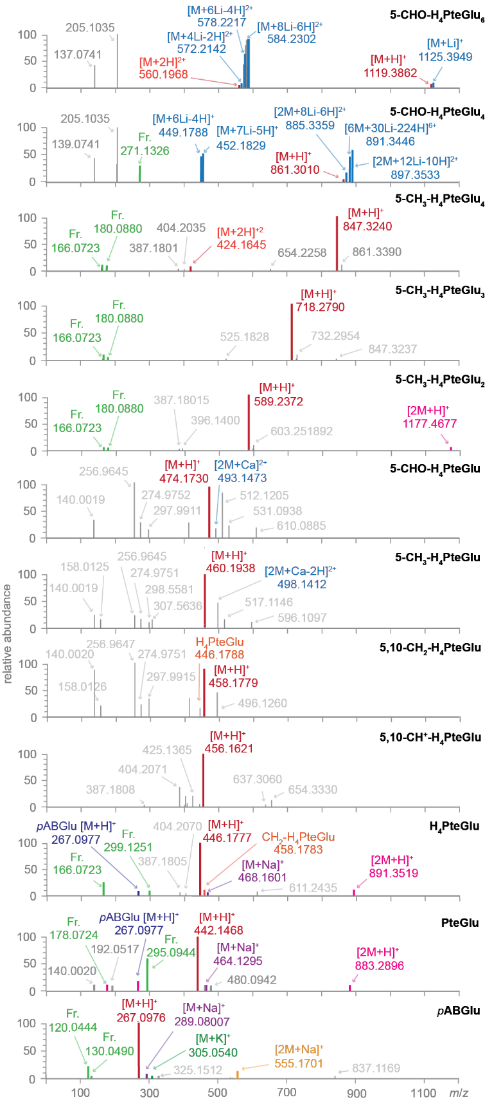
Figure S1. Direct infusion mass spectrometry of folate standards in acidic eluents. Mass spectra were collected in full scan positive ion mode. Precursor ion peaks are denoted in red, cationic adducts in blue, interconversion and degradation products in purple, dimer ions in pink, fragment ions in green, and unidentified peaks in grey.
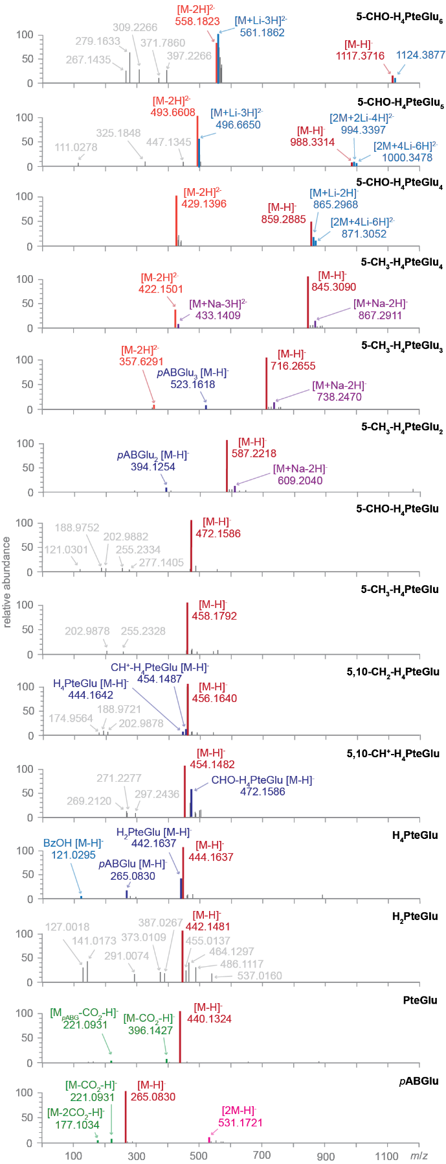
Figure S2. Direct infusion mass spectrometry of folate standards in basic eluents. Mass spectra were collected in full scan negative ion mode. Precursor ion peaks are denoted in red, cationic adducts in blue, interconversion and degradation products in purple, dimer ions in pink, fragment ions in green, and unidentified peaks in grey.
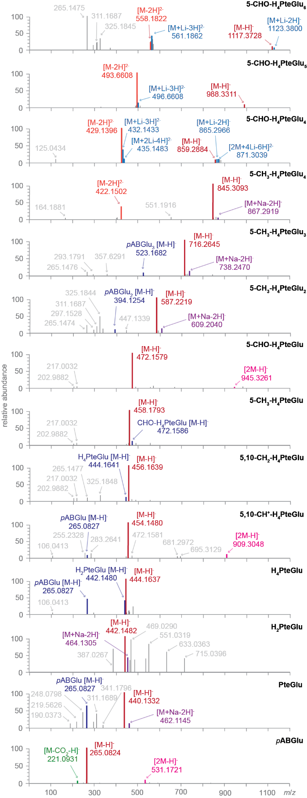
Figure S3. Direct infusion mass spectrometry of folate standards in acidic eluents. Mass spectra were collected in full scan negative ion mode. Precursor ion peaks are denoted in red, cationic adducts in blue, interconversion and degradation products in purple, dimer ions in pink, fragment ions in green, and unidentified peaks in grey.
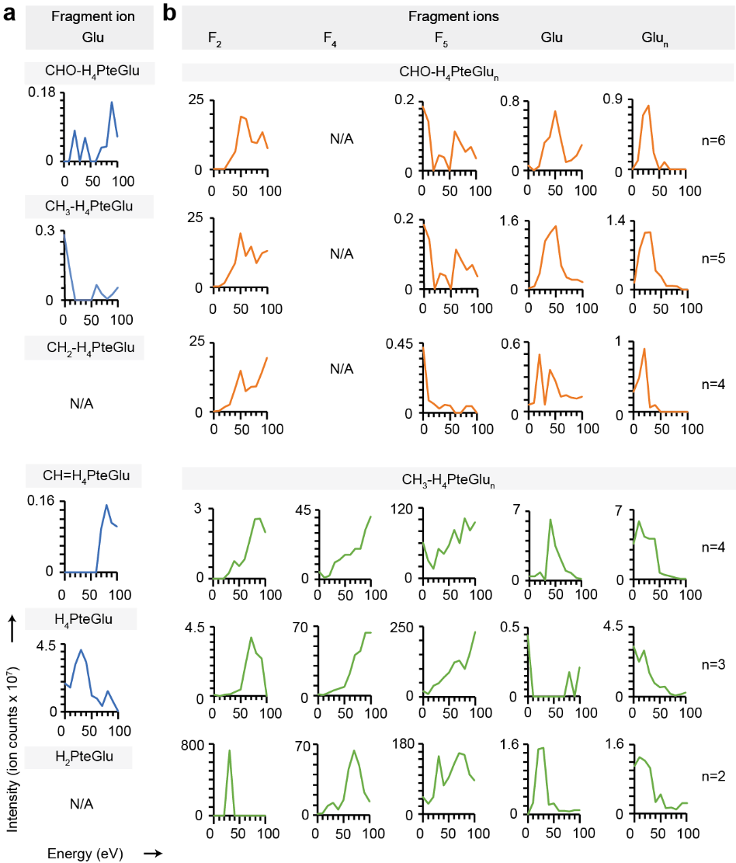
Figure S4. Fragmentation products from in-source CID of folate polyglutamates. (a) Glutamate was observed as a fragmentation product from in-source CID of folate monoglutamates. (b) Glutamate and polyglutamate as well as fragments F₂, F₃, and F₄ were observed from in-source CID of folate polyglutamates.
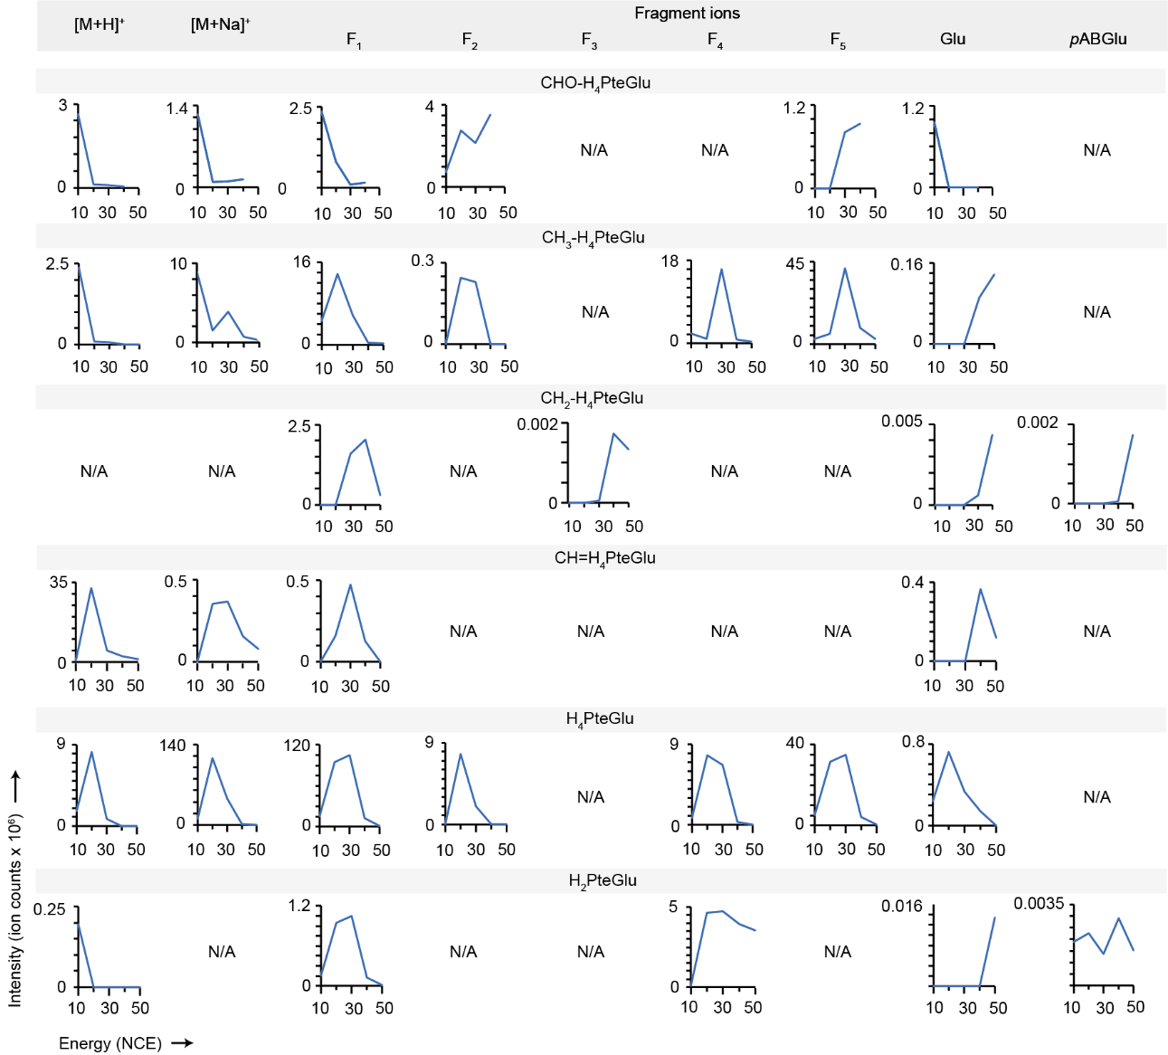
Figure S5. Fragmentation products from AIF of folate monoglutamates on MS2. Fragments F₁ through F₅ as well as glutamate and pABGlu were formed. F₃ was unique to CH₂-THF.

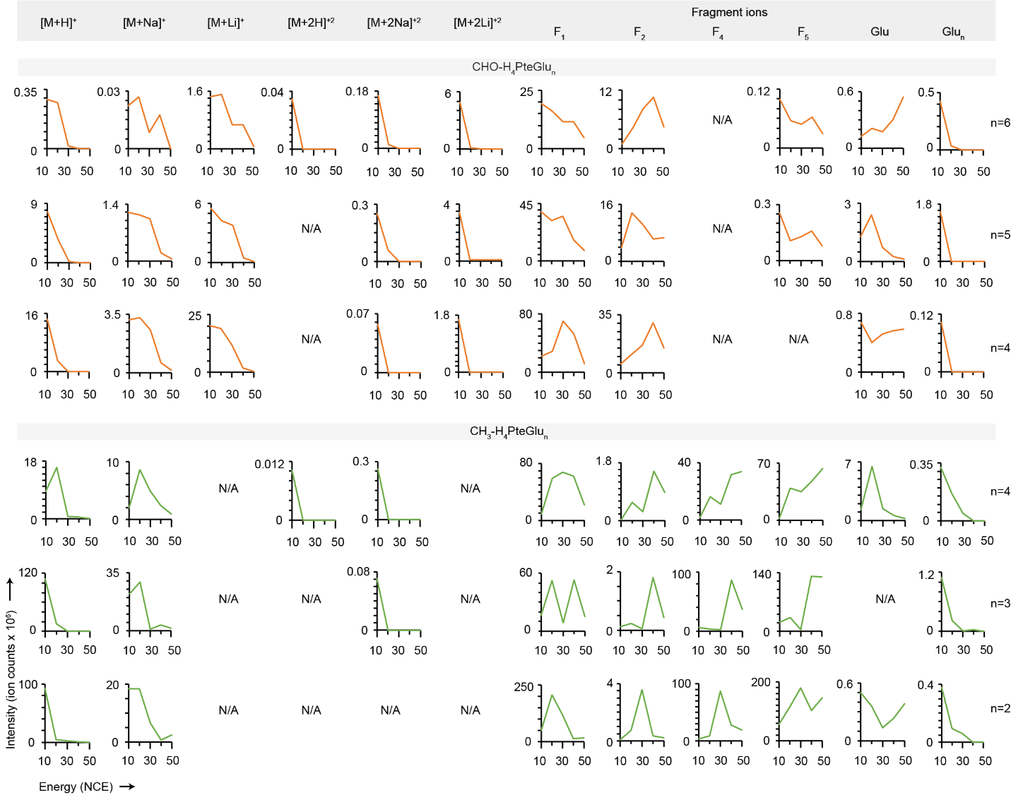
Figure S6. Fragmentation products from AIF of folate polyglutamates on MS2. Fragments F₁, F₂, F₄, and F₅ as well as glutamate and polyglutamates were formed.
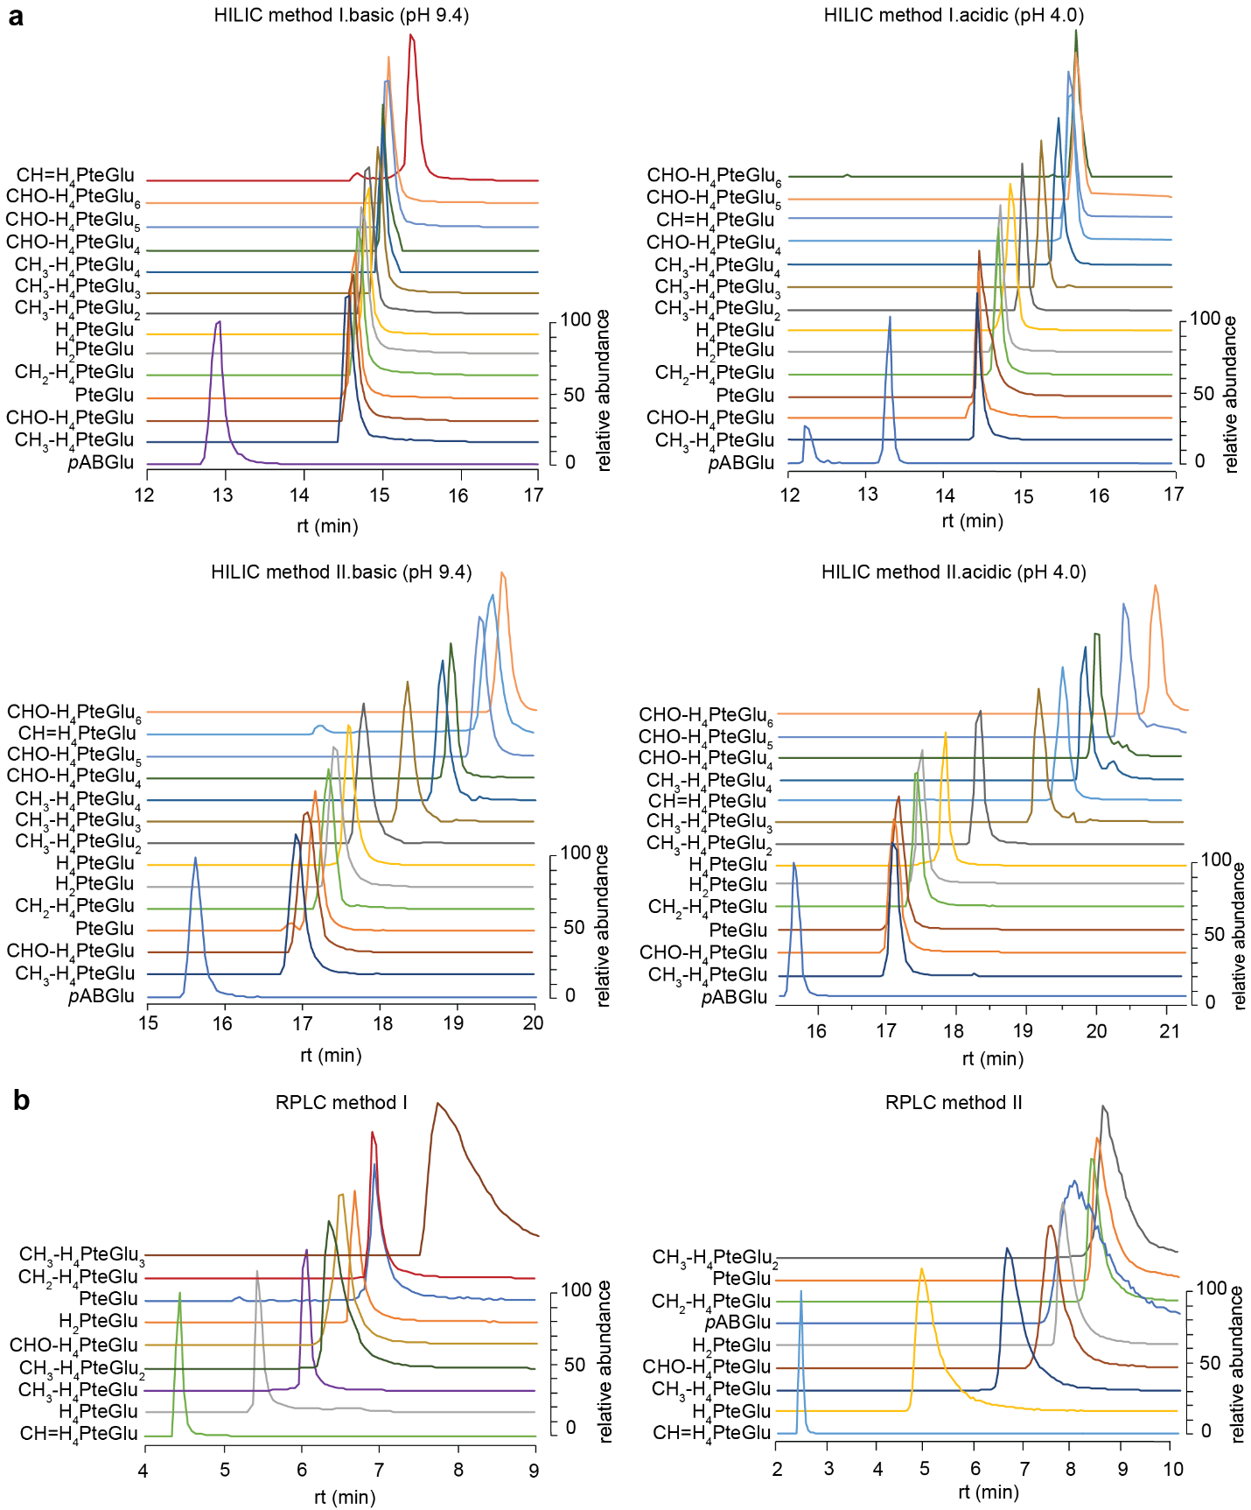
Figure S7. LC separation of folate standards. Extracted ion chromatograms (EICs) of folate standards were obtained from (a) HILIC or (b) RPLC coupled to MS operating in positive ion mode.
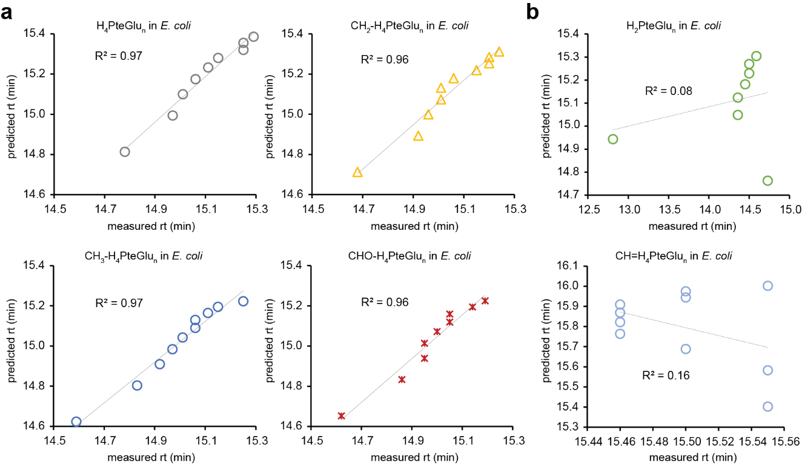
Figure S8. Predicted versus observed retention times of folates in HILIC. (a) The retention times of folate polyglutamates from E. coli in HILIC (method I basic) were measured and compared to predictions. (b) For CH=H₄PteGlu and H₂PteGlu, the lengths of polyglutamate tails did not alter retention times unlike other folate species, resulting in poor prediction of their retention times.
Supplementary Tables
Table S1. Previously studies on LC-MS-based determination of folates.
no. | detected folate derivatives | sample | LC mode | Ionization | MS analyzer | MS monitoring | ref.
Methods detected folate polyglutamates as is
1 | PteGlu  H₄PteGlu  CH=H₄PteGlu  5-CH₃-H₄PteGlu₁₋₉  10-CHO-H₄PteGlu | Saccharomyces cerevisiae | RPLC | ESI (+) | QToF | DDA | [10]
2 | H₂PteGlu₁₋₅  H₄PteGlu₁₋₅  CH=H₄PteGlu₁₋₅  CH₂-H₄PteGlu₁₋₅  5-CH₃-H₄PteGlu₁₋₅  10-CHO-H₄PteGlu₁₋₅ | Escherichia coli MG1655 | RPLC | ESI (-) | (Q)-Orbitrap | Full scan | [11]
3 | PteGlu₁₋₆  H₄PteGlu₁₋₆  CH=H₄PteGlu₁₋₆  CH₂-H₄PteGlu₁₋₆  5-CH₃-H₄PteGlu₁₋₆  5-CHO-H₄PteGlu₁₋₆ | Human liver cancer cell line (HepG2) | HILIC | ESI (+) | QqQ-LIT | MRM | [3]
4 | PteGlu₁₋₆  H₄PteGlu₁₋₆  CH=H₄PteGlu₁₋₆  CH₂-H₄PteGlu₁₋₆  5-CH₃-H₄PteGlu₁₋₆  5-CHO-H₄PteGlu₁₋₆ | E. coli K12 | HILIC | ESI (+) | QIT | MRM | [3]
5 | PteGlu  H₄PteGlu  CH=H₄PteGlu  5-CH₃-H₄PteGlu₁₋₆  5/10-CHO-H₄PteGlu | Beans | RPLC | ESI (+) | QqQ | MRM | [12]
6 | PteGlu  H₄PteGlu  5-CH₃-H₄PteGlu₁₋₅  5/10-CHO-H₄PteGlu | Bifidobacterium adolescentis | RPLC | ESI (+) | QqQ | MRM | [13]
7 | PteGlu₁₋₇  H₄PteGlu₁₋₁₁  CH=H₄PteGlu  5-CH₃-H₄PteGlu₁₋₁₁  5-CHO-H₄PteGlu₁₋₁₁ | Erythrocytes | RPLC | ESI (+) | QqQ | SIM | [8]
8 | 5-CH₃-H₄PteGlu₁₋₈ | Vegetables | RPLC | ESI (+) | QqQ | SRM | [14]
9 | pABGlu₁₋₅  PteGlu₁₋₅  H₂PteGlu₁₋₅  H₄PteGlu₁₋₅  CH=H₄PteGlu₁₋₅  CH₂-H₄PteGlu₁₋₅  5-CH₃-H₄PteGlu₁₋₆  5/10-CHO-H₄PteGlu₁₋₅ | E. coli K12 NCM3722 | HILIC | ESI (+)/(-) | QqQ | MRM | [1, 2]
10 | pABGlu₂  5-CH₃-H₄PteGlu₁₋₇  5/10-CHO-H₄PteGlu₁₋₂ | S. cerevisiae | HILIC | ESI (+)/(-) | QqQ | MRM | [1, 2]
11 | PteGlu₁₋₈  H₂PteGlu₁₋₈  H₄PteGlu₁₋₈  CH=H₄PteGlu₁₋₈  5-CH₃-H₄PteGlu₁₋₈  5/10-CHO-H₄PteGlu₁₋₈ | Plant and animal tissue | RPLC | ESI (-) | QqQ | MRM | [9]
12 | PteGlu₁₋₇  H₂PteGlu₁₋₇  H₄PteGlu₁₋₇  CH=H₄PteGlu  CH₂-H₄PteGlu₁₋₇  5-CH₃-H₄PteGlu₁₋₇  5-CHO-H₄PteGlu | E. coli OP50  E. coli HT1115  Lymphocytes  Human/mouse fibroblast  Mouse embryo | RPLC | ESI (-) | QqQ | MRM | [15]
Methods detected folate polyglutamates after cleavage
13 | H₂PteGlu  H₄PteGlu  CH=H₄PteGlu  CH₂-H₄PteGlu  5-CH₃-H₄PteGlu  10-CHO-H₄PteGlu | Human kidney cell line (293T)  Human colon cancer cell line (HCT116)  Human pancreas cancer cell line (8988T)  Human liver cancer cell line (HepG2) | RPLC | ESI-(+)/(-) | (Q)-Orbitrap | Full scan | [16]
Methods for folate monoglutamates
14 | PteGlu  H₂PteGlu  H₄PteGlu  CH=H₄PteGlu  CH₂-H₄PteGlu  5-CH₃-H₄PteGlu  5-CHO-H₄PteGlu | Caenorhabditis  elegans | RPLC | ESI/APCI-(+) | QqQ |  | [17]
15 | PteGlu  H₂PteGlu  H₄PteGlu  CH=H₄PteGlu  CH₂-H₄PteGlu  5-CH₃-H₄PteGlu  5-CHO-H₄PteGlu | Pulse seed | RPLC | ESI-(+) | QqQ | SRM | [18]
16 | PteGlu  H₄PteGlu  CH=H₄PteGlu  CH₂-H₄PteGlu  5-CH₃-H₄PteGlu  5-CHO-H₄PteGlu | Tissue  Blood  Plasma | RPLC | ESI-(+) | QqQ | MRM | [19]
17 | PteGlu  5-CH₃-H₄PteGlu | Plasma | RPLC | ESI | QqQ | MRM | [20]
18 | PteGlu  H₄PteGlu  5-CH₃-H₄PteGlu  5-CHO-H₄PteGlu | Vegetables  Meat  Cereals | RPLC | ESI-(+) | IT | SRM | [21]
Abbreviations: RPLC, reversed phase liquid chromatography; HILIC, hydrophilic interactions liquid chromatography; ESI, electrospray ionization; QqQ, triple quadrupole; QIT, quadrupole ion trap; IT, ion trap; TOF, time of flight; DDA, data independent acquisition; MRM, multiple reaction monitoring; SRM, single reaction monitoring. pABGlu for p-aminobenzoyl-glutamate, PteGlu for pteroylglutamate (folate); H₄PteGlu for tetrahydropteroylglutamate (tetrahydrofolate); H₂PteGlu for dihydropteroylglutamate (dihydrofolate), 5/10-CHO-H₄PteGlu for formyl-tetrahydropteroylglutamate, 5,10-CH=H₄PteGlu for methenyl-tetrahydropteroylglutamate, 5,10-CH₂-H₄PteGlu for methylene-tetrahydropteroylglutamate, 5-CH₃-H₄PteGlu for methyl-tetrahydropteroylglutamate.
Table S2. Authenticated folate standards used in the present study.
compounds name | formula (as supplied) | molecular weight (as supplied) | purity (%) | abbreviation
7,8-dihydrofolic acid | C₁₉H₂₁N₇O₆ | 443.4 | 93.0 | H₂PteGlu
(6S)-5,6,7,8-tetrahydrofolic acid | C₁₉H₂₃N₇O₆ | 445.4 | 98.0 | H₄PteGlu
(6R, S)-5,10-methenyl-5,6,7,8-tetrahydrofolic acid chloride | C₂₀H₂₂N₇O₆(Cl) | 491.9 | 97.2 | 5,10-CH=H₄PteGlu
(6R, S)-5,10-methylene-5,6,7,8-tetrahydrofolic acid, calcium salt | C₂₀H₂₃N₇O₆(Ca) | 495.5 | 95.1 | 5,10-CH₂-H₄PteGlu
(6R, S)-5-methyl-5,6,7,8-tetrahydrofolic acid, calcium salt | C₂₀H₂₃N₇O₆•4H₂O(Ca) | 497.5 | 98.4 | 5-CH₃-H₄PteGlu
(6S)-5-formyl-5,6,7,8-tetrahydrofolic acid, calcium salt | C₂₀H₂₁N₇O₇(Ca) | 511.5 | 99.6 | 5-CHO-H₄PteGlu
(6R, S)-5-methyl-5,6,7,8-tetrahydropteroyldi-γ-L-glutamic acid trihydrochloride | C₂₅H₃₂N₈O₉•3HCl | 698 | 93.8 | 5-CH₃-H₄PteGlu₂
(6R, S)-5-methyl-5,6,7,8-tetrahydropteroyltri-γ-L-glutamic acid trihydrochloride | C₃₀H₃₉N₉O₁₂•3HCl | 827.1 | 93.0 | 5-CH₃-H₄PteGlu₃
(6R, S)-5-methyl-5,6,7,8-tetrahydropteroyltetra-γ-L-glutamic acid trihydrochloride | C₃₅H₄₆N₁₀O₁₅•3HCl | 956.2 | 90.1 | 5-CH₃-H₄PteGlu₄
(6R, S)-5-formyl-5,6,7,8-tetrahydropteroyltetra-γ-L-glutamic acid, lithium salt | C₃₅H₃₉N₁₀O₁₆(Li)₅ | 890.5 | 95.7 | 5-CHO-H₄PteGlu₄
(6R, S)-5-formyl-5,6,7,8-tetrahydropteroylpenta-γ-L-glutamic acid, lithium salt | C₄₀H₄₅N₁₁O₁₆(Li)₆ | 1025.5 | 97.7 | 5-CHO-H₄PteGlu₅
(6R, S)-5-formyl-5,6,7,8-tetrahydropteroylhexa-γ-L-glutamic acid, lithium salt | C₄₅H₅₁N₁₂O₂₂(Li)₇ | 1160.6 | 98.8 | 5-CHO-H₄PteGlu₆

Table S3. Chemical formulae for folate polyglutamates
compound | abbreviation | formula
glutamate | Glu | C₅H₉NO₄
diglutamate | Glu₂ | C₁₀H₁₆N₂O₇
triglutamate | Glu₃ | C₁₅H₂₃N₃O₁₀
tetraglutamate | Glu₄ | C₂₀H₃₀N₄O₁₃
pentaglutamate | Glu₅ | C₂₅H₃₇N₅O₁₆
hexaglutamate | Glu₆ | C₃₀H₄₄N₆O₁₉
heptaglutamate | Glu₇ | C₃₅H₅₁N₇O₂₂
octaglutamate | Glu₈ | C₄₀H₅₈N₈O₂₅
nonaglutamate | Glu₉ | C₄₅H₆₅N₉O₂₈
decaglutamate | Glu₁₀ | C₅₀H₇₂N₁₀O₃₁
para-aminobenzoylglutamate | pABGlu | C₁₂H₁₄N₂O₅
para-aminobenzoyldiglutamate | pABGlu₂ | C₁₇H₂₁N₃O₈
para-aminobenzoyltriglutamate | pABGlu₃ | C₂₂H₂₈N₄O₁₁
para-aminobenzoyltetraglutamate | pABGlu₄ | C₂₇H₃₅N₅O₁₄
para-aminobenzoylpentadiglutamate | pABGlu₅ | C₃₂H₄₂N₆O₁₇
para-aminobenzoylhexaglutamate | pABGlu₆ | C₃₇H₄₉N₇O₂₀
para-aminobenzoylheptaglutamate | pABGlu₇ | C₄₂H₅₆N₈O₂₃
para-aminobenzoyloctaglutamate | pABGlu₈ | C₄₇H₆₃N₉O₂₆
para-aminobenzoylnonaglutamate | pABGlu₉ | C₅₂H₇₀N₁₀O₂₉
para-aminobenzoyldecaglutamate | pABGlu₁₀ | C₅₇H₇₇N₁₁O₃₂
pteroylglutamate | PteGlu | C₁₉H₁₉N₇O₆
pteroyldiglutamate | PteGlu₂ | C₂₄H₂₆N₈O₉
pteroyltriglutamate | PteGlu₃ | C₂₉H₃₃N₉O₁₂
pteroyltetraglutamate | PteGlu₄ | C₃₄H₄₀N₁₀O₁₅
pteroylpentaglutamate | PteGlu₅ | C₃₉H₄₇N₁₁O₁₈
pteroylhexaglutamate | PteGlu₆ | C₄₄H₅₄N₁₂O₂₁
pteroylheptaglutamate | PteGlu₇ | C₄₉H₆₁N₁₃O₂₄
pteroyloctaglutamate | PteGlu₈ | C₅₄H₆₈N₁₄O₂₇
pteroylnonaglutamate | PteGlu₉ | C₅₉H₇₅N₁₅O₃₀
pteroyldecaglutamate | PteGlu₁₀ | C₆₄H₈₂N₁₆O₃₃
dihydropteroylglutamate | H₂PteGlu | C₁₉H₂₁N₇O₆
dihydropteroyldiglutamate | H₂PteGlu₂ | C₂₄H₂₈N₈O₉
dihydropteroyltriglutamate | H₂PteGlu₃ | C₂₉H₃₅N₉O₁₂
dihydropteroyltetraglutamate | H₂PteGlu₄ | C₃₄H₄₂N₁₀O₁₅
dihydropteroylpentaglutamate | H₂PteGlu₅ | C₃₉H₄₉N₁₁O₁₈
dihydropteroylhexaglutamate | H₂PteGlu₆ | C₄₄H₅₆N₁₂O₂₁
dihydropteroylheptaglutamate | H₂PteGlu₇ | C₄₉H₆₃N₁₃O₂₄
dihydropteroyloctaglutamate | H₂PteGlu₈ | C₅₄H₇₀N₁₄O₂₇
dihydropteroylnonaglutamate | H₂PteGlu₉ | C₅₉H₇₇N₁₅O₃₀
dihydropteroyldecaglutamate | H₂PteGlu₁₀ | C₆₄H₈₄N₁₆O₃₃
tetrahydropteroylglutamate | H₄PteGlu | C₁₉H₂₃N₇O₆
tetrahydropteroyldiglutamate | H₄PteGlu₂ | C₂₄H₃₀N₈O₉
tetrahydropteroyltriglutamate | H₄PteGlu₃ | C₂₉H₃₇N₉O₁₂
tetrahydropteroyltetraglutamate | H₄PteGlu₄ | C₃₄H₄₄N₁₀O₁₅
tetrahydropteroylpentaglutamate | H₄PteGlu₅ | C₃₉H₅₁N₁₁O₁₈
tetrahydropteroylhexaglutamate | H₄PteGlu₆ | C₄₄H₅₈N₁₂O₂₁
tetrahydropteroylheptaglutamate | H₄PteGlu₇ | C₄₉H₆₅N₁₃O₂₄
tetrahydropteroyloctaglutamate | H₄PteGlu₈ | C₅₄H₇₂N₁₄O₂₇
tetrahydropteroylnonaglutamate | H₄PteGlu₉ | C₅₉H₇₉N₁₅O₃₀
tetrahydropteroyldecaglutamate | H₄PteGlu₁₀ | C₆₄H₈₆N₁₆O₃₃
methenyltetrahydropteroylglutamate | CH=H₄PteGlu | C₂₀H₂₁N₇O₆
methenyltetrahydropteroyldiglutamate | CH=H₄PteGlu₂ | C₂₅H₂₈N₈O₉
methenyltetrahydropteroyltriglutamate | CH=H₄PteGlu₃ | C₃₀H₃₅N₉O₁₂
methenyltetrahydropteroyltetraglutamate | CH=H₄PteGlu₄ | C₃₅H₄₂N₁₀O₁₅
methenyltetrahydropteroylpentaglutamate | CH=H₄PteGlu₅ | C₄₀H₄₉N₁₁O₁₈
methenyltetrahydropteroylhexaglutamate | CH=H₄PteGlu₆ | C₄₅H₅₆N₁₂O₂₁
methenyltetrahydropteroylheptaglutamate | CH=H₄PteGlu₇ | C₅₀H₆₃N₁₃O₂₄
methenyltetrahydropteroyloctaglutamate | CH=H₄PteGlu₈ | C₅₅H₇₀N₁₄O₂₇
methenyltetrahydropteroylnonaglutamate | CH=H₄PteGlu₉ | C₆₀H₇₇N₁₅O₃₀
methenyltetrahydropteroyldecaglutamate | CH=H₄PteGlu₁₀ | C₆₅H₈₄N₁₆O₃₃
methylenetetrahydropteroylglutamate | CH₂-H₄PteGlu | C₂₀H₂₃N₇O₆
methylenetetrahydropteroyldiglutamate | CH₂-H₄PteGlu₂ | C₂₅H₃₀N₈O₉
methylenetetrahydropteroyltriglutamate | CH₂-H₄PteGlu₃ | C₃₀H₃₇N₉O₁₂
methylenetetrahydropteroyltetraglutamate | CH₂-H₄PteGlu₄ | C₃₅H₄₄N₁₀O₁₅
methylenetetrahydropteroylpentaglutamate | CH₂-H₄PteGlu₅ | C₄₀H₅₁N₁₁O₁₈
methylenetetrahydropteroylhexaglutamate | CH₂-H₄PteGlu₆ | C₄₅H₅₈N₁₂O₂₁
methylenetetrahydropteroylheptaglutamate | CH₂-H₄PteGlu₇ | C₅₀H₆₅N₁₃O₂₄
methylenetetrahydropteroyloctaglutamate | CH₂-H₄PteGlu₈ | C₅₅H₇₂N₁₄O₂₇
methylenetetrahydropteroylnonaglutamate | CH₂-H₄PteGlu₉ | C₆₀H₇₉N₁₅O₃₀
methylenetetrahydropteroyldecaglutamate | CH₂-H₄PteGlu₁₀ | C₆₅H₈₆N₁₆O₃₃
methyltetrahydropteroylglutamate | CH₃-H₄PteGlu | C₂₀H₂₅N₇O₆
methyltetrahydropteroyldiglutamate | CH₃-H₄PteGlu₂ | C₂₅H₃₂N₈O₉
methyltetrahydropteroyltriglutamate | CH₃-H₄PteGlu₃ | C₃₀H₃₉N₉O₁₂
methyltetrahydropteroyltetraglutamate | CH₃-H₄PteGlu₄ | C₃₅H₄₆N₁₀O₁₅
methyltetrahydropteroylpentaglutamate | CH₃-H₄PteGlu₅ | C₄₀H₅₃N₁₁O₁₈
methyltetrahydropteroylhexaglutamate | CH₃-H₄PteGlu₆ | C₄₅H₆₀N₁₂O₂₁
methyltetrahydropteroylheptaglutamate | CH₃-H₄PteGlu₇ | C₅₀H₆₇N₁₃O₂₄
methyltetrahydropteroyloctaglutamate | CH₃-H₄PteGlu₈ | C₅₅H₇₄N₁₄O₂₇
methyltetrahydropteroylnonaglutamate | CH₃-H₄PteGlu₉ | C₆₀H₈₁N₁₅O₃₀
methyltetrahydropteroyldecaglutamate | CH₃-H₄PteGlu₁₀ | C₆₅H₈₈N₁₆O₃₃
formyltetrahydropteroylglutamate | CHO-H₄PteGlu | C₂₀H₂₃N₇O₇
formyltetrahydropteroyldiglutamate | CHO-H₄PteGlu₂ | C₂₅H₃₀N₈O₁₀
formyltetrahydropteroyltriglutamate | CHO-H₄PteGlu₃ | C₃₀H₃₇N₉O₁₃
formyltetrahydropteroyltetraglutamate | CHO-H₄PteGlu₄ | C₃₅H₄₄N₁₀O₁₆
formyltetrahydropteroylpentaglutamate | CHO-H₄PteGlu₅ | C₄₀H₅₁N₁₁O₁₉
formyltetrahydropteroylhexaglutamate | CHO-H₄PteGlu₆ | C₄₅H₅₈N₁₂O₂₂
formyltetrahydropteroylheptaglutamate | CHO-H₄PteGlu₇ | C₅₀H₆₅N₁₃O₂₅
formyltetrahydropteroyloctaglutamate | CHO-H₄PteGlu₈ | C₅₅H₇₂N₁₄O₂₈
formyltetrahydropteroylnonaglutamate | CHO-H₄PteGlu₉ | C₆₀H₇₉N₁₅O₃₁
formyltetrahydropteroyldecaglutamate | CHO-H₄PteGlu₁₀ | C₆₅H₈₆N₁₆O₃₄
¹pteroylglutamate, folate; dihydropteroylglutamate, dihydrofolate; tetrahydropteroylglutamate, tetrahydrofolate; methenyltetrahydropteroylglutamate, methenyltetrahydrofolate; methylenetetrahydropteroylglutamate, methylenetetrahydrofolate; methyltetrahydropteroylglutamate, methyltetrahydrofolate; formyltetrahydropteroylglutamate, formyltetrahydrofolate
Table S4. Response factors of folate polyglutamates (100 uM concentration) obtained by direct injection of standard compounds diluted in basic A in positive mode.
Analyte | C (uM) | m/z | Intensity ª | Response factor (Intensity/C) | Intensity relative to the respective monoglutamate form
Positive ion mode
CH₃-H₄PteGlu | 100 | 460.1933 | 6.E+06 | 6.E+04 | 1.00
CH₃-H₄PteGlu₂ | 100 | 589.2349 | 1.E+07 | 1.E+05 | 1.80
CH₃-H₄PteGlu₃ | 100 | 718.2790 | 6.E+06 | 6.E+04 | 0.90
CH₃-H₄PteGlu₄ | 100 | 847.3208 | 9.E+05 | 9.E+03 | 0.14
CHO-H₄PteGlu | 100 | 474.1720 | 5.E+06 | 5.E+04 | 1.00
CHO-H₄PteGlu₄ | 100 | 861.3014 | 2.E+06 | 2.E+04 | 0.38
CHO-H₄PteGlu₅ | 100 | 990.3404 | 9.E+05 | 9.E+03 | 0.20
CHO-H₄PteGlu₆ | 100 | 1119.3861 | 3.E+05 | 3.E+03 | 0.06
Negative ion mode
CH₃-H₄PteGlu | 100 | 458.1796 | 1.08E+07 | 1.E+05 | 1.00
CH₃-H₄PteGlu₂ | 100 | 587.2221 | 2.72E+06 | 3.E+04 | 0.25
CH₃-H₄PteGlu₃ | 100 | 716.2657 | 1.72E+06 | 2.E+04 | 0.16
CH₃-H₄PteGlu₄ | 100 | 845.3093 | 3.95E+05 | 4.E+03 | 0.04
CHO-H₄PteGlu | 100 | 472.1583 | 4.56E+06 | 5.E+04 | 1.00
CHO-H₄PteGlu₄ | 100 | 859.2887 | 6.08E+06 | 6.E+04 | 1.33
CHO-H₄PteGlu₅ | 100 | 988.3318 | 1.39E+06 | 1.E+04 | 0.31
CHO-H₄PteGlu₆ | 100 | 1117.3737 | 2.95E+05 | 3.E+03 | 0.06
ª intensity represents the average of triplicates
Table S5. Fragment ions of folate species formed during in-source fragmentation as well as in-source CID and AIF MS2 analysis in positive ion mode. Fragment ions F₁ through F₅ correspond to the structures illustrated in Fig. 4A.
Compound | m/z
Compound | F₁ | F₂ | F₃ | F₄ | F₅
H₂PteGlu | 297.1094 | 269.1145 | 193.0832 | 178.0723 | 164.0567
H₄PteGlu | 299.1251 | 271.1302 | 195.0989 | 180.0880 | 166.0723
CH=H₄PteGlu | 309.1095 | 295.1302 | 205.0832 | N/A | N/A
CH₂-H₄PteGlu | 311.1251 | 297.1458 | 207.0989 | N/A | N/A
CH₃-H₄PteGlu | 313.1408 | 285.1458 | 209.1145 | 194.1036 | 180.0880
5-CHO-H₄PteGlu | 327.1200 | 299.1251 | 223.0938 | 208.0829 | 194.0673
10-CHO-H₄PteGlu | 327.1200 | 299.1251 | 195.0989 | 180.0880 | 166.0723

Table S6. LC retention times of folate standards.
Compound | rt (min)
Compound | HILIC method I.acidic | HILIC method I.basic | HILIC method II.acidic | HILIC method II.basic | RPLC method I | RPLC method II
pABGlu | 13.34 | 12.93 | 15.67 | 15.6 | N/A ª | 8.40
PteGlu | 14.47 | 14.65 | 17.1 | 17.17 | 6.92 | 8.87
H₂PteGlu | 14.74 | 14.73 | 17.5 | 17.42 | 6.67 | 8.13
H₄PteGlu | 14.88 | 14.78 | 17.83 | 17.58 | 5.42 | 5.20
5,10-CH=H₄PteGlu | 15.68 | 15.37 | 19.52 | 19.47 | 4.43 | 2.64
5,10-CH₂-H₄PteGlu | 14.71 | 14.68 | 17.45 | 17.33 | 6.89 | 8.73
5-CH₃-H₄PteGlu | 14.44 | 14.59 | 17.08 | 16.91 | 6.05 | 6.96
5-CHO-H₄PteGlu | 14.46 | 14.62 | 17.17 | 17.05 | 6.53 | 7.91
5-CH₃-H₄PteGlu₂ | 15.03 | 14.83 | 18.33 | 17.78 | 6.35 | 8.95
5-CH₃-H₄PteGlu₃ | 15.28 | 14.94 | 19.17 | 18.36 | 7.75 | N/A ^{b}
5-CH₃-H₄PteGlu₄ | 15.49 | 15.00 | 19.84 | 18.81 | N/A ^{b} | N/A ^{b}
5-CHO-H₄PteGlu₄ | 15.56 | 15.05 | 20.09 | 18.93 | N/A ^{b} | N/A ^{b}
5-CHO-H₄PteGlu₅ | 15.62 | 15.08 | 20.38 | 19.3 | N/A ^{b} | N/A ^{b}
5-CHO-H₄PteGlu₆ | 15.72 | 15.07 | 20.83 | 19.59 | N/A ^{b} | N/A ^{b}
ª Not tested. ^{b} Tested but no peak observed.
Table S7. LC peak resolution (Rs)
Analyte  (in elution order) | rt (min) | h_{max}  (intensity) | h_{0.5}  (intensity) | t_{start} @ h_{0.5} (min) | t_{end} @ h_{0.5} (min) | W_{0.5} (min) | Rs-adjacent band pairs |  | critical redox pairs | Rs
HILIC method I.basic
CH₃-H₄PteGlu | 14.59 | 9.88E+08 | 4.94E+08 | 14.54 | 14.64 | 0.10 | 0.17 |  | PteGlu | 0.43
CHO-H₄PteGlu | 14.62 | 6.42E+08 | 3.21E+08 | 14.57 | 14.68 | 0.11 | 0.17 |  | H₂PteGlu | 0.43
PteGlu | 14.65 | 1.99E+08 | 9.93E+07 | 14.60 | 14.70 | 0.10 | 0.24
CH₂-H₄PteGlu | 14.68 | 3.85E+08 | 1.93E+08 | 14.68 | 14.73 | 0.05 | 0.35 |  | H₂PteGlu | 0.27
H₂PteGlu | 14.73 | 2.56E+08 | 1.28E+08 | 14.68 | 14.80 | 0.12 | 0.27 |  | H₄PteGlu | 0.27
H₄PteGlu | 14.78 | 1.82E+08 | 9.11E+07 | 14.76 | 14.86 | 0.10 | 0.30
CH₃-H₄PteGlu₂ | 14.83 | 9.49E+08 | 4.75E+08 | 14.78 | 14.88 | 0.10 | 0.62 |  | CH₂-H₄PteGlu | -4.29
CH₃-H₄PteGlu₃ | 14.94 | 9.27E+08 | 4.63E+08 | 14.9 | 15.01 | 0.11 | 0.32 |  | CH=H₄PteGlu | -4.29
CH₃-H₄PteGlu₄ | 15.00 | 8.45E+08 | 4.22E+08 | 14.95 | 15.06 | 0.11 | 0.37
CHO-H₄PteGlu₄ | 15.05 | 2.55E+08 | 1.27E+08 | 15.14 | 15.19 | 0.05 | 0.21 |  | CH₃-H₄PteGlu | -0.71
CHO-H₄PteGlu₅ | 15.08 | 4.08E+08 | 2.04E+08 | 15.02 | 15.14 | 0.12 | -0.05 |  | CH₂-H₄PteGlu | -0.71
CHO-H₄PteGlu₆ | 15.07 | 3.36E+08 | 1.68E+08 | 15.04 | 15.15 | 0.11 | 1.42
CH=H₄PteGlu | 15.37 | 6.57E+08 | 3.28E+08 | 15.34 | 15.48 | 0.14
HILIC method II.basic
CH₃-H₄PteGlu | 16.91 | 1.21E+09 | 6.07E+08 | 16.85 | 17.01 | 0.16 | 0.45 |  | PteGlu | 1.13
CHO-H₄PteGlu | 17.05 | 6.57E+08 | 3.29E+08 | 16.95 | 17.16 | 0.21 | 0.44 |  | H₂PteGlu | 1.13
PteGlu | 17.17 | 2.97E+08 | 1.48E+08 | 17.12 | 17.23 | 0.11 | 0.79
CH₂-H₄PteGlu | 17.33 | 5.43E+08 | 2.71E+08 | 17.27 | 17.4 | 0.13 | 0.38 |  | H₂PteGlu | 0.61
H₂PteGlu | 17.42 | 3.27E+08 | 1.63E+08 | 17.35 | 17.50 | 0.15 | 0.61 |  | H₄PteGlu | 0.61
H₄PteGlu | 17.58 | 4.70E+08 | 2.35E+08 | 17.5 | 17.66 | 0.16 | 0.84
CH₃-H₄PteGlu₂ | 17.78 | 1.28E+09 | 6.38E+08 | 17.72 | 17.84 | 0.12 | 0.31 |  | CH₂-H₄PteGlu | -9.02
CH₃-H₄PteGlu₃ | 18.36 | 1.31E+09 | 6.55E+08 | 16.3 | 18.41 | 2.11 | 0.24 |  | CH=H₄PteGlu | -9.02
CH₃-H₄PteGlu₄ | 18.81 | 1.11E+09 | 5.57E+08 | 18.76 | 18.87 | 0.11 | 0.46
CHO-H₄PteGlu₄ | 18.93 | 7.93E+04 | 3.97E+04 | 19.82 | 19.02 | 0.20 | 1.25 |  | CH₃-H₄PteGlu | -1.71
CHO-H₄PteGlu₅ | 19.30 | 4.54E+08 | 2.27E+08 | 19.25 | 19.40 | 0.15 | 1.10 |  | CH₂-H₄PteGlu | -1.71
CHO-H₄PteGlu₆ | 19.59 | 4.04E+08 | 2.02E+08 | 19.53 | 19.69 | 0.16
CH=H₄PteGlu | 19.47 | 6.54E+08 | 3.27E+08 | 19.35 | 19.5 | 0.15
HILIC method I.acidic
CH₃-H₄PteGlu | 14.44 | 2.66E+08 | 1.33E+08 | 14.43 | 14.49 | 0.06 | 0.12 |  | PteGlu | 2.28
CHO-H₄PteGlu | 14.46 | 5.27E+07 | 2.63E+07 | 14.45 | 14.59 | 0.14 | 0.07 |  | H₂PteGlu | 2.28
PteGlu | 14.47 | 7.95E+07 | 3.98E+07 | 14.43 | 14.47 | 0.04 | 2.18
CH₂-H₄PteGlu | 14.71 | 9.94E+07 | 4.97E+07 | 14.66 | 14.75 | 0.09 | 0.19 |  | H₂PteGlu | 0.92
H₂PteGlu | 14.74 | 9.13E+07 | 4.56E+07 | 14.69 | 14.79 | 0.10 | 0.92 |  | H₄PteGlu | 0.92
H₄PteGlu | 14.88 | 3.56E+07 | 1.78E+07 | 14.87 | 14.95 | 0.08 | 1.36
CH₃-H₄PteGlu₂ | 15.03 | 4.81E+08 | 2.40E+08 | 15.03 | 15.08 | 0.05 | 2.95 |  | CH₂-H₄PteGlu | -6.02
CH₃-H₄PteGlu₃ | 15.28 | 4.89E+08 | 2.44E+08 | 15.28 | 15.33 | 0.05 | 1.65 |  | CH=H₄PteGlu | -6.02
CH₃-H₄PteGlu₄ | 15.49 | 4.44E+08 | 2.22E+08 | 15.44 | 15.54 | 0.10 | 0.52
CHO-H₄PteGlu₄ | 15.56 | 1.80E+08 | 8.99E+07 | 15.64 | 15.70 | 0.06 | 0.59 |  | CH₃-H₄PteGlu | -2.12
CHO-H₄PteGlu₅ | 15.62 | 2.57E+08 | 1.29E+08 | 15.61 | 15.67 | 0.06 | 0.91 |  | CH₂-H₄PteGlu | -2.12
CHO-H₄PteGlu₆ | 15.72 | 1.91E+08 | 9.54E+07 | 15.71 | 15.78 | 0.07
CH=H₄PteGlu | 15.68 | 5.08E+08 | 2.54E+08 | 15.63 | 15.73 | 0.10
HILIC method II.acidic
CH₃-H₄PteGlu | 17.08 | 3.09E+08 | 1.54E+08 | 17.03 | 17.17 | 0.14 | 0.08 |  | PteGlu | 1.82
PteGlu | 17.1 | 1.97E+08 | 9.87E+07 | 17.04 | 17.19 | 0.15 | 0.27 |  | H₂PteGlu | 1.82
CHO-H₄PteGlu | 17.17 | 3.06E+08 | 1.53E+08 | 17.09 | 17.25 | 0.16 | 1.18
CH₂-H₄PteGlu | 17.45 | 2.80E+08 | 1.40E+08 | 17.38 | 17.5 | 0.12 | 0.26 |  | H₂PteGlu | 1.77
H₂PteGlu | 17.5 | 2.66E+08 | 1.33E+08 | 17.44 | 17.55 | 0.11 | 1.77 |  | H₄PteGlu | 1.77
H₄PteGlu | 17.83 | 1.22E+08 | 6.12E+07 | 17.77 | 17.88 | 0.11 | 2.68
CH₃-H₄PteGlu₂ | 18.33 | 6.81E+08 | 3.40E+08 | 18.28 | 18.39 | 0.11 | 3.96 |  | CH₂-H₄PteGlu | -9.05
CH₃-H₄PteGlu₃ | 19.17 | 6.87E+08 | 3.44E+08 | 19.12 | 19.26 | 0.14 | 3.16 |  | CH=H₄PteGlu | -9.05
CH₃-H₄PteGlu₄ | 19.84 | 5.35E+08 | 2.67E+08 | 19.79 | 19.90 | 0.11 | 1.13
CHO-H₄PteGlu₄ | 20.09 | 1.88E+08 | 9.42E+07 | 20.05 | 20.20 | 0.15 | 1.14 |  | CH₃-H₄PteGlu | -1.68
CHO-H₄PteGlu₅ | 20.38 | 2.69E+08 | 1.34E+08 | 20.33 | 20.48 | 0.15 | 1.77 |  | CH₂-H₄PteGlu | -1.68
CHO-H₄PteGlu₆ | 20.83 | 2.52E+08 | 1.26E+08 | 20.79 | 20.94 | 0.15
CH=H₄PteGlu | 19.52 | 1.02E+09 | 5.08E+08 | 19.41 | 19.56 | 0.15
RPLC method I
CH=H₄PteGlu | 4.438 | 1.62E+08 | 8.12E+07 | 4.37 | 4.48 | 0.11 | 5.53 |  | PteGlu | -1.26
H₄PteGlu | 5.4221 | 1.77E+06 | 8.84E+05 | 5.4 | 5.5 | 0.10 | 3.07 |  | H₂PteGlu | -1.26
CH₃-H₄PteGlu | 6.0466 | 1.41E+08 | 7.06E+07 | 5.97 | 6.11 | 0.14 | 1.36
CHO-H₄PteGlu | 6.5289 | 1.32E+07 | 6.59E+06 | 6.37 | 6.65 | 0.28 | 0.45 |  | H₂PteGlu | -7.39
H₂PteGlu | 6.6741 | 1.16E+07 | 5.80E+06 | 6.65 | 6.75 | 0.10 | N/A |  | H₄PteGlu | -7.39
pABGlu | N/A | N/A | N/A | N/A | N/A | N/A | N/A
CH₂-H₄PteGlu | 6.8866 | 6.46E+07 | 3.23E+07 | 6.85 | 7 | 0.15 | 0.14 |  | CH₂-H₄PteGlu | 11.11
PteGlu | 6.92 | 3.42E+05 | 1.71E+05 | 6.87 | 7.00 | 0.13 | -1.63 |  | CH=H₄PteGlu | 11.11
CH₃-H₄PteGlu₂ | 6.3532 | 4.63E+07 | 2.32E+07 | 6.28 | 6.56 | 0.28 | 1.87
CH₃-H₄PteGlu₃ | 7.751 | 8.54E+06 | 4.27E+06 | 7.6 | 8.20 | 0.60 | N/A |  | CH₃-H₄PteGlu | -3.42
CH₃-H₄PteGlu₄ | N/A | N/A | N/A | N/A | N/A | N/A | N/A |  | CH₂-H₄PteGlu | -3.42
CHO-H₄PteGlu₄ | N/A | N/A | N/A | N/A | N/A | N/A | N/A
CHO-H₄PteGlu₅ | N/A | N/A | N/A | N/A | N/A | N/A | N/A
CHO-H₄PteGlu₆ | N/A | N/A | N/A | N/A | N/A | N/A | N/A
RPLC method II
CH=H₄PteGlu | 2.6404 | 8.69E+08 | 4.34E+08 | 2.59 | 2.65 | 0.06 | 6.58 |  | PteGlu | -1.15
H₄PteGlu | 5.2045 | 2.97E+06 | 1.48E+06 | 5.06 | 5.46 | 0.40 | 2.59 |  | H₂PteGlu | -1.15
CH₃-H₄PteGlu | 6.9636 | 2.45E+07 | 1.23E+07 | 6.89 | 7.29 | 0.40 | 1.27
CHO-H₄PteGlu | 7.9092 | 1.60E+07 | 8.00E+06 | 7.67 | 8.15 | 0.48 | 0.31 |  | H₂PteGlu | -4.54
H₂PteGlu | 8.1304 | 5.03E+07 | 2.51E+07 | 8.02 | 8.38 | 0.36 | 0.24 |  | H₄PteGlu | -4.54
pABGlu | 8.4027 | 3.45E+06 | 1.72E+06 | 7.95 | 8.95 | 1.00 | 0.31
CH₂-H₄PteGlu | 8.734 | 7.29E+06 | 3.65E+06 | 8.67 | 8.93 | 0.26 | 0.24 |  | CH₂-H₄PteGlu | 22.47
PteGlu | 8.87 | 4.24E+07 | 2.12E+07 | 8.80 | 9.20 | 0.40 | 0.10 |  | CH=H₄PteGlu | 22.47
CH₃-H₄PteGlu₂ | 8.9497 | 6.26E+06 | 3.13E+06 | 8.82 | 9.40 | 0.58 | N/A
CH₃-H₄PteGlu₃ | 15.77 | N/A | N/A | N/A | N/A | N/A | N/A |  | CH₃-H₄PteGlu | -3.17
CH₃-H₄PteGlu₄ | N/A | N/A | N/A | N/A | N/A | N/A | N/A |  | CH₂-H₄PteGlu | -3.17
CHO-H₄PteGlu₄ | N/A | N/A | N/A | N/A | N/A | N/A | N/A
CHO-H₄PteGlu₅ | N/A | N/A | N/A | N/A | N/A | N/A | N/A
CHO-H₄PteGlu₆ | N/A | N/A | N/A | N/A | N/A | N/A | N/A

Supplementary References
1. Kwon YK, Lu W, Melamud E, Khanam N, Bognar A, Rabinowitz JD (2008) A domino effect in antifolate drug action in Escherichia coli. Nat Chem Biol 4:602–608. https://doi.org/10.1038/nchembio.108
2. Lu W, Kwon YK, Rabinowitz JD (2007) Isotope Ratio-Based Profiling of Microbial Folates. J Am Soc Mass Spectrom 18:898–909. https://doi.org/10.1016/j.jasms.2007.01.017
3. Schittmayer M, Birner-Gruenberger R, Zamboni N (2018) Quantification of Cellular Folate Species by LC-MS after Stabilization by Derivatization. Anal Chem 90:7349–7356. https://doi.org/10.1021/acs.analchem.8b00650
4. Osborn MJ, Talbert3 PT, Huennekens FM (1960) The Structure of “Active Formaldehyde” (N5,N10-Methylene Tetrahydrofolic Acid). J Am Chem Soc 82:4921–4927
5. Jagerstad M, Jastrebova J (2014) 5,10-Methylene-tetrahydrofolate dissociates into tetrahydrofolate and formaldehyde at physiological pH and acidic pH, typical conditions used during sample extraction and LC-MS/MS analysis of biological samples. Biomedical Chromatography 28:1041–1042. https://doi.org/10.1002/bmc.3214
6. Baggott JE (2000) Hydrolysis of 5,10-methenyltetrahydrofolate to 5-formyltetrahydrofolate at pH 2.5 to 4.5. Biochemistry 39:14647–14653. https://doi.org/10.1021/bi001362m
7. Chen L, Ducker GS, Lu W, Teng X, Rabinowitz JD (2017) An LC-MS chemical derivatization method for the measurement of five different one-carbon states of cellular tetrahydrofolate. Anal Bioanal Chem 409:5955–5964. https://doi.org/10.1007/s00216-017-0514-4
8. Van Haandel L, Becker M, Williams T, Stobaugh J, Leeder JS (2012) Comprehensive quantitative measurement of folate polyglutamates in human erythrocytes by ion pairing ultra-performance liquid chromatography/tandem mass spectrometry. Rapid Communications in Mass Spectrometry 26:1617–1630. https://doi.org/10.1002/rcm.6268
9. Garratt LC, Ortori CA, Tucker GA, Sablitzky F, Bennett MJ, Barrett DA (2005) Comprehensive metabolic profiling of mono- and polyglutamated folates and their precursors in plant and animal tissue using liquid chromatography/negative ion electrospray ionisation tandem mass spectrometry. Rapid Communications in Mass Spectrometry 19:2390–2398. https://doi.org/10.1002/rcm.2074
10. Gmelch L, Wirtz D, Witting M, Weber N, Striegel L, Schmitt-Kopplin P, Rychlik M (2020) Comprehensive vitamer profiling of folate monoand polyglutamates in baker’s yeast (Saccharomyces cerevisiae) as a function of different sample preparation procedures. Metabolites 10:1–19. https://doi.org/10.3390/metabo10080301
11. Schober AF, Mathis AD, Ingle C, Park JO, Chen L, Rabinowitz JD, Junier I, Rivoire O, Reynolds KA (2019) A Two-Enzyme Adaptive Unit within Bacterial Folate Metabolism. Cell Rep 27:3359-3370.e7. https://doi.org/10.1016/j.celrep.2019.05.030
12. Luo S, Duan H, Zou Y, Qiu R, Wang C (2017) Quantification of Total Folate, Folate Species and Polyglutamyl Folate Distribution in Winged Beans (Psophocarus tetragonolobus (L) DC) from Different Cultivars and Growth Stages by Ultra-High Performance Liquid Chromatography Tandem Mass Spectrometry
13. Kopp M, Dürr K, Steigleder M, Clavel T, Rychlik M (2016) Development of stable isotope dilution assays for the quantitation of intra- and extracellular folate patterns of Bifidobacterium adolescentis. J Chromatogr A 1469:48–59. https://doi.org/10.1016/j.chroma.2016.09.048
14. Wang C, Riedl KM, Schwartz SJ (2010) A liquid chromatography-tandem mass spectrometric method for quantitative determination of native 5-methyltetrahydrofolate and its polyglutamyl derivatives in raw vegetables. J Chromatogr B Analyt Technol Biomed Life Sci 878:2949–2958. https://doi.org/10.1016/j.jchromb.2010.08.043
15. Leung KY, De Castro SCP, Cabreiro F, Gustavsson P, Copp AJ, Greene NDE (2013) Folate metabolite profiling of different cell types and embryos suggests variation in folate one-carbon metabolism, including developmental changes in human embryonic brain. Mol Cell Biochem 378:229–236. https://doi.org/10.1007/s11010-013-1613-y
16. Ghergurovich JM, Xu X, Wang JZ, Yang L, Ryseck RP, Wang L, Rabinowitz JD (2021) Methionine synthase supports tumour tetrahydrofolate pools. Nat Metab 3:1512–1520. https://doi.org/10.1038/s42255-021-00465-w
17. Annibal A, Tam H, Latza C, Antebi A (2019) Comparison of ESI-MS/MS and APCI-MS methods for the quantification of folic acid analogs in C. elegans. Journal of Mass Spectrometry 54:316–327. https://doi.org/10.1002/jms.4337
18. Zhang H, Jha AB, Warkentin TD, Vandenberg A, Purves RW (2018) Folate stability and method optimization for folate extraction from seeds of pulse crops using LC-SRM MS. Journal of Food Composition and Analysis 71:44–55. https://doi.org/10.1016/j.jfca.2018.04.008
19. Nandania J, Kokkonen M, Euro L, Velagapudi V (2018) Simultaneous measurement of folate cycle intermediates in different biological matrices using liquid chromatography–tandem mass spectrometry. J Chromatogr B Analyt Technol Biomed Life Sci 1092:168–178. https://doi.org/10.1016/j.jchromb.2018.06.008
20. Zheng XH, Jiang LY, Zhao LT, Zhang QY, Ding L (2015) Simultaneous quantitation of folic acid and 5-methyltetrahydrofolic acid in human plasma by HPLC-MS/MS and its application to a pharmacokinetic study. J Pharm Anal 5:269–275. https://doi.org/10.1016/j.jpha.2015.05.004
21. Freisleben A, Schieberle P, Rychlik M (2003) Specific and sensitive quantification of folate vitamers in foods by stable isotope dilution assays using high-performance liquid chromatography-tandem mass spectrometry. Anal Bioanal Chem 376:149–156. https://doi.org/10.1007/s00216-003-1844-y

