Supplemental Information
S1 Chemical structures of the compounds used for treatment
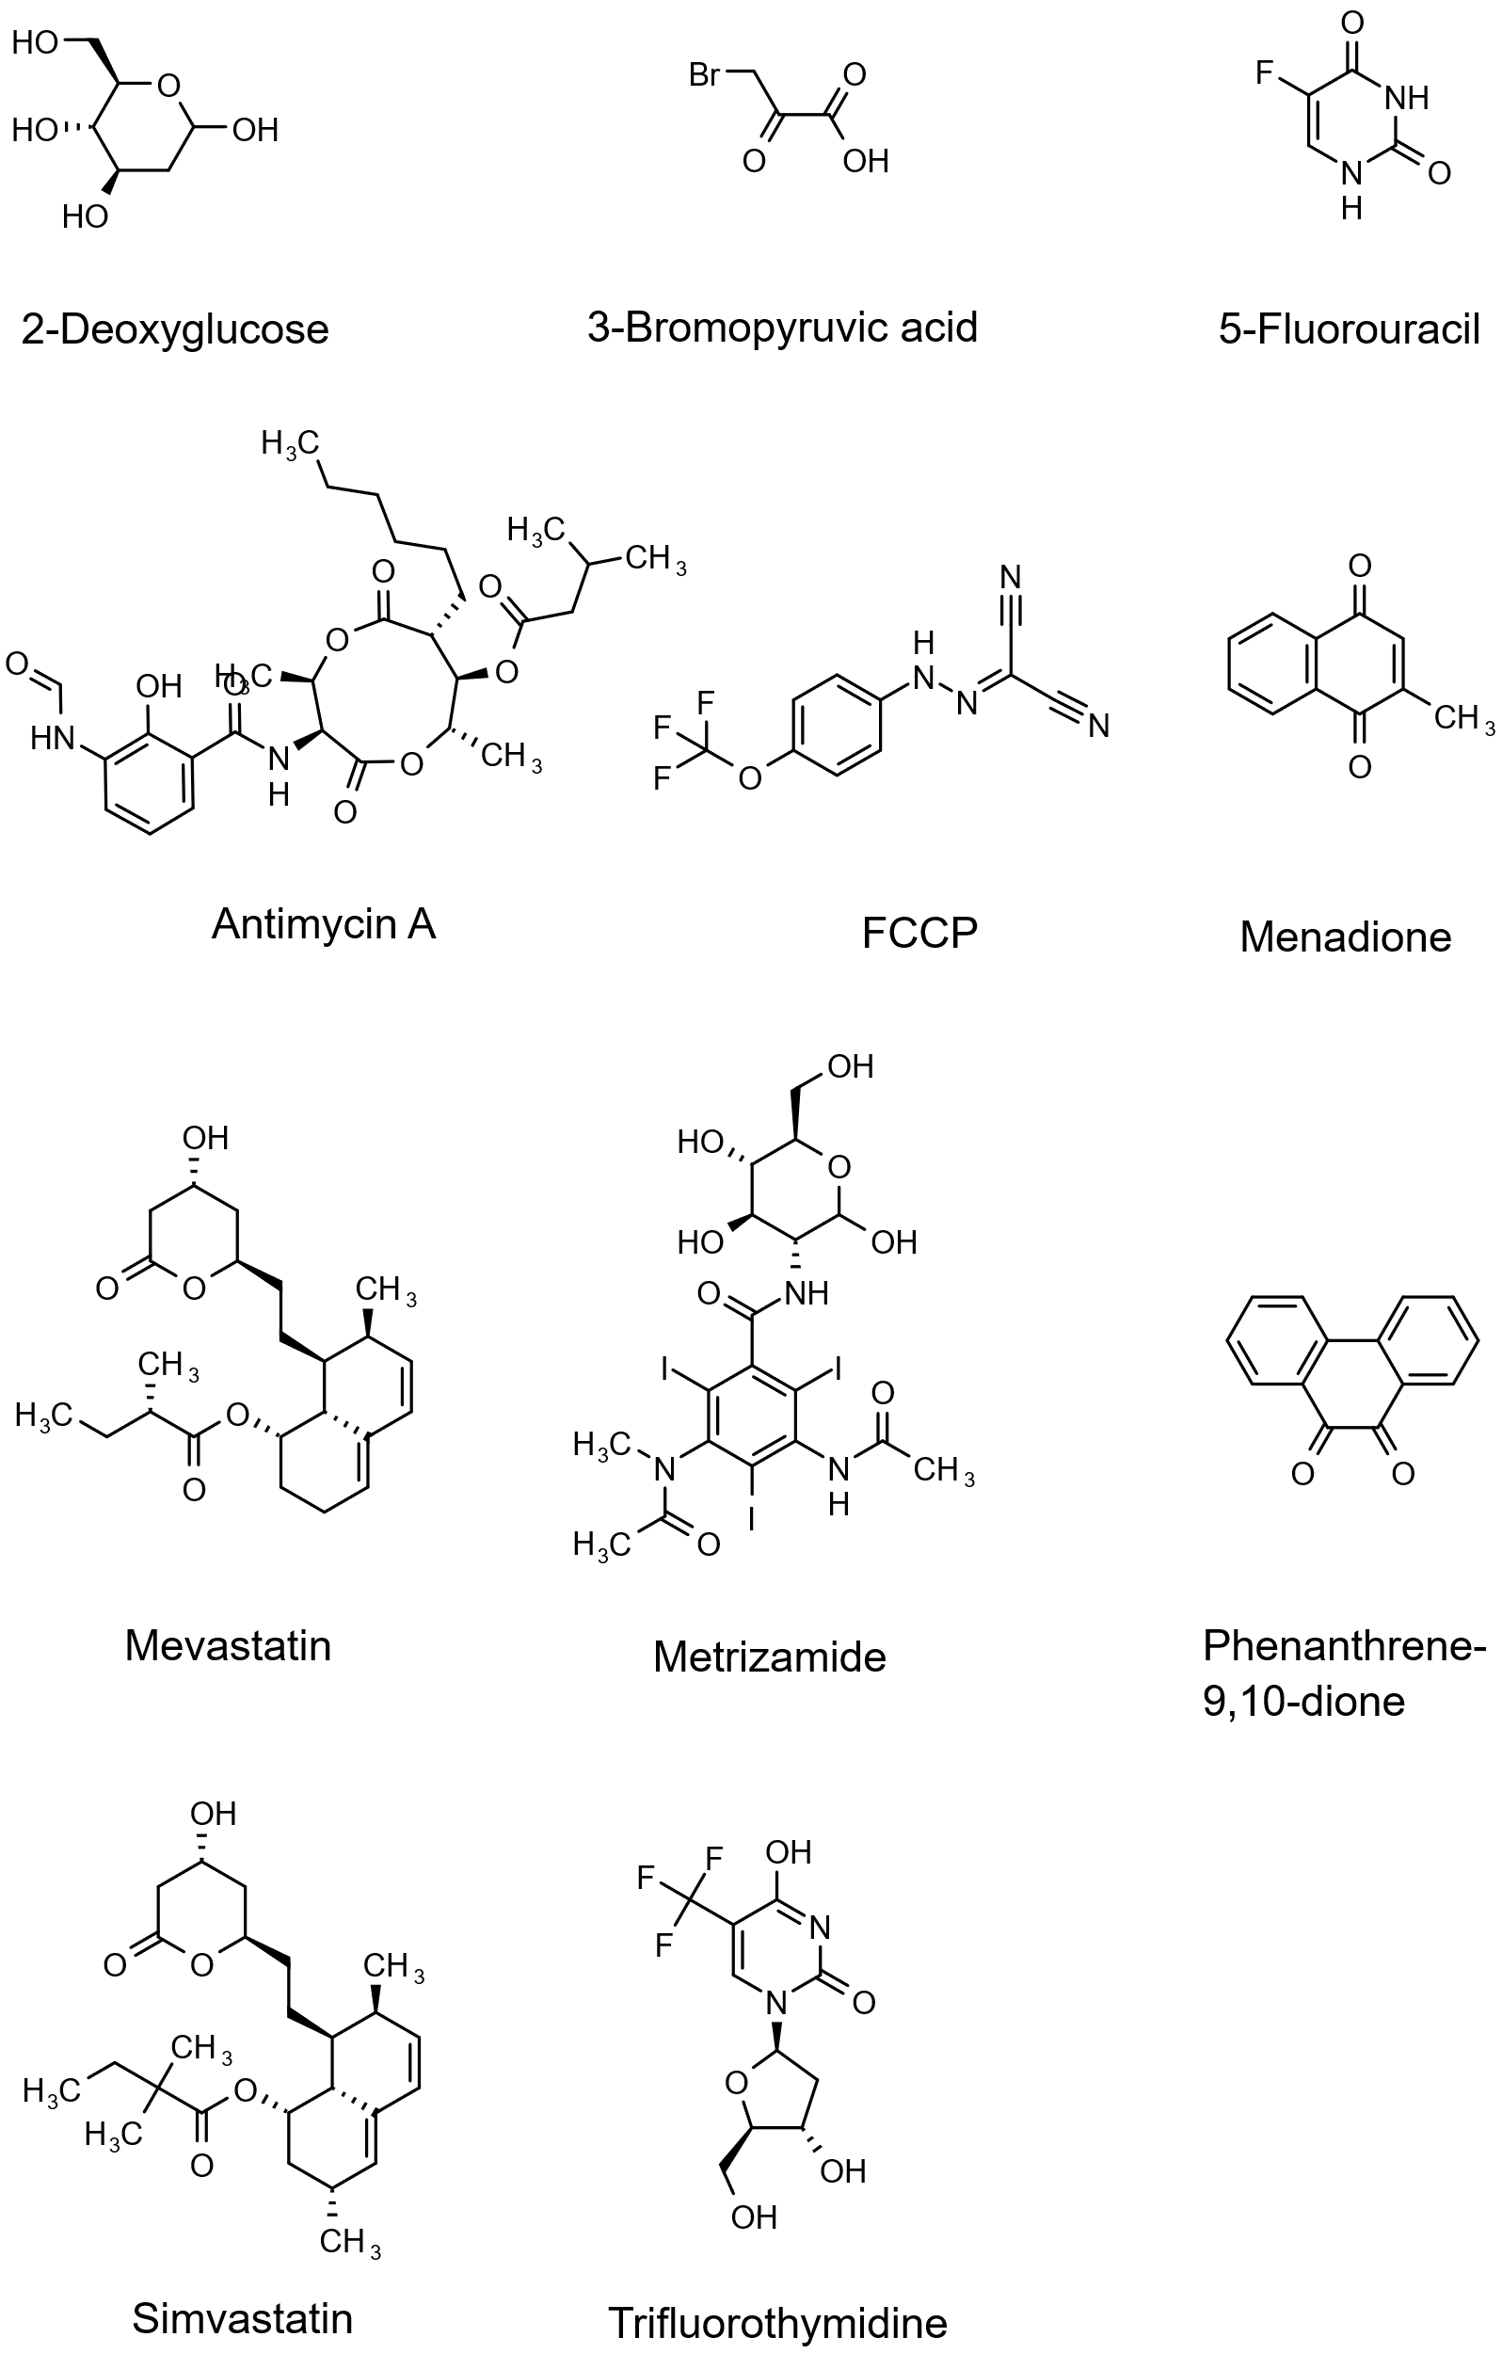

S2 Compound concentrations used for cell treatment
Compound | Concentration / µmol ⋅ l⁻¹
Antimycin A | 94.4
3-Bromopyruvic acid | 78.9
FCCP | 53.4
Menadione | 36.8
Mevastatin | 77.5
Phenanthrene-9,10-dione | 24.8
Simvastatin | 43.0
2-Deoxyglucose | 1000.0
5-Fluorouracil | 1000.0
Metrizamide | 1000.0
Trifluorothymidine | 1000.0

S3 Gradient table for the reversed phase liquid chromatography method
Time / min | % A  (water, 0.1 % formic acid) | % B  (acetonitrile, 0.1 % formic acid) | Flow / µl ⋅ min⁻¹
0.0 | 95 | 5 | 300
1.0 | 95 | 5 | 300
7.5 | 0 | 100 | 300
10.0 | 0 | 100 | 300
10.1 | 95 | 5 | 300
15.0 | 95 | 5 | 300

S4 Gradient table for the hydrophilic interaction chromatography liquid chromatography method
Time / min | % A  (90 % water, 10 % acetonitrile, 10 mM ammonium acetate, pH 9) | % B  (90 % acetonitrile, 10 % water, 10 mM ammonium acetate, pH 9) | Flow / µl ⋅ min⁻¹
0.0 | 1 | 99 | 400
0.5 | 1 | 99 | 400
6.0 | 40 | 60 | 400
8.0 | 80 | 20 | 400
9.0 | 80 | 20 | 400
10.0 | 1 | 99 | 400
15.0 | 1 | 99 | 400

S5 Mass spectrometry parameters
Polarity | Parameter | Value
Both | Mass range | m/z 20 – 1300
Both | 1/K₀ | 0.45 – 1.45 Vs/cm²
Both | Ramp time | 100 ms
Both | ESI source end plate offset | 500 V
Both | Nebulizer | 2.2 bar
Both | Dry gas flow | 9 l/min
Both | Dry temperature | 220 °C
Negative | Capillary voltage | 3600 V
Negative | Collision energy | -20 eV & -50 eV
Positive | Capillary voltage | 4500 V
Positive | Collision energy | 20 eV & 50 eV

S6 Processing parameters
Polarity | LC-Method | Parameter | Value
Both | Both | MS2 spectrum import | On
Both | Both | Mass range | m/z 50 – 1500
Both | HILIC | Crop chromatograms after | 9 min
Both | Reversed phase | Crop chromatograms after | 10 min
Both | Both | Seed intensity | 1000
Both | Both | Minimum cluster size | 75
Both | Both | Minimum seed cluster size | 100
Both | Both | Chromatographic alignment mobility delta | 0.05
Both | Both | Chromatographic alignment mass delta | m/z 0.015
Both | Both | Recursive feature extraction | On
Both | Both | Group features mobility threshold | 0.05
Both | Both | Group features mass threshold | m/z 0.015
Both | Both | Group features retention time threshold | 10 s
Both | Both | Ion deconvolution EIC | 0.8
Negative | HILIC | Ion deconvolution ions | primary ion [M-H]⁻  common ion [M-H-H2O]⁻  seed ions [M+Cl]⁻[M+CH3CO2]⁻
Negative | Reversed phase | Ion deconvolution ions | primary ion [M-H]⁻  common ion [M-H-H2O]⁻  seed ion [M+Cl]⁻
Positive | HILIC | Ion deconvolution ions | primary ion [M+H]⁺  common ion [M+H-H2O]⁺  seed ions [M+Na]⁺ [M+K]⁺ [M+NH4]⁺
Positive | Reversed phase | Ion deconvolution ions | primary ion [M+H]⁺  common ion [M+H-H2O]⁺  seed ions [M+Na]⁺ [M+K]⁺
Both | Both | Within-batch correction | On, QC samples
Both | Both | Within-batch correction algorithm | LOESS, bandwidth = 0.7
Both | Both | Post-correction variance threshold | 20
Both | Both | Pre-correction variance threshold | 40
Negative | Both | Mass recalibration | On, Na formate negative ion list
Positive | Both | Mass recalibration | On, Na formate positive ion list

S7 Enrichment analysis parameters
Method | Parameter | Value
MSEA/ORA | Input/ID type | KEGG ID
MSEA/ORA | Feature type | Metabolites
MSEA/ORA | Metabolite set | KEGG
All | Minimum entries per metabolite set | 2
MSEA | Group label | Categorial
MSEA | Filtering | None
MSEA | Normalization | None
MSEA | Reference metabolome | None
Mummichog | Ion mode | Mixed
Mummichog | Mass tolerance | 5.0 ppm
Mummichog | Retention time | Not present
Mummichog | Ranked by | p-values
Mummichog | Enforce primary ions | Yes
Mummichog | Algorithm | Mummichog
Mummichog | p-value cutoff | Default top 10 % peaks
Mummichog | Pathway Library | Homo sapiens, KEGG

S8 Target-associated pathways. NA: Not Available.
Compound | Target/MOA | Target-associated pathways | Pathway ID
2-Deoxyglucose | Hexokinase | Glycolysis / Gluconeogenesis  Fructose and mannose metabolism  Galactose metabolism  Starch and sucrose metabolism  Amino sugar and nucleotide sugar metabolism  Neomycin, kanamycin and gentamicin biosynthesis | hsa00010  hsa00051  hsa00052  hsa00500  hsa00520  hsa00524
3-Bromopyruvic acid | Hexokinase | Glycolysis / Gluconeogenesis  Fructose and mannose metabolism  Galactose metabolism  Starch and sucrose metabolism  Amino sugar and nucleotide sugar metabolism  Neomycin, kanamycin and gentamicin biosynthesis | hsa00010  hsa00051  hsa00052  hsa00500  hsa00520  hsa00524
5-Fluorouracil | Thymidylate Synthase | Pyrimidine metabolism  One carbon pool by folate | hsa00240  hsa00670
Antimycin A | Complex III | NA | NA
FCCP | Mitochondrial decoupler, indirect inhibition of F-type ATP-synthase | NA | NA
Menadione | ROS formation | Cysteine and methionine metabolism  Glutathione metabolism | hsa00270  hsa00480
Metrizamide | Hexokinase | Glycolysis / Gluconeogenesis  Fructose and mannose metabolism  Galactose metabolism  Starch and sucrose metabolism  Amino sugar and nucleotide sugar metabolism  Neomycin, kanamycin and gentamicin biosynthesis | hsa00010  hsa00051  hsa00052  hsa00500  hsa00520  hsa00524
Mevastatin | HMG-CoA Reductase | Terpenoid backbone biosynthesis | hsa00900
Phenanthrene-9,10-dione | ROS formation | Cysteine and methionine metabolism  Glutathione metabolism | hsa00270  hsa00480
Simvastatin | HMG-CoA Reductase | Terpenoid backbone biosynthesis | hsa00900
Trifluorothymidine | Thymidylate Synthase | Pyrimidine metabolism  One carbon pool by folate | hsa00240  hsa00670

