Supplementary Information (SI)

Part A: Extracellular flux (XF) assay
The normalized data was analyzed on the software mentioned in the methodology section. The statistical analysis was performed on the normalized data. A one-way ANOVA with Tukey’s multiple-comparison was performed on the original baseline measurements for the OCR (Table S1) and ECAR (Table S2).
Table S1: One-way ANOVA significance results with Tukey’s multiple-comparison test to determine statistical significance amongst strains for their baseline OCR measurements
Tukey's multiple comparisons test | Significant? | Adjusted p Value
ANOVA | Yes | 0,0004
Wildtype vs. ∆mtp | Yes | 0,0005
Wildtype vs. mtp-complement | No | 0,4873
∆mtp vs. mtp-complement | Yes | 0,0035

Table S2: One-way ANOVA significance results with Tukey’s multiple-comparison test to determine statistical significance amongst strains for their baseline ECAR measurements

Tukey's multiple comparisons test | Significant? | Adjusted p Value
ANOVA | No | 0,2549
Wildtype vs. ∆mtp | No | 0,6164
Wildtype vs. mtp-complement | No | 0,7917
∆mtp vs. mtp-complement | No | 0,2275

Following the baseline measurement statistical analysis, a one-way ANOVA with Tukey’s multiple-comparison test was performed on the calculated change in OCR (Table S3) and change in ECAR (Table S4).

Table S3: One-way ANOVA significance results with Tukey’s multiple-comparison test to determine statistical significance amongst M. tuberculosis strains for the change in OCR

Tukey's multiple comparisons test | Significant? | Adjusted p Value
ANOVA | Yes | 0,0019
Wildtype vs. ∆mtp | Yes | 0,0058
Wildtype vs. mtp-complement | No | 0,9981
∆mtp vs. mtp-complement | Yes | 0,0036

Table S4: One-way ANOVA significance results with Tukey’s multiple-comparison test to determine statistical significance amongst strains for the change in ECAR

Tukey's multiple comparisons test | Significant? | Adjusted p Value
ANOVA | Yes | 0,0006
Wildtype vs. ∆mtp | Yes | 0,0297
Wildtype vs. mtp-complement | Yes | 0,0004
∆mtp vs. mtp-complement | No | 0,1057
Part B: Metabolomics
Normalization
The data was initially normalized using the BCA protein concentrations and internal standards (methodology section). The protein concentrations were calculated using the BCA absorbance according to the kit (methodology), using the mentioned standards.

Table S5: The absorbance (540_{nm}) and calculated protein concentrations (ug/mL) of the wild-type, ∆mtp, and mtp-complement samples

Sample | Absorbance (540_{nm}) | Protein concentrations (ug/mL)
Wildtype 1 | 0.426 | 465.11
Wildtype 2 | 0.484 | 529.56
Wildtype 3 | 0.538 | 589.56
Wildtype 4 | 0.528 | 578.44
Wildtype 5 | 0.521 | 570.67
∆mtp 1 | 0.507 | 555.11
∆mtp 2 | 0.608 | 667.33
∆mtp 3 | 0.496 | 542.89
∆mtp 4 | 0.599 | 657.33
∆mtp 5 | 0.579 | 635.11
mtp-complement 1 | 0.479 | 524.00
mtp-complement 2 | 0.409 | 446.22
mtp-complement 3 | 0.357 | 388.44
mtp-complement 4 | 0.426 | 465.11
mtp-complement 5 | 0.383 | 417.33

Figure S1: Line graph representing the protein concentrations (ug/mL) at the specific absorbance (540_{nm})

Statistical analysis
A one-way ANOVA with Tukey’s multiple-comparisons was performed on the total labelled and total abundance data. The results are show in in Tables 7-8, respectively

Table S6: One-way ANOVA with Tukey’s multiple-comparison statistical test for total abundance
 | Adjusted p-value
Compound | ANOVA | WT vs ∆mtp | WT vs mtp-complement | mtp vs mtp-complement
sn-glycerol-3-phosphate | <0,0001 | 0.00370 | 0.01410 | <0,0001
3-phosphoglycerate | 0.02170 | 0.03820 | 0.99550 | 0.03320
Phosphoenolpyruvate | 0.69200 | >0,9999 | 0.73340 | 0.73920
Pyruvate | 0.00010 | 0.22900 | 0.00090 | 0.00010
lactate | 0.02640 | 0.02130 | 0.23620 | 0.30230
Citrate | 0.00680 | 0.22400 | 0.08340 | 0.00540
Succinate | 0.00300 | 0.46500 | 0.01740 | 0.00290
Fumarate | 0.00260 | 0.26120 | 0.00220 | 0.02570
Malate | 0.00200 | 0.16780 | 0.00160 | 0.02920
Glyoxylate | 0.57700 | 0.99570 | 0.66010 | 0.60800
Methylcitrate | <0,0001 | <0,0001 | <0,0001 | 0.00670
alpha-Ketoglutarate | 0.04300 | 0.03570 | 0.24970 | 0.43700
Itaconic acid | 0.32940 | 0.84160 | 0.59390 | 0.30770
Citramalate | 0.09320 | 0.70640 | 0.27810 | 0.08470
Methylsuccinate | <0,0001 | <0,0001 | <0,0001 | 0.97070
Dihydroxyacetonephosphate  (DHAP) | 0.00180 | 0.00160 | 0.01750 | 0.26700
D-Erythose-4-phosphate | 0.00480 | 0.03240 | 0.00430 | 0.40490
Ribose-5-phosphate | 0.01070 | 0.02060 | 0.01700 | 0.99180
Fructose-6-phosphate | 0.00740 | 0.04210 | 0.00680 | 0.48350
Fructose-1,6-biphosphate | 0.00060 | 0.98060 | 0.00140 | 0.00110
Sedoheptulose-7-phosphate | 0.01220 | 0.04740 | 0.01230 | 0.66900
Glyceraldehyde-DHA | 0.00210 | 0.83040 | 0.00650 | 0.00280
Erythrose | 0.00300 | 0.98490 | 0.00650 | 0.00510
Ribose-ribulose | 0.00150 | 0.77040 | 0.00510 | 0.00190
Hexose | 0.00510 | 0.99970 | 0.00950 | 0.00920
Sedoheptulose | <0,0001 | <0,0001 | 0.00390 | 0.01440
Trehalose | 0.00030 | 0.65910 | 0.00040 | 0.00130
Succinic semialdehyde | 0.00010 | 0.99970 | 0.00030 | 0.00030
6-phosphogluconate | 0.14630 | 0.14300 | 0.87280 | 0.29150
Alanine | 0.05170 | 0.99670 | 0.07350 | 0.08280
Arginine | 0.00320 | 0.04330 | 0.19520 | 0.00260
Asparagine | 0.00040 | 0.01590 | 0.03350 | 0.00030
Aspartate | <0,0001 | 0.00060 | <0,0001 | 0.00030
Cysteine | 0.12690 | 0.99670 | 0.18260 | 0.16310
Glycine | 0.01300 | 0.77290 | 0.04170 | 0.01430
Glutamate | 0.01670 | 0.01340 | 0.15200 | 0.30400
Glutamine | 0.01290 | 0.39380 | 0.09030 | 0.01080
Isoleucine | 0.00200 | 0.92150 | 0.00300 | 0.00510
Leucine | 0.29220 | 0.27540 | 0.53280 | 0.85330
Histidine | 0.04470 | 0.41910 | 0.27000 | 0.03690
Lysine | 0.45340 | 0.90320 | 0.43240 | 0.67750
Methionine | 0.04130 | 0.07300 | 0.05600 | 0.98420
Phenylalanine | 0.01100 | 0.32030 | 0.09560 | 0.00900
Threonine | 0.05290 | 0.08050 | 0.07830 | 0.99980
Homoserine | 0.07640 | 0.08230 | 0.16160 | 0.89750
Proline | 0.25700 | 0.73080 | 0.59070 | 0.23160
Serine | 0.00450 | 0.10660 | 0.00350 | 0.11330
Tryptophan | 0.00500 | 0.14610 | 0.09210 | 0.00390
Valine | 0.01600 | 0.07290 | 0.58070 | 0.01490
Tyrosine | 0.09580 | 0.09230 | 0.23880 | 0.80070
Homocysteine | <0,0001 | <0,0001 | <0,0001 | 0.04120
Cystathionine | 0.20150 | 0.21880 | 0.96190 | 0.31460
Ornithine | 0.61170 | 0.68700 | 0.64370 | 0.99700
Citrulline | 0.01250 | 0.03280 | 0.01550 | 0.87910
Ergothioneine | 0.00580 | 0.00550 | 0.52440 | 0.03010
Glutathione | 0.31510 | 0.31930 | 0.94440 | 0.47390

Table S7: One-way ANOVA with Tukey’s multiple-comparison statistical test for percentage of total labelled abundance
 | Adjusted p-value
Compound | ANOVA | WT vs ∆mtp | WT vs mtp-complement | ∆mtp vs mtp-complement
sn-glycerol-3-phosphate | <0,0001 | 0.5984 | <0,0001 | <0,0001
3-phosphoglycerate | 0.0002 | 0.7266 | 0.0008 | 0.0003
Phosphoenolpyruvate | <0,0001 | 0.6823 | 0.0001 | 0.0004
Pyruvate | <0,0001 | 0.1385 | <0,0001 | <0,0001
lactate | 0.7088 | >0,9999 | 0.5773 | 0.5769
Citrate | 0.7718 | 0.8115 | 0.8134 | 0.4597
Succinate | <0,0001 | 0.5130 | 0.0001 | <0,0001
Fumarate | 0.9921 | 0.9914 | 0.9971 | 0.9985
Malate | 0.0025 | 0.6477 | 0.0106 | 0.0028
Glyoxylate | 0.3394 | 0.3193 | 0.8577 | 0.5915
Methylcitrate | 0.0005 | 0.9999 | 0.0010 | 0.0010
alpha-Ketoglutarate | 0.0407 | 0.0397 | 0.7410 | 0.1265
Itaconic acid | 0.7856 | 0.9993 | 0.8095 | 0.8282
Citramalate | 0.0036 | 0.1903 | 0.0028 | 0.0493
Methylsuccinate | 0.0059 | 0.8962 | 0.0079 | 0.0154
Dihydroxyacetonephosphate  (DHAP) | 0.0011 | 0.0989 | 0.0237 | 0.0008
D-Erythose-4-phosphate | 0.0340 | 0.4460 | 0.1987 | 0.0284
Ribose-5-phosphate | 0.0505 | 0.9875 | 0.0861 | 0.0681
Fructose-6-phosphate | <0,0001 | <0,0001 | <0,0001 | <0,0001
Fructose-1,6-biphosphate | 0.0001 | 0.1720 | 0.0001 | 0.0011
Sedoheptulose-7-phosphate | <0,0001 | 0.0012 | <0,0001 | <0,0001
Glyceraldehyde-DHA | 0.5171 | 0.9154 | 0.4971 | 0.7294
Erythrose | 0.0010 | 0.0034 | 0.7879 | 0.0014
Ribose-ribulose | 0.1561 | 0.5830 | 0.5249 | 0.1356
Hexose | 0.1712 | 0.5229 | 0.6242 | 0.4199
Sedoheptulose | <0,0001 | 0.0006 | <0,0001 | 0.0317
Trehalose | <0,0001 | 0.0759 | <0,0001 | <0,0001
Succinic semialdehyde | 0.0665 | 0.9541 | 0.0794 | 0.1243
6-phosphogluconate | 0.0033 | 0.0520 | 0.1653 | 0.0026
Alanine | <0,0001 | 0.0166 | <0,0001 | <0,0001
Arginine | <0,0001 | 0.1235 | 0.0004 | <0,0001
Asparagine | <0,0001 | <0,0001 | 0.0222 | 0.0003
Aspartate | 0.0023 | 0.0063 | 0.0034 | 0.8998
Cysteine | <0,0001 | <0,0001 | <0,0001 | <0,0001
Glycine | <0,0001 | 0.7363 | <0,0001 | <0,0001
Glutamate | 0.0297 | 0.2936 | 0.0240 | 0.2707
Glutamine | 0.0002 | 0.0040 | 0.0529 | 0.0001
Isoleucine | <0,0001 | 0.2466 | <0,0001 | <0,0001
Leucine | <0,0001 | 0.8505 | <0,0001 | <0,0001
Histidine | 0.0034 | 0.5148 | 0.0181 | 0.0034
Lysine | <0,0001 | 0.6445 | <0,0001 | 0.0001
Methionine | <0,0001 | 0.0118 | 0.0004 | <0,0001
Phenylalanine | <0,0001 | 0.8084 | <0,0001 | <0,0001
Threonine | <0,0001 | 0.8338 | <0,0001 | <0,0001
Homoserine | <0,0001 | 0.8503 | <0,0001 | <0,0001
Proline | <0,0001 | 0.6736 | <0,0001 | <0,0001
Serine | <0,0001 | 0.2021 | <0,0001 | 0.0001
Tryptophan | <0,0001 | 0.0414 | <0,0001 | 0.0005
Valine | 0.0103 | 0.0850 | 0.0085 | 0.3374
Tyrosine | <0,0001 | 0.7032 | <0,0001 | <0,0001
Ornithine | <0,0001 | 0.0089 | <0,0001 | <0,0001
Citrulline | <0,0001 | 0.0004 | <0,0001 | <0,0001
Ergothioneine | 0.9624 | 0.9654 | 0.9995 | 0.9727
GSH | 0.5779 | 0.8626 | 0.8452 | 0.5491
sn-glycerol-3-phosphate | <0,0001 | 0.5984 | <0,0001 | <0,0001
3-phosphoglycerate | 0.0002 | 0.7266 | 0.0008 | 0.0003

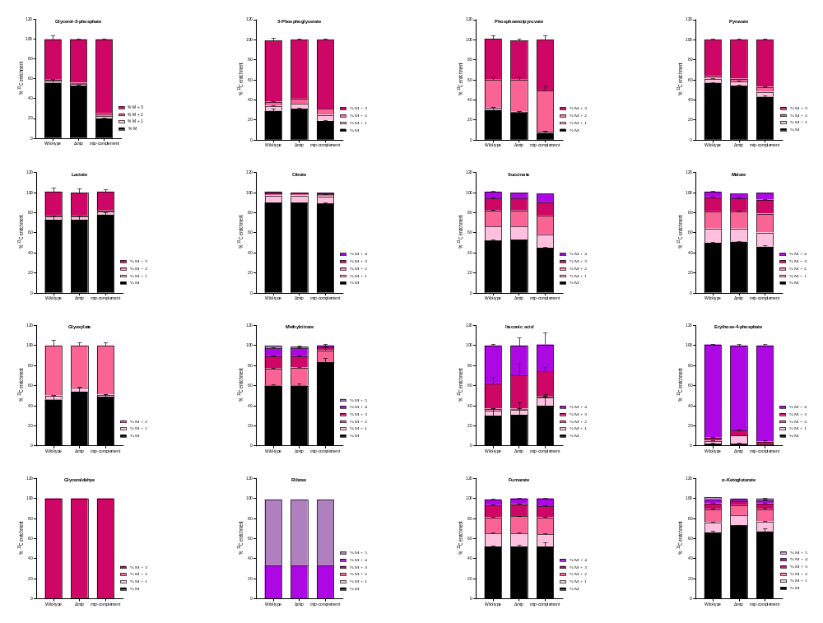
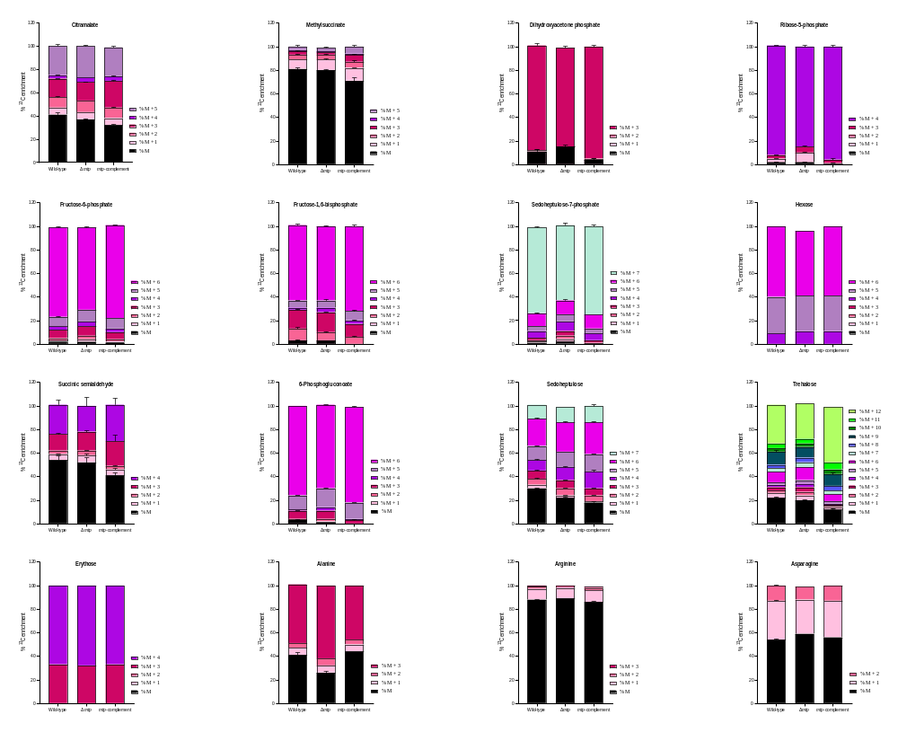
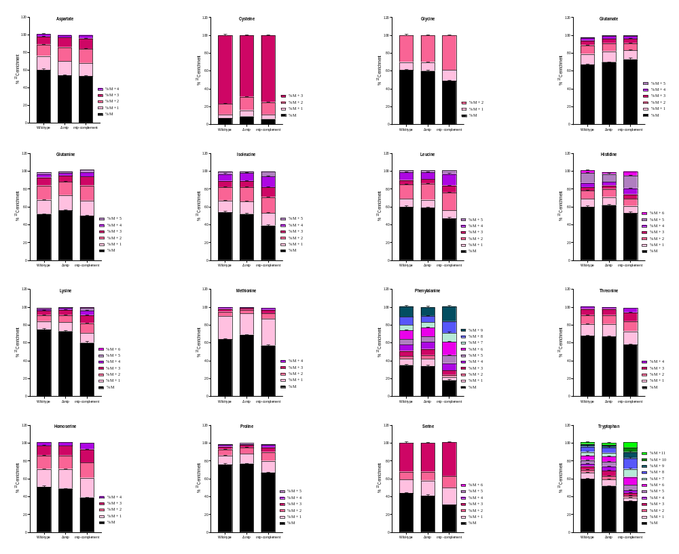
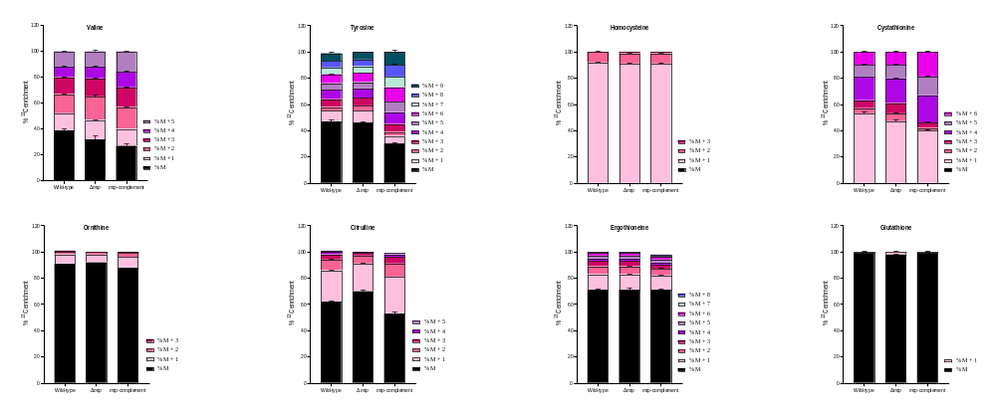

Figure S2. The percent ¹³C enrichment and carbon isotopologue distribution of the 56 compounds analysed. This data is representative of one experiment, with the experiment being repeated a minimum of two times. Each column represents the mean of at least four replicates with the standard error of mean (SEM).

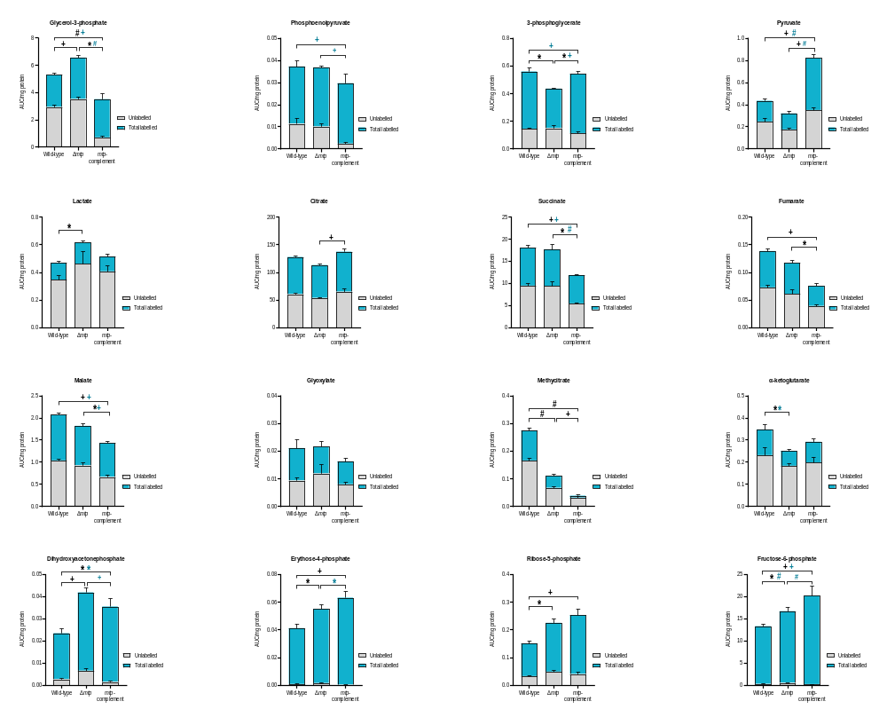
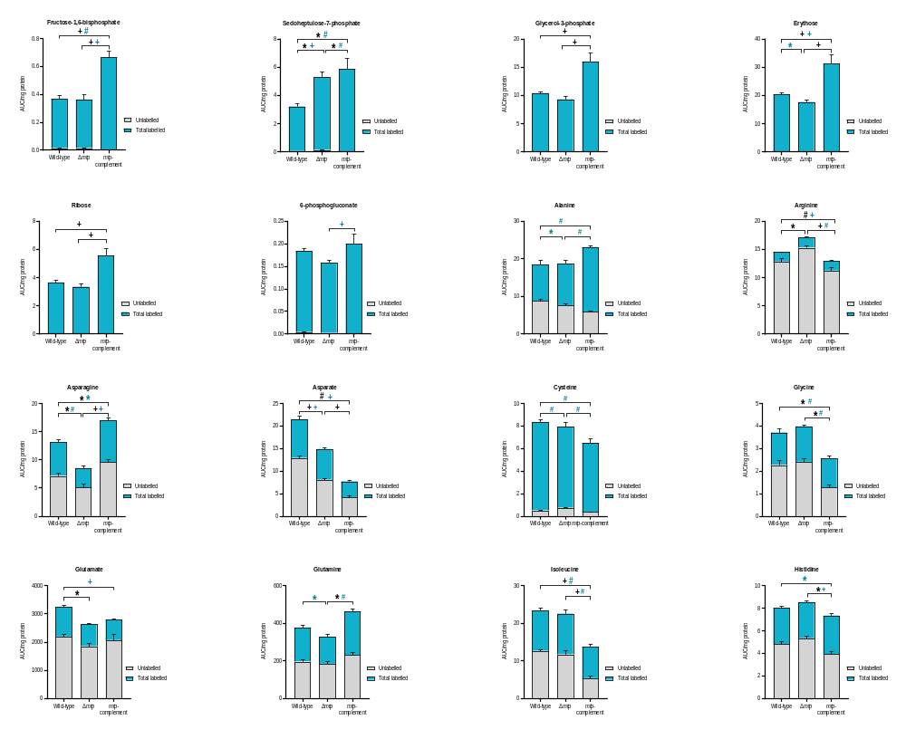
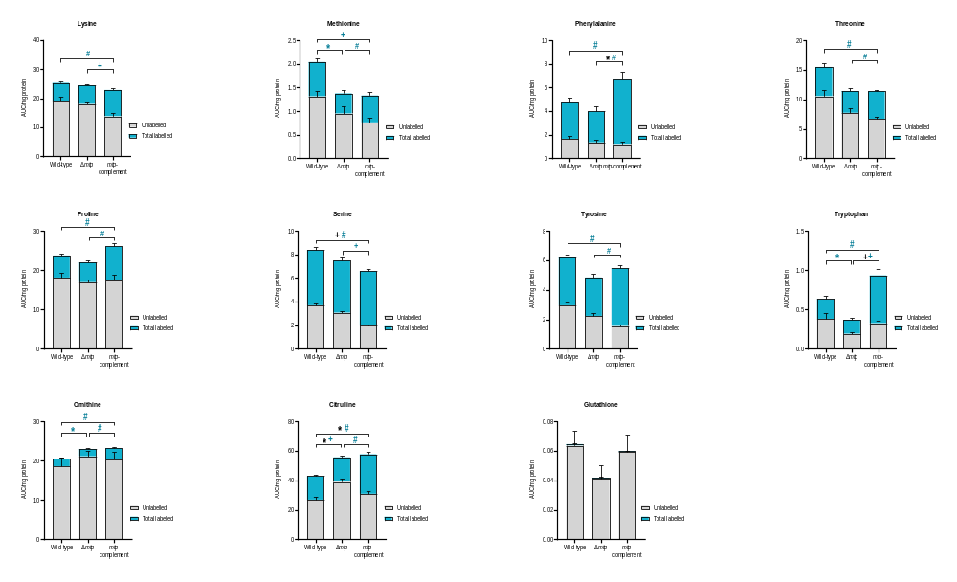
Figure S3. The total abundance of the 56 compounds analysed. This data is representative of one experiment, with the experiment being repeated a minimum of two times. Each column represents the mean of atleast four replicates with the standard error of mean (SEM). A one-way ANOVA with Tukeys’s multiple-comparison test was performed for the statistical analysis. The statistical tests were performed on the total abundance (black) and the total labelled abundance (blue) for each compound. n = four biologically independent samples. False discovery (FDR) adjusted p value *p < 0.05, + p ≤ 0.01, # p ≤ 0.0001.

