Figure. S1. Venn diagram showing the overlap of cohort participants with metabolomics data using the Nightingale and Metabolon platforms
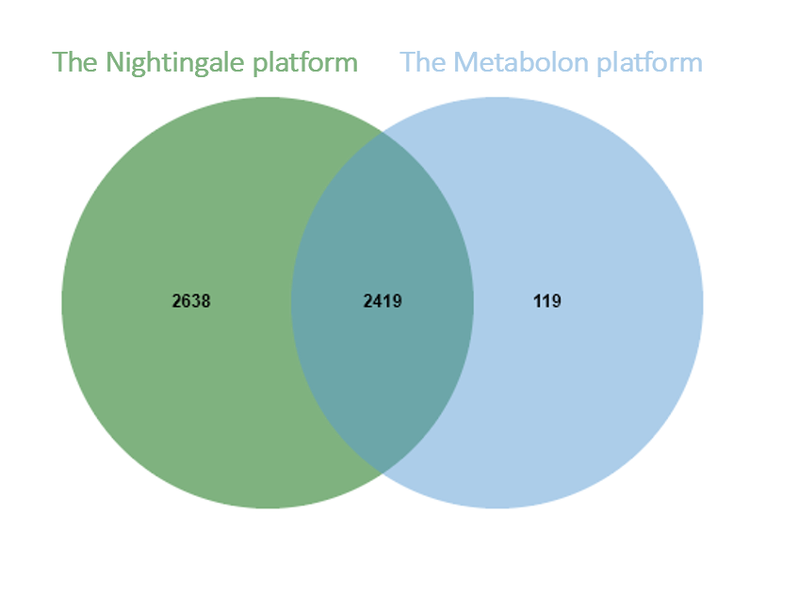

Figure S2. Overlap of significant metabolites identified in the cross-sectional, full follow-up, and ≤5-year follow-up analyses for hematologic malignancies (A) and colorectal cancer (B).
