Metabolic and Lipidomic Stability in EDTA Plasma from Hospitalized Patients: Impact of Refrigerated Storage Time and Additional Freeze—thaw Cycle
Sander Johannes Thorbjørnsen Guttorm^{a,b}, Liana Gukasyan^{a,c}, Christian Prebensen^{c,d}, Niclas G. Karlssonª, Aleksander Rygh Holten^{d,e}, Dag Kvale^{c,d}, Helge Rootwelt^{b}, Katja Benedikte Prestø Elgstøen^{b}, Erik Koldberg Amundsen^{a,b}
ªFaculty of Health Sciences, Department of Life Sciences and Health, Oslo Metropolitan University, Oslo, Norway
^{b}Department of Medical Biochemistry, Oslo University Hospital, Oslo, Norway
^{c}Department of Infectious Diseases, Oslo University Hospital, Oslo, Norway
^{d}Institue of Clinical Medicine, Faculty of Medicine, University of Oslo, Oslo, Norway
^{e}Department of Acute Medicine, Oslo University Hospital, Oslo, Norway
Corresponding Author
Sander Johannes Thorbjørnsen Guttorm
Faculty of Health Sciences, Department of Life Sciences and Health, Oslo Metropolitan University, Oslo, Norway
Department of Medical Biochemistry, Oslo University Hospital - Rikshospitalet, Oslo, Norway
Mail: sajtho@ous-hf.no

Cress-Checklist:
Section | Number | Item | Response
Title/Keywords | 1 | - Clearly indicate in the title that content is a stability study,  - Define in the title what analytes are being evaluated in what matrix, at which temperature, over what period of time,  - Use recommended keywords: stability, the name of the analyte(s) if <3 analytes, preanalytical and sample type (we recommend that all of them are used to properly identify a stability study). | The title “Metabolic and Lipidomic Stability in EDTA Plasma from Hospitalized Patients: Impact of Refrigerated Storage Time and a Single Additional Freeze-thaw Cycle” clearly reflects the study's focus on pre-analytical stability in EDTA plasma from medical ward patients. The title also defines that the evaluated analytes are the metabolome and lipidome. In addition the temperature is also clearly stated. Key-words include pre-analytical stability, metabolome, lipidome and sample type.
Abstract | 2 | - State that the study is a stability study,  - Clearly define what the aims of the study are,  - Include an overview of the study design,  - Define which analytes are being examined, in which matrices, in which tube types, at which temperature and over what period of time, as a minimum,  - Cover headline results and the key findings of the study, as a minimum,  - Draw appropriate conclusions; do not generalize beyond the study results. | The abstract clearly states this is a stability study, defines aims, describes design, analytes (metabolome and lipidome), matrix (EDTA plasma), temperature (4°C), and time points (0, 24, 72h). Key findings and a appropriate conclusion is also provided.
Introduction | 3 | - Discuss the importance of sample stability,  - Provide a thorough overview of the current position and existing studies,  - State the knowledge gap being filled. | The introduction provides a strong rationale for studying pre-analytical variability in patients. It highlights the gap in knowledge compared to healthy cohorts.
Aim | 4 | - Clearly define the aims of the study  - Provide in details how the study will address these aims,  - State the analytes, matrix, temperature and period of time involved. | The study aims to evaluate the impact of post-centrifugation storage time (up to 72 hours) and a single freeze–thaw cycle on the EDTA plasma metabolome and lipidome in medical ward patients.
Materials and Methods | 5 | - State where the study was done,  - State the start date and the end date of the study  - Thoroughly describe materials and methods to a depth that allows the study to be replicated,  - Provide sufficient detail to allow transferability to different healthcare settings. | Sample location is clearly stated “The study was conducted at Oslo university hospital”. Samples were collected from Three K2EDTA plasma tubes with gel (Greiner Bio-One, 5 ml) were collected per patient. Samples were centrifuged (centrifugation conditions) and aliquoted under controlled conditions.
Mesurand/Analytes | 6 | - Define the analyte(s) involved in the study. | Analytes include metabolites and lipids detected via global LC–MS metabolomics and lipidomics, clearly stated throughout the manuscript.
Samples | 7 | - Define the tube type, manufacturer and additive,  - Define the sample matrix (e.g. whole blood, serum, plasma, urine, faeces, saliva, cerebrospinal fluid etc),  - Define sample volume,  - State if samples were specifically collected for the study or leftover samples have been used,  - State whether individual participants or pools were used,  - If pools have been used, provide the protocol and appropriate reference, according to which pool has been prepared. | Tube type, manufacturer, volume and additative is clearly stated. The sample matrix was EDTA-plasma. Samples were specifically collected for this study. We used samples from 20 individual patients. Aliquots were stored at –80°C after defined storage durations. Freeze–thaw effects were assessed by thawing samples after refreezing. Sample preparation included protein precipitation and pooling of supernatant aliquotes to create the pooled quality control.
Participants | 8 | - Define the patient population used including gender, age, geographical location, comorbidities, relevant medication, health status and ethnicity as a minimum.  - State how this information was obtained and verified | The cohort included 20 patients, age 48–92 (median 79), admitted to medical ward at Oslo University Hospital. Inclusion criteria: adult, medical ward admission. See Supplementary for more details regarding comorbidities for each patient, days after admission the samples were collected and NEWS2 score at sampling time point. This information was verified post-hoc by a specialist in infection medicine.
Pre-analytical conditions | 9 | - State how samples were collected (i.e. method of phlebotomy),  - State how tubes were mixed,  - State sample transport conditions (mode of transport, temperature, time),  - Specify the exact time and all relevant conditions (temperature, centrifuge conditions, mechanical forces, etc.) the sample was exposed to from the sample collection to the first time point (time zero) of the stability experiment:  - Specify time elapsed from the sample collection to the time of separation of the serum or plasma from cells,  - If samples were stored prior to time zero, specify sample storage conditions,  - If samples were frozen, please state how samples were thawed,  - State how temperatures were monitored throughout the process (measurement device, measurement method, measurement time points, device calibration status, etc.),  - State any additional preanalytical sources of biases that may have been introduced. | Venous blood was collected in K2EDTA tubes, centrifuged within 30 min of collection (2200 g, 10 min), to separate plasma from blood cells. Then stored at 4°C for 0, 24, 72h, then aliquoted and frozen at –80°C. Samples were then transferred to another lab for analysis on dry ice (30 minutes). Samples were stored in -80 before analysis. Storage temperature was monitored throughout the study. Samples were thawed at RT for 1 hour before analysis.
Analytical procedure | 10 | - State the method of analysis, analytical platform, relevant details of the reaction including any deviations from manufacturers recommendations,  - Define assay traceability to international standards,  - State the number of replicate analyses,  - State within and between batch variation (CVA%) at the concentration level close to concentrations studied in the stability experiment (state if data are from the manufacturer or from in-house verification study),  - State a protocol (provide a reference) according to which CVA (%) was obtained (if in-house data are provided),  - Define whether analysis was done as a single batch or multiple batches  - If samples were run in multiple batches, state relevant conditions between batches and how bias between batches was controlled. | Global LC–MS metabolomics and lipidomics were performed using validated platforms. Instrumentation, ionization modes, and column types are described in the supplementary information. Internal standards were not used in sample preparation, but it is included in our system suitability test which we use to quality assure the instrumentation before each analysis. Pooled quality controls, extraction blanks, solvent blanks and were also included. Within batch variation is included in the supplementary information. As global metabolomics and lipidomics are hypothesis generating approaches, concentrations can not be given out. Instead we have added all the peak areas for each feature in each sample in the supplementary information.
Spiking studies | 11 | - Define how (if any) spiking studies were performed. | No spiking studies were performed.
Length of study | 12 | - State the duration over which stability of the analytes in each sample will be measured in the study and the frequency of time points | Stability assessed at 0, 24, and 72 hours post-centrifugation. Freeze–thaw cycle assessed after 3 months.
Storage conditions | 13 | - Clearly define the storage conditions during the experiment and how they were recorded and controlled,  - State all relevant variables described in detail under Sections 7 and 9. | Samples were stored at 4°C for 0, 24, and 72 hours post-centrifugation. Temperature was monitored throughout the study. Long-term storage was at –80°C. Freeze–thaw cycles were documented.
Statistical analysis | 14 | - Include details of how the sample size and the number of replicates required was justified and how this minimizes the effect of analytical imprecision,  - State whether the mean or median of replicate samples was used,  - Define the instability equation,  - State what statistical tools were and rationale behind their use. | To have all analysis within one batch we opted for sampling 20 patients, 3 samples per patient, bringing the total number of samples to 60. This was done to reduce the batch-to-batch variation which often occurs and can be a difficult challenge in global metabolomics and lipidomics. Having only 60 samples also made sure that the instrumental drift within one batch would be minimized as the samples would be analyzed quicker compared to having more samples. Data were processed using Compound Discoverer with SERRF QC correction. Statistical tests included ANOVA, t-test and Cohen’s d for effect size. PCA was used for global assessing variation. Compond Discoverer is a commercial software designed for processing global metabolomics and lipidomics data, we added software version and data workflow used to the manuscript to ensure that it is repeatable for others. R studio was used due to the ease of use to do statistical calculations and possibility to create figures.
Outliers | 15 | - State how many outliers were identified  - Define what tools were used to remove outliers and why | No outliers were identified.
Acceptability criteria | 16 | - State MPD with evidence for its selection from referenced studies,  - Follow the Milan hierarchy to defining analytical performance specifications. | Instability was inferred from changes in feature abundance over time and freeze–thaw cycles. Cohen’s d threshold of ±0.25 was used to identify practically significant changes, following Gowan’s criterium.
Results | 17 | - Provide textual, tabulated and graphical presentation of the data,  - Plot results on a scatter graph with PD% on the ordinate and the time with appropriate units on the abscissa,  - Present data using consistent terminology throughout the manuscript,  - Provide raw data in an excel format. | Results include feature counts, PCA plots, volcano plots, and effect size distributions. Including the figures tables with p-values, log2fold changes and effect sizes is also given in the supplementary information. Figures are clearly labeled. Supplementary tables including peak areas for all features in each sample for annotated and non annotated compounds.
Discussion | 18 | - State how the study addresses the original aims,  - Demonstrate how it can be applied (or not) to other healthcare systems,  - Define any limitations, particularly those that prevent transferability of data. | Discussion interprets findings in the context of clinical sample reliability. Specific metabolites and lipids are discussed with references to known instability mechanisms. As the results show that 90% of the analytes were not significantly affected by the pre-analytical factors we induced, we demonstrate that samples taken under these conditions can be used for global metabolomics and lipidomics studies.
Funding | 19 | - State any funding sources whether financial or in the form of consumables, | Funding was provided by Oslo Metropolitan University and Oslo University Hospital.
Ethical | 20 | - State if the study has been granted ethical approval,  - State if patient consent (if applicable) was obtained. | The study have REK approval (REK2019/306). Consent was obtained from patients or legal representatives.

Supplementary figure 1:
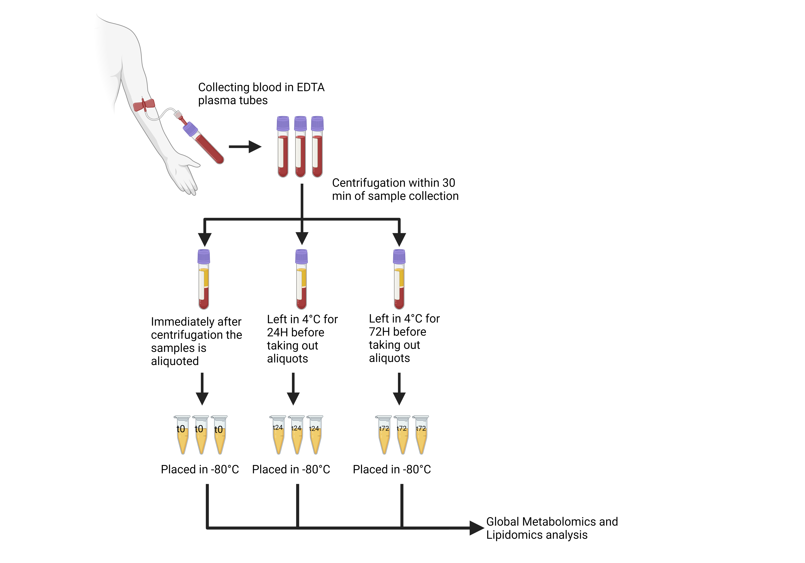
Figure 1: Study design showing overview of sample collection and handling before global LC-MS metabolomics and lipidomics analysis.
Supplementary Figure 2:
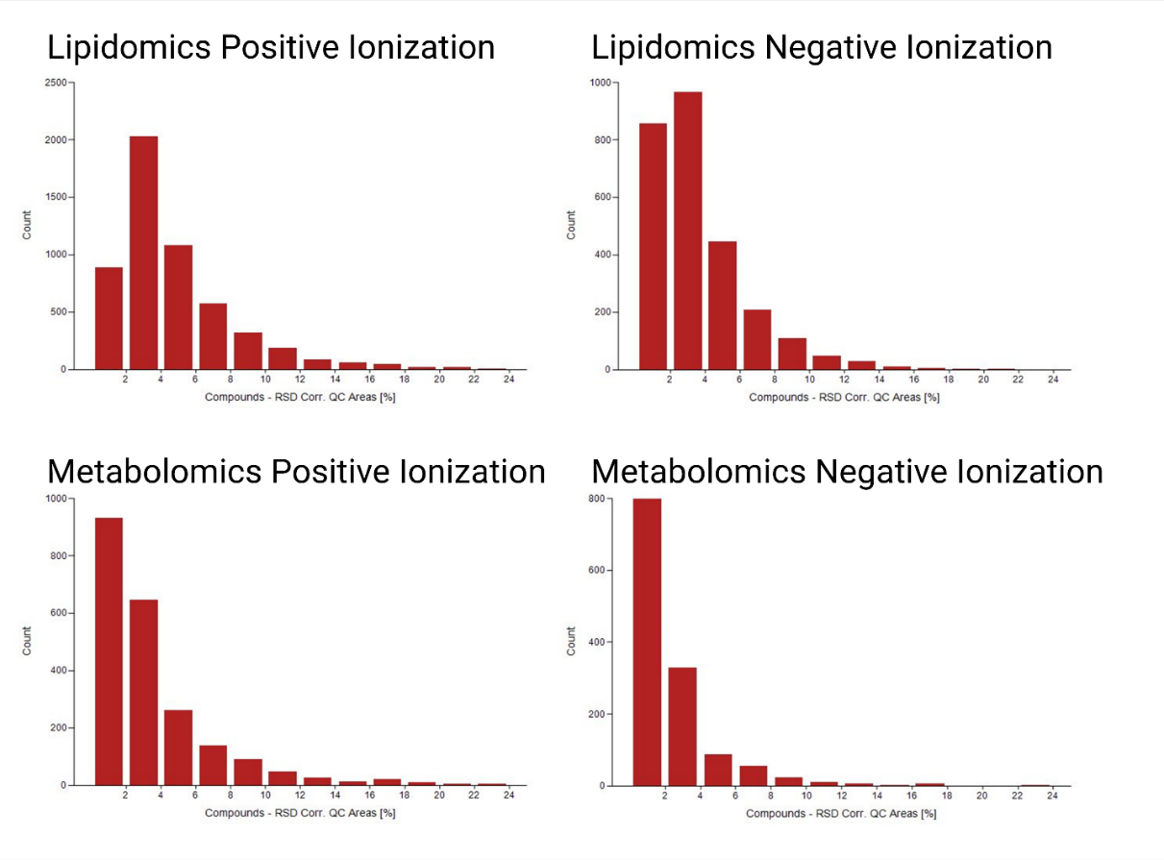
Figure 2: Histogram showing number of features (count) and their respective relative standard deviation (RSD %) in pooled quality control samples, for data obtained from lipidomics and metabolomics methods in both positive and negative ionization modes.

Supplementary figure 3:
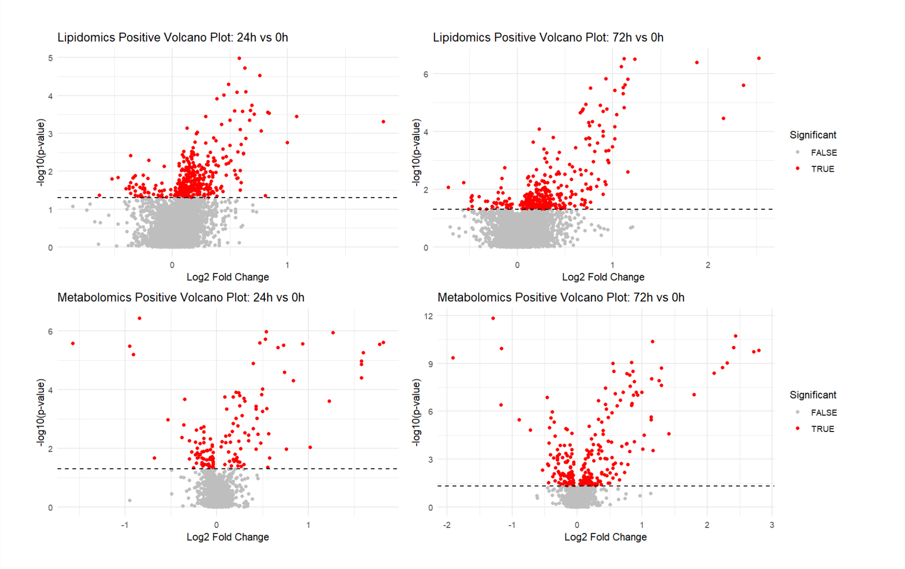
Figure 3: Volcano plots showing the distribution of differentially abundant metabolite and lipid features according to their p-value and log2fold change.

Supplementary figure 4:
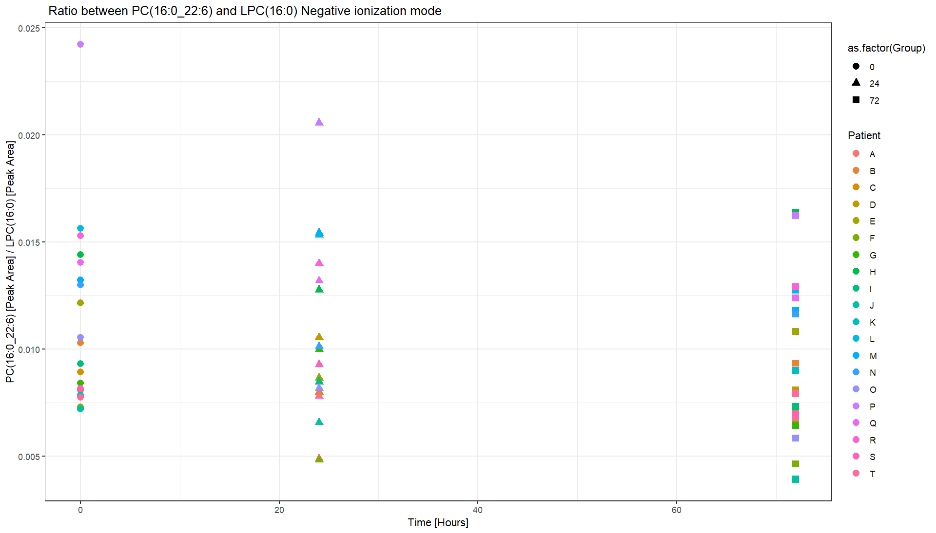
Figure 4: Scatterplot showing the ratio between PC(16:0_22:6) and LPC(16:0) for each patient at each timepoint.

Materials and small equipment:
Organic solvents used included Methanol (MeOH, LC-MS grade, Rathburn Chemicals), 2-propanol (IPA, LC-MS grade, VWR chemicals) and acetonitrile (ACN, LC-MS grade, Rathburn Chemicals). In addition, formic acid (FA, 98%, place) and ammonium format (AF, LC-MS grade, Sigma Aldrich), all water used was of type 1 (>18 MΩ cm) (MilliQ, Merck Millipore, Darmstadt, Germany). Small equipment included pipettes (FisherbrandTM EliteTM adjustable-volume pipettes from Fisher Scientific). For LC analysis, Snap-top vial, Snap Ring Cap and 0.1 mL Micro-Insert, from Matriks AS (Oslo, Norway). Analytical weight AG 245 from Mettler-Toledo (Columbus, OH, USA). For sample preparation FrescoTM Microcentrifuge from Thermo Fisher Scientific (Waltham, MA, USA).
Sample preparation:
Before preparing the samples for analysis the EDTA plasma aliquots were thawed in room temperature (30 minutes, in capped tubes). Proteins were precipitated by adding 90 µL of cold organic solvent (2-propanol (IPA) for lipidomics and methanol (MeOH) for metabolomics) to 30 µL of EDTA plasma. Samples were then vortexed before centrifugation (10 min, 4 degrees Celsius, at 21 100 g). After centrifugation the supernatant was taken out and placed in HPLC vials with glass inserts and capped. One aliquot (20 µL) from each supernatant after sample preparation was combined to create a pooled quality control (PQC). Separate PQCs were made and used for lipidomics and metabolomics analysis. Blank samples were prepared in the same fashion as the EDTA-plasma samples, except EDTA-plasma was replaced by water. All storage samples were analyzed in one analytical batch, likewise for samples with a single additional freeze-thaw cycle.
Global LCMS Metabolomics Analysis:
Global metabolomics was performed using an Ultimate 3000 HPLC coupled to a Q-Exactive Orbitrap MS (Thermo Fisher) with electrospray ionization. A Pursuit XRs Diphenyl column (250 mm x 2.0 mm, particle size 3.0 µm) was used for separating metabolites features from each other. The method uses gradient elution combining mobile phase A (water and 0.1% formic acid) and mobile phase B (MeOH and 0.1% formic acid). Samples were analyzed in both positive and negative ionization modes, and the injection volume was set to 2 µL. All samples were analyzed in MS1 with a resolution of 70 000, for acquiring fragmentation spectra (MSMS) data-dependent acquisition (top 5) was used. Resolution for MSMS acquisition was set to 17 500, and the stepped normalized collision energies were set to 20, 50 and 80, dynamic exclusion was set to 10 seconds. Ions were fragmented in the collision cell then analyzed in using the orbitrap. Scan range was set to 50-750 m/z in both ionization modes, electrospray voltage was 3.5 kV for positive and negative ionization mode respectively. PQCs were injected every fifth sample, system suitability tests and blank samples were run at the beginning and end of each sequence. For more details regarding, system suitability mixture, LC and MS conditions and parameters please see protocol from Skogvold et al. 2025 [1].
Global LCMS Lipidomics Analysis:
Global lipidomics was performed using a Vanquish Horizon UHPLC coupled to a Fusion Orbitrap Tribrid MS (Thermo Fisher). Lipids were separated using a C30 Accucore column (150 mm x 2.1 mm, particle size 2.6 µm) and analyzed in both ionization modes. Gradient elution was used combining mobile phase A (acetonitrile (60%), water (40%) and 2 mM ammonium formate) and mobile phase B (IPA (85.5%), acetonitrile (9.5%), water (5%) and 2 mM ammonium formate). PQCs, blanks and system suitability tests were run as described above. All samples were analyzed in MS1 with 120 000 resolution, MSMS spectra were acquired using scheduled data-dependent acquisition as described by Guttorm et al. [2]. For MSMS acquisition resolution was 30 000, and stepped normalized collision energies were set to 20,40 and 100 in positive mode and 40, 60 and 130 in negative mode. Ions were fragmented in the dual linear ion-trap then analyzed in the orbitrap. Scan range was set to 150-1500 in both ionization modes, and electrospray voltage was set to 3.6 kV and 2.8 kV in positive and negative ionization mode. Injection volume was set to 2 µL. Additional methodological details are provided in Guttorm et al. [2].
Metabolite and Lipid Annotation:
Metabolites and lipids were annotated using online (mzCloud, HMDB, LIPIDMAPS, GNPS) and our own in-house library consisting of analytical standards. For lipid annotation LipidSearch (v5.1) software was also used. Annotation grade was decided following the metabolomics standard initiative and Schymanski et al. [3]. Annotation criteria included mass accuracy <5 ppm (Level 3 and higher) and retention time within ±1 min of analytical standards (Level 1). Level 1 required complete match of MSMS spectrum, m/z (±5 ppm), and retention time against in-house analytical standards. For level 2 of confidence m/z had to be within ±5 ppm, the MSMS spectrum had to match a spectra in a online database or with LipidSearch database, in addition retention time had to match compound class. Level 3 involved a SIRIUS match, and in addition m/z had to be within ±5 ppm, MSMS spectra had to have partial agreement with an online library, and retention time consistent with the compound class. All Level 1–2 annotations were manually verified for spectral quality and biological plausibility.

[1] H.B. Skogvold, E.S. Sand, K.B.P. Elgstøen, Global Metabolomics Using LC-MS for Clinical Applications, in: M. Giera, E. Sánchez-López (Eds.), Clin. Metabolomics Methods Protoc., Springer US, New York, NY, 2025: pp. 23–39. https://doi.org/10.1007/978-1-0716-4116-3_2.
[2] S.J.T. Guttorm, S.R.H. Wilson, E.K. Amundsen, H. Rootwelt, K.B.P. Elgstøen, Scheduled Data-Dependent Acquisition MS Provides Enhanced Identification and Sensitivity in Clinical Lipidomics, Anal. Chim. Acta (2025) 344426. https://doi.org/10.1016/j.aca.2025.344426.
[3] E.L. Schymanski, J. Jeon, R. Gulde, K. Fenner, M. Ruff, H.P. Singer, J. Hollender, Identifying Small Molecules via High Resolution Mass Spectrometry: Communicating Confidence, Environ. Sci. Technol. 48 (2014) 2097–2098. https://doi.org/10.1021/es5002105.

