Table S1 Differentially expressed metabolites with nominal P<0.05 among healthy controls, HUA, and gout patients
Metabolites | Molecular weight | Molecular formula | P-value
2'-O-methyladenosine | 281.27 | C₁₁H₁₅N₅O₄ | 0.015
Adenine | 135.1267 | C₅H₅N₅ | 0.031
Alpha-N-Phenylacetyl-L-glutamine | 264.28 | C₁₃H₁₆N₂O₄ | 0.038
Arginine | 174.20 | C₆H₁₄N₄O₂ | 0.040
Argininosuccinic acid | 290.273 | C₁₀H₁₈N₄O₆ | 0.032
Asparagine | 132.12 | C₄H₈N₂O₃ | 0.040
Carnitine-C0 | 161.20 | C₇H₁₅NO₃ | 0.038
D-Glucuronic acid | 194.14 | C₆H₁₀O₇ | 0.006
Flavone | 222.24 | C₁₅H₁₀O₂ | 0.016
Glutamine | 146.14 | C₅H₁₀N₂O₃ | 0.004
Hordenine | 165.23 | C₁₀H₁₅NO | 0.015
L-Pipecolic acid | 129.16 | C₆H₁₁NO₂ | 0.010
N-Acetyl-L-alanine | 131.13 | C₅H₉NO₃ | 0.028
N-Acetyl-L-phenylalanine | 207.23 | C₁₁H₁₃NO₃ | 0.046
Phenylalanine | 165.19 | C₉H₁₁NO₂ | 0.021
Phenyllactic acid | 166.17 | C₉H₁₀O₃ | 0.004
Purine | 120.11 | C₅H₄N₄ | 0.006
Sarcosine | 89.09 | C₃H₇NO₂ | 0.023
Serine | 105.09 | C₃H₇NO₃ | 0.034
S-Lactoylglutathione | 379.386 | C₁₃H₂₁N₃O₈S | 0.017
Uric acid | 168.11 | C₅H₄N₄O₃ | ＜0.001
Tyrosine | 181.189 | C₉H₁₁NO₃ | 0.031
Vitamin-B5 (Pantothenic acid) | 219.23 | C₉H₁₇NO₅ | 0.039
Vitamin-B9 (Folic_acid) | 441.397 | C₁₉H₁₉N₇O₆ | 0.030

Table S2 Differentially expressed metabolites with nominal P<0.05 among healthy controls, HUA, and gout patients in female participants
Metabolites | Molecular weight | Molecular formula | P-value
Dihydroxyacetone phosphate | 170.06 | C₃H₇O₆P | 0.019
Glycine | 75.067 | C₂H₅NO₂ | 0.015
L-Kynurenine | 208.21 | C₁₀H₁₂N₂O₃ | 0.040
S-Lactoylglutathione | 379.386 | C₁₃H₂₁N₃O₈S | 0.004
Uric acid | 168.11 | C₅H₄N₄O₃ | 0.006

Table S3 Differentially expressed metabolites with nominal P<0.05 among healthy controls, HUA, and gout patients in male participants
Metabolites | Molecular weight | Molecular formula | P-value
1-Methylxanthine | 166.14 | C₆H₆N₄O₂ | 0.035
5-Aminolevulinic acid | 131.13 | C₅H₉NO₃ | 0.049
Acetyl-DL-Leucine | 173.21 | C₈H₁₅NO₃ | 0.031
Adenine | 135.1267 | C₅H₅N₅ | 0.012
D-Fructose 1,6-bisphosphate | 340.12 | C₆H₁₄O₁₂P₂ | 0.035
D-Glucuronic acid | 194.14 | C₆H₁₀O₇ | 0.022
Flavone | 222.24 | C₁₅H₁₀O₂ | 0.003
Glutamine | 146.14 | C₅H₁₀N₂O₃ | 0.001
Glycyl-L-leucine | 188.22 | C₈H₁₆N₂O₃ | 0.022
Hordenine | 165.23 | C₁₀H₁₅NO | 0.027
Kynurenic acid | 189.17 | C₁₀H₇NO₃ | 0.008
L-2-Aminoadipic acid | 161.16 | C₆H₁₁NO₄ | 0.001
Leucine | 131.17 | C₆H₁₃NO₂ | 0.032
L-Pipecolic acid | 129.16 | C₆H₁₁NO₂ | 0.002
N1-Methyl-2-pyridone-5-carboxamide | 152.15 | C₇H₈N₂O₂ | 0.003
N4-Acetylcytidine | 285.25 | C₁₁H₁₅N₃O₆ | 0.025
Phenylalanine | 165.19 | C₉H₁₁NO₂ | 0.015
Phenyllactic acid | 166.17 | C₉H₁₀O₃ | 0.005
Purine | 120.11 | C₅H₄N₄ | 0.023
S-Adenosylhomocysteine | 384.41 | C₁₄H₂₀N₆O₅S | 0.043
Sarcosine | 89.09 | C₃H₇NO₂ | 0.049
S-Carboxymethyl-L-cysteine | 179.19 | C₅H₉NO₄S | 0.036
Tyrosine | 181.189 | C₉H₁₁NO₃ | 0.006
Uric acid | 168.11 | C₅H₄N₄O₃ | ＜0.001
Vitamin-B5 (Pantothenic acid) | 219.23 | C₉H₁₇NO₅ | 0.017
Vitamin-B9 (Folic_acid) | 441.397 | C₁₉H₁₉N₇O₆ | 0.034

Table S4 Differentially expressed metabolites with FDR<0.1 among healthy controls, HUA, and gout patients in male participants
Metabolites | Molecular weight | Molecular formula | P-value
Flavone | 222.24 | C₁₅H₁₀O₂ | 0.075
Glutamine | 146.14 | C₅H₁₀N₂O₃ | 0.080
L-2-Aminoadipic acid | 161.16 | C₆H₁₁NO₄ | 0.063
L-Pipecolic acid | 129.16 | C₆H₁₁NO₂ | 0.068
N1-Methyl-2-pyridone-5-carboxamide | 152.15 | C₇H₈N₂O₂ | 0.079
Phenyllactic acid | 166.17 | C₉H₁₀O₃ | 0.095
Uric acid | 168.11 | C₅H₄N₄O₃ | ＜0.001

Table S5 The full MRM transition table for all 189 metabolites
Metabolites | Polarity | Precursor ions | Product ions | Retention times (min)
1-Methylxanthine | Positive | 167.06 | 110 | 1.91
2,3-Dihydroxybenzoic acid | Negtative | 153.02 | 108.1 | 1.21
2'-Deoxyguanosine 5'-diphosphate (dGDP) | Positive | 428.04 | 152.1 | 1.03
2-Hydroxyadenine | Positive | 152.06 | 106.9 | 5.93
2-keto-D-Gluconic acid | Negtative | 193.03 | 103 | 7.09
2'-O-methyladenosine | Positive | 282.12 | 136 | 7.11
2-Thiocytidine | Positive | 260.07 | 128.1 | 5.12
3,7-Dimethyluric acid | Positive | 197.07 | 42.3 | 1.47
3-Methyluric acid | Negtative | 181.03 | 42.2 | 5.81
3-Methyluridine | Positive | 259.1 | 127 | 3.88
4-Guanidinobutyric acid | Positive | 146.1 | 45.1 | 12.28
4-Pyridoxic acid | Positive | 184.06 | 148.1 | 1.03
5-Amino-4-carbamoylimidazole (AICA) | Positive | 127.06 | 55.1 | 7.55
5-Aminolevulinic acid | Positive | 132.07 | 55.2 | 8.42
5-Aminopentanoic acid | Positive | 118.09 | 55.2 | 9.54
5'-Deoxyadenosine | Positive | 252.11 | 136 | 3.85
5-Hydroxy-L-tryptophan | Positive | 221.2 | 204 | 10
5-Methoxytryptamine | Positive | 191.12 | 130 | 3.73
5'-Methylthioadenosine | Positive | 298.1 | 136 | 2.6
7-methylguanosine | Positive | 298.12 | 166 | 5.58
7-Methylxanthine | Positive | 167.06 | 123.9 | 3.25
Acetylcholine | Positive | 147 | 87 | 7.45
Acetyl-DL-Leucine | Positive | 174.12 | 86 | 8.41
Aconitate | Negtative | 173 | 85 | 12.72
Adenine | Positive | 136.06 | 65 | 9.9
Adenosine 5'-phosphosulfate (APS) | Negtative | 426.01 | 346 | 15
Adenosine | Positive | 268.11 | 136 | 4.81
Allantoic acid | Positive | 177.06 | 61.1 | 2.33
Alpha-N-Phenylacetyl-L-glutamine | Positive | 265.12 | 130.1 | 7.09
Aminohippuric acid | Positive | 195.08 | 120.1 | 11.65
AMP | Positive | 348.1 | 136 | 13.95
Anserine | Positive | 241.3 | 109 | 14
Arginine | Positive | 175.11 | 70 | 16.37
Argininosuccinic acid | Positive | 291.13 | 70.2 | 15.73
Asparagine | Positive | 133.1 | 74.2 | 12.28
Aspartate | Positive | 134 | 74.1 | 13.24
ATP | Positive | 508.01 | 136.2 | 16.03
beta-D-Glucosamine | Positive | 180.09 | 84 | 9.56
beta-Hydroxybutyric acid | Negtative | 103.04 | 41.2 | 5.77
Betaine | Positive | 118.1 | 43.1 | 8.56
Biopterin | Positive | 238.1 | 178 | 1.03
cAMP | Positive | 330.1 | 136 | 8.17
Carnitine-C0 | Positive | 162.1 | 85 | 11.29
Cholesterol sulfate | Negtative | 465.3 | 96.9 | 0.73
Choline | Positive | 105.12 | 45.3 | 6.37
Citraconic acid | Negtative | 129.02 | 41.3 | 14.77
Citrulline | Positive | 176.1 | 159.1 | 12.73
CMP (Cytidine 5'-monophosphate) | Positive | 324.1 | 112.2 | 15.8
Creatine | Positive | 132.08 | 90.2 | 11.26
Creatinine | Positive | 114.1 | 44 | 4.55
CTP (Cytidine triphosphate) | Positive | 484 | 112.2 | 16.36
Cytidine diphosphate choline (CDPcholine) | Positive | 489.12 | 184.1 | 14.76
Cytidine monophosphate N-acetylneuraminic acid | Positive | 615.16 | 112 | 14.62
Cytidine | Positive | 244.1 | 112 | 7.42
Cytosine | Positive | 112.05 | 40.2 | 1.99
Deoxyadenosine monophosphate (dAMP) | Positive | 332.08 | 136.2 | 14.84
Deoxycytidine monophosphate (dCMP) | Positive | 308.07 | 112 | 10.1
Deoxycytidine | Positive | 228.1 | 112 | 3.5
Deoxyguanosine | Positive | 268.11 | 152 | 7.32
Deoxyinosine | Positive | 253.1 | 137 | 3.11
Deoxythymidine monophosphate (dTMP) | Negtative | 321.05 | 79.1 | 12.9
D-Fructose 1,6-bisphosphate | Negtative | 338.99 | 97 | 13.92
D-glucosamine 1-phosphate | Negtative | 258.04 | 79.1 | 13.77
D-Glucose 6-phosphate | Negtative | 259.01 | 79 | 15.38
D-Glucuronic acid | Negtative | 193.03 | 113.1 | 12.45
Dihydrothymine | Positive | 129.07 | 41.2 | 1.21
Dihydroxyacetone phosphate | Negtative | 169 | 79.01 | 1.98
Dimethylglycine | Positive | 104.07 | 58.1 | 8.66
DL-2-Aminooctanoic acid | Positive | 160.14 | 114.1 | 9.96
Flavin adenine dinucleotide (FAD) | Positive | 786.2 | 347.9 | 13.24
Flavone | Positive | 223.08 | 77.1 | 9.86
FMN (Flavin mononucleotide) | Positive | 457.11 | 359.1 | 14.11
Fumarate | Negtative | 115 | 55 | 2.7
GABA | Positive | 104.1 | 87 | 11.8
gamma-Glutamyl-L-methionine | Positive | 279.1 | 84 | 12
gamma-L-Glutamyl-L-phenylalanine | Positive | 295.13 | 120 | 11.93
gamma-L-Glutamyl-L-valine | Positive | 247.13 | 72.1 | 9.55
GDP | Positive | 444 | 152.1 | 16.29
GDP-L-fucose | Positive | 590.09 | 152.1 | 15.2
Glutamate | Positive | 148.1 | 84.1 | 12.98
Glutamine | Positive | 147 | 84.1 | 12.9
Glutathione disulfide | Positive | 613.16 | 355 | 16
Glyceric acid | Negtative | 105.02 | 75.1 | 8.8
Glycerol-3-Phosphate | Positive | 173.001 | 99 | 14.82
Glycerophosphocholine | Positive | 258.12 | 104.2 | 12.46
Glycine | Positive | 76 | 59 | 10.45
Glycocholic acid | Positive | 466.32 | 412.3 | 8.21
Glycyl-L-leucine | Positive | 189.13 | 86.2 | 16.29
Guanosine | Positive | 284.1 | 152.1 | 8.4
histamine | Positive | 112.09 | 41.3 | 1.12
Hordenine | Positive | 166.13 | 121 | 8.32
Hydroxyisocaproic acid | Negtative | 131.07 | 85.1 | 1.3
Hydroxyproline | Positive | 132.1 | 67.9 | 11.09
Hypoxanthine | Positive | 137 | 110 | 4.29
Imidazole | Positive | 69.05 | 42.3 | 2.88
IMP (Inosine 5'-monophosphate) | Positive | 349.1 | 137 | 14.77
Inosine | Positive | 269.09 | 137.1 | 6.41
Inositol | Negtative | 179.02 | 87 | 2.45
Isobutyryl-CoA | Positive | 838.17 | 331.1 | 13.3
Kynurenic acid | Positive | 190.05 | 144.1 | 7.05
L-2-Aminoadipic acid | Positive | 162.08 | 98.2 | 13.48
L-2-Hydroxygluterate | Negtative | 147.03 | 85.1 | 12.73
L-Abrine | Positive | 219.12 | 132 | 8.51
L-Carnosine | Positive | 227.12 | 110.1 | 11.66
L-Dihydroorotic acid | Negtative | 157.02 | 42.2 | 5.56
Leucine | Positive | 132.11 | 86.2 | 8.42
L-histidinol | Positive | 142.1 | 81.2 | 8.16
L-Homocysteic acid | Positive | 184.03 | 56.3 | 8.56
L-Homocysteine | Positive | 136.05 | 90 | 7.14
L-Homoserine | Positive | 120.07 | 74.2 | 11.42
L-Kynurenine | Positive | 209.09 | 94.1 | 8.41
L-Lactate | Negtative | 89 | 45 | 7.11
L-Malate | Negtative | 133 | 115 | 13.02
L-Methionine sulfoxide | Positive | 166.06 | 74.2 | 12.01
L-Pipecolic acid | Positive | 130.09 | 55.3 | 16.47
Lysine | Positive | 147.1 | 84 | 12.08
Methionine | Positive | 150.1 | 133 | 9.13
Methylguanidine | Positive | 74.07 | 43.2 | 4.07
N1-Methyl-2-pyridone-5-carboxamide | Positive | 153.07 | 107.9 | 1.68
N2,N2-Dimethylguanosine | Positive | 312.13 | 180.1 | 5.33
N4-Acetylcytidine | Positive | 286.11 | 154.1 | 3.99
N6-acetyl lysine | Positive | 189.2 | 84.2 | 12.5
N6-methyladenosine | Positive | 282.12 | 150 | 9.53
N-Acetylaspartylglutamic acid (NAAG) | Positive | 305.1 | 148.1 | 14.63
N-Acetylcadaverine | Positive | 145.14 | 86 | 10
N-Acetyl-D-glucosamine | Positive | 222.1 | 138.1 | 7.47
N-Acetylglutamine | Positive | 189.09 | 130.1 | 16.35
N-Acetyl-L-alanine | Negtative | 130.05 | 88 | 7.41
N-Acetyl-L-phenylalanine | Positive | 208.1 | 120.1 | 8.32
N-Acetyl-L-tyrosine | Positive | 224.09 | 136 | 9.9
N-Acetylputrescine | Positive | 131.12 | 72.2 | 10.17
NAD | Positive | 664.1 | 428 | 14.46
NADP | Positive | 744.1 | 136 | 16.22
Naringin | Positive | 581.19 | 273 | 1.05
N-Carbamoyl-L-aspartic acid | Negtative | 175.03 | 132.1 | 12.73
Neopterin (Neo) | Positive | 254.1 | 206.1 | 10
N-Formylmethionine | Negtative | 176.04 | 127.9 | 6.35
NG,NG-Dimethyl-L-arginine (ADMA) | Positive | 203.15 | 70.3 | 15.41
Nicotinamide ribotide | Positive | 335.07 | 123.1 | 14.75
Nicotinic acid adenine dinucleotide (NAAD) | Positive | 665.1 | 135.9 | 14.82
Nicotinuric acid | Positive | 181.06 | 134.9 | 9.92
Ornithine | Positive | 133.1 | 70.1 | 16.37
Orotic acid | Negtative | 155.01 | 42.2 | 7.24
O-Succinyl-L-homoserine | Positive | 220.08 | 102 | 13.15
Phenylalanine | Positive | 166.1 | 103.1 | 8.34
Phenyllactic acid | Negtative | 165.05 | 103.2 | 8.35
Phosphoenolpyruvate | Negtative | 167 | 79 | 15.3
Phosphorylcholine | Positive | 184.08 | 86.4 | 16.13
p-Hydroxybenzoic acid | Negtative | 137.02 | 65.3 | 1.03
Proline | Positive | 116.1 | 70.1 | 9.82
Propionylglycine | Negtative | 130.05 | 74.1 | 7.35
Pseudouridine | Positive | 245.2 | 113 | 4.95
Purine | Positive | 121.05 | 94.1 | 8.33
S-Adenosylhomocysteine | Positive | 385.13 | 136 | 12.66
Salicyluric acid | Positive | 196.06 | 121 | 7.27
Sarcosine | Positive | 90 | 44.2 | 10.62
S-Carboxymethyl-L-cysteine | Positive | 180.04 | 89 | 3.4
Sepiapterin | Positive | 238.1 | 192.1 | 4.1
Serine | Positive | 106 | 60 | 12.16
S-Lactoylglutathione | Positive | 380.11 | 233 | 14.83
S-Methyl-L-cysteine | Positive | 136.05 | 77 | 9.55
Succinate | Negtative | 117 | 73 | 8
Sucrose | Negtative | 341.11 | 89 | 12.62
Taurine | Positive | 126 | 44 | 9.4
Thymine | Negtative | 125.03 | 42.3 | 2
TMP (Thiamine monophosphate) | Positive | 345.1 | 122.1 | 16.87
TPP (Thiamine pyrophosphate) | Positive | 425.1 | 122 | 15.61
Tryptamine | Positive | 161.11 | 115 | 15
Tryptophan | Positive | 205.1 | 146.3 | 8.35
Tyrosine | Positive | 182.1 | 136.1 | 9.84
UDPglucose | Negtative | 565 | 323 | 14.67
UMP (Uridine 5'-monophosphate) | Positive | 325.1 | 97 | 14.83
Ureidopropionic acid | Positive | 133.06 | 90.2 | 11.27
Uric acid | Negtative | 167.02 | 124 | 10.73
Uridine 5'-diphospho-glucuronic acid (UDP-D-Glucuronate) | Negtative | 579.02 | 403.1 | 15.78
Uridine | Negtative | 243.06 | 110 | 4.52
Urocanic acid | Positive | 139.05 | 93 | 4.14
Valine | Positive | 118.1 | 72.1 | 9.54
Vitamin-B1(Thiamine) | Positive | 265 | 81 | 11.77
Vitamin-B2(Riboflavin) | Positive | 377 | 243.2 | 6.39
Vitamin-B3(Nicotinamide) | Positive | 123 | 106 | 1.26
Vitamin-B3(Nicotinic acid) | Positive | 124 | 80.2 | 5.52
Vitamin-B5(Pantothenic acid) | Positive | 220.1 | 90.1 | 7.47
Vitamin-B6(Pyridoxal) | Positive | 168 | 94 | 2.03
Vitamin-B6(pyridoxine) | Positive | 170.1 | 134.1 | 2.05
Vitamin-B7(Biotin) | Positive | 245.1 | 227.1 | 6.49
Vitamin-B9(Folic_acid) | Positive | 442.1 | 295.1 | 13.98
Xanthosine | Positive | 285 | 153 | 8.41
Xanthurenic acid | Positive | 206.05 | 160 | 8.39

Figure S1 Distribution of relative standard deviation (RSD) in quality control (QC) samples
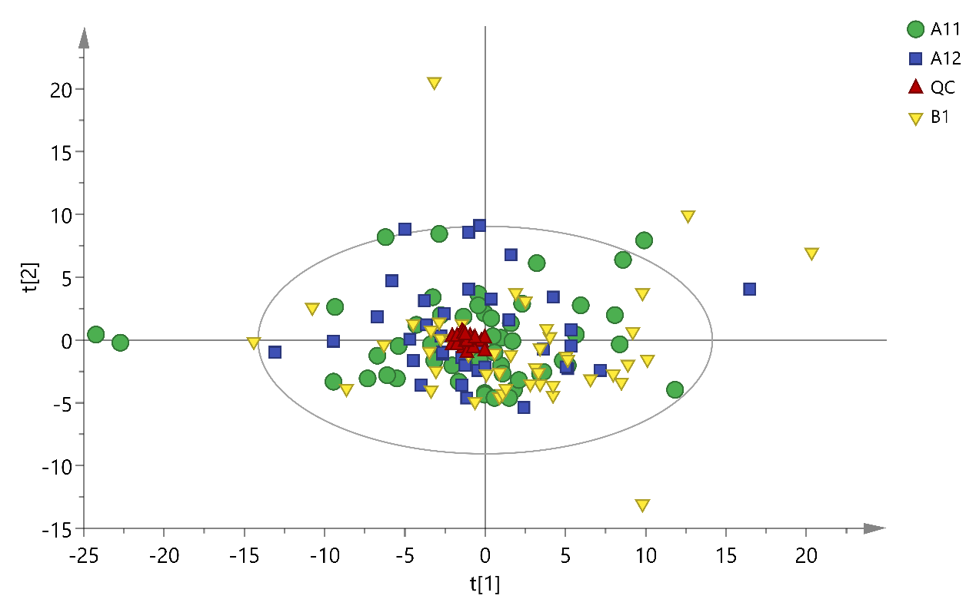
Figure S2 Unsupervised PCA score plot of healthy controls, HUA patients, gout patients, and quality control (QC) samples. Green circles: healthy controls; blue squares: HUA patients; yellow inverted triangles: gout patients; red triangles: QC samples.
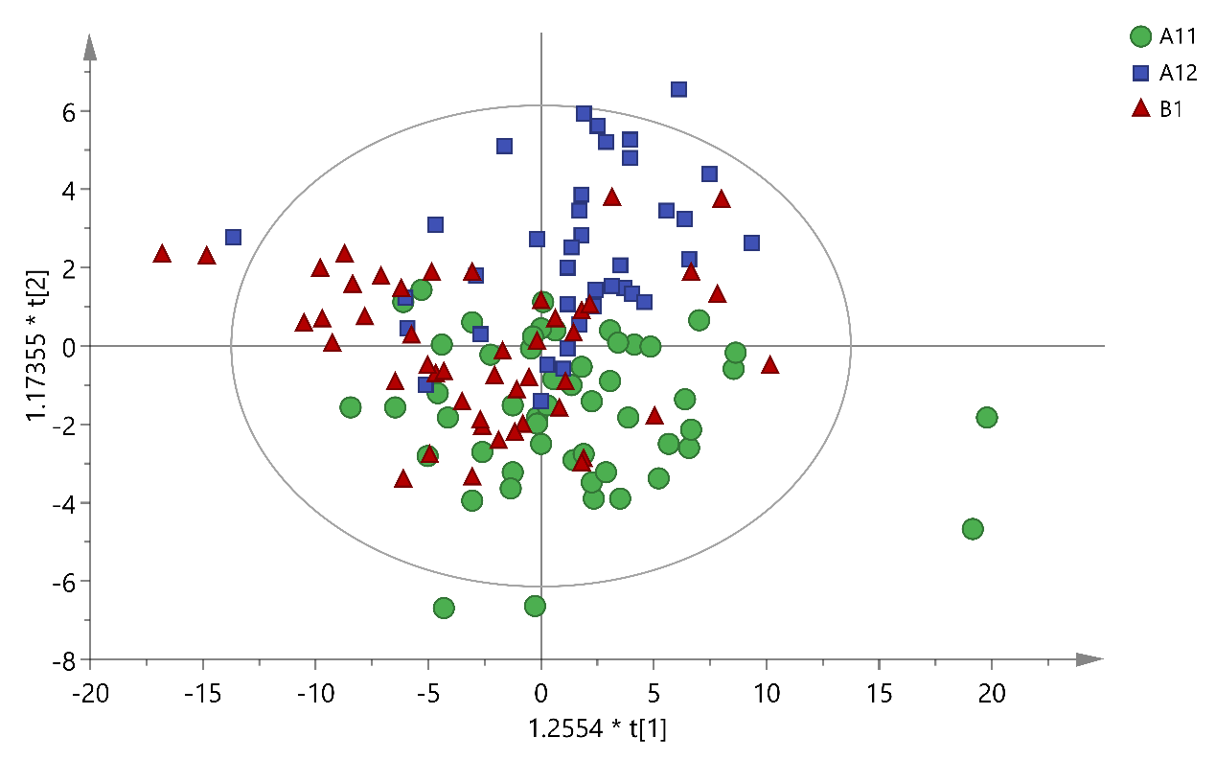
Figure S3 Supervised OPLS-DA score plot of healthy controls, HUA, and gout patients. Green circles: healthy controls; blue squares: HUA patients; red triangles: gout patients.

