Supplementary Information: Metabolic insights into the pathophysiology of tuberculous meningitis in FFPE postmortem human brain tissue

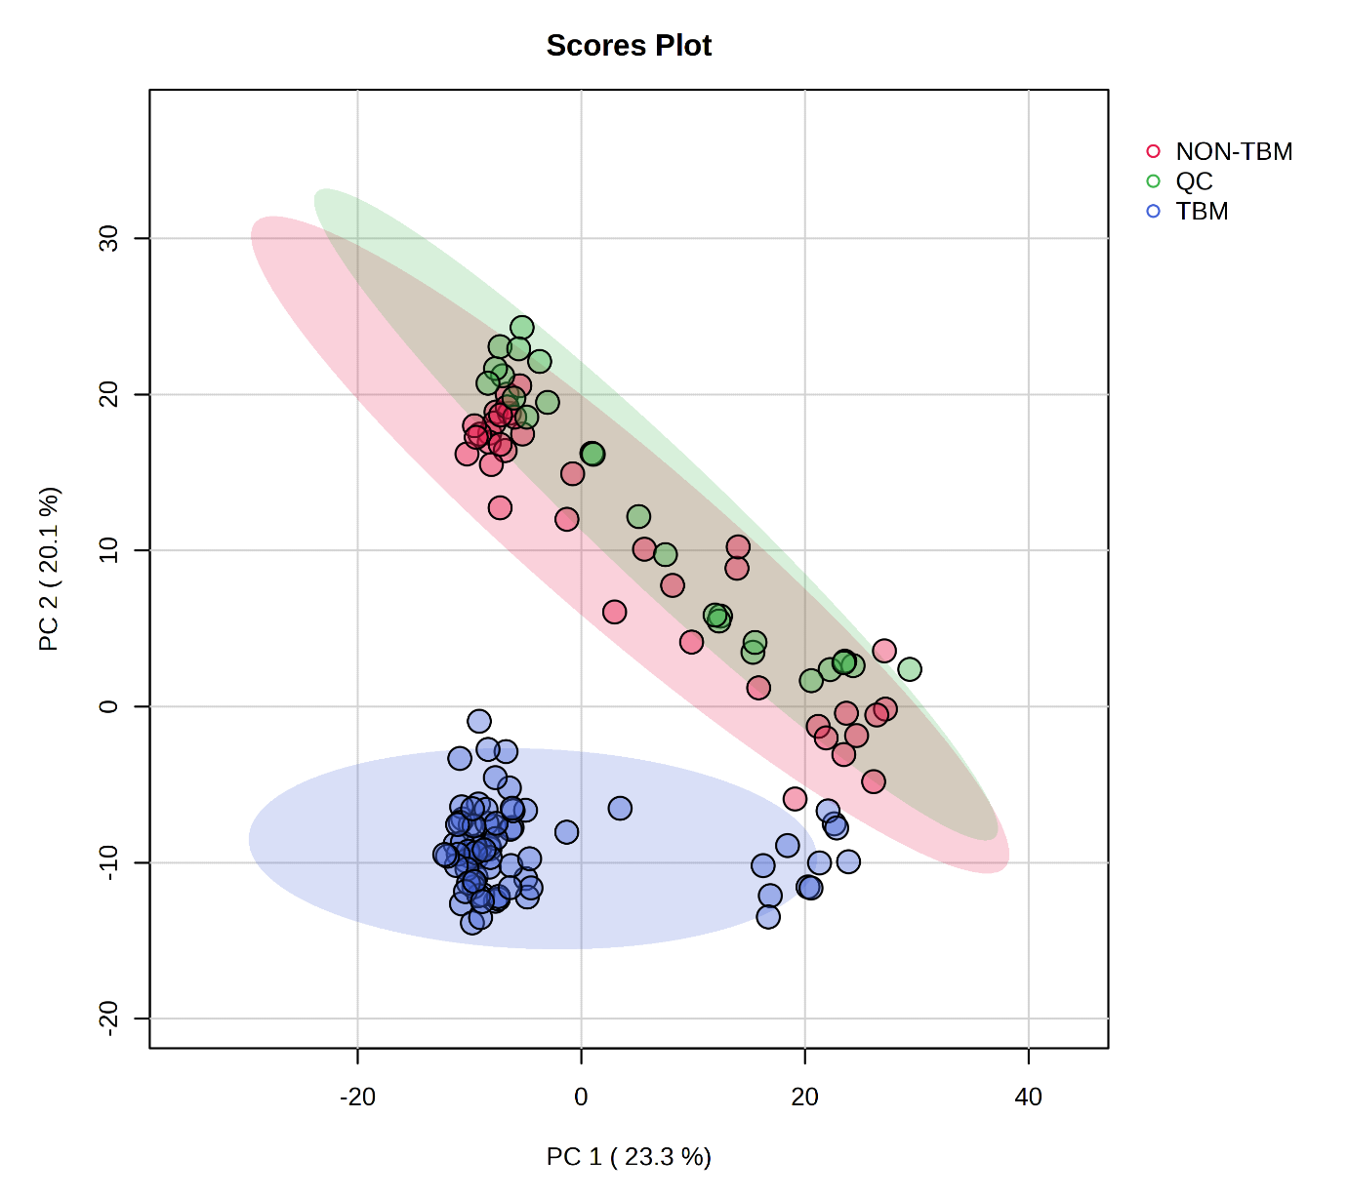
Fig. S1. A PCA scores plot showing PC1 (23.3% of the variance) and PC2 (20.1% of the variance), indicating variation between the sample groups: non-TBM controls (red), TBM group (blue), and QC group (green). Principal components 1 and 2 account for 43.4% of the total variation.

