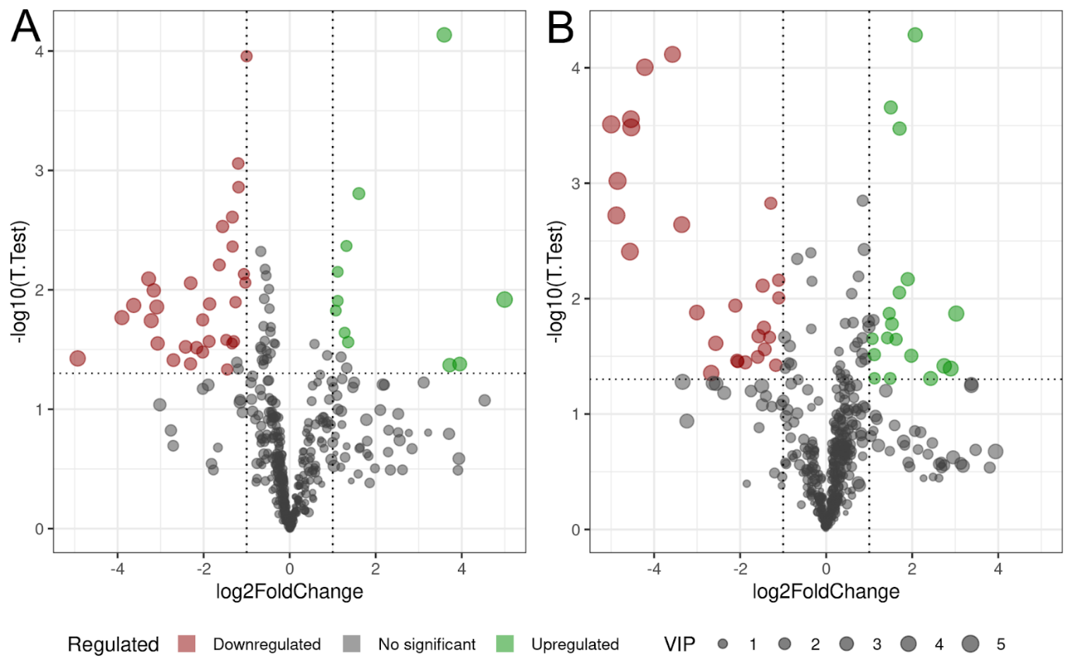
Supplemental Fig. 1. Volcano plots showing differential metabolite abundance in mouse liver following chronic BPA exposure. (A) Negative electrospray ionization mode (ESI−). (B) Positive electrospray ionization mode (ESI+). The x-axis shows log₂ fold change (log₂FC) between BPA-treated and control groups, and the y-axis shows − log₁₀ (t-test p-value). Each point represents a metabolite feature, with point size proportional to the Variable Importance in Projection (VIP) score from the OPLS-DA model. Vertical dashed lines indicate fold-change thresholds, and the horizontal dashed line indicates the statistical significance threshold. Metabolites meeting the predefined criteria for differential abundance are highlighted as downregulated (red) or upregulated (green) in BPA-treated mice, while gray points represent non-significant features.
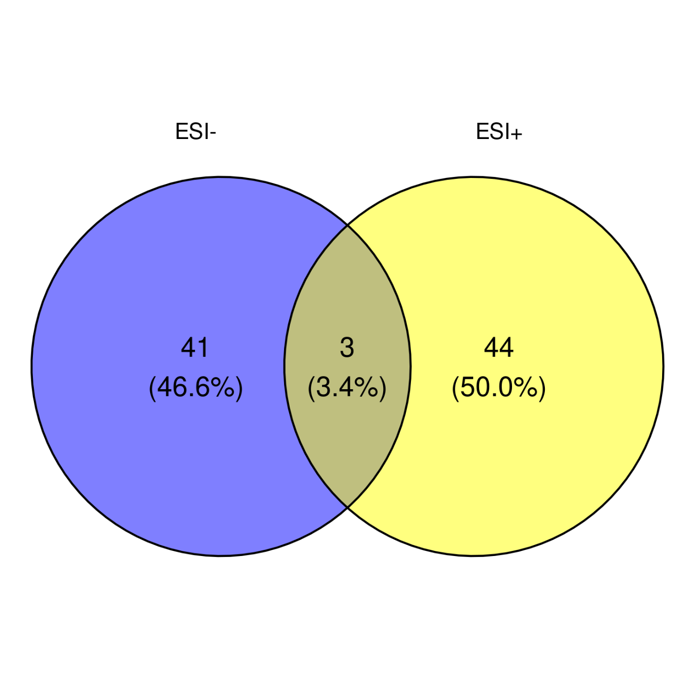Supplemental Fig. 2. Venn diagram depicting the distribution of differentially abundant metabolites (DAMs) identified in liver tissue using ESI− (blue) and ESI+ (yellow) ionization modes. Unique DAMs detected in each mode are shown in the non-overlapping regions, while shared metabolites are presented in the central intersection.

