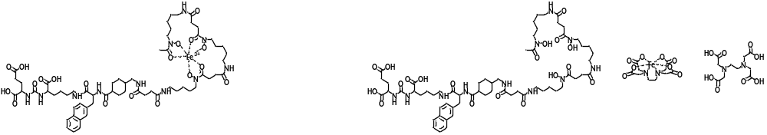
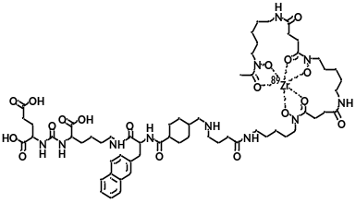
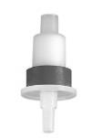
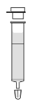
Incubation for 30 min at 35 ºC
296 µl 25 µM EDTA solution
(pH 4.3 – 4.5) +
74 µl of precursor (I) (1 nmol/ µl DMSO)
1.Water
Waste Water
[Fe(III)EDTA]⁻
EDTA
2. EtOH
MidiTrap
G-10
MWCO: 700
Solvent exchange
Waste: EtOH
Water
EuK-2NaI-Amc-N-sucDf (II, iron-free precursor)
in aqueous solution
Zr-89 in 1 M oxalic acid
1 M Na₂CO₃
0.5 M HEPES
0.25 M NaOAc
Water
[⁸⁹Zr]Zr-PSMA-DFO
Saline
solution
Waste Water
Free Zr-89
70% EtOH
I: EuK-2Nal-AMCH-N-sucDf-Fe
Precursor
II: EuK-2Nal-AMCHN-sucDf
Precursor (iron-free)
III: [⁸⁹Zr]Zr-PSMA-DFO
Radioligand
II (iron free precursor)
Supplementary Figure 1 Schematic demonstration of labeling procedure of.
Step 1 is the remove of Fe (III) from EuK-2Nal-AMCH-N-sucDf-Fe by transchelation to EDTA. 100 µg (74 nmol) of precursor is dissolved in DMSO (1 nmol/µl). To this solution, 296 µl (7.4 µmol) of an EDTA solution (25 µM) is added and the reaction mixture is incubated for 30 min at 35 ºC (pH 4.3 – 4.5). Step 2 is the isolation of the free iron compound. After 30 min, EDTA and [Fe(III)EDTA]⁻ are removed by solid phase extraction (Sep-Pak™ C₁₈ plus light cartridge). Then the free iron compound in EtOH is passed through a PD MidiTrap™ G-10 column to have it in water (1.2 ml). Step 3 is the labeling EuK-2Nal-AMCH-N-sucDf. To 1 ml of Zr-89 in 1 M oxalic acid solution, 1.2 ml of 1 M sodium carbonate, 2 ml of 0.5 M HEPES (pH 6.8 - 7.2) are added, followed by 838 µl of 0.25 M sodium acetate (gentisic acid 5mg/ml) and 162 µl of the free iron compound in water, final pH 6.8-7.2. After 2 h, reaction mixture mixture (5.2 ml) is given to a Sep-Pak™ C₁₈ plus light cartridge and the Zr-89-N-sucDf-AMCHA-2Nal-EuK ([⁸⁹Zr]Zr-PSMA-DFO) is eluted with 1 ml of 70% EtOH.

