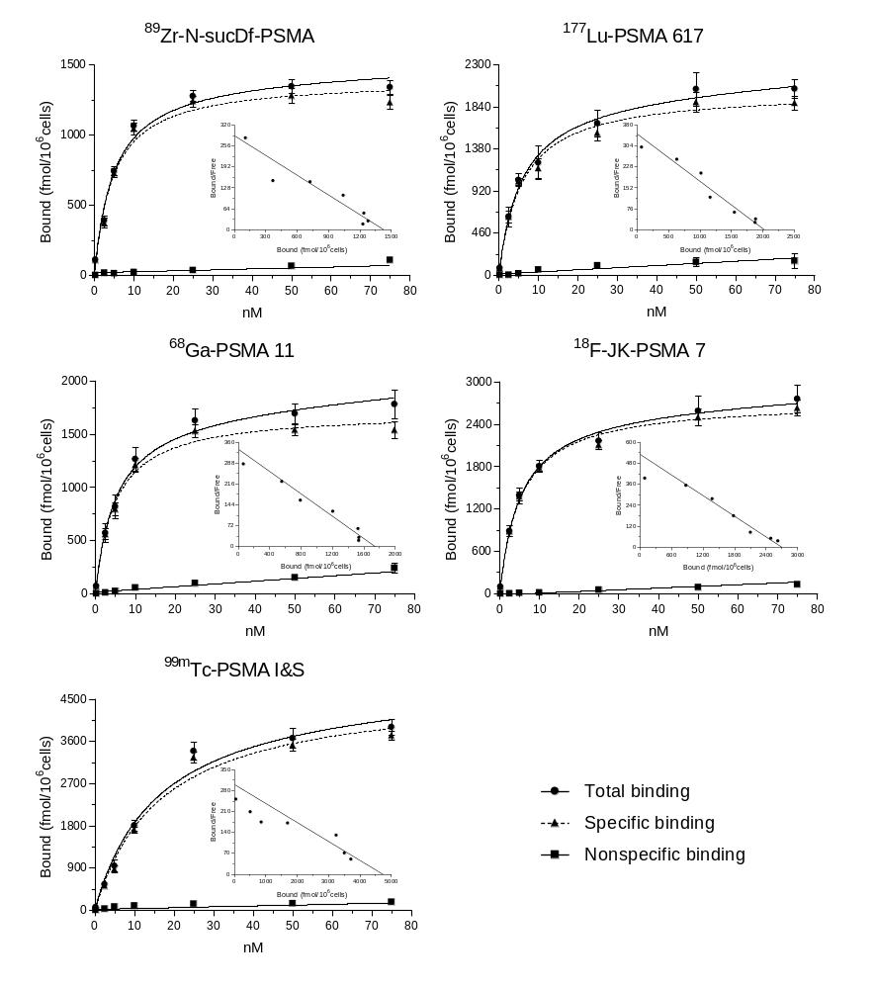
K_{d} = 5.07 ± 0.45 nM
[¹⁸F]F-JK-PSMA-7
K_{d} = 5.15 ± 0.60 nM
[⁶⁸Ga]Ga-PSMA-11
[⁸⁹Zr]Zr-PSMA DFO
K_{d} = 4.97 ± 0.57 nM
Supplementary Figure 2.
Radioligand binding assay on LNCaP cells. The total, specific and non-specific binding has been plotted against increasing concentrations ranging from 0.25 to 75 nM of [⁸⁹Zr]Zr-PSMA-DFO, [⁶⁸Ga]Ga-PSMA-11 and [¹⁸F]F-JK-PSMA-7

