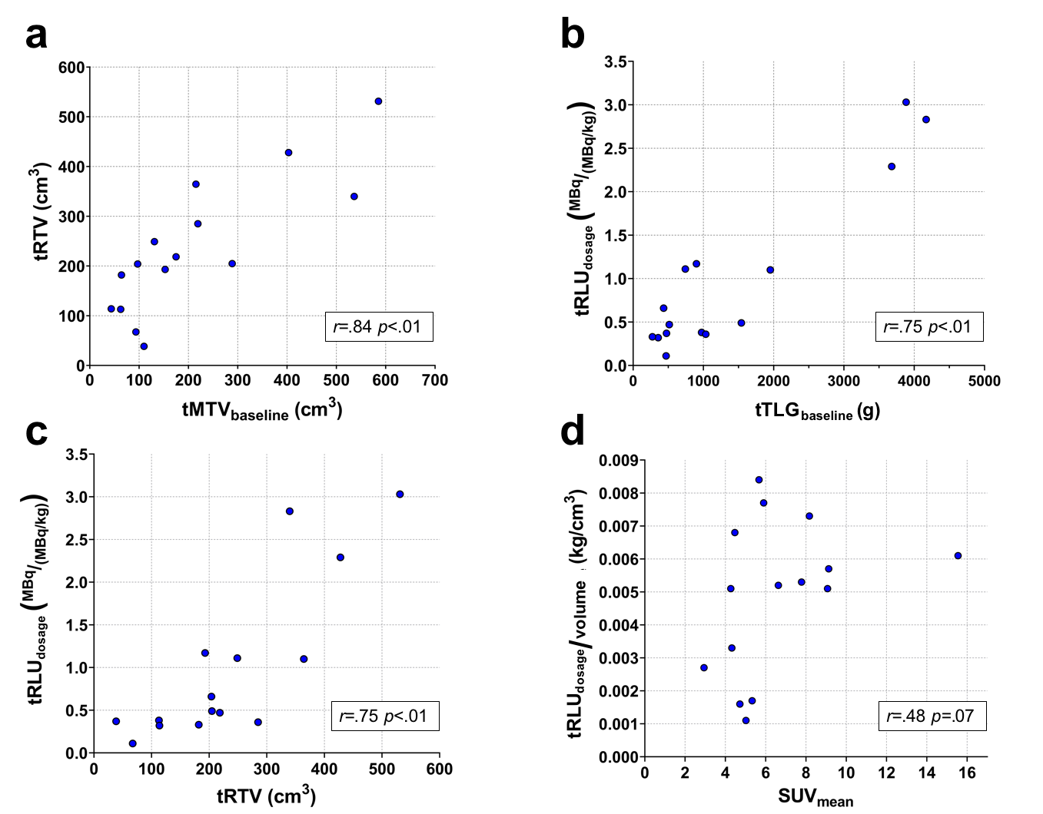
Supplementary Fig. 1. (a) The ¹⁷⁷Lu-lilotomab satetraxetan uptake volume tRTV plotted against tMTV_{baseline}. A statistically significant correlation between the volumes tMTV_{baseline} and tRTV was found as expected (b) The ¹⁷⁷Lu-lilotomab satetraxetan uptake normalized by dosage level, tRLU_{dosage}, plotted against tTLG_{baseline}. A significant correlation between tTLG_{baseline} and tRLU_{dosage} indicates that ¹⁷⁷Lu-lilotomab satetraxetan targets FDG avid viable tumor cells as visualized by PET. (c) tRLU_{dosage} plotted against tRTV (day 4) shows that increasing tumor volume does not have a reducing effect on ¹⁷⁷Lu-lilotomab satetraxetan uptake intensity. (d) ¹⁷⁷Lu-lilotomab satetraxetan activity concentration tRLU ^{dosage} /volume plotted against SUV_{mean}. Lacking correlation between tRLU ^{dosage}/volume and baseline SUV_{mean} can be interpreted as glucose metabolism not necessarily correspond with CD37 expression. For all panels; blue dots represent data for individual patients and results from the Spearman-rank correlation tests are indicated in each panel.

