Figure S1. ⁸⁹Zr-Isatuximab stability results summary
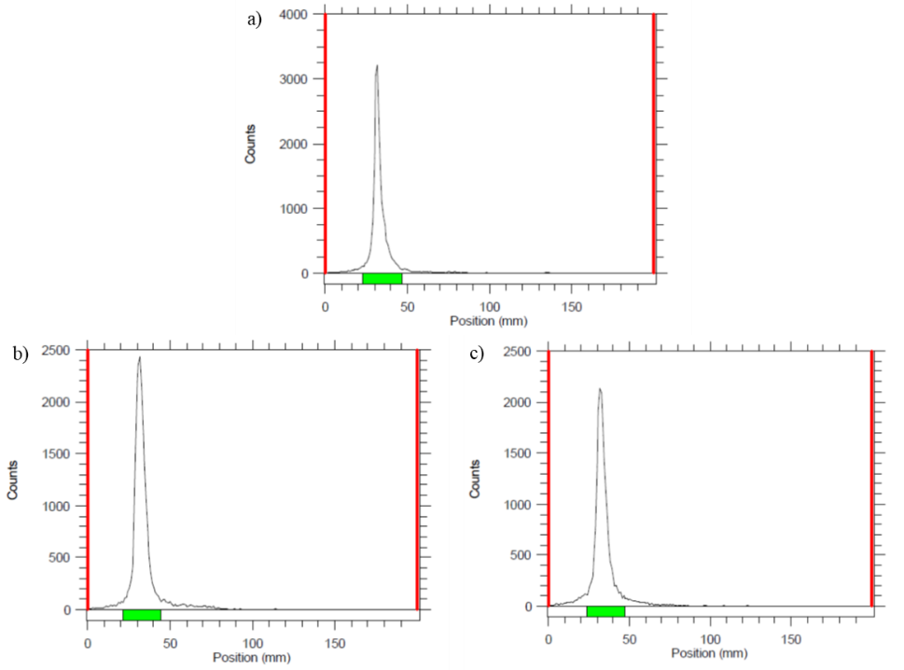
Figure S2. ⁸⁹Zr-Isatuximab iTLC 7d stability results in a) 0.9% saline, b) mouse serum, and c) human serum.

Figure S3. Immunoreactivity results for DFO-Isatuximab with a 16:1 molar ratio.

