Supplemental Material

Supplemental Table 1 patient based biochemical and PET-derived values
Patient | Ca [mmol/l] | Ph [mmol/l] | FGF23 [%] | NTx [BCE/l] | TRP  [%] | TmP/GFR [mmol/l] | SUVmax PMT | SUVpeak PMT | SUVmean PMT | TV [ml] PMT | TLU [ml] PMT | SUVmax  fracture | SUVpeak fracture
01 | 2.5 | 0.66 | 329 | 33.5 | 74 | 0.66 | 15.79 | 7.14 | 8.88 | 1.19 | 10.61 | 1.62 | 1.01
02 | 2.69 | 1.41 | 800 | 14.3 | 90 | 1.4 | 0.00 | 0.00 | 0.00 | 0.00 | 0.00 | 0.00 | 0.00
03 | 2.35 | 1.06 | 452 | 14.2 | 58 | 1.06 | 60.28 | 17.27 | 38.35 | 0.25 | 9.54 | 2.55 | 1.66
04 | 2.32 | 0.57 | 299 | 25.0 |  |  | 7.08 | 4.42 | 4.27 | 1.74 | 7.43 | 4.2 | 2.39
05 | 2.32 | 0.69 | 207 | 13.2 | 86 | 0.69 | 9.11 | 5.09 | 5.47 | 1.37 | 7.49 | 7.24 | 4.76
06 | 2,32 | 0.53 | 1214 | 21.5 | 42 | 0.53 | 33.36 | 15.75 | 18.82 | 2.44 | 45.9 | 2.73 | 1.23
07 | 2.18 | 0.41 | 85 | 13.2 | 61 | 0.41 | 75.15 | 39.56 | 48.29 | 2.04 | 98.53 | 5.76 | 2.9
08 | 2.35 | 0.53 | 102 | 23.0 | 61 | 0.53 | 14.8 | 7.41 | 8.32 | 1.34 | 11.18 | 3.8 | 1.54
09 | 2.37 | 0.52 | 146 | 12.7 |  |  | 7.82 | 4.27 | 4.82 | 1.74 | 8.39 | 2.85 | 1.88
10 | 2.54 | 0.87 | 1818 | 39.0 | 82 | 0.87 | 0.00 | 0.00 | 0.00 | 0.00 | 0.00 | 0.00 | 0.00
11 | 254 | 0.67 | 182 | 22.1 | 59 | 0.67 | 9.61 | 8.83 | 5.28 | 2.44 | 12.87 | 4.56 | 2.69
12 | 2.47 | 0.55 | 340 | 29.8 | 80 | 0.55 | 92.36 | 42.7 | 59.4 | 1.41 | 83.76 | 5.1 | 3.34
13 | 2.23 | 1.07 | 1429 | 7.0 |  | 1.07 | 0.00 | 0.00 | 0.00 | 0.00 | 0.00 | 0.00 | 0.00
14 | 2.25 | 0.60 | 44 | 22.4 | 62 | 0.60 | 5.5 | 2.72 | 3.11 | 1.2 | 3.75 | 2.84 | 1.73
15 | 2.57 | 0.47 | 490 | 20.3 | 86 | 0.47 | 36.77 | 20.34 | 20.86 | 1.84 | 38.4 | 7.35 | 4.28
16 | 2.39 | 0.55 | 100 |  | 87 | 0.55 | 0.00 | 0.00 | 0.00 | 0.00 | 0.00 | 0.00 | 0.00
17 | 2.35 | 0.49 | 77 |  | 83 | 0.49 | 0.00 | 0.00 | 0.00 | 0.00 | 0.00 | 0.00 | 0.00
18 | 2.27 | 0.80 | 150 |  | 87 | 0.80 | 0.00 | 0.00 | 0.00 | 0.00 | 0.00 | 0.00 | 0.00
19 | 2.54 | 0.89 | 118 | 16.4 | 89 | 0.89 | 0.00 | 0.00 | 0.00 | 0.00 | 0.00 | 0.00 | 0.00
20 | 2.29 | 0.77 | 90 | 6.7 | 74 |  | 0.00 | 0.00 | 0.00 | 0.00 | 0.00 | 0.00 | 0.00

Abbreviations: Ca: calcium; Ph: phosphate; FGF23: fibroblast growth factor 23; NTx: N-terminal telopeptide; TRP: tubular reabsorption of phosphate; TmP/GFR: tubular maximum phosphate reabsorption capacity; SUV: standardized uptake value; TV: tumor volume; TLU: Total lesion uptake
Supplemental Table 2 PET parameter and laboratory values
PET Parameter (n = 12) |  | median | range
PMT | SUVmax | 15.30 | 5.50 – 92.36
PMT | SUVpeak | 8.12 | 2.72 – 42.70
PMT | SUVmean | 8.6 | 3.11 – 59.40
PMT | TV [ml] | 1.58 | 0.25 – 2.44
PMT | TLU [ml] | 10.90 | 3.75 – 98.53
Hottest fracture | SUVmax | 4.00 | 1.62 – 7.35
Hottest fracture | SUVpeak | 2.14 | 1.01 – 4.76
Laboratory values (n = 20) | Normal range | median | range
Calcium [mmol/l] | 2.1 – 2.6 | 2.36 | 2.18 – 2.57
Phosphorus [mmol/l] | 0.87 -1.45 | 0.63 | 0.41 -1.06
ALK [U/l] | 53.00 – 128.00 | 205.50 | 67.00 – 481.00
PTH [pg/ml] | 15.00 – 57.00 | 51.80 | 12.90 – 284.50
Vitamin D [ng/ml] | 20.00 – 40.00 | 27.00 | 11.00 – 54.00
FGF23 [%] | 35 – 100 | 176 | 44 – 1214
N-Telopeptide [BCE/l] | 5.40 – 24.20 | 20.90 | 12.70 – 33.50
TRP [%] | 82 – 90 | 74 | 42 – 86
TmP/GFR [mmol/l] | 0.80 – 1.60 | 0.66 | 0.41 – 1.10
Abbreviations: ALK: alkaline phosphatase; FGF23: fibroblast growth factor 23; PMT: phosphaturic mesenchymal tumors; PTH: parathyroid hormone; SUV: standardized uptake value; TLU: total lesion uptake; TmP: tubular maximum of phosphate reabsorption; TmP/GFR: tubular maximum of phosphate reabsorption capacity; TRP: tubular reabsorption of phosphate; TV: tumor volume

Supplemental Table 3 PMT in SSTR – directed PET/CT
 |  | number [n] | percentage [%]
Detection of PMT in SSTR-directed PET/CT |  | 12 | 60
PMT positive patients (n = 12) |  | number [n] | percentage [%] or range
Localization of PMT in SSTR- directed PET/CT | lower limb | 6 | 50
Localization of PMT in SSTR- directed PET/CT | trunk | 4 | 33
Localization of PMT in SSTR- directed PET/CT | pelvis | 1 | 8
Localization of PMT in SSTR- directed PET/CT | hand/foot | 1 | 8
Origin of PMT | bone | 4 | 19
Origin of PMT | soft tissue | 8 | 38
Pathological fractures parallel to detected PMT |  | 23 | 3 - 69
Abbreviations: PMT: phosphaturic mesenchymal tumors; SSTR: somatostatin receptor
Supplemental Table 4: IRS for all PMT+ patients (n = 12). Proportion: 0 for 0 %, 1 for 1-9 %, 2 for 10-50 %, 3 for 51 – 80 % and 4 ≥ 80 %. Intensity: 1 for weak intensity, 2 for medium intensity and 3 for strong intensity.
Patient | Proportion [%] | intensity | IRS [proportion x intensity]
01 | 4 | 2 | 8
03 | 4 | 3 | 12
04 | n.e. | n.e. | n.e.
05 | 3 | 1 | 3
06 | 3 | 2 | 6
07 | 2 | 2 | 4
08 | 4 | 3 | 12
09 | 2 | 3 | 6
11 | 1 | 1 | 1
12 | 3 | 3 | 9
14 | 2 | 1 | 2
15 | 3 | 2 | 6
Abbreviations: IRS: immunoreactive score; n.e.: not evaluable; PMT: phosphaturic mesenchymal tumors; SSTR: somatostatin receptor

Supplemental Table 5: Spearman rank test PET values and biochemical values
Correlation parameters |  | number | r-value | p-value
SUVmax | Calcium [mmol/l] | 12 | 0.22 | 0.49
SUVmax | Phosphorus [mmol/l] | 12 | -0.25 | 0.44
SUVmax | FGF23 [%] | 12 | 0.48 | 0.12
SUVmax | N-Telopeptide [BCE/l] | 12 | -0.01 | 1.00
SUVmax | TRP [%] | 10 | -0.08 | 0.83
SUVmax | TmP/GFR [mmol/l] | 10 | -0.38 | 0.27
SUVpeak | Calcium [mmol/l] | 12 | 0.24 | 0.44
SUVpeak | Phosphorus [mmol/l] | 12 | 0.27 | 0.39
SUVpeak | FGF23 [%] | 12 | 0.46 | 0.13
SUVpeak | N-Telopeptide [BCE/l] | 12 | -0.01 | 1.00
SUVpeak | TRP [%] | 10 | -0.09 | 0.82
SUVpeak | TmP/GFR [mmol/l] | 10 | -0.46 | 0.19
SUVmean | Calcium [mmol/l] | 12 | 0.17 | 0.60
SUVmean | Phosphorus [mmol/l] | 12 | -0.24 | 0.45
SUVmean | FGF23 [%] | 12 | 0.48 | 0.12
SUVmean | N-Telopeptide [BCE/l] | 12 | -0.04 | 0.92
SUVmean | TRP [%] | 10 | 0.01 | 1.00
SUVmean | TmP/GFR [mmol/l] | 10 | -0.37 | 0.29
TV [ml] | Calcium [mmol/l] | 12 | 0.04 | 0.90
TV [ml] | Phosphorus [mmol/l] | 12 | -0.05 | 0.08
TV [ml] | FGF23 [%] | 12 | 0.11 | 0.74
TV [ml] | N-Telopeptide [BCE/l] | 12 | -0.27 | 0.39
TV [ml] | TRP [%] | 10 | -0.18 | 0.62
TV [ml] | TmP/GFR [mmol/l] | 10 | -0.49 | 0.15
TLU [ml] | Calcium [mmol/l] | 12 | 0.23 | 0.48
TLU [ml] | Phosphorus [mmol/l] | 12 | -0.51 | 0.09
TLU [ml] | FGF23 [%] | 12 | 0.30 | 0.34
TLU [ml] | N-Telopeptide [BCE/l] | 12 | -0.01 | 1.00
TLU [ml] | TRP [%] | 10 | -0.14 | 0.70
TLU [ml] | TmP/GFR [mmol/l] | 10 | -0.71 | 0.03
Abbreviations: FGF23: fibroblast growth factor 23; SUV: standardized uptake value; TLU: total lesion uptake; TmP/GFR: tubular maximum of phosphate reabsorption capacity; TRP: tubular reabsorption of phosphate; TV: tumor volume
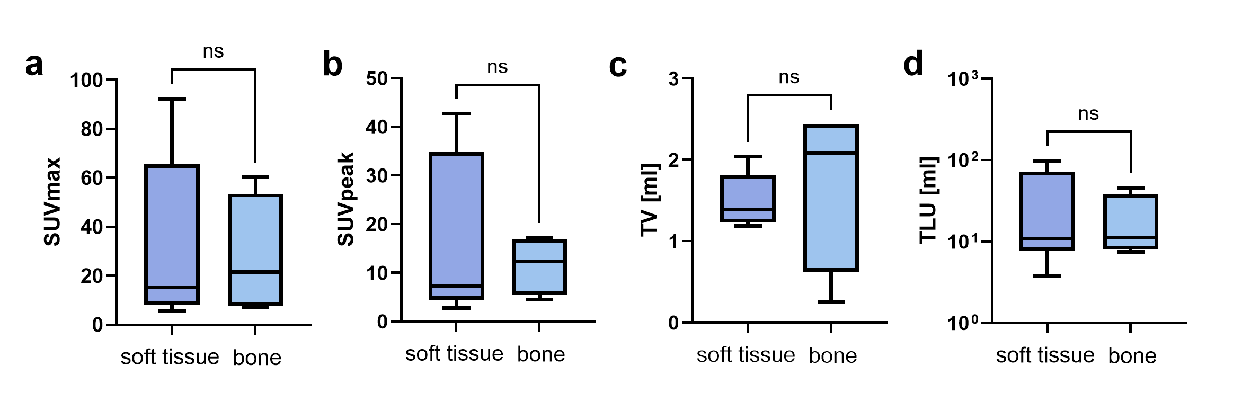
Supplemental Fig. 1 No significant differences in PMT of osseous and soft tissue origin in PET-derived parameters SUVmax (A), SUVpeak (B), TV (C) and TLU (D).
Abbreviations: PMT: phosphaturic mesenchymal tumors; SUV: standardized uptake value; TLU: total lesion uptake; TV: tumor volume
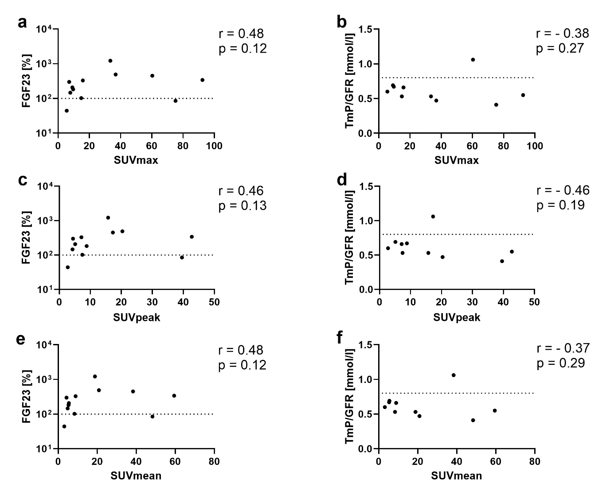
Supplemental Fig. 2 Correlation of PET derived values SUVmax (A-B), SUVpeak (C-D), SUVmean (E-F) and biochemical values FGF23 (A; C; E) and TmP/GFR (B; D; F).
Abbreviations: FGF23: fibroblast growth factor 23; SUV: standardized uptake value; TmP/GFR: tubular maximum of phosphate reabsorption capacity

