Proof-of-concept of CAIX-targeted α-particle delivery in a patient-derived hypoxic head and neck squamous cell carcinoma model
Sylvia T.M. Wenker^{1,2}, Gerben M. Franssen¹, Janneke D.M. Molkenboer-Kuenen¹, Mark W. Konijnenberg^{1,3}, Daphne Lobeek^{1,4}, Giulia Tamborino³, Hans Peters², Sanne A.M. van Lith¹, Sandra Heskamp¹, Johan Bussink²

¹Department of Medical Imaging: Nuclear Medicine, Radboudumc, Nijmegen, The Netherlands
²Department of Radiation Oncology: Radiotherapy & Oncoimmunology laboratory, Radboudumc, Nijmegen, The Netherlands
³Department of Radiology & Nuclear Medicine, Erasmus MC, Rotterdam, The Netherlands
⁴Department of Radiology and Nuclear Medicine, Catharina Hospital, Michelangelolaan 2, 5623EJ Eindhoven, The Netherlands

Corresponding author: Sandra Heskamp, +31 24 36 14511, sandra.heskamp@radboudumc.nl

First author: Sylvia T.M. Wenker

Supplemental material & methods

Conjugation
Humanized IgG1 anti-CAIX monoclonal antibody girentuximab (hG250) (provided by Telix Pharmaceuticals, Melbourne, Australia) was functionalized with p-SCN-Bn-DOTA (1020407-41-3 Macrocyclics, Plano, USA) as described previously [1]. P-SCN-Bn-DOTA (15 eq) in DMSO (Millipore, Burlington, MA, USA) was added to hG250 (1 eq) in 0.1 M NaHCO₃ buffer (pH=9) (Sigma-Aldrich, Saint Louis, MS, USA) at 350 rpm at room temperature (RT) for 1 h. The reaction mixture was dialyzed against 0.25 M ammonium acetate (Sigma-Aldrich) pH=5.5 containing 2 g/L chelex resin (Biorad, San Francisco, USA). The concentration of hG250-Bn-DOTA (DOTA-hG250) was calculated from the absorption at 280 nm measured on the Infinite m200pro (Tecan, Zürich, Switzerland).

Radiolabeling and quality control
DOTA-hG250 was incubated with indium-111 (¹¹¹In) chloride (Curium, Petten, the Netherlands) in 0.5 M 2-(N-morpholino)ethanesulfonic acid (MES) (Sigma-Aldrich) buffer pH 5.5 at 37°C for 30 min, with molar activities ranging from 18 to 240 MBq/nmol. DOTA-hG250 was incubated with ²²⁵Ac chloride (van Overeem Nuclear bv, Breda, the Netherlands) in 0.1 M TRIS (Sigma-Aldrich) buffer pH 9 at 37°C for 30 min, with a molar activity of 150 kBq/nmol. Radiochemical purity were based on instant thin-layer chromatography (iTLC) on a silica gel chromatography strip (Agilent Technologies, Santa Clara, CA, USA) using 0.1 M citrate buffer (Sigma-Aldrich) pH 6 as the mobile phase. For [¹¹¹In]In-DOTA-hG250, iTLC was evaluated using the Typhoon FLA 7000 (GE Healthcare, Chicago, IL, USA). For [²²⁵Ac]Ac-DOTA-hG250, the iTLC strip was cut in 10 pieces which were measured in a γ-counter (Wizard-2480, Perkin Elmer, Waltham, MA, USA), using the francium-221 (²²¹Fr) signal as a surrogate for ²²⁵Ac (measured 1 h after running the iTLC, at ²²¹Fr/²²⁵Ac equilibrium) [2-4]. Radiochemical purity exceeded 95%.

Cell culture
CT26-CAIX cells, a hCAIX-transfected murine colorectal carcinoma cell line, were kindly provided by Prof D. Neri Swiss Federal Institute of Technology, Zürich, Switzerland [5]. SK-RC-52 cells, a human clear cell renal cell carcinoma cell line, were kindly provided by Memorial Sloan Kettering Cancer Center, New York (CVCL_6198). CT26-CAIX cells and SK-RC-52 cells were cultured as previously described [6].

Immunoreactive fraction (IRF)
The IRF of [¹¹¹In]In-DOTA-hG250 and of [²²⁵Ac]Ac-DOTA-hG250 was determined as described previously [7]. The IRF of [¹¹¹In]In-DOTA-hG250 was determined in CT26-CAIX cells and the IRF of [²²⁵Ac]Ac-DOTA-hG250 was determined in SK-RC-52 cells. Both cell lines constitutively overexpress CAIX independent of oxygen levels as previously described [6]. A serial dilution of CT26-CAIX and SK-RC-52 cells (5.84x10⁴ – 1.5x10⁷ and 2.54 x10⁴ – 1.30x10⁷ cells/mL, respectively) in RPMI (Gibco, Thermo Fisher Scientific, Waltham, MA, USA) containing 0.5% bovine serum albumin (BSA) (Sigma-Aldrich, Saint Louis, MS, USA) were incubated with 2,017 counts per minute (cpm) [¹¹¹In]In-DOTA-hG250 (0.89 fmol per well) and 9,016 cpm [²²⁵Ac]Ac-DOTA-hG250 (2.92 pmol per well), respectively at 37°C. After 20 min, cells were centrifuged (300 g, 5 min), washed, and the activity in the cell pellet was measured in a γ-counter. The bound activity fraction of the total added activity was plotted against the cell concentration in Graphpad Prism (version 10.6), and the IRF was obtained from a nonlinear one phase exponential association fit.

Animal experiments
All animal experiments were conducted in accordance with the principles laid out by the Dutch Act on Animal Experiments and ethical approval was provided by the institutional Animal Welfare Committee of the Radboud University Medical Center and the Central Authority for Scientific Procedures on Animals and carried out under the supervision of the local Animal Welfare Body. In total, 40 female wild type Balb/c nu/nu (6-8 weeks, Janvier Laboratories, Le Genes-Saint-Ile, France) were used. Mice were housed in individually ventilated cages with ad libitum access to animal chow and water. Before starting the experiment, animals were allowed to acclimatize for at least one week. Mice were transplanted subcutaneously with SCCNij153 tumor chunks (diameter of ±2 mm) on the right flank. SCCNij153 is a patient-derived HNSCC xenograft which is maintained through subcutaneous transplantation in female Balb/c nu/nu mice at the central animal facility of the Radboudumc [8]. Previously, we have shown that SCCNij153 tumor cells upregulate CAIX in hypoxic tumor areas [8, 9]. For each animal experiment, the number of animals transplanted with SCCNij153 tumor chunks was determined based on an expected tumor take of 80%. Mice with tumors outside the previous predefined determined tumor size volume range (~100-200 mm³) were excluded. Tumors were measured 1x/week with a caliper and tumor volumes (mm³) were calculated using the following formula: 4/3 * π * length/2 * height/2 *width/2. Allocation to the treatment groups was block-randomized by tumor size, using a random number generator. Due to radiation protection reasons, mice were housed per group. To minimize confounding effects, cages were stored randomly. The order in which mice were treated, measured and examined by the biotechnicians was random, and was performed by biotechnicians blinded for group allocation. The researcher was not blinded during treatment injections, dissection and analysis. Mice were sacrificed by cervical dislocation when humane endpoints (HEP) were reached or at the end of the experiment as assessed by biotechnician blinded for group allocation. HEP were defined as following: tumor volume ≥ 2.0 cm³, tumor ulceration, >20% body weight loss of their initial body weight, or severe clinical deterioration.

Quantitative micro-SPECT/CT imaging
Prior to scanning, mice were anesthetized with isoflurane (2-4 %, flow with air). The torso area of the mice was scanned in prone position at 1, 2, 3 and 7 days p.i. using the U-SPECT6/CT MILabs, GP-M 0.60 mm diameter multipinhole mouse collimator and MILabs U-SPECT/CT acquisition software version 12.29-st. SPECT scans were acquired in one frame, 20 bed positions using an acquisition time of 12 min (day 1), 15.4 min (day 2), 19.7 min (day 3) and 53 min (day 7) per scan. CT scans were acquired for 1.6 min using a one bed position total body scan, default setting with 50 kV and 0.4 mA. Micro-SPECT scans were reconstructed using MILabs reconstruction software version 12.00 using the following parameters: energy window ¹¹¹In (171.0 keV ± 20% [153.9-188.1] and 245.0 keV ± 20% [220.5-269.5], with adjacent scatter windows of 6.8% and 9.8%), 128 subsets, 4 iterations, gaussian FWHM filters of 0.6 mm and a voxel size of 0.4*0.4*0.4 mm. CT scans were reconstructed using a voxel size of 80 µm and Hann filter.

Calculation of the estimated absorbed dose values
Dosimetry calculations for the whole tumor volume and organs were based on the [¹¹¹In]In-DOTA-hG250 biodistribution data, while dosimetry calculations for CAIX+ and CAIX- tumor volumes were based on [¹¹¹In]In-DOTA-hG250 SPECT quantification. Radiotracer uptake (in MBq/mL) in CAIX+ and CAIX- tumor volumes, time integrated activity coefficients (TIAC), absorbed dose values (in Gy/kBq), and the dose-distribution map for ²²⁵Ac, were obtained as previously described [10]. The S-values for a mean tumor volume of 0.15 cm³ were obtained as previously described [11, 12]. Absorbed dose estimates for ²²⁵Ac were derived from [¹¹¹In]In-DOTA-hG250 data using a relative biological effectiveness of 5.

Autoradiography and CAIX Immunofluorescence (IF)
Snap-frozen tumor sections (4 µm) were mounted on FLEX IHC Microscope Slides (Agilent Technologies). Sections were fixated with ice cold acetone at 4°C for 10 min. The slides were exposed to phospholuminescence plates in a Fujifilm BAS cassette 2025 for 1 week and scanned using Typhoon FLA 7000 bioimaging analyzer at a pixel size of 25 µm × 25 µm to obtain autoradiography images. Thereafter, slides were used for imaging of Hoechst (perfusion) and IF staining for CAIX, pimonidazole (hypoxia), 9F1 (vessels) and DAPI (nucleus), as described previously [10, 13]. The spatial correlation between the radiosignal (autoradiography) and CAIX expression (IF) was performed as described previously [10]. Original grey value images were used for quantitative analysis.

CAIX immunohistochemistry (IHC)
FFPE tumor sections (4 µm) were mounted on FLEX IHC Microscope Slides. Sections were deparaffinated and dehydrated, followed by antigen retrieval in 10 mM sodium citrate pH 6.0. Between consecutive steps of the staining process, sections were rinsed 3 times in PBS. Endogenous peroxidase activity was blocked at RT by 10 min incubation with 3% H₂O₂ and non-specific binding was blocked by 30 min incubation with normal goat serum. Immediately after, sections were incubated at RT for 1h with primary anti-CAIX (1:1000 dilution in 1% BSA, #NB100-417, Novus Biologicals). Slides were incubated with secondary antibody at RT by 30 min incubation with goat-anti-rabbit (1:200, BA-1000, Vector Laboratories, Newark, CA, USA) followed by Vectastain ABC-HRP kit according to manufacturer’s instructions (PK-6100, Vector Laboratories). Slides were incubated for 8 min with Bright DAB solution (BS04-500, Immunologic, Arnhem, the Netherlands) and counterstained with hematoxylin, dehydrated and mounted with a cover slip using permount (15832544, ThermoScientific, Waltham, MA, USA). Hematoxylin and Eosin (H&E) stained tumor material were analyzed to determine the necrotic area in percentage of the whole tumor area by draws tumor areas and resulted area.

γH2AX IF
FFPE tumor sections (4 µm) were mounted on FLEX IHC Microscope Slides. Sections were deparaffinated and dehydrated, followed by antigen retrieval in 10 mM sodium citrate pH 6.0. Between consecutive steps of the staining process, sections were rinsed 3 times in Tris-buffered saline with 0.05% Tween (TBST, Merck). Endogenous peroxidase activity was blocked at RT by 10 min incubation with 3% H₂O₂ and non-specific binding was blocked by 10 min incubation with TBST + 1% BSA. Immediately after, sections were incubated at RT for 1h with primary anti-γH2AX antibody (1:500 dilution in TBST + 1% BSA, #9718, Cell Signaling Technology, MA, USA). Slides were incubated with secondary antibody at RT by 30 min incubation with Opal polymer anti-mouse with anti-rabbit HRP (#ARH1001EA, Akoya Biosciences, MA, USA), followed by Opal-620 fluorophore working solution (1:200, #FP1495001KT, Akoya Biosciences) according to manufacturer’s instructions. Again, antigen retrieval was performed as described above. Slides were blocked at RT by 10 min incubation with TBST + 1% BSA. Immediately after, sections were incubated with primary anti-CAIX antibody (1:2000 dilution in 1% BSA, #NB100-417, Novus Biologicals). Slides were incubated with secondary antibody at RT by 30 min incubation with Opal-520 fluorophore working solution (#FP1487001KT, Akoya Biosciences), followed by another antigen retrieval step with 10 mM sodium citrate. Slides were incubated at RT for 2 min with DAPI (#D1306, ThermoFisher, MA, USA) and mounted a cover slip using Fluoromount (F2680 Sigma-Aldrich).

Supplemental Tables
Suppl. Table 1: Overview of mice experiment parameters. n/a: not applicable.
Study | Radiopharmaceutical | Administered activity | # mice | Tumor size at day 0 | Time points | End  points | Statistics
BioD ¹¹¹In | [¹¹¹In]In-DOTA-hG250 | 1.7 ± 0.0 MBq | 20  n=5/  group | 141.5 ± 81.3 mm³ | 1, 2, 3 and 7 days | %IA/g | Descriptive
SPECT | [¹¹¹In]In-DOTA-hG250 | 22.1 ± 0.5 MBq | 7 | 240.8 ± 128.2 mm³ | 1, 2, 3 and 7 days | %IA/mL | One-way ANOVA Kruskall-Wallis test
BioD ²²⁵Ac | [²²⁵Ac]Ac-DOTA-hG250 | 15 kBq | 5  n=2-3/  group | 82.7 ± 14.3 mm³ | 7 days | %IA/g  %IA/g: ²¹³Bi redistribution | n/a  Welch’t t-test

Suppl. Table 2: Ex vivo biodistribution analysis of [¹¹¹In]In-DOTA-hG250 in SCCNij153 tumor-bearing BALB/c nu/nu mice (n=5/group) at 1, 2, 3 and 7 days p.i.. Data represent mean ± SD of tissue uptake expressed as percentage of injected activity per gram (%IA/g).
 | 1 day p.i. | 2 days p.i. | 3 days p.i. | 7 days p.i.
Blood | 20.1 ± 1.7 | 18.9 ± 2.3 | 16.5 ± 3.1 | 9.7 ± 2.7
Tumor | 15.4 ± 6.9 | 20.4 ± 5.9 | 25.4 ± 5.0 | 25.3 ± 4.6
Liver | 6.2 ± 1.0 | 6.5 ± 1.3 | 8.0 ± 1.3 | 6.4 ± 0.9
Kidney | 4.9 ± 0.7 | 4.8 ± 0.5 | 4.3 ± 0.8 | 3.0 ± 0.4
Heart | 4.5 ± 0.6 | 4.8 ± 0.5 | 4.0 ± 1.1 | 2.7 ± 0.8
Lung | 7.9 ± 1.5 | 6.7 ± 1.1 | 6.5 ± 1.3 | 4.4 ± 0.9
Brown Fat | 4.4 ± 0.5 | 5.0 ± 1.0 | 4.2 ± 0.8 | 2.5 ± 0.4
Salivary gland | 5.8 ± 0.9 | 5.8 ± 0.7 | 5.4 ± 1.1 | 4.1 ± 2.0
Stomach | 2.3 ± 0.4 | 2.4 ± 0.3 | 2.2 ± 0.8 | 1.5 ± 0.2
Pancreas | 2.4 ± 0.4 | 2.2 ± 0.2 | 2.3 ± 0.6 | 1.5 ± 0.5
Spleen | 5.7 ± 1.2 | 5.9 ± 0.7 | 7.5 ± 3.0 | 5.5 ± 0.7
Duodenum | 3.9 ± 1.0 | 5.1 ± 3.6 | 5.4 ± 3.5 | 2.8 ± 0.4
Jejunum | 3.2 ± 0.2 | 3.3 ± 1.6 | 3.1 ± 1.7 | 1.5 ± 0.2
Ileum | 3.5 ± 0.5 | 3.1 ± 1.0 | 2.8 ± 0.4 | 1.6 ± 0.2
Colon | 2.1 ± 0.2 | 2.2 ± 0.4 | 1.9 ± 0.6 | 1.2 ± 0.2
Lymph nodes | 6.0 ± 1.5 | 8.7 ± 2.1 | 7.9 ± 1.3 | 8.7 ± 6.6
Bone marrow | 5.4 ± 0.6 | 5.1 ± 0.7 | 6.7 ± 3.4 | 3.4 ± 1.2
Bone | 1.8 ± 0.3 | 2.0 ± 0.8 | 1.9 ± 0.7 | 1.3 ± 0.3
Muscle | 1.3 ± 0.1 | 1.4 ± 0.2 | 1.2 ± 0.2 | 0.7 ± 0.1
Tail | 3.0 ± 0.3 | 3.2 ± 0.4 | 3.1 ± 0.3 | 2.0 ± 0.2

Suppl. Table 3: Uptake (%IA/mL) of [¹¹¹In]In-DOTA-hG250 in CAIX+ and CAIX- tumor area based on SPECT quantification study (n=7). Difference between tumor uptake in CAIX+ and CAIX- tumor is tested using a one-way ANOVA Kruskal-Wallis Dunn’s multiple comparisons test.
 | Tumor uptake (%IA/mL) in CAIX+ tumor area | Tumor uptake (%IA/mL) in CAIX- tumor area | Adjusted P-value
1 day p.i. | 13.9 ± 1.8 | 4.7 ± 0.7 | 0.0035
2 days p.i. | 17.6 ± 4.1 | 6.0 ± 1.0 | 0.0059
3 days p.i. | 20.1 ± 4.2 | 6.7 ± 1.2 | 0.0070
7 days p.i. | 26.8 ± 10.3 | 8.1 ± 2.3 | 0.0053

Suppl. Table 4: Calculated absorbed dose with SD (Gy) of organs at risk for 15 kBq [²²⁵Ac]Ac-DOTA-hG250 in SCCNij153 tumor-bearing BALB/c nu/nu mice based on biodistribution data. Absorbed doses for tumor and kidney are not corrected for the ²¹³Bi redistribution
 | Absorbed dose (Gy) | SD (Gy)
Tumor | 103.9 | 12.7
Liver | 22.0 | 12.7
Kidney | 11.7 | 7.0
Lungs | 16.1 | 7.4
Heart | 10.9 | 5.5
Stomach | 7.0 | 4.0
Pancreas | 7.0 | 3.9
Spleen | 18.4 | 8.2
Small intestine | 10.9 | 4.2

Suppl. Table 5: Ex vivo biodistribution analysis of 15 kBq [²²⁵Ac]Ac-DOTA-hG250 in SCCNij153 tumor-bearing BALB/c nu/nu mice (n=3) at 7 days p.i.. Data represent mean ± SD of tissue uptake expressed as %IA/g.
 | 7 days p.i.
Blood | 11.0 ± 1.5
Tumor | 38.7 ± 3.9
Liver | 9.7 ± 1.8
Kidney | 2.3 ± 0.2
Heart | 4.0 ± 1.2
Lung | 3.0 ± 0.2
Brown Fat | 3.9 ± 0.4
Salivary gland | 3.6 ± 0.9
Stomach | 2.4 ± 0.3
Pancreas | 1.7 ± 0.4
Spleen | 13.2 ± 2.8
Duodenum | 2.5 ± 1.1
Jejunum | 1.5 ± 0.2
Ileum | 1.7 ± 0.2
Colon | 1.4 ± 0.3
Lymph nodes | 10.5 ± 3.7
Bone marrow | 8.5 ± 1.1
Bone | 6.2 ± 1.7
Muscle | 0.9 ± 0.1
Tail | 2.3 ± 0.5

Supplemental Figures

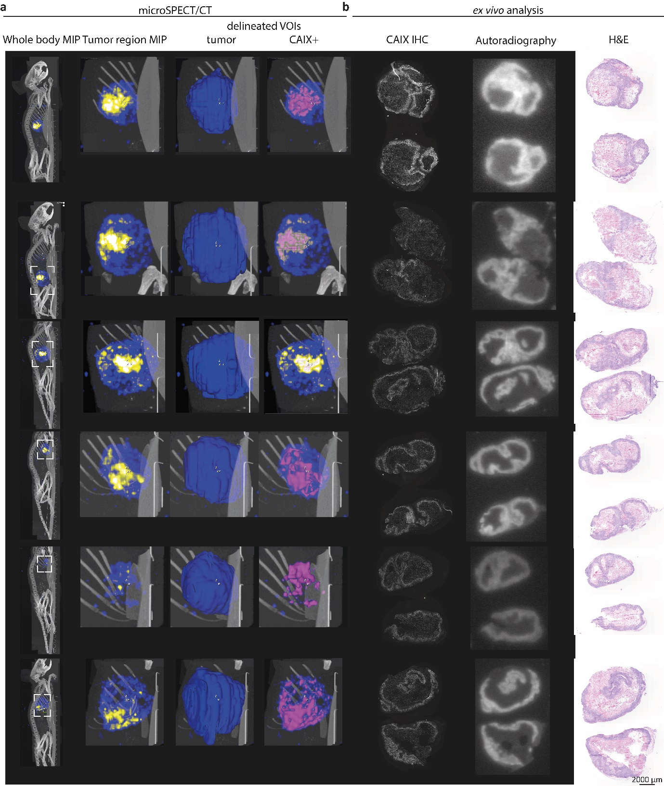
Suppl. Figure 1: Accumulation of [¹¹¹In]In-DOTA-hG250 in SCCNij153 tumor-bearing BALB/c nu/nu mice a A representative SPECT/CT showing uptake at 7 days p.i. showing: whole body MIP, zoomed tumor region MIP, delineated VOIs of the whole tumor and of the CAIX+ tumor volume b CAIX IHC, ex vivo autoradiography and H&E of tumor sections.
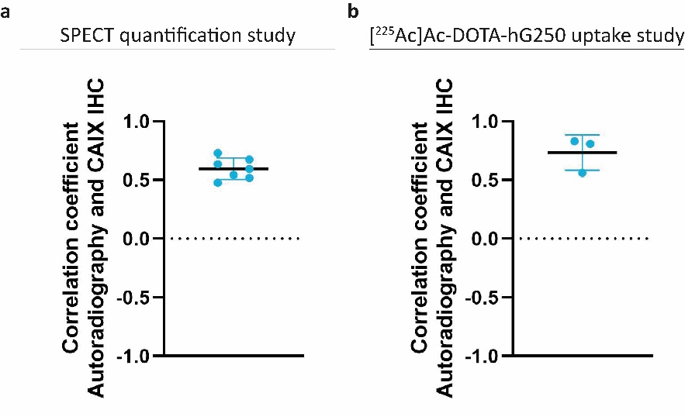
Suppl. Figure 2: Spatial correlation of autoradiography and CAIX IF images expressed as correlation coefficient in SCCNij153 tumor-bearing BALB/c nu/nu mice A Mean and SD from SPECT quantification study (n=7) injected with [¹¹¹In]In-DOTA-hG250 B Mean and SD from [²²⁵Ac]Ac-DOTA-hG250 uptake study (n=3).

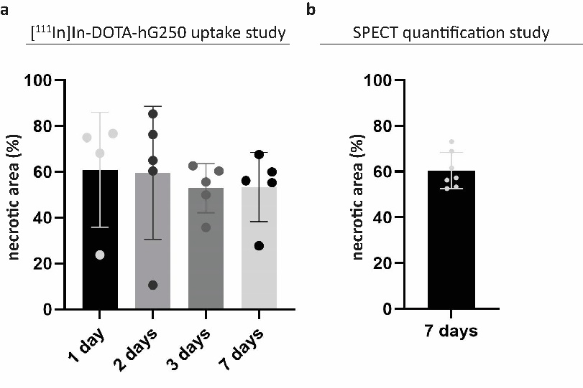
Suppl. Figure 3: Mean and SD of necrotic area in percentage of the total tumor area, based on H&E analysis. A Mice that received [¹¹¹In]In-DOTA-hG250 (n=20) and were sacrificed at day 1, 2, 3 and 7 p.i. for biodistribution analysis. B Mice that received [¹¹¹In]In-DOTA-hG250 (n=7) and were sacrificed at day 7 p.i. for SPECT quantification study.

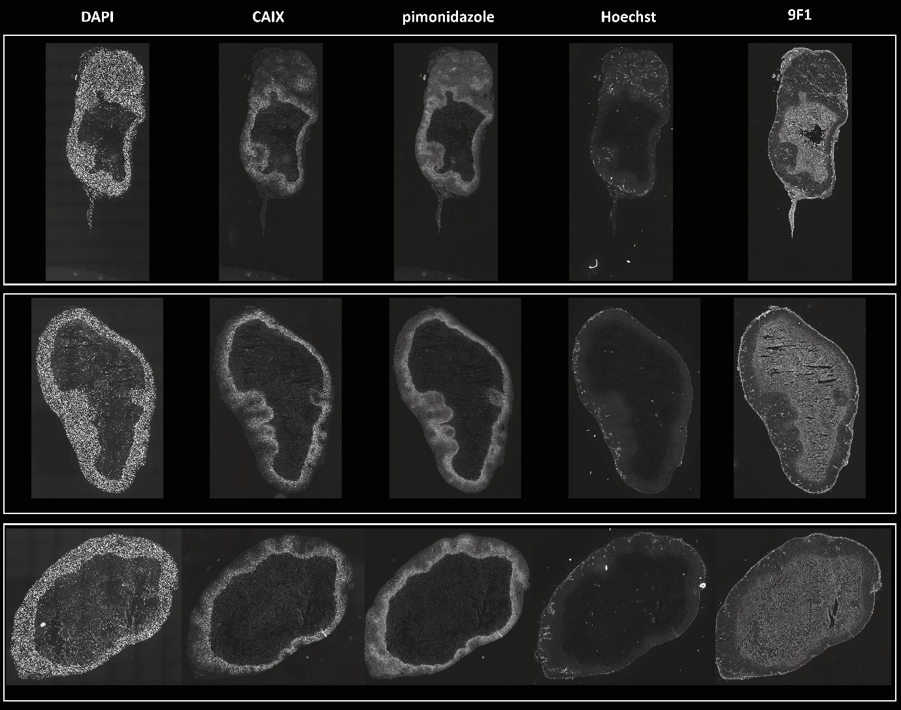
Suppl. Figure 4: Overview of IHC stainings in grey scale images of nuclei (DAPI), CAIX, hypoxia (pimonidazole), perfusion (Hoechst) and vessels (9F1) in tumor sections of SCCNij153 tumor-bearing BALB/c nu/nu mice (n=3) injected with [²²⁵Ac]Ac-DOTA-hG250. Brightness of gray images are adjusted for presenting purposes.

References
1. Lewis, M.R., A. Raubitschek, and J.E. Shively (1994) A facile, water-soluble method for modification of proteins with DOTA. Use of elevated temperature and optimized pH to achieve high specific activity and high chelate stability in radiolabeled immunoconjugates. Bioconjug Chem 5: 565–76.
2. Hooijman, E.L., Y. Chalashkan, S.W. Ling, et al. (2021) Development of [²²⁵Ac]Ac-PSMA-I&T for Targeted Alpha Therapy According to GMP Guidelines for Treatment of mCRPC. Pharmaceutics 13: 715.
3. IAEA (2024) Production and Quality Control of Actinium-225 Radiopharmaceuticals, Vienna
4. Hooijman, E.L., V. Radchenko, S.W. Ling, et al. (2024) Implementing Ac-225 labelled radiopharmaceuticals: practical considerations and (pre-)clinical perspectives. EJNMMI Radiopharm. Chem.. 9: 9.
5. Cazzamalli, S., B. Ziffels, F. Widmayer, et al. (2018) Enhanced Therapeutic Activity of Non-Internalizing Small-Molecule-Drug Conjugates Targeting Carbonic Anhydrase IX in Combination with Targeted Interleukin-2. Clin. Cancer Res. 24: 3656–3667.
6. Kleinendorst, S.C., E. Oosterwijk, J. Molkenboer-Kuenen, et al. (2024) Towards effective CAIX-targeted radionuclide and checkpoint inhibition combination therapy for advanced clear cell renal cell carcinoma. Theranostics 14: 3693–3707.
7. Lindmo, T., E. Boven, F. Cuttitta, et al. (1984) Determination of the immunoreactive function of radiolabeled monoclonal antibodies by linear extrapolation to binding at infinite antigen excess. Journal of immunological methods 72: 77–89.
8. Hoeben, B.A.W., M.H.W. Starmans, R.T.H. Leijenaar, et al. (2014) Systematic analysis of ¹⁸F-FDG PET and metabolism, proliferation and hypoxia markers for classification of head and neck tumors. BMC Cancer 14: 130.
9. Huizing, F.J., B.A.W. Hoeben, G. Franssen, et al. (2017) Preclinical validation of ¹¹¹In-girentuximab-F(ab′)2 as a tracer to image hypoxia related marker CAIX expression in head and neck cancer xenografts. Radiother. Oncol. 124: 521–525.
10. Wenker, S.T.M., M.W. Konijnenberg, D. Lobeek, et al. (2026) CAIX-targeted α therapy directed against hypoxic tumor cells in combination with immune checkpoint inhibitors in a syngeneic mouse tumor model. Theranostics 16: 4508–4520.
11. Tamborino, G., J. Nonnekens, L. Struelens, et al. (2022) Therapeutic efficacy of heterogeneously distributed radiolabelled peptides: Influence of radionuclide choice. Phys Med 96: 90–100.
12. Agostinelli, S., J. Allison, K. Amako, et al. (2003) Geant4—a simulation toolkit. Nuclear Instruments and Methods in Physics Research Section A: Accelerators, Spectrometers, Detectors and Associated Equipment 506: 250–303.
13. Hoeben, B.A., J.H. Kaanders, G.M. Franssen, et al. (2010) PET of hypoxia with 89Zr-labeled cG250-F(ab')2 in head and neck tumors. J Nucl Med 51: 1076–83.

