Supplemental Material

- Bland-Altman Analysis

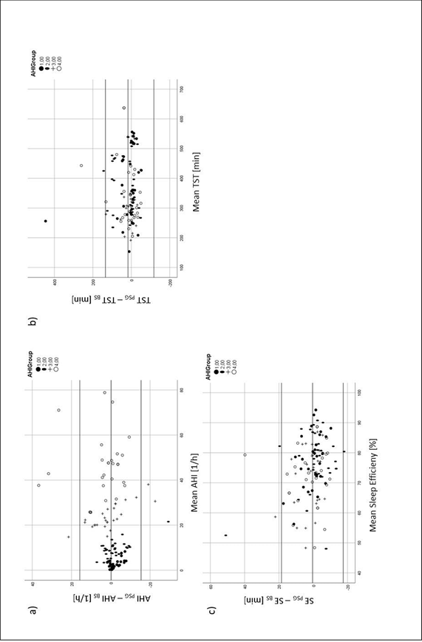
Figure 6. Bland-Altman-analysis of a) AHI b) TST and b) SE.
Additionally we performed a Bland-Altman analysis (figure 6), which confirmed the results of the correlation analysis. The outliers seen in the Bland-Altman analysis are patients who had asymptomatic, comorbid periodic leg movement disorder firstly diagnosed in polysomnography.

- ROC Analysis

Stage | Sensitivity | Specificity | AUC | Asympt. Significance
Wake | 0.65 | 0.59 | 0.623 | 0.000
REM | 0.72 | 0.68 | 0.715 | 0.000
NREM | 0.74 | 0.70 | 0.751 | 0.001
Average | 0.7 | 0.66

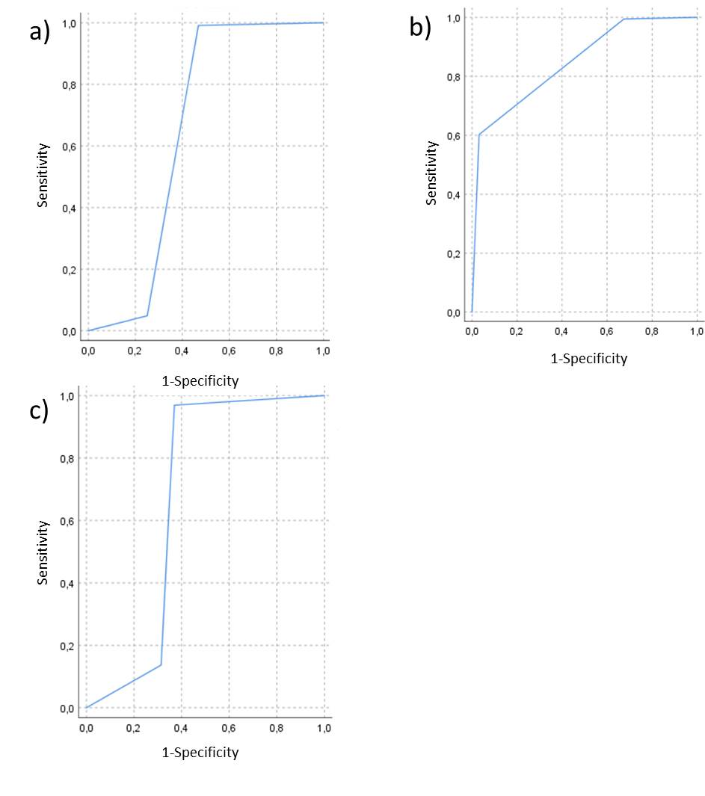
Figure 4. ROC analysis of diagnostic accuracy of sleep stage estimation of Nox BodySleepTM 1.0 versus manual scoring of PSG regarding a) wake, b)NREM and c) REM stage.

