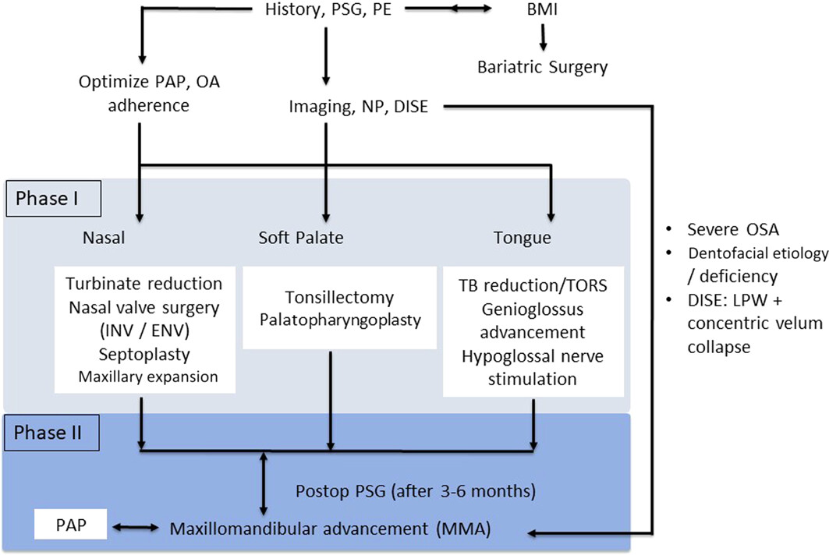
Supplement 1. Updated Stanford Sleep Surgery Algorithm. BMI, body mass index; DISE, drug-indued sleep endoscopy; DOME, distraction osteogenesis maxillary expansion; INV/ENV, internal/external valve; LPW, lateral pharyngeal wall; NP, nasopharyngoscopy; OA, oral appliance; OSA, obstructive sleep apnea; PAP, positive airway pressure; PE, physical exam; Postop, postoperative; PSG, polysomnography; TB, tongue-bases; TORS, transoral robotic surgery.

