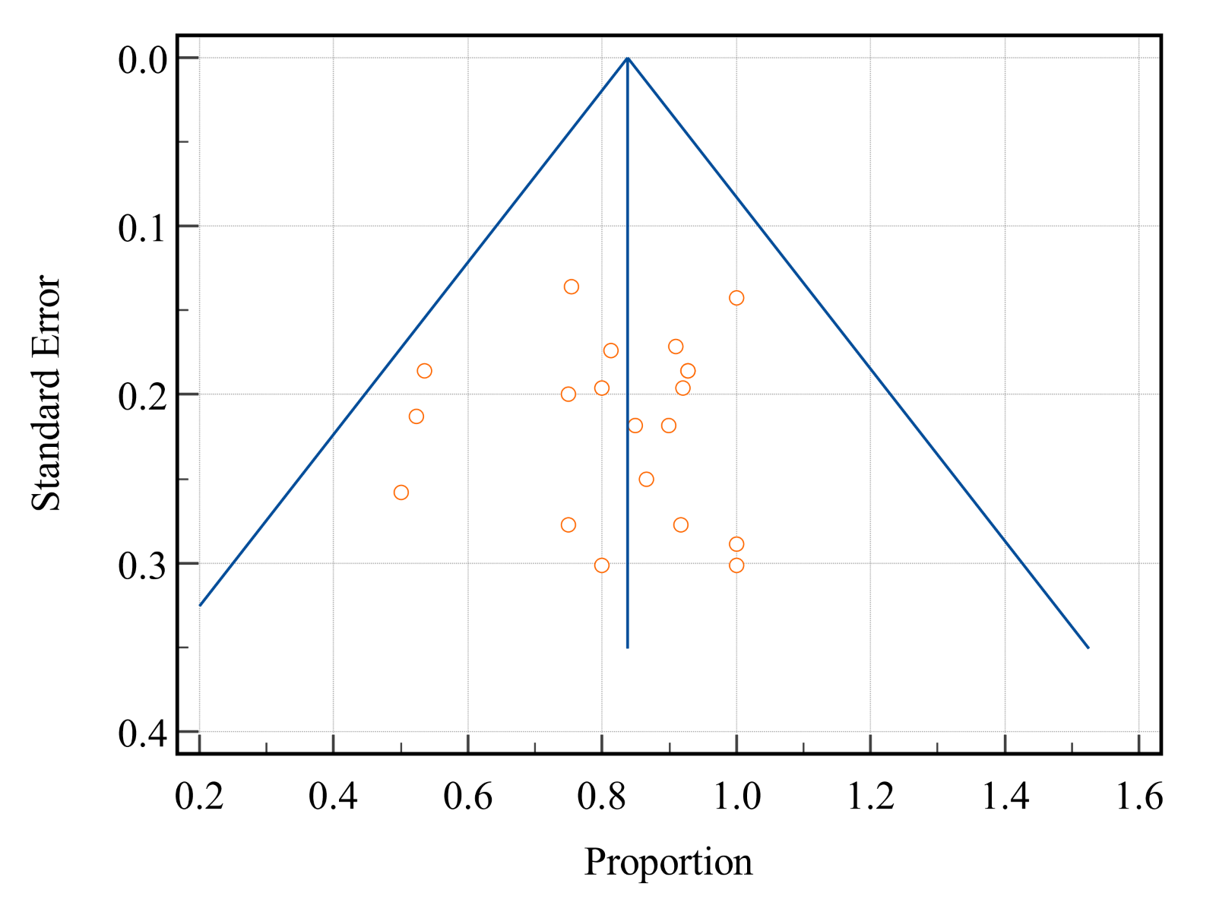 Supplement 5. Egger’s Test for Publication Bias.

