Detecting arousals and sleep from respiratory inductance plethysmography
Supplementary materials
Eysteinn Finnsson^{1, 2, †}, Ernir Erlingsson^{1, 3, †}, Hlynur D Hlynsson¹, Vaka Valsdóttir¹, Thora B Sigmarsdottir¹, Eydís Arnardóttir¹, Scott A Sands⁴, Sigurður Æ Jónsson¹, Anna S Islind², Jón S Ágústsson¹
¹Nox Research, Nox Medical, Reykjavik, Iceland
²Department of Computer Science, Reykjavik University, Reykjavik, Iceland
³Department of Computer Science, University of Iceland, Reykjavik, Iceland
⁴Division of Sleep and Circadian Disorders, Department of Medicine, Brigham and Women’s Hospital and Harvard Medical School, Boston, MA, USA

†These authors contributed equally
Correspondence:
eysteinnf@noxmedical.com
Nox Medical, Katrínartún 2, 105 Reykjavík, Iceland

Model architecture
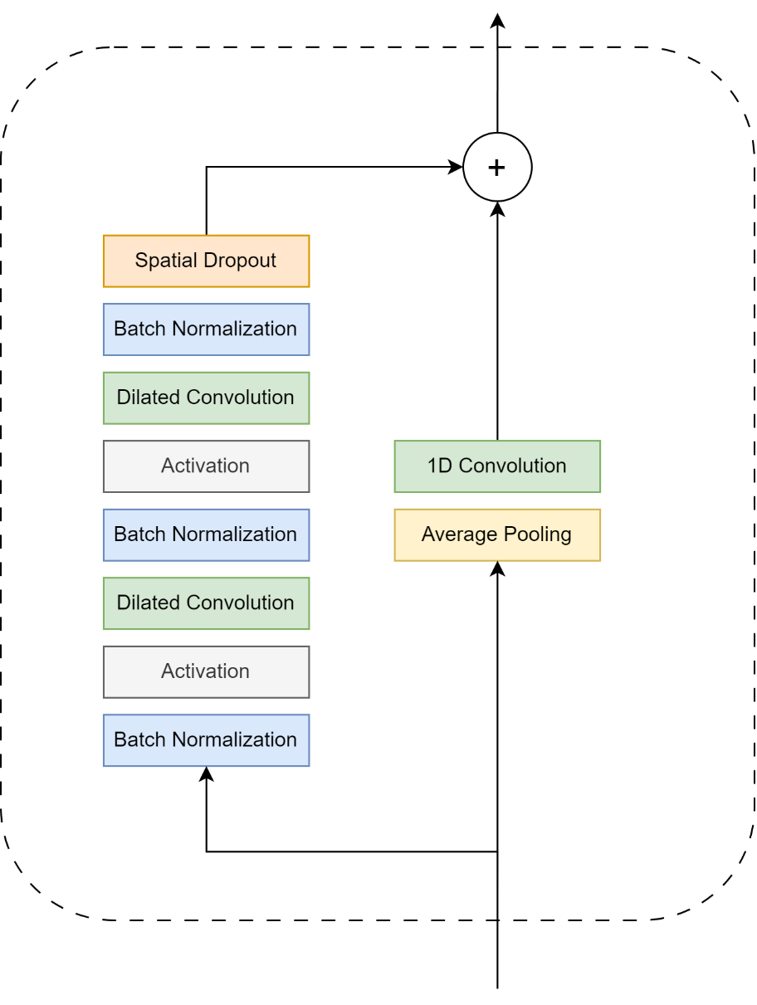
Figure S1: An example of a residual block used for Nox BodySleep 2.0 (NBS2) where raw time series data is processed through a series of steps. These steps include 1) Batch normalization, which normalizes across the respective data batch; 2) Activation function, NBS2 uses “Swish” which maps respective results to a range between a slightly negative value and one [1]; 3) Dilated Convolution, which uses spaced-out filters to capture long-range dependencies in time-series data; 4) Dropout, a common technique applied during training to increase the network´s robustness [2]. Additionally, the residual block includes a skip-connection, which is a pathway that effectively bypasses the main step sequence [3, 4]. The order of operations in our model was inspired by an architecture proposed by He et al. [5].
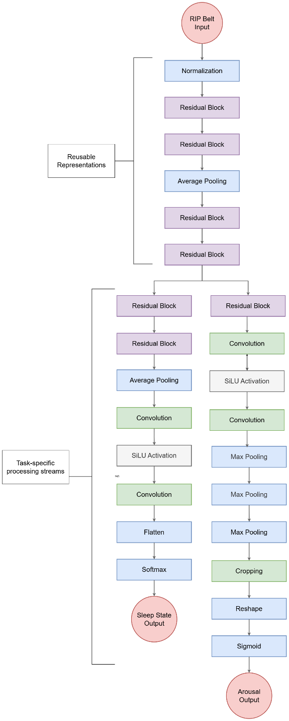
Figure S2: The model architecture for NBS2, where residual layers are illustrated in Figure S1. The RIP belt signals are provided as input (at 25Hz) to yield the sleep-state (Wake, REM, NREM) and arousal probabilities, where the former is returned for each sleep epoch and the latter on a second basis. The first six layers learn low-level features that are shared by both output branches. The arousal branch has two more layers than the sleep-state branch as it employs a different method to reduce the output to the desired temporal resolution; i.e., the arousal branch pools the data whereas the sleep-state branch flattens it and performs a Softmax activation.
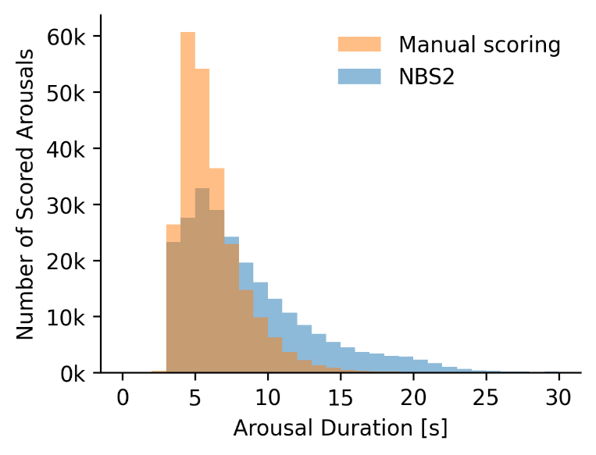
Figure S3: Distribution of arousal durations across the dataset (n=1299 patients). The histogram compares all manually scored arousals to all NBS2-scored arousals. In accordance with AASM scoring guidelines, neither approach scores arousals shorter than 3 seconds. NBS2 tends to score longer arousals (mean: 8.1 seconds, n=241,817) compared to manual scoring (mean: 6.2 seconds, n= 241,377). This discrepancy in arousal duration may be due to differences in scoring conventions between the training and validation datasets, which were sourced from different scoring sites.

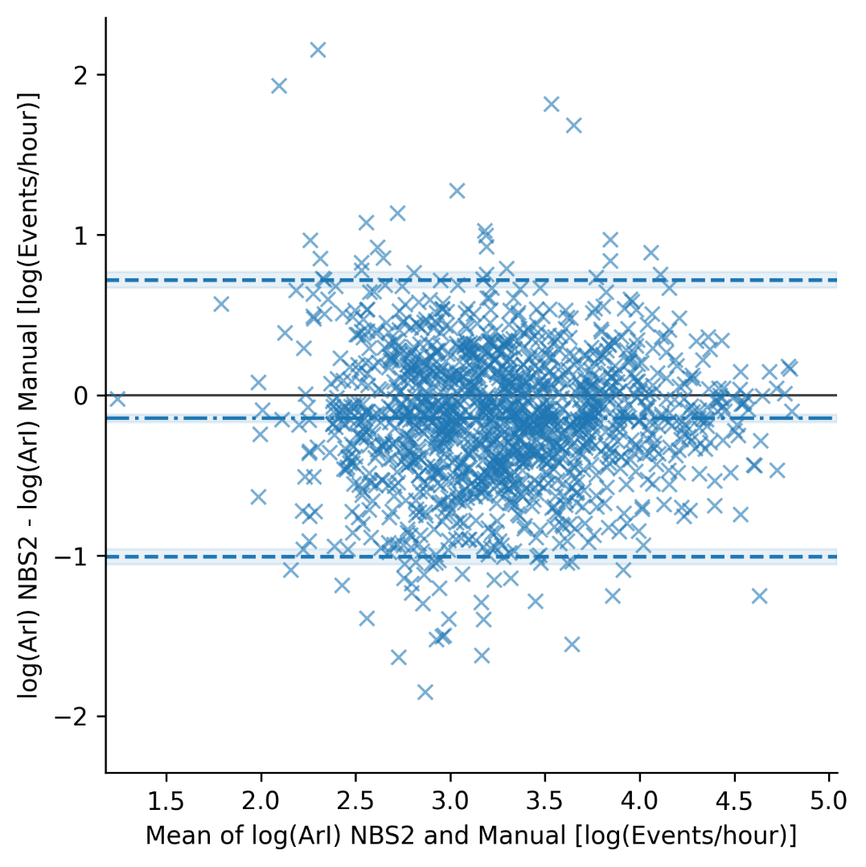
Figure S4: Bland-Altman plot of log-transformed Arousal Index (ArI) values, illustrating the agreement between Nox BodySleep 2.0 (NBS2) predicted and manually scored estimates.

Stratified results
This section presents additional results for the Nox BodySleep 2.0 algorithm, showing performance metrics and confusion matrices segmented by apnea-hypopnea index (AHI) and periodic limb movement index (PLMSI) subgroups.

Patient-level results statistics
Table S1: Distribution of algorithm performance across the study population (n=1299), reported as mean (standard deviation).
 | Sensitivity % | Specificity % | Accuracy % | F1 Score %
Wake | 75.0 (17.3) | 95.8 (7.2) | 92.3 (6.1) | 76.8 (14.7)
NREM | 93.6 (7.8) | 79.7 (13.8) | 89.3 (6.2) | 91.4 (6.8)
REM | 78.2 (22.9) | 98.2 (2.3) | 95.9 (3.2) | 76.6 (24.4)
Arousal | 64.3 (17.3) | 85.8 (10.1) | 81.6 (7.1) | 59.8 (13.3)

Epoch-level results segmented by AHI groups
Table S2: Epoch-level performance of the algorithm in detecting sleep states and arousals for the subset of patients with AHI < 5 events/hour (n=118). Results are reported as median [95% confidence interval] for sensitivity, specificity, accuracy, and F1 score.
 | Sensitivity % | Specificity % | Accuracy % | F1 Score %
Wake | 76.9 [72.9, 80.7] | 97.1 [96.3, 97.8] | 93.1 [92.0, 94.1] | 81.5 [78.5, 84.2]
NREM | 95.3 [94.4, 96.1] | 79.4 [76.7, 82.0] | 89.8 [88.7, 90.8] | 92.4 [91.6, 93.2]
REM | 79.8 [76.0, 83.1] | 98.6 [98.2, 98.9] | 95.8 [95.2, 96.4] | 84.9 [82.6, 86.9]
Arousal | 59.4 [56.2, 62.6] | 88.9 [87.6, 90.0] | 83.5 [82.3, 84.7] | 56.7 [54.0, 59.1]

Table S3: Epoch-level performance of the algorithm in detecting sleep states and arousals for the subset of patients with 5 ≤ AHI < 15 events/hour (n=416). Results are reported as median [95% confidence interval] for sensitivity, specificity, accuracy, and F1 score.
 | Sensitivity % | Specificity % | Accuracy % | F1 Score %
Wake | 77.8 [75.7, 79.8] | 96.9 [96.5, 97.2] | 93.1 [92.6, 93.5] | 81.7 [80.3, 83.1]
NREM | 94.9 [94.4, 95.3] | 80.4 [78.8, 81.9] | 90.1 [89.5, 90.6] | 92.7 [92.3, 93.1]
REM | 80.4 [78.4, 82.2] | 98.3 [98.1, 98.5] | 96.0 [95.7, 96.2] | 84.1 [82.8, 85.2]
Arousal | 58.9 [57.3, 60.6] | 89.4 [88.8, 90.0] | 84.0 [83.5, 84.6] | 56.6 [55.4, 57.8]

Table S4: Epoch-level performance of the algorithm in detecting sleep states and arousals for the subset of patients with 15 ≤ AHI < 30 events/hour (n=344). Results are reported as median [95% confidence interval] for sensitivity, specificity, accuracy, and F1 score.
 | Sensitivity % | Specificity % | Accuracy % | F1 Score %
Wake | 76.9 [74.9, 78.9] | 96.5 [95.7, 97.1] | 92.8 [92.1, 93.5] | 80.0 [78.3, 81.5]
NREM | 94.1 [93.1, 94.8] | 80.8 [79.4, 82.2] | 89.7 [89.0, 90.3] | 92.4 [91.9, 92.9]
REM | 82.5 [80.6, 84.3] | 98.1 [97.9, 98.4] | 95.9 [95.6, 96.2] | 85.3 [84.0, 86.4]
Arousal | 63.2 [61.3, 65.0] | 88.1 [87.3, 88.8] | 82.7 [82.0, 83.2] | 61.3 [60.1, 62.5]

Table S5: Epoch-level performance of the algorithm in detecting sleep states and arousals for the subset of patients with AHI ≥ 30 events/hour (n=421). Results are reported as median [95% confidence interval] for sensitivity, specificity, accuracy, and F1 score.
 | Sensitivity % | Specificity % | Accuracy % | F1 Score %
Wake | 78.9 [77.3, 80.4] | 95.0 [94.4, 95.7] | 91.2 [90.5, 91.8] | 81.0 [79.6, 82.4]
NREM | 92.4 [91.6, 93.1] | 80.5 [79.2, 81.7] | 88.2 [87.5, 88.8] | 91.0 [90.4, 91.5]
REM | 78.7 [76.4, 80.8] | 98.0 [97.8, 98.3] | 95.8 [95.5, 96.1] | 81.2 [79.6, 82.6]
Arousal | 72.3 [70.4, 74.2] | 81.1 [79.9, 82.3] | 78.1 [77.3, 78.8] | 69.5 [68.1, 70.9]

Confusion matrices for sleep segmented by AHI groups
Table S6: Normalized epoch-level confusion matrix for algorithm-classified versus manually classified sleep states in the subset of patients with AHI < 5 events/hour (n=118). True labels are presented in rows, predicted labels in columns, and the total number of scored epochs is displayed in the far-right column.
 | Wake | NREM | REM | # Epochs
Wake | 77% | 22% | 1% | 19,366
NREM | 3% | 95% | 2% | 63,989
REM | 2% | 19% | 80% | 14,403

Table S7: Normalized epoch-level confusion matrix for algorithm-classified versus manually classified sleep states in the subset of patients with 5 ≤ AHI < 15 events/hour (n=416). True labels are presented in rows, predicted labels in columns, and the total number of scored epochs is displayed in the far-right column.
 | Wake | NREM | REM | # Epochs
Wake | 78% | 21% | 1% | 66,326
NREM | 3% | 95% | 2% | 222,097
REM | 2% | 18% | 80% | 44,077

Table S8: Normalized epoch-level confusion matrix for algorithm-classified versus manually classified sleep states in the subset of patients with 15 ≤ AHI < 30 events/hour (n=344). True labels are presented in rows, predicted labels in columns, and the total number of scored epochs is displayed in the far-right column.
 | Wake | NREM | REM | # Epochs
Wake | 77% | 22% | 1% | 51,426
NREM | 4% | 94% | 2% | 184,720
REM | 1% | 16% | 83% | 39,789

Table S9: Normalized epoch-level confusion matrix for algorithm-classified versus manually classified sleep states in the subset of patients with AHI ≥ 30 events/hour (n=421). True labels are presented in rows, predicted labels in columns, and the total number of scored epochs is displayed in the far-right column.
 | Wake | NREM | REM | # Epochs
Wake | 79% | 20% | 1% | 79,060
NREM | 5% | 92% | 2% | 213,295
REM | 2% | 19% | 79% | 37,958

Confusion matrices for arousal segmented by AHI groups
Table S10: Normalized epoch-level confusion matrix for algorithm-classified versus manually classified arousals in the subset of patients with AHI < 5 events/hour (n=118). True labels are presented in rows, predicted labels in columns, and the total number of scored epochs is displayed in the far-right column.
 | Arousal | No Arousal | # Epochs
Arousal | 59% | 41% | 17,754
No Arousal | 11% | 89% | 80,030

Table S11: Normalized epoch-level confusion matrix for algorithm-classified versus manually classified arousals in the subset of patients with 5 ≤ AHI < 15 events/hour (n=416). True labels are presented in rows, predicted labels in columns, and the total number of scored epochs is displayed in the far-right column.
 | Arousal | No Arousal | # Epochs
Arousal | 59% | 41% | 58,737
No Arousal | 11% | 89% | 273,881

Table S12: Normalized epoch-level confusion matrix for algorithm-classified versus manually classified arousals in the subset of patients with 15 ≤ AHI < 30 events/hour (n=344). True labels are presented in rows, predicted labels in columns, and the total number of scored epochs is displayed in the far-right column.
 | Arousal | No Arousal | # Epochs
Arousal | 63% | 37% | 60,070
No Arousal | 12% | 88% | 215,930

Table S13: Normalized epoch-level confusion matrix for algorithm-classified versus manually classified arousals in the subset of patients with AHI ≥ 30 events/hour (n=421). True labels are presented in rows, predicted labels in columns, and the total number of scored epochs is displayed in the far-right column.
 | Arousal | No Arousal | # Epochs
Arousal | 72% | 28% | 114,212
No Arousal | 19% | 81% | 216,192

Epoch-level results segmented by PLMSI groups
Table S14: Epoch-level performance of the algorithm in detecting sleep states and arousals for the subset of patients with PLMSI < 15 events/hour (n=1248). Results are reported as median [95% confidence interval] for sensitivity, specificity, accuracy, and F1 score.
 | Sensitivity % | Specificity % | Accuracy % | F1 Score %
Wake | 78.1 [77.0, 79.2] | 96.3 [95.9, 96.6] | 92.5 [92.2, 92.8] | 81.2 [80.3, 82.0]
NREM | 93.9 [93.5, 94.3] | 80.7 [79.9, 81.5] | 89.4 [89.1, 89.7] | 92.1 [91.9, 92.4]
REM | 80.9 [79.8, 81.9] | 98.2 [98.1, 98.3] | 95.9 [95.7, 96.1] | 83.9 [83.2, 84.6]
Arousal | 66.0 [64.8, 67.2] | 87.0 [86.5, 87.4] | 81.9 [81.5, 82.3] | 63.8 [62.9, 64.7]

Table S15: Epoch-level performance of the algorithm in detecting sleep states and arousals for the subset of patients with PLMSI ≥ 15 events/hour (n=51). Results are reported as median [95% confidence interval] for sensitivity, specificity, accuracy, and F1 score.
 | Sensitivity % | Specificity % | Accuracy % | F1 Score %
Wake | 73.6 [67.0, 79.6] | 95.4 [93.4, 96.9] | 90.1 [87.8, 92.1] | 78.3 [73.6, 82.6]
NREM | 93.9 [91.7, 95.6] | 74.3 [69.3, 78.9] | 86.9 [84.7, 88.9] | 90.2 [88.3, 91.9]
REM | 68.6 [58.6, 77.1] | 98.6 [97.8, 99.2] | 95.2 [93.8, 96.4] | 76.1 [68.7, 81.8]
Arousal | 67.1 [61.6, 72.2] | 80.6 [77.3, 83.5] | 77.2 [75.2, 79.2] | 59.1 [55.9, 62.3]

Confusion matrices for sleep segmented by PLMSI groups
Table S16: Normalized epoch-level confusion matrix for algorithm-classified versus manually classified sleep states in the subset of patients with PLMSI < 15 events/hour (n=1248). True labels are presented in rows, predicted labels in columns, and the total number of scored epochs is displayed in the far-right column.
 | Wake | NREM | REM | # Epochs
Wake | 78% | 21% | 1% | 206,490
NREM | 4% | 94% | 2% | 658,446
REM | 2% | 17% | 81% | 131,814

Table S17: Normalized epoch-level confusion matrix for algorithm-classified versus manually classified sleep states in the subset of patients with PLMSI ≥ 15 events/hour (n=51). True labels are presented in rows, predicted labels in columns, and the total number of scored epochs is displayed in the far-right column.
 | Wake | NREM | REM | # Epochs
Wake | 74% | 24% | 2% | 9,688
NREM | 5% | 94% | 1% | 25,655
REM | 3% | 29% | 68% | 4,413

Confusion matrices for arousal segmented by PLMSI groups
Table S18: Normalized epoch-level confusion matrix for algorithm-classified versus manually classified arousals in the subset of patients with PLMSI < 15 events/hour (n=1248). True labels are presented in rows, predicted labels in columns, and the total number of scored epochs is displayed in the far-right column.
 | Arousal | No Arousal | # Epochs
Arousal | 66% | 34% | 240,989
No Arousal | 13% | 87% | 756,026

Table S19: Normalized epoch-level confusion matrix for algorithm-classified versus manually classified arousals in the subset of patients with PLMSI ≥ 15 events/hour (n=51). True labels are presented in rows, predicted labels in columns, and the total number of scored epochs is displayed in the far-right column.
 | Arousal | No Arousal | # Epochs
Arousal | 67% | 33% | 9,784
No Arousal | 19% | 81% | 30,007

Parameter results segmented by AHI groups
Table S20: Parameter results for patients with AHI < 5 events/hour (n=118). Values are reported as median [95% confidence interval]. Arousal Index is measured in events/hour, and Total Sleep Time in minutes. Agreement is assessed using the intraclass correlation coefficient (ICC, unitless) and Bland-Altman (BA) analysis.
 | Arousal Index | Total Sleep Time
ICC | 0.68 [0.57, 0.78] | 0.92 [0.87, 0.95]
BA bias | -3.62 [-5.55, -1.80] | 10.66 [5.69, 15.96]
BA aggrement | 20.26 [-23.88, 16.62] | 55.58 [-44.82, 66.29]
BA aggrement lower | -23.88 [-28.95, -18.92] | -44.82 [-56.68, -33.62]
BA aggrement upper | 16.62 [13.32, 19.89] | 66.29 [52.24, 80.71]

Table S21: Parameter results for patients with 5 ≤ AHI < 15 events/hour (n=416). Values are reported as median [95% confidence interval]. Arousal Index is measured in events/hour, and Total Sleep Time in minutes. Agreement is assessed using the intraclass correlation coefficient (ICC, unitless) and Bland-Altman (BA) analysis.
 | Arousal Index | Total Sleep Time
ICC | 0.67 [0.57, 0.76] | 0.91 [0.88, 0.93]
BA bias | -3.07 [-4.07, -2.13] | 9.34 [6.85, 11.87]
BA aggrement | 19.87 [-22.92, 16.82] | 50.74 [-41.44, 60.10]
BA aggrement lower | -22.92 [-26.35, -20.31] | -41.44 [-47.96, -35.20]
BA aggrement upper | 16.82 [14.69, 19.30] | 60.10 [52.70, 68.24]

Table S22: Parameter results for patients with 15 ≤ AHI < 30 events/hour (n=344). Values are reported as median [95% confidence interval]. Arousal Index is measured in events/hour, and Total Sleep Time in minutes. Agreement is assessed using the intraclass correlation coefficient (ICC, unitless) and Bland-Altman (BA) analysis.
 | Arousal Index | Total Sleep Time
ICC | 0.54 [0.41, 0.66] | 0.88 [0.81, 0.93]
BA bias | -3.60 [-4.76, -2.46] | 7.22 [3.85, 10.39]
BA aggrement | 21.30 [-24.93, 17.68] | 58.68 [-51.46, 66.04]
BA aggrement lower | -24.93 [-27.64, -22.31] | -51.46 [-72.11, -34.55]
BA aggrement upper | 17.68 [15.24, 20.57] | 66.04 [51.35, 82.64]

Table S23: Parameter results for patients with AHI ≥ 30 events/hour (n=421). Values are reported as median [95% confidence interval]. Arousal Index is measured in events/hour, and Total Sleep Time in minutes. Agreement is assessed using the intraclass correlation coefficient (ICC, unitless) and Bland-Altman (BA) analysis.
 | Arousal Index | Total Sleep Time
ICC | 0.62 [0.53, 0.69] | 0.92 [0.89, 0.94]
BA bias | -6.44 [-8.33, -4.63] | 6.57 [3.79, 9.30]
BA aggrement | 37.84 [-44.26, 31.41] | 55.34 [-48.76, 61.94]
BA aggrement lower | -44.26 [-50.46, -39.30] | -48.76 [-58.72, -39.77]
BA aggrement upper | 31.41 [26.88, 36.67] | 61.94 [54.47, 70.00]

Parameter results segmented by PLMSI groups
Table S24: Parameter results for patients with PLMSI < 15 events/hour (n=1248). Values are reported as median [95% confidence interval]. Arousal Index is measured in events/hour, and Total Sleep Time in minutes. Agreement is assessed using the intraclass correlation coefficient (ICC, unitless) and Bland-Altman (BA) analysis.
 | Arousal Index | Total Sleep Time
ICC | 0.74 [0.69, 0.77] | 0.91 [0.89, 0.93]
BA bias | -4.62 [-5.40, -3.86] | 7.86 [6.30, 9.41]
BA aggrement | 27.19 [-31.83, 22.59] | 54.42 [-46.54, 62.37]
BA aggrement lower | -31.83 [-34.91, -29.30] | -46.54 [-54.10, -40.42]
BA aggrement upper | 22.59 [20.37, 25.24] | 62.37 [56.68, 68.78]

Table S25: Parameter results for patients with PLMSI ≥ 15 events/hour (n=51). Values are reported as median [95% confidence interval]. Arousal Index is measured in events/hour, and Total Sleep Time in minutes. Agreement is assessed using the intraclass correlation coefficient (ICC, unitless) and Bland-Altman (BA) analysis.
 | Arousal Index | Total Sleep Time
ICC | 0.70 [0.42, 0.85] | 0.85 [0.73, 0.94]
BA bias | 1.93 [-2.63, 6.40] | 11.48 [1.64, 21.67]
BA aggrement | 31.88 [-29.91, 33.72] | 70.34 [-58.22, 81.79]
BA aggrement lower | -29.91 [-39.06, -21.26] | -58.22 [-85.18, -35.00]
BA aggrement upper | 33.72 [24.74, 43.79] | 81.79 [53.84, 108.84]

REFERENCES

1. Ramachandran P, Zoph B, Le QV (2017) Searching for Activation Functions
2. Srivastava N, Hinton G, Krizhevsky A, et al (2014) Dropout: A Simple Way to Prevent Neural Networks from Overfitting. Journal of Machine Learning Research 15:1929–1958
3. He K, Zhang X, Ren S, Sun J (2015) Deep Residual Learning for Image Recognition
4. He T, Zhang Z, Zhang H, et al (2019) Bag of Tricks for Image Classification with Convolutional Neural Networks
5. He K, Zhang X, Ren S, Sun J (2016) Identity Mappings in Deep Residual Networks

