SUPPLEMENTARY MATERIALS
FIGURE 3 Receiver operating characteristic curve for pulse transit time–derived systolic blood pressure detecting nocturnal hypertension.
The curve plots sensitivity versus 1 – specificity for pulse transit time–derived systolic blood pressure in predicting a mean nighttime blood pressure ≥ 120/70 mm Hg (ambulatory blood pressure monitoring reference). The area under the curve is 0.62 (95% CI 0.48–0.77). Coordinates and Youden index values (optimum threshold approximately 104 mm Hg) are provided in the accompanying table.
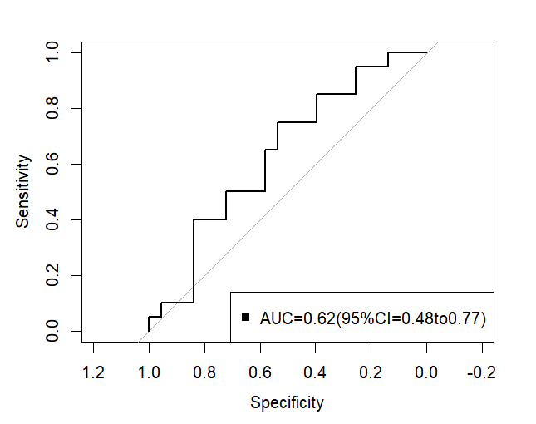
Threshold (mmHg) | Specificity | Sensitivity | Youden’s J Index
-Inf | 0.00000000 | 1.00 | 0.00000000
87.5 | 0.02325581 | 1.00 | 0.02325581
92.0 | 0.06976744 | 1.00 | 0.06976744
93.5 | 0.11627907 | 1.00 | 0.11627907
95.0 | 0.13953488 | 0.95 | 0.08953488
96.5 | 0.16279070 | 0.95 | 0.11279070
97.5 | 0.23255814 | 0.95 | 0.18255814
98.5 | 0.25581395 | 0.95 | 0.20581395
99.5 | 0.25581395 | 0.90 | 0.15581395
101.0 | 0.25581395 | 0.85 | 0.10581395
102.5 | 0.32558140 | 0.85 | 0.17558140
104.0 | 0.39534884 | 0.85 | 0.24534884
105.5 | 0.39534884 | 0.80 | 0.19534884
106.5 | 0.39534884 | 0.75 | 0.14534884
107.5 | 0.44186047 | 0.75 | 0.19186047
110.5 | 0.53488372 | 0.70 | 0.23488372
113.5 | 0.53488372 | 0.65 | 0.18488372
114.5 | 0.58139535 | 0.60 | 0.18139535
115.5 | 0.58139535 | 0.50 | 0.08139535
116.5 | 0.72093023 | 0.40 | 0.12093023
117.5 | 0.74418605 | 0.40 | 0.14418605
119.0 | 0.76744186 | 0.40 | 0.16744186
120.5 | 0.79069767 | 0.40 | 0.19069767
121.5 | 0.81395349 | 0.40 | 0.21395349
122.5 | 0.83720930 | 0.35 | 0.18720930
123.5 | 0.83720930 | 0.30 | 0.13720930
126.0 | 0.83720930 | 0.25 | 0.08720930
128.5 | 0.83720930 | 0.20 | 0.03720930
130.0 | 0.83720930 | 0.10 | -0.06279070
132.5 | 0.90697674 | 0.10 | 0.00697674
135.0 | 0.93023256 | 0.10 | 0.03023256
136.5 | 0.95348837 | 0.10 | 0.05348837
138.5 | 0.95348837 | 0.05 | 0.00348837
141.5 | 1.00000000 | 0.05 | 0.05000000
Inf | 1.00000000 | 0.00 | 0.00000000

FIGURE 4 Receiver operating characteristic curve for pulse transit time–derived diastolic blood pressure detecting nocturnal hypertension.
This curve evaluates pulse transit time–derived diastolic blood pressure against the same nocturnal-hypertension standard as in Figure A (a mean nighttime blood pressure ≥ 120/70 mm Hg, as determined by ambulatory blood pressure monitoring). The area under the curve is 0.58 (95% CI 0.42–0.74). The table lists all thresholds, sensitivities, specificities, and Youden index values (optimum threshold approximately 78.5 mm Hg).
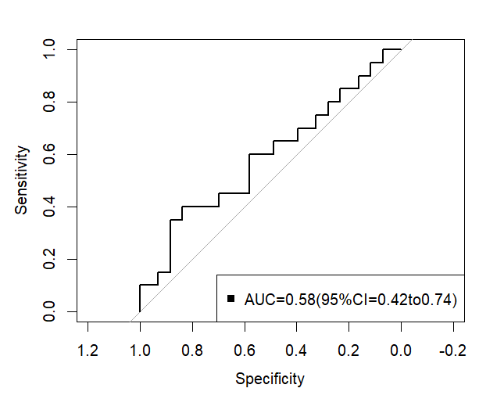

Threshold (mmHg) | Specificity | Sensitivity | Youden’s J Index
-Inf | 0.00000000 | 1.00 | 0.00000000
50.0 | 0.02325581 | 1.00 | 0.02325581
53.5 | 0.04651163 | 1.00 | 0.04651163
54.5 | 0.06976744 | 1.00 | 0.06976744
55.5 | 0.06976744 | 0.95 | 0.01976744
57.5 | 0.09302326 | 0.95 | 0.04302326
59.5 | 0.11627907 | 0.90 | 0.01627907
60.5 | 0.16279070 | 0.90 | 0.06279070
61.5 | 0.16279070 | 0.85 | 0.01279070
62.5 | 0.20930233 | 0.85 | 0.05930233
63.5 | 0.23255814 | 0.85 | 0.08255814
64.5 | 0.23255814 | 0.80 | 0.03255814
65.5 | 0.27906977 | 0.75 | 0.02906977
66.5 | 0.30232558 | 0.75 | 0.05232558
67.5 | 0.32558140 | 0.70 | 0.02558140
69.0 | 0.39534884 | 0.65 | 0.04534884
70.5 | 0.48837209 | 0.65 | 0.13837209
71.5 | 0.48837209 | 0.60 | 0.08837209
72.5 | 0.58139535 | 0.55 | 0.13139535
73.5 | 0.58139535 | 0.45 | 0.03139535
74.5 | 0.65116279 | 0.45 | 0.10116279
75.5 | 0.67441860 | 0.45 | 0.12441860
76.5 | 0.69767442 | 0.40 | 0.09767442
77.5 | 0.74418605 | 0.40 | 0.14418605
78.5 | 0.81395349 | 0.40 | 0.21395349
79.5 | 0.83720930 | 0.35 | 0.18720930
80.5 | 0.88372093 | 0.30 | 0.18372093
82.0 | 0.88372093 | 0.20 | 0.08372093
84.0 | 0.88372093 | 0.15 | 0.03372093
85.5 | 0.93023256 | 0.10 | 0.03023256
88.0 | 0.95348837 | 0.10 | 0.05348837
90.5 | 0.97674419 | 0.10 | 0.07674419
96.5 | 1.00000000 | 0.10 | 0.10000000
102.5 | 1.00000000 | 0.05 | 0.05000000
Inf | 1.00000000 | 0.00 | 0.00000000
FIGURE 5 Receiver operating characteristic curve for pulse transit time–derived systolic blood pressure detecting masked hypertension.
The curve assesses pulse transit time–derived systolic blood pressure performance in identifying masked hypertension, defined by abnormal daytime or nighttime ambulatory blood pressure monitoring in patients without a prior hypertension diagnosis. The area under the curve is 0.58 (95% CI 0.38–0.77). Threshold coordinates and Youden indices (optimum threshold approximately 104 mm Hg) accompany the plot.
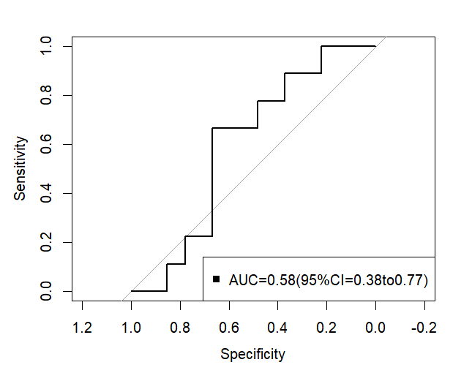
Threshold (mmHg) | Specificity | Sensitivity | Youden’s J Index
-Inf | 0.00000000 | 1.0000000 | 0.00000000
87.5 | 0.03703704 | 1.0000000 | 0.03703704
92.0 | 0.11111111 | 1.0000000 | 0.11111111
93.5 | 0.18518519 | 1.0000000 | 0.18518519
95.0 | 0.22222222 | 0.8888889 | 0.11111111
96.5 | 0.25925926 | 0.8888889 | 0.14814815
97.5 | 0.33333333 | 0.8888889 | 0.22222222
99.0 | 0.37037037 | 0.8888889 | 0.25925926
101.0 | 0.37037037 | 0.7777778 | 0.14814815
102.5 | 0.44444444 | 0.7777778 | 0.22222222
104.5 | 0.48148148 | 0.7777778 | 0.25925926
106.5 | 0.48148148 | 0.6666667 | 0.14814815
107.5 | 0.55555556 | 0.6666667 | 0.22222223
110.5 | 0.66666667 | 0.4444444 | 0.11111111
114.0 | 0.66666667 | 0.3333333 | 0.00000000
115.5 | 0.66666667 | 0.2222222 | -0.11111111
118.5 | 0.77777778 | 0.1111111 | -0.11111111
121.5 | 0.81481481 | 0.1111111 | -0.07407407
123.0 | 0.85185185 | 0.1111111 | -0.03703704
127.5 | 0.85185185 | 0.0000000 | -0.14814815
132.5 | 0.92592593 | 0.0000000 | -0.07407407
135.0 | 0.96296296 | 0.0000000 | -0.03703704
Inf | 1.00000000 | 0.0000000 | 0.00000000

FIGURE 6 Receiver operating characteristic curve for pulse transit time–derived diastolic blood pressure detecting masked hypertension.
This curve presents pulse transit time–derived diastolic blood pressure accuracy for masked hypertension; the area under the curve is 0.51 (95% CI 0.29–0.73). A full table of thresholds, sensitivities, specificities, and Youden indices (optimum threshold approximately 64 mm Hg) accompany the plot.
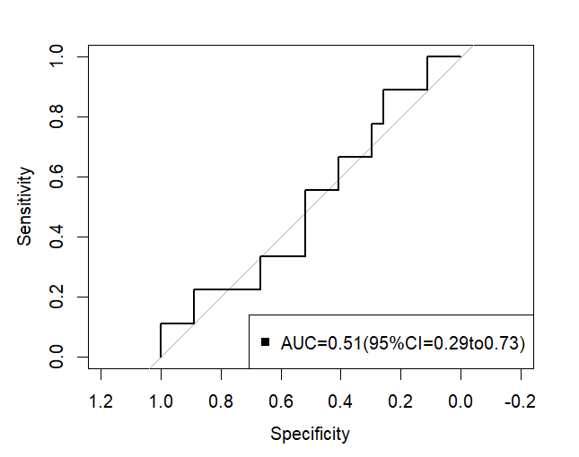
Threshold (mmHg) | Specificity | Sensitivity | Youden’s J Index
-Inf | 0.00000000 | 1.0000000 | 0.00000000
50.0 | 0.03703704 | 1.0000000 | 0.03703704
53.5 | 0.07407407 | 1.0000000 | 0.07407407
54.5 | 0.11111111 | 1.0000000 | 0.11111111
55.5 | 0.11111111 | 0.8888889 | 0.00000000
57.5 | 0.14814815 | 0.8888889 | 0.03703704
60.5 | 0.18518519 | 0.8888889 | 0.07407407
62.5 | 0.22222222 | 0.8888889 | 0.11111111
64.0 | 0.25925926 | 0.8888889 | 0.14814815
65.5 | 0.25925926 | 0.7777778 | 0.03703704
66.5 | 0.29629630 | 0.7777778 | 0.07407407
67.5 | 0.29629630 | 0.6666667 | -0.03703703
69.0 | 0.33333333 | 0.6666667 | 0.00000000
70.5 | 0.40740741 | 0.6666667 | 0.07407407
71.5 | 0.40740741 | 0.5555556 | -0.03703703
72.5 | 0.51851852 | 0.4444444 | -0.03703704
73.5 | 0.51851852 | 0.3333333 | -0.14814815
74.5 | 0.59259259 | 0.3333333 | -0.07407407
75.5 | 0.62962963 | 0.3333333 | -0.03703704
76.5 | 0.66666667 | 0.2222222 | -0.11111111
77.5 | 0.74074074 | 0.2222222 | -0.03703704
79.0 | 0.85185185 | 0.2222222 | 0.07407407
80.5 | 0.88888889 | 0.2222222 | 0.11111111
83.0 | 0.88888889 | 0.1111111 | 0.00000000
87.5 | 0.96296296 | 0.1111111 | 0.07407407
96.5 | 1.00000000 | 0.1111111 | 0.11111111
Inf | 1.00000000 | 0.0000000 | 0.00000000

