Overview and description of the ten exercises. The participants consented to have these images published.

Second session | Third session
1. Knee flexion: The participants were instructed to lay prone and lift their right heel towards their glutes while the left leg was relaxing.  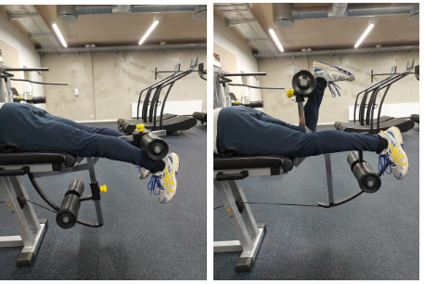 | 6. Standing ankle plantarflexion: The participants were instructed to stand upright in a smith racket on one leg and extend their right ankle as much as possible while stabilizing their torso.  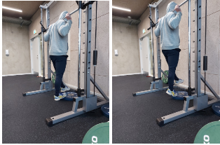
2. Hip flexion: The participants stood upright on their left leg and were instructed to move their right leg forward while keeping it straight and stabilizing themself by holding on to the rails of the cable tower.  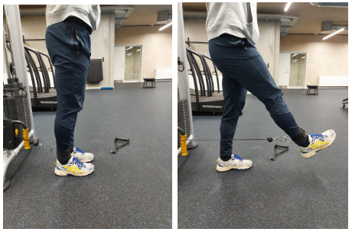 | 7. Knee extension: The participants were seated and instructed to extend their right leg while stabilizing their upper body by holding the handles.  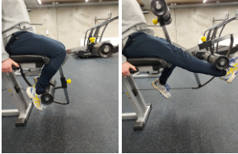
3. Hip adduction: The participants stood upright on their left leg and were instructed to move their right leg inwards while keeping it straight and stabilizing themself by holding on to the rails of the cable tower.  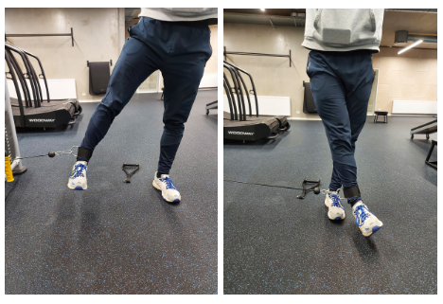 | 8. Hip extension: The participants stood upright on their left leg and were instructed to move their right leg back while keeping it straight and stabilizing themself by holding on to the rails of the cable tower.  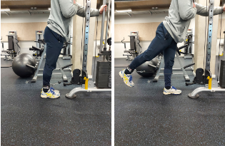
4. Ankle dorsiflexion: The participants were seated on a bench, with the cable tower attached to their toes on their right foot, and then instructed to perform an ankle dorsiflexion.  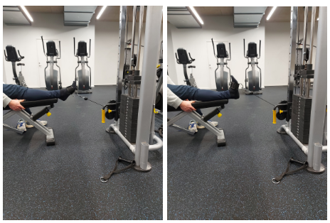 | 9. Hip abduction: The participants stood upright on their left leg and were instructed to move their right leg outward while keeping it straight by holding on to the rails of the cable tower.  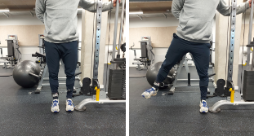
5. Seated ankle plantarflexion: The participants were seated in a smith racket with the barbell placed on the distal part of the thigh. Their right foot was elevated by being placed on a plate then they were instructed to perform an ankle plantarflexion.  .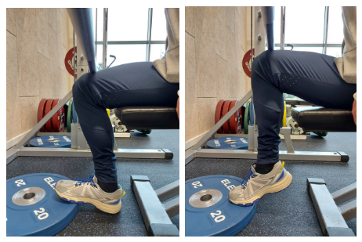 | 10. Leg press: The participants were seated in a leg press machine and were instructed to use their right leg to press against the plate.  