Supplementary Figures 4-7 present heatmaps of Euclidean distances (from multiple correspondence analysis) showing the relationships between influential figures and weight management methods in judo athletes, across four decades and by sex and weight category. Overall, early decades (1980–1990) tend to be dominated by a few traditional figures such as judo coaches and strength & conditioning coaches, while later decades show a diversification of influences, with doctors, nutritionists, parents, and others playing more prominent roles. Patterns vary between sexes and weight categories, with some groups maintaining stronger ties to specific influences over time.
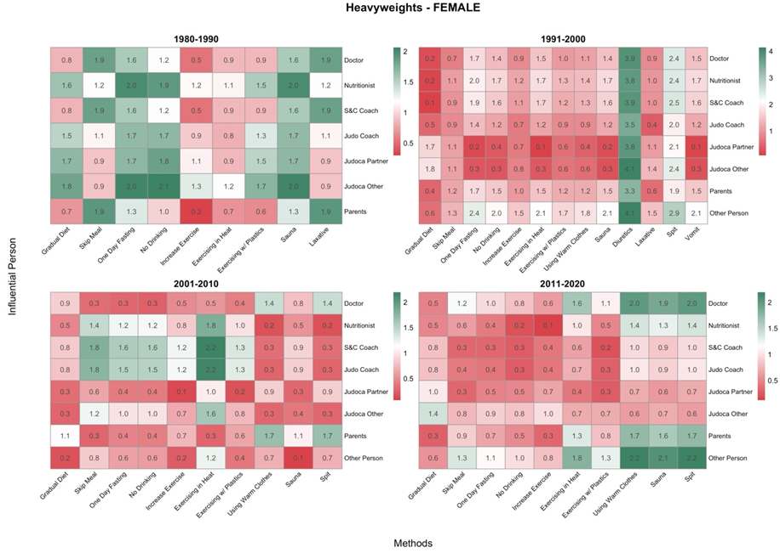
Figure 4. Heatmaps displaying the associations between influential figures and rapid weight loss methods among female judo athletes in the Heavyweights category, across four competitive periods (1980–1990, 1991–2000, 2001–2010, 2011–2020). Weight categories were grouped as follows: the Heavyweights group includes half-middleweight, middleweight, and half-heavyweight divisions. During 1980–1990, doctors and nutritionists showed moderate influence on most methods, indicated by red and light green hues. From 1991–2000, the influence of doctors diminished (more green tones), while other figures such as judo partners and S&C coaches became more prominent. In 2011–2020, influence was more evenly distributed across figures and methods, reflecting a diversification of guidance sources in recent years.
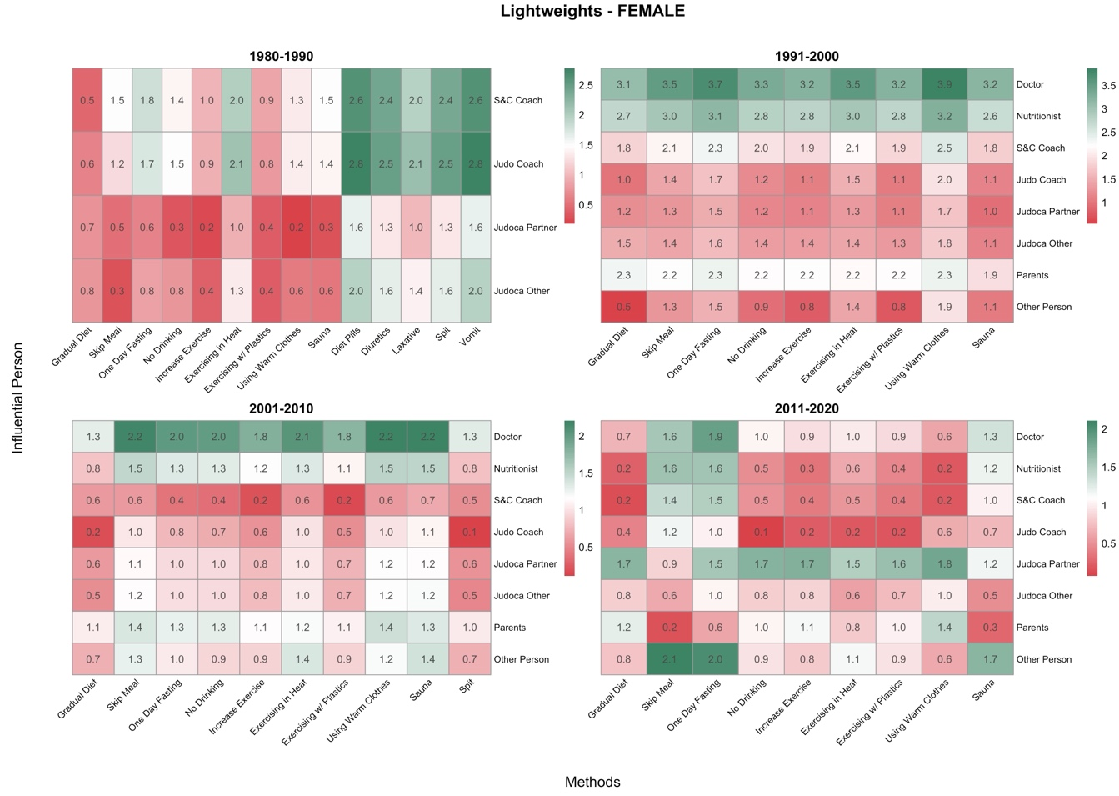
Figure 5. Heatmaps displaying the associations between influential figures and weight loss methods among female judo athletes in the Lightweights category, across four competitive decades (1980–1990, 1991–2000, 2001–2010, 2011–2020). Weight categories were grouped as follows: the Lightweights group includes extra-lightweight, half-lightweight, and lightweight divisions. In 1980–1990, S&C coaches and judo coaches had strong influence across multiple methods, shown by intense red tones. This influence remained relatively strong in the 1991–2000 and 2001–2010 decades, though parents and other people began to appear in closer association with some methods. By 2011–2020, influence was more evenly spread, although S&C coaches and doctors still maintained close relationships with several methods.

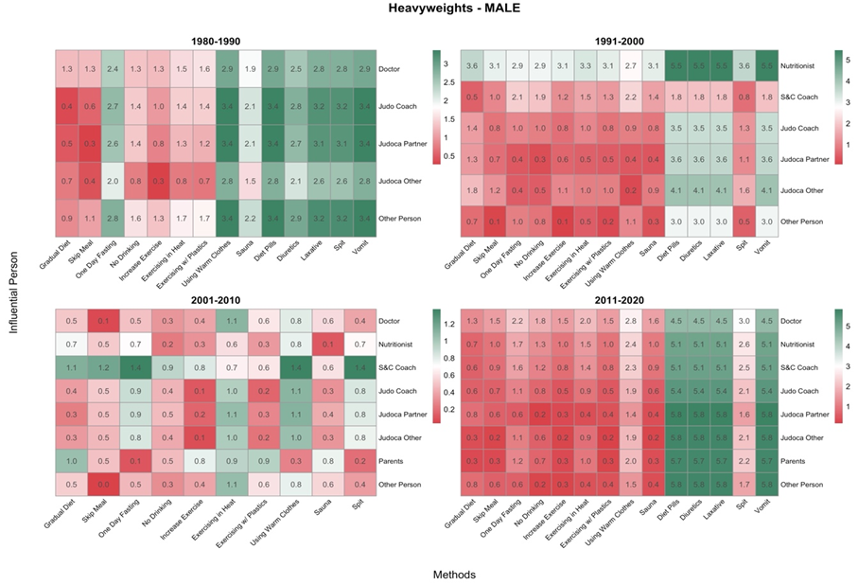
Figure 6. Heatmaps displaying the associations between influential figures and weight loss methods among male judo athletes in the Heavyweights category, across four competitive decades (1980–1990, 1991–2000, 2001–2010, 2011–2020). Weight categories were grouped as follows: the Heavyweights group includes half-middleweight, middleweight, and half-heavyweight divisions. In 1980–1990, S&C coaches and judo coaches were closely linked to methods such as sauna and diet pills, reflected by intense red shades. From 1991–2000, nutritionists and doctors gained prominence, especially in strategies like sauna and exercise in heat. By 2011–2020, traditional figures such as doctors and nutritionists dominated associations, particularly in methods like sauna and diuretics, which appeared in close proximity.

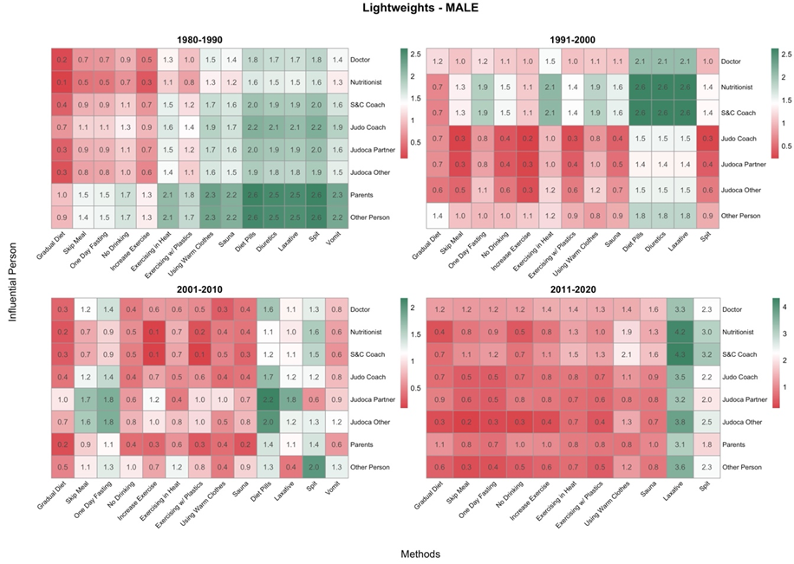
Figure 7. Heatmaps displaying the associations between influential figures and weight loss methods among male judo athletes in the Lightweights category, across four competitive decades (1980–1990, 1991–2000, 2001–2010, 2011–2020). Weight categories were grouped as follows: the Lightweights group includes extra-lightweight, half-lightweight, and lightweight divisions. In 1980–1990, S&C coaches and judo coaches had a strong presence across many methods, as indicated by the red colors. This trend continued in 1991–2000, although nutritionists and doctors started gaining relevance, especially in gradual diet and increased exercise. By 2011–2020, the influence network became more complex, with both traditional figures (doctors, S&C coaches) and non-traditional ones (parents, others) showing proximity to various methods, indicating a more diverse approach to guidance.

Table S5. Weight category ranges across competitive periods in judo. Categories are shown for female and male athletes, distinguishing between classifications used before and after the major International Judo Federation (IJF) rule changes around 1999–2000. Categories were harmonized to ensure comparability across periods by grouping equivalent competitive divisions rather than exact historical weight limits.
Period | Extra-lightweight | Half-lightweight | Lightweight | Half-middleweight | Middleweight | Half-heavyweight | Heavyweight
FEMALE CATEGORIES
Pre-1999 | ≤48 kg | ≤52 kg | ≤56 kg | ≤61 kg | ≤66 kg | ≤72 kg | >72 kg
Post-1999 (current) | ≤48 kg | ≤52 kg | ≤57 kg | ≤63 kg | ≤70 kg | ≤78 kg | >78 kg
MALE CATEGORIES
Pre-1999 | ≤60 kg | ≤65 kg | ≤71 kg | ≤78 kg | ≤86 kg | ≤95 kg | >95 kg
Post-1999 (current) | ≤60 kg | ≤66 kg | ≤73 kg | ≤81 kg | ≤90 kg | ≤100 kg | >100 kg

