The Relationship Between Resistance Exercise and Cardiometabolic Health: A Cross-sectional Analysis of the 1970 British Cohort Study

Sports Sciences for Health

Supplementary Information

Authors
Ravi K. Narangª, ravi.narang.22@ucl.ac.uk, ORCID: 0000-0002-0724-8127
John J. Mitchell^{b}, john.mitchell.12@ucl.ac.uk, ORCID: 0000-0002-2719-5536
Mark Hamer^{a,c}, m.hamer@ucl.ac.uk, ORCID: 0000-0002-8726-7992
Joanna M. Blodgett^{a,c}, joanna.blodgett@ucl.ac.uk, ORCID: 0000-0001-7684-3571

ªInstitute of Sport, Exercise and Health, 170 Tottenham Court Road, University College London, London, W1T 7HA, UK
^{b}Primary Care and Population Health, Rowland Hill Street, University College London, London, NW3 2PF, UK
^{c}University College London Hospitals NIHR Biomedical Research Centre, 170 Tottenham Court Road, University College London, London, W1T 7HA, UK

Corresponding author
Joanna M. Blodgett, Institute of Sport, Exercise and Health, 170 Tottenham Court Road, University College London, London, W1T 7HA, UK, joanna.blodgett@ucl.ac.uk

Table S1
Characteristics of the Analytical Sample and the Excluded Sample
 | Analytical sample  n=4881 | Excluded sample^{d}  n=3700 | P  (Included vs excluded)
Sex
Male | 2326 (47.7%) | 1828 (49.4%) | 0.11^{b}
Female | 2555 (52.3%) | 1872 (50.6%) | 0.11^{b}
Resistance exercise frequency
None | 3521 (72.1%) | 2238 (73.3%) | 0.55^{b}
≤1 time/month | 279 (5.7%) | 156 (5.1%) | 0.55^{b}
2-4 times/month | 475 (9.7%) | 282 (9.2%) | 0.55^{b}
≥2 times/week | 606 (12.4%) | 377 (12.3%) | 0.55^{b}
Smoking status, n (%)
Never | 2441 (50.0%) | 1637 (44.3%) | <0.01^{b}
Ex-smoker | 1572 (32.2%) | 1150 (31.1%) | <0.01^{b}
Less than daily | 232 (4.8%) | 217 (5.9%) | <0.01^{b}
Daily | 636 (13.0%) | 693 (18.7%) | <0.01^{b}
Alcohol intake (AUDIT-PC), n (%)
None | 486 (10.0%) | 498 (13.7%) | <0.01^{b}
Irregular or regular non-risky | 3281 (67.4%) | 2247 (61.8%) | <0.01^{b}
Risky | 1098 (22.6%) | 888 (24.4%) | <0.01^{b}
Highest academic qualification, n (%)
No formal qualifications | 1258 (26.1%) | 1181 (32.6%) | <0.01^{b}
GCSE or equivalent | 1524 (31.6%) | 1136 (31.3%) | <0.01^{b}
A level or equivalent | 273 (5.7%) | 189 (5.2%) | <0.01^{b}
Undergraduate or equivalent | 1492 (31.0%) | 949 (26.2%) | <0.01^{b}
Higher degree | 269 (5.6%) | 173 (4.8%) | <0.01^{b}
General state of health (self-rated), n (%)
Excellent | 922 (18.9%) | 549 (14.9%) | <0.01^{b}
Very good | 1811 (37.1%) | 1178 (31.9%) | <0.01^{b}
Good | 1347 (27.6%) | 1113 (30.1%) | <0.01^{b}
Fair | 601 (12.3%) | 566 (15.3%) | <0.01^{b}
Poor | 200 (4.1%) | 289 (7.8%) | <0.01^{b}
Disability classification (EU-SILC), n (%)
None | 4144 (84.9%) | 2923 (79.1%) | <0.01^{b}
Hampered to some extent | 497 (10.2%) | 438 (11.9%) | <0.01^{b}
Severely hampered | 239 (4.9%) | 333 (9.0%) | <0.01^{b}
Use of anti-hypertensive medication, n (%) | 222 (4.5%) | 806 (8.3%) | <0.01^{b}
Use of medication for dyslipidemia, n (%) | 53 (1.1%) | 24 (0.2%) | <0.01^{b}
Use of blood glucose-regulating medication, n (%) | 87 (1.8%) | 329 (3.4%) | <0.01^{b}
Activity time of MVPA (hr/day), median (Q1-Q3) | 0.79 (0.55-1.08) | 0.85 (0.56-1.13) | 0.42^{c}
Systolic blood pressure (mmHg), median (Q1-Q3)ª | 123.0 (114.0-133.7) | 124.3 (114.7-135.7) | <0.01^{c}
Total cholesterol (mmol/L), median (Q1-Q3)ª | 5.38 (4.70-6.00) | 5.40 (4.70-6.00) | 0.69^{c}
HDL-C (mmol/L), median (Q1-Q3)ª | 1.50 (1.20-1.80) | 1.40 (1.20-1.70) | <0.01^{c}
TC:HDL-C ratio, median (Q1-Q3)ª | 3.56 (2.85-4.55) | 3.71 (2.90-4.69) | 0.01^{c}
Serum HbA1c (mmol/mol), median (Q1-Q3)ª | 36.0 (33.0-38.0) | 36.0 (34.0-39.0) | <0.01^{c}
ªAdjusted for medication use.
^{b}Categorical variables compared using Pearson’s chi-squared test.
^{c}Continuous (non-normal distribution) variables compared using Mann-Whitney U test.
^{d}Excluded sample includes individuals who did participate in data collection at the age 46 sweep, but who had missing data for resistance exercise, covariates, or outcomes.
AUDIT-PC, Alcohol use disorders identification test – primary care; EU-SILC, European Statistics of Income and Living Condition; HbA1c, haemoglobin A1c; HDL-C, high-density lipoprotein cholesterol; MVPA, moderate-vigorous physical activity; TC, total cholesterol.

Table S2
Maximum grip strength according to resistance exercise frequency
Resistance exercise frequency | Maximum grip strength (kg)
Resistance exercise frequency | Male |  |  | Female
Resistance exercise frequency | n | Mean (SD) | Median (Q1,Q3) | n | Mean (SD) | Median (Q1,Q3)
None | 1604 | 47.9 (9.1) | 48.0 (42.0, 54.0) | 1917 | 29.7 (5.7) | 30.0 (26.0-34.0)
≤1 time/month | 139 | 48.6 (7.7) | 49.0 (44.0, 53.0) | 140 | 30.3 (4.9) | 30.0 (27.0, 34.0)
2-4 times/month | 215 | 48.2 (8.6) | 49.0 (43.0, 54.0) | 260 | 30.2 (5.3) | 30.0 (26.0, 33.0)
≥2 times/week | 368 | 49.4 (8.0) | 50.0 (45.0, 55.0) | 238 | 30.9 (5.5) | 31.0 (28.0, 35.0)
SD, standard deviation

Table S3
Characteristics of the Study Population According to Resistance Exercise frequency
 | None | ≤1 time/month | 2-4 times/month | ≥2 times/week | P
Sex
Male | 1604 (45.6%) | 139 (49.8%) | 215 (45.3%) | 368 (60.7%) | <0.01^{b}
Female | 1917 (54.4%) | 140 (50.2%) | 260 (54.7%) | 238 (39.3%) | <0.01^{b}
Smoking status, n (%)
Never | 1709 (48.5%) | 153 (54.8%) | 260 (54.7%) | 319 (52.6%) | <0.01^{b}
Ex-smoker | 1092 (31.0%) | 90 (32.3%) | 172 (36.2%) | 218 (36.0%) | <0.01^{b}
Less than daily | 174 (4.9%) | 14 (5.0%) | 16 (3.4%) | 28 (4.6%) | <0.01^{b}
Daily | 546 (15.5%) | 22 (7.9%) | 27 (5.7%) | 41 (6.8%) | <0.01^{b}
Alcohol intake (AUDIT-PC), n (%)
None | 391 (11.1%) | 20 (7.2%) | 33 (7.0%) | 42 (6.9%) | <0.01^{b}
Irregular or regular non-risky | 2343 (66.8%) | 188 (67.9%) | 335 (70.7%) | 415 (68.6%) | <0.01^{b}
Risky | 775 (22.1%) | 69 (24.9%) | 106 (22.4%) | 148 (24.5%) | <0.01^{b}
Highest academic qualification, n (%)
No formal qualifications | 968 (27.8%) | 50 (18.3%) | 84 (17.8%) | 156 (26.3%) | <0.01^{b}
GCSE or equivalent | 1135 (32.6%) | 75 (27.5%) | 131 (27.8%) | 183 (30.9%) | <0.01^{b}
A level or equivalent | 196 (5.6%) | 15 (5.5%) | 35 (7.4%) | 27 (4.6%) | <0.01^{b}
Undergraduate or equivalent | 1015 (29.2%) | 109 (39.9%) | 179 (37.9%) | 189 (31.9%) | <0.01^{b}
Higher degree | 164 (4.7%) | 24 (8.8%) | 43 (9.1%) | 38 (6.4%) | <0.01^{b}
General state of health (self-rated), n (%)
Excellent | 576 (16.4%) | 62 (22.2%) | 103 (21.7%) | 181 (29.9%) | <0.01^{b}
Very good | 1247 (35.4%) | 100 (35.8%) | 216 (45.5%) | 248 (40.9%) | <0.01^{b}
Good | 1017 (28.9%) | 82 (29.4%) | 124 (26.1%) | 124 (20.5%) | <0.01^{b}
Fair | 501 (14.2%) | 32 (11.5%) | 28 (5.9%) | 40 (6.6%) | <0.01^{b}
Poor | 180 (5.1%) | 3 (1.1%) | 4 (0.8%) | 13 (2.1%) | <0.01^{b}
Disability classification (EU-SILC), n (%)
None | 2943 (83.6%) | 240 (86.3%) | 421 (88.6%) | 540 (89.1%) | <0.01^{b}
Hampered to some extent | 385 (10.9%) | 34 (12.2%) | 37 (7.8%) | 41 (6.8%) | <0.01^{b}
Severely hampered | 193 (5.5%) | 4 (1.4%) | 17 (3.6%) | 25 (4.1%) | <0.01^{b}
Use of anti-hypertensive medication, n (%) | 172 (4.9%) | 12 (4.3%) | 18 (3.8%) | 20 (3.3%) | 0.29^{b}
Use of medication for dyslipidemia, n (%) | 42 (1.2%) | 1 (0.4%) | 2 (0.4%) | 8 (1.3%) | 0.26^{b}
Use of blood glucose-regulating medication, n (%) | 73 (2.1%) | 4 (1.4%) | 4 (0.8%) | 6 (1.0%) | 0.09^{b}
Activity time of MVPA (hr/day), median (Q1-Q3) | 0.77 (0.53-1.07) | 0.79 (0.58-1.11) | 0.81 (0.58-1.09) | 0.85 (0.60-1.16) | <0.01^{c}
Systolic blood pressure (mmHg), median (Q1-Q3)ª | 123.3 (114.3-134.0) | 122.0 (113.3-132.3) | 122.0 (112.3-132) | 123.0 (113.7-134.0) | 0.17^{c}
Total cholesterol (mmol/L), median (Q1-Q3)ª | 5.38 (4.70-6.00) | 5.40 (4.80-5.90) | 5.30 (4.80-6.00) | 5.34 (4.70-6.00) | <0.01
HDL-C (mmol/L), median (Q1-Q3)ª | 1.50 (1.20-1.80) | 1.50 (1.20-1.80) | 1.50 (1.30-1.80) | 1.50 (1.30-1.80) | 0.99^{c}
TC:HDL-C ratio, median (Q1-Q3)ª | 3.62 (2.89-4.60) | 3.51 (2.78-4.50) | 3.43 (2.79-4.42) | 3.42 (2.78-4.45) | <0.01^{c}
Serum HbA1c (mmol/mol), median (Q1-Q3)ª | 36.0 (34.0-38.0) | 35.0 (33.0-37.0) | 35.0 (33.0-37.0) | 35.0 (33.0-37.0) | <0.01^{c}
ªAdjusted for medication use.
^{b}Categorical variables compared using Pearson’s chi-squared test.
^{c}Continuous (non-normal distribution) variables compared using Kruskal-Wallis test.
AUDIT-PC, Alcohol use disorders identification test – primary care; EU-SILC, European Statistics of Income and Living Condition; HbA1c, haemoglobin A1c; HDL-C, high-density lipoprotein cholesterol; MVPA, moderate-vigorous physical activity; Q1, 25th centile; Q3, 75th centile; TC, total cholesterol.

Table S4
Linear Regression Analysis of Resistance Exercise Frequency with Systolic Blood Pressure
Model  N=4,765 | Resistance exercise frequency | Systolic blood pressure
Model  N=4,765 | Resistance exercise frequency | Coefficient (Sympercent) | 95% CI | P
Adjusted for sex | None | Referent
Adjusted for sex | ≤1 time/month | -1.03 | -2.43, 0.37 | 0.15
Adjusted for sex | 2-4 times/month | -1.33 | -2.43, -0.24 | 0.02
Adjusted for sex | ≥2 times/week | -1.24 | -2.23, -0.26 | 0.01
Adjusted for sex and MVPA | None | Referent
Adjusted for sex and MVPA | ≤1 time/month | -0.97 | -2.37, 0.42 | 0.17
Adjusted for sex and MVPA | 2-4 times/month | -1.28 | -2.38, -0.19 | 0.02
Adjusted for sex and MVPA | ≥2 times/week | -1.12 | -2.11, -0.14 | 0.03
Adjusted for sex, MVPA, and all other covariatesª | None | Referent
Adjusted for sex, MVPA, and all other covariatesª | ≤1 time/month | -0.65 | -2.05, 0.75 | 0.36
Adjusted for sex, MVPA, and all other covariatesª | 2-4 times/month | -0.73 | -1.83, 0.36 | 0.19
Adjusted for sex, MVPA, and all other covariatesª | ≥2 times/week | -0.75 | -1.75, 0.25 | 0.14
ªOther covariates include smoking status, alcohol consumption, educational attainment, self-rated health, and disability.
CI, confidence interval; MVPA, moderate-vigorous physical activity.

Table S5
Linear Regression Analysis of Resistance Exercise Frequency with Total Cholesterol:HDL-C cholesterol
Model  N=3,980 | Resistance exercise frequency | Total cholesterol:HDL-C cholesterol
Model  N=3,980 | Resistance exercise frequency | Coefficient (Sympercent) | 95% CI | P
Adjusted for sex | None | Referent
Adjusted for sex | ≤1 time/month | -5.18 | -9.31, -1.05 | 0.01
Adjusted for sex | 2-4 times/month | -5.52 | -8.76, -2.28 | <0.01
Adjusted for sex | ≥2 times/week | -7.98 | -10.88, -5.09 | <0.01
Adjusted for sex and MVPA | None | Referent
Adjusted for sex and MVPA | ≤1 time/month | -4.72 | -8.78, -0.66 | 0.02
Adjusted for sex and MVPA | 2-4 times/month | -5.00 | -8.19, -1.81 | <0.01
Adjusted for sex and MVPA | ≥2 times/week | -7.04 | -9.89, -4.19 | <0.01
Adjusted for sex, MVPA, and all other covariatesª | None | Referent
Adjusted for sex, MVPA, and all other covariatesª | ≤1 time/month | -2.37 | -6.40, 1.66 | 0.25
Adjusted for sex, MVPA, and all other covariatesª | 2-4 times/month | -2.40 | -5.56, 0.75 | 0.14
Adjusted for sex, MVPA, and all other covariatesª | ≥2 times/week | -3.99 | -6.83, -1.15 | 0.01
ªOther covariates include smoking status, alcohol consumption, educational attainment, self-rated health, and disability.
CI, confidence interval; HDL-C, high-density lipoprotein cholesterol; MVPA, moderate-vigorous physical activity.

Table S6
Linear Regression Analysis of Resistance Exercise Frequency with Serum HbA1c
Model  N=3,948 | Resistance exercise frequency | Serum HbA1c
Model  N=3,948 | Resistance exercise frequency | Coefficient (Sympercent) | 95% CI | P
Adjusted for sex | None | Referent
Adjusted for sex | ≤1 time/month | -2.73 | -4.91, -0.54 | 0.01
Adjusted for sex | 2-4 times/month | -3.04 | -4.76, -1.32 | <0.01
Adjusted for sex | ≥2 times/week | -3.03 | -4.56, -1.50 | <0.01
Adjusted for sex and MVPA | None | Referent
Adjusted for sex and MVPA | ≤1 time/month | -2.56 | -4.73, -0.38 | 0.02
Adjusted for sex and MVPA | 2-4 times/month | -2.87 | -4.58, -1.16 | <0.01
Adjusted for sex and MVPA | ≥2 times/week | -2.76 | -4.28, -1.23 | <0.01
Adjusted for sex, MVPA, and all other covariatesª | None | Referent
Adjusted for sex, MVPA, and all other covariatesª | ≤1 time/month | -1.13 | -3.29, 1.03 | 0.31
Adjusted for sex, MVPA, and all other covariatesª | 2-4 times/month | -1.23 | -2.92, 0.46 | 0.15
Adjusted for sex, MVPA, and all other covariatesª | ≥2 times/week | -1.17 | -2.69, 0.35 | 0.13
ªOther covariates include smoking status, alcohol consumption, educational attainment, self-rated health, and disability.
CI, confidence interval; HbA1c, glycated haemoglobin; MVPA, moderate-vigorous physical activity.

Table S7
Linear Regression Analysis of Resistance Exercise Frequency with Systolic Blood Pressure – Outcome Values Unadjusted for Medication Use
Model | Resistance exercise frequency | Systolic blood pressure
Model | Resistance exercise frequency | Coefficient^{b} (Sympercent) | 95% CI | P
Adjusted for sex | None | Referent
Adjusted for sex | ≤1 time/month | -0.97 | -2.34, 0.40 | 0.17
Adjusted for sex | 2-4 times/month | -1.24 | -2.31, -0.17 | 0.02
Adjusted for sex | ≥2 times/week | -1.11 | -2.08, -0.14 | 0.02
Adjusted for sex and MVPA | None | Referent
Adjusted for sex and MVPA | ≤1 time/month | -0.92 | -2.28, 0.45 | 0.19
Adjusted for sex and MVPA | 2-4 times/month | -1.20 | -2.27, -0.13 | 0.03
Adjusted for sex and MVPA | ≥2 times/week | -1.01 | -1.97, -0.04 | 0.04
Adjusted for sex, MVPA, and all other covariatesª | None | Referent
Adjusted for sex, MVPA, and all other covariatesª | ≤1 time/month | -0.63 | -2.00, 0.75 | 0.37
Adjusted for sex, MVPA, and all other covariatesª | 2-4 times/month | -0.70 | -1.77, 0.37 | 0.20
Adjusted for sex, MVPA, and all other covariatesª | ≥2 times/week | -0.69 | -1.66, 0.29 | 0.17
ªOther covariates include smoking status, alcohol consumption, educational attainment, self-rated health, and disability
^{b}Sympercent represents the percentage difference after transformation of the outcome variable into the 100 log_{e} scale
CI, confidence interval; MVPA, moderate-vigorous physical activity.

Table S8
Linear Regression Analysis of Resistance Exercise Frequency with Total Cholesterol:HDL-C cholesterol – Outcome Values Unadjusted for Medication Use
Model | Resistance exercise frequency | Total cholesterol:HDL-C cholesterol
Model | Resistance exercise frequency | Coefficient^{b} (Sympercent) | 95% CI | P
Adjusted for sex | None | Referent
Adjusted for sex | ≤1 time/month | -4.91 | -9.02, -0.79 | 0.02
Adjusted for sex | 2-4 times/month | -5.27 | -8.50, -2.03 | <0.01
Adjusted for sex | ≥2 times/week | -8.00 | -10.87, -5.12 | <0.01
Adjusted for sex and MVPA | None | Referent
Adjusted for sex and MVPA | ≤1 time/month | -4.46 | -8.51, -0.41 | 0.03
Adjusted for sex and MVPA | 2-4 times/month | -4.76 | -7.94, -1.58 | <0.01
Adjusted for sex and MVPA | ≥2 times/week | -7.09 | -9.92, -4.25 | <0.01
Adjusted for sex, MVPA, and all other covariatesª | None | Referent
Adjusted for sex, MVPA, and all other covariatesª | ≤1 time/month | -2.14 | -6.15, 1.88 | 0.30
Adjusted for sex, MVPA, and all other covariatesª | 2-4 times/month | -2.19 | -5.34, 0.96 | 0.17
Adjusted for sex, MVPA, and all other covariatesª | ≥2 times/week | -4.03 | -6.86, -1.20 | 0.01
ªOther covariates include smoking status, alcohol consumption, educational attainment, self-rated health, and disability
^{b}Sympercent represents the percentage difference after transformation of the outcome variable into the 100 log_{e} scale
CI, confidence interval; HDL-C, high-density lipoprotein cholesterol; MVPA, moderate-vigorous physical activity.

Table S9
Linear Regression Analysis of Resistance Exercise Frequency with Serum HbA1c – Outcome Values Unadjusted for Medication Use
Model | Resistance exercise frequency | Serum HbA1c
Model | Resistance exercise frequency | Coefficient^{b} (Sympercent) | 95% CI | P
Adjusted for sex | None | Referent
Adjusted for sex | ≤1 time/month | -2.45 | -4.50, -0.40 | 0.02
Adjusted for sex | 2-4 times/month | -2.83 | -4.44, -1.22 | <0.01
Adjusted for sex | ≥2 times/week | -2.81 | -4.25, -1.38 | <0.01
Adjusted for sex and MVPA | None | Referent
Adjusted for sex and MVPA | ≤1 time/month | -2.29 | -4.33, -0.25 | 0.03
Adjusted for sex and MVPA | 2-4 times/month | -2.67 | -4.27, -1.06 | <0.01
Adjusted for sex and MVPA | ≥2 times/week | -2.56 | -3.99, -1.13 | <0.01
Adjusted for sex, MVPA, and all other covariatesª | None | Referent
Adjusted for sex, MVPA, and all other covariatesª | ≤1 time/month | -0.94 | -2.97, 1.09 | 0.36
Adjusted for sex, MVPA, and all other covariatesª | 2-4 times/month | -1.14 | -2.73, 0.44 | 0.16
Adjusted for sex, MVPA, and all other covariatesª | ≥2 times/week | -1.08 | -2.51, 0.34 | 0.14
ªOther covariates include smoking status, alcohol consumption, educational attainment, self-rated health, and disability
^{b}Sympercent represents the percentage difference after transformation of the outcome variable into the 100 log_{e} scale
CI, confidence interval; HbA1c, glycated haemoglobin; MVPA, moderate-vigorous physical activity.

Figure S1
Frequency Histograms for (A) MVPA, (B) Systolic blood pressure, (C) TC:HDL-C, and (D) HbA1c
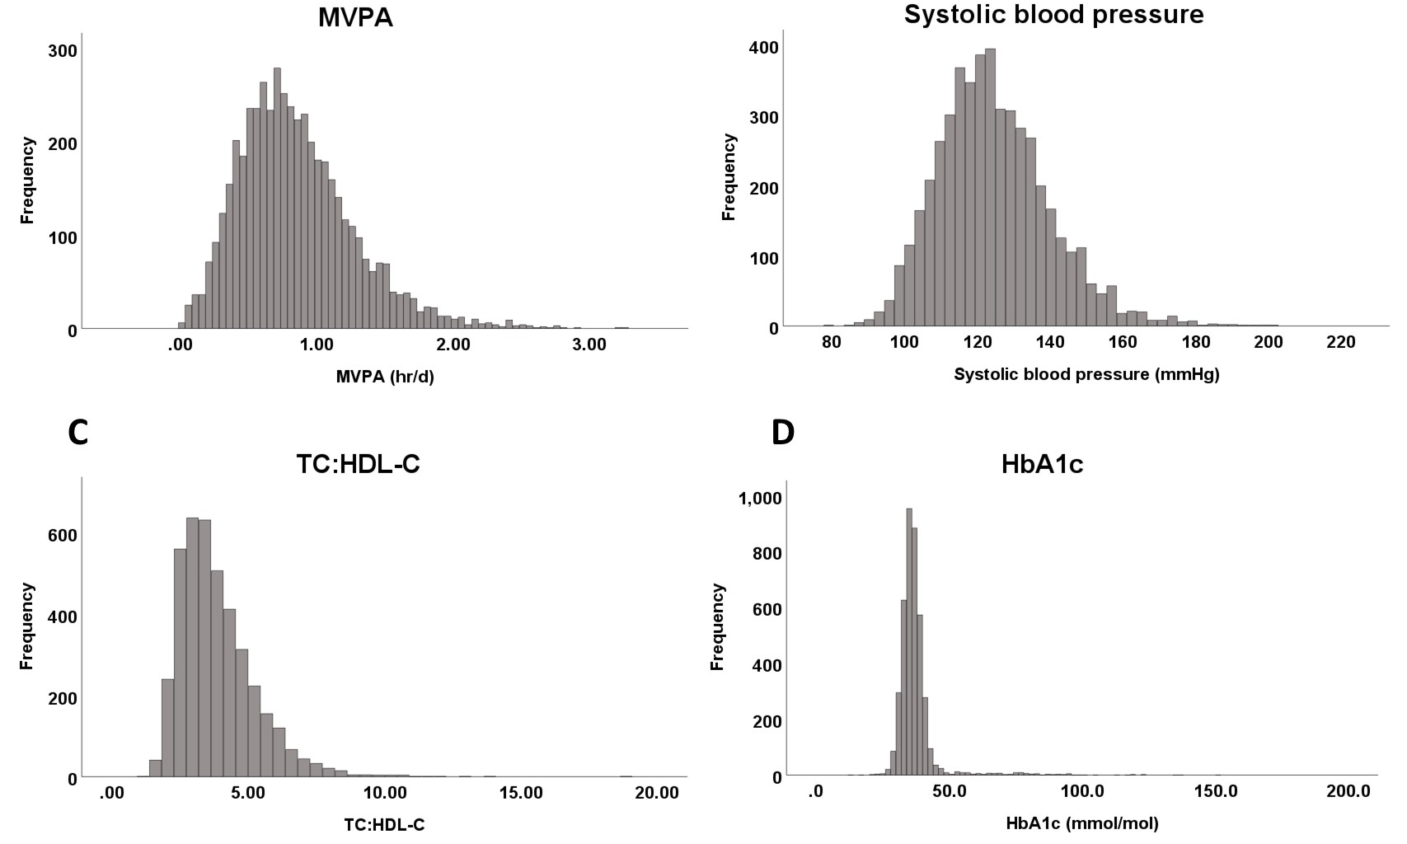
HbA1c, haemoglobin A1c; MVPA, moderate-vigorous physical activity; TC:HDL-C, total cholesterol:high-density lipoprotein-cholesterol.

Figure S2
Regression Analysis Between Resistance Exercise Frequency and Systolic Blood Pressure – Stratified by Sex
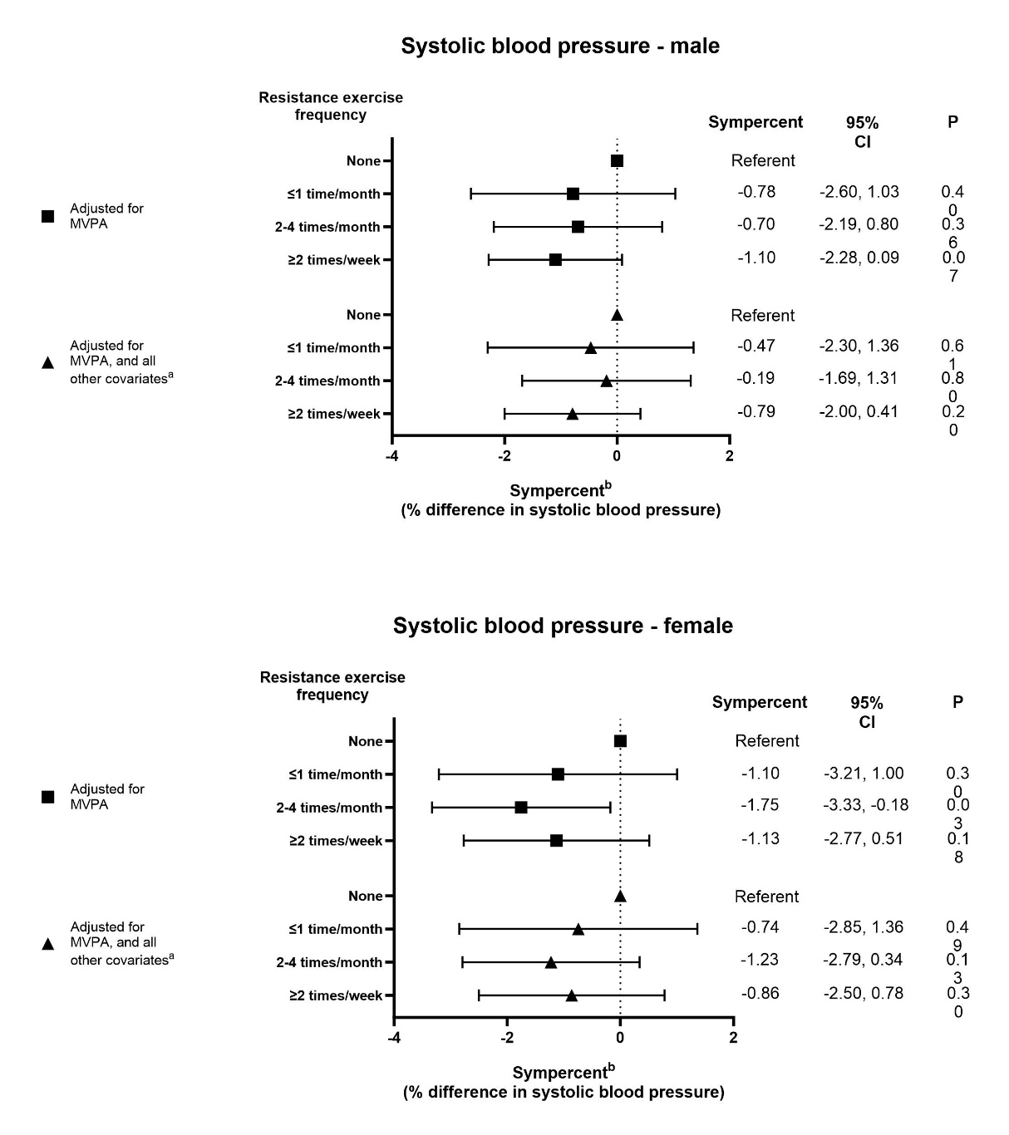
ªOther covariates include smoking status, alcohol consumption, educational attainment, self-rated health, and disability
^{b}Sympercent represents the percentage difference after transformation of the outcome variable into the 100 log_{e} scale
CI, confidence interval; MVPA, moderate-vigorous physical activity.

Figure S3
Regression Analysis Between Resistance Exercise Frequency and Total Cholesterol:HDL-C – Stratified by Sex
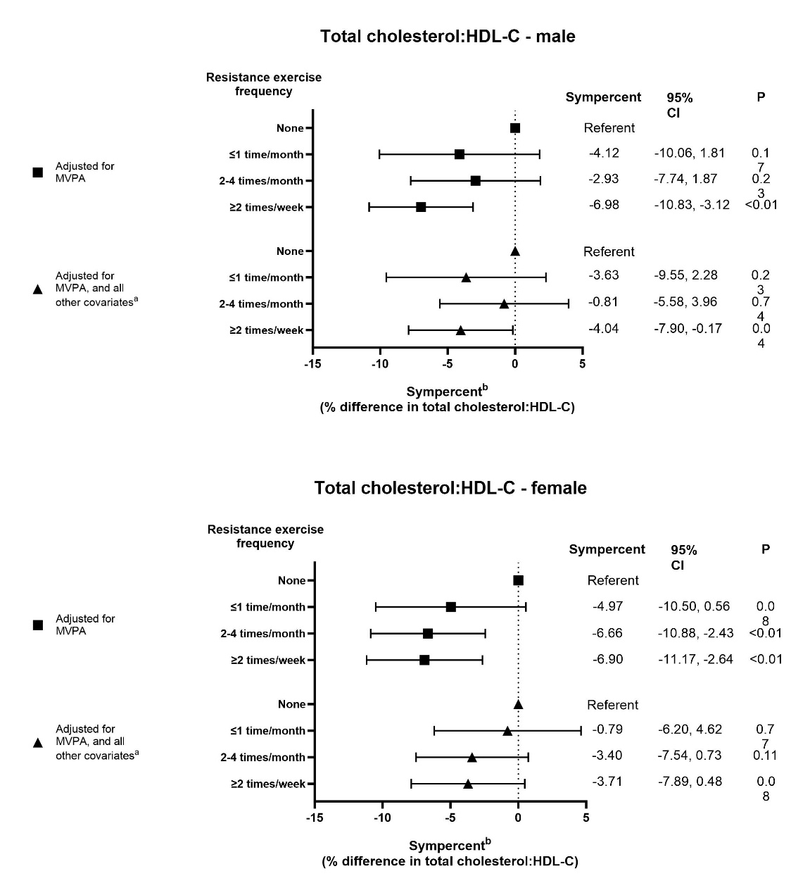
ªOther covariates include smoking status, alcohol consumption, educational attainment, self-rated health, and disability
^{b}Sympercent represents the percentage difference after transformation of the outcome variable into the 100 log_{e} scale
CI, confidence interval; HDL-C, high-density lipoprotein cholesterol; MVPA, moderate-vigorous physical activity.

Figure S4
Regression Analysis Between Resistance Exercise Frequency and Serum HbA1c – Stratified by Sex
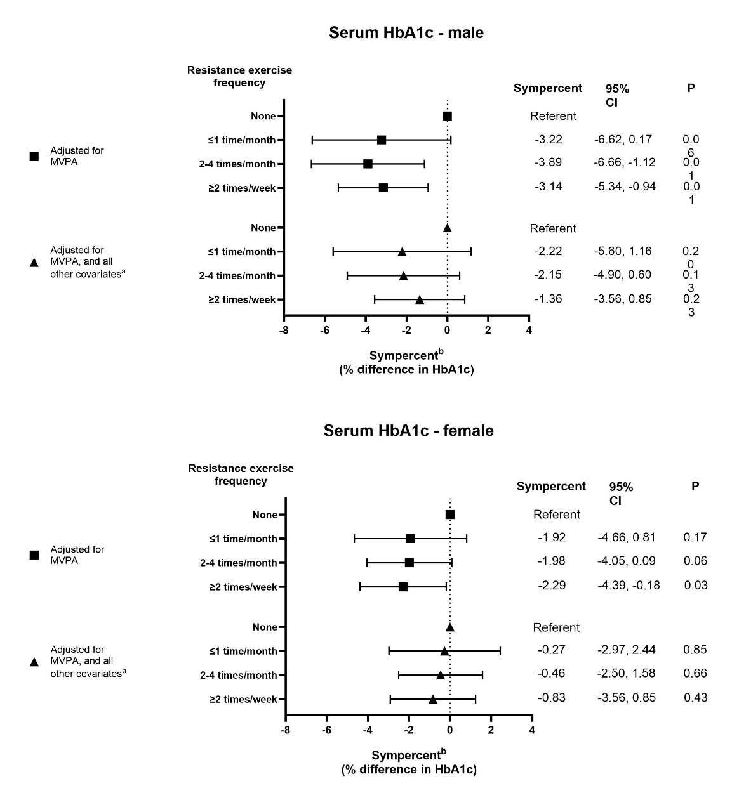
ªOther covariates include smoking status, alcohol consumption, educational attainment, self-rated health, and disability
^{b}Sympercent represents the percentage difference after transformation of the outcome variable into the 100 log_{e} scale
CI, confidence interval; HbA1c, haemoglobin A1c; MVPA, moderate-vigorous physical activity.

