Supporting Information for
Evaluation of net and bottle sampling methods for zooplankton collection in reservoirs: An assessment using data from a nationwide reservoir monitoring program in Japan

*Hiromichi Suzuki¹, Tomonori Osugi², Hidetaka Ichiyanagi², Jotaro Urabe¹

1, Graduate School of Life Sciences, Tohoku University, Sendai, Miyagi 980-8578, Japan
2, Water Resources Environmental Center, Chiyoda, Tokyo 102-0083, Japan
*Corresponding author: hiromichi.suzuki.t2@dc.tohoku.ac.jp

Table S1. List of revised species names. The left column shows the names listed in the National Census on River and Dam Environment database, and the right column shows the corrected species names following our taxonomic revisions.
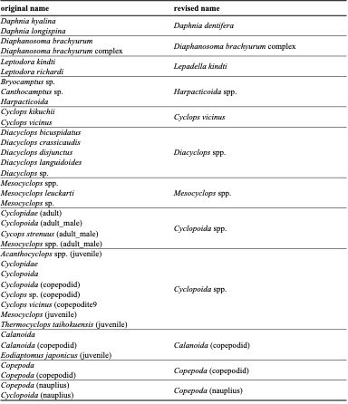
Table S1. Continued
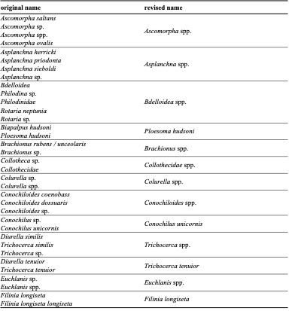
Table S1. Continued
