Table S1. GC temperature program for GC-MSD of PBDEs, MeO-PBDEs, ECFO-PBDEs and ECFO-BRP.
Injector information
Mode | Pulsed splitless
Heater | 280°C
Pressure | 10.42psi
Total flow | 54.2mL/min
Septum purge flow | 3mL/min
Gas saver | 20mL/min
Injection pulse pressure | 20psi until 0.5min
Purge flow to split vent | 50mL/min at 2min
Column information
Column | DB-5MS  with 30m length, 0.25mm ID, 0.1μm film thickness
Flow rate | Constant flow at 1.2mL/min
Oven information
Equilibration time | 0.5min
Oven program | 60°C for 2min  then 15°C/min to 250°C for 0min  then 5°C/min to 280°C for 5min  then 30°C/min to 290°C for 20min
Thermal Aux (MSD transfer line) information
Heater | 290°C

Table S2. Ion monitored for GCMS of PBDEs and MeO-PBDEs in tissue extracts.
Group no.  (Start time, min) | Rt, min | m/z  (dwell time, msec) | m/z type | m/z formula | Substance
1  (11.5) | 12.31 | 248 (200)  250 (200) | M  M + 2 | ¹²C₁₂H₉⁷⁹BrO  ¹²C₁₂H₉⁷⁹Br⁸¹BrO | BDE-3  (4-MoBDE)
2  (14.3) | 14.50 | 326 (200)  328 (200)  330 (200) | M  M + 2  M + 4 | ¹²C₁₂H₈⁷⁹Br₂O  ¹²C₁₂H₈⁷⁹Br⁸¹BrO  ¹²C₁₂H₈⁸¹Br₂O | BDE-15  (4, 4’-DiBDE)
3  (15.8) | 16.20 | 404 (200)  406 (200)  408 (200) | M  M + 2  M + 4 | ¹²C₁₂H₇⁷⁹Br₃O  ¹²C₁₂H₇⁷⁹Br₂⁸¹BrO  ¹²C₁₂H₇⁷⁹Br⁸¹Br₂O | BDE-28  (2, 4, 4’-TrBDE)
4  (17.5) | 18.29 | 484 (150)  486 (150)  488 (150) | M  M + 2  M + 4 | ¹²C₁₂H₆⁷⁹Br₄O  ¹²C₁₂H₆⁷⁹Br₃⁸¹BrO  ¹²C₁₂H₆⁷⁹Br₂⁸¹Br₂O | BDE-47  (2, 2’, 4, 4’-TeBDE)
4  (17.5) | 18.29 | 496 (100)  498 (100)  500 (100) | M  M + 2  M + 4 | ¹³C₁₂H₆⁷⁹Br₄O  ¹³C₁₂H₆⁷⁹Br₃⁸¹BrO  ¹³C₁₂H₆⁷⁹Br₂⁸¹Br₂O | ¹³C-BDE-47
4  (17.5) | 19.08 | 496 (100)  498 (100)  500 (100) | M  M + 2  M + 4 | ¹³C₁₂H₆⁷⁹Br₃O  ¹³C₁₂H₆⁷⁹Br₃⁸¹BrO  ¹³C₁₂H₆⁷⁹Br₂⁸¹Br₂O | ¹³C-BDE-77
5  (19.2) | 19.58 | 514 (200)  516 (200)  518 (200) | M + 2  M + 4  M + 6 | ¹²C₁₃H₈⁷⁹Br₃⁸¹BrO₂  ¹²C₁₃H₈⁷⁹Br₃⁸¹Br₂O₂  ¹²C₁₃H₈⁷⁹Br⁸¹Br₃O₂ | 6-OMe  -BDE-47
6  (19.9) | 20.15 | 341 (200)  356 (200)  516 (200) | M-CH₃⁷⁹Br⁸¹Br  M - ⁷⁹Br⁸¹Br  M + 2 | ¹²C₁₂H₅⁷⁹Br₂O₂  ¹²C₁₃H₈⁷⁹Br₂O₂  ¹²C₁₃H₈⁷⁹Br₃⁸¹BrO₂ | 5-OMe  -BDE-47
7  (25.0) | 25.80 | 654 (200)  656 (200)  658 (200) | M + 4  M + 6  M + 8 | ¹³C₁₂H₄⁷⁹Br₄⁸¹Br₂O  ¹³C₁₂H₄⁷⁹Br₃⁸¹Br₃O  ¹³C₁₂H₄⁷⁹Br₂⁸¹Br₄O | ¹³C-BDE-138

Table S3. Ion monitored for GCMS of ECFO-BPR and ECFO-PBDEs in tissue extracts.
Group no.  (Start time, min) | Rt, min | m/z  (dwell time, msec) | m/z type | m/z formula | Substance
1  (12.0) | 13.78 | 249 (100)  251 (200)  253 (100)  266 (200) | M - CO₂CH₃  M - CO₂CH₃ + 2  M - CO₂CH₃ + 4  M - CO₂ + 2 | ¹²C₆H₃⁷⁹Br₂O  ¹²C₆H₃⁷⁹Br⁸¹BrO  ¹²C₆H₃⁸¹Br₂O  ¹²C₇H₆⁷⁹Br⁸¹BrO | 2,4-DiBP
2  (20.0) | 24.23 | 340 (200)  342 (200)  344 (200)  502 (100) | M-CO₂CH₂⁷⁹Br⁸¹Br  M-CO₂CH₂⁷⁹Br⁸¹Br +2  M-CO₂CH₂⁷⁹Br⁸¹Br +4  M-CO₂CH₂ +2 | ¹²C₁₃H₁₀⁷⁹Br₂O  ¹²C₁₃H₁₀⁷⁹Br⁸¹BrO  ¹²C₁₃H₁₀⁸¹Br₂O  ¹²C₁₃H₁₀⁷⁹Br₂⁸¹Br₂O₂ | 6-ECFO-BDE-47
2  (20.0) | 27.58 | 341 (200)  354 (100)  356 (200)  358 (100)  560 (100) | M - CO₂CH₃  ⁷⁹Br⁸¹Br + 2  M-CO₂⁷⁹Br⁸¹Br  M-CO₂⁷⁹Br⁸¹Br +2  M-CO₂⁷⁹Br⁸¹Br +4  M + 4 | ¹²C₁₃H₉⁷⁹Br⁸¹BrO  ¹²C₁₄H₁₂⁷⁹Br₂O  ¹²C₁₄H₁₂⁷⁹Br⁸¹BrO  ¹²C₁₄H₁₂⁸¹Br₂O  ¹²C₁₅H₁₂⁷⁹Br₂⁸¹Br₂O₃ | 3-ECFO-BDE-47

Table S4. Percent amino acid sequence identities of two Japanese medaka C1r C1s like sequence with reported fish othologues
 | ENSORLT00000015464ª  (ENSORLP00000015463)^{b} | ENSORLT00000015483ª  (ENSORLP00000015482)^{b}
carp C1rs-aª | 47.60% | 37.70%
carp C1rs-b^{b} | 47.10% | 37.60%
trout C1r/C1s^{c} | 58.10% | 32.80%
yellow perch C1r/s^{d} | 62.90% | 33.50%

a:transcript ID in Ensemble Database
b:protein ID in Ensemble Database
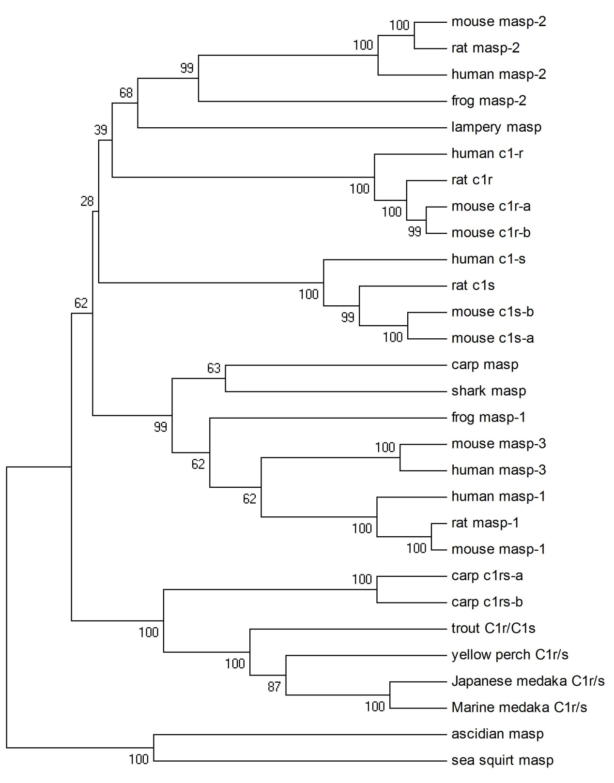

Figure S1. Phylogenetic tree of C1r, C1s and Maspothologuesin multiple species. The tree is constructed by using MUSCLE for multiple sequence alignment and UPGMA method. Bootstrap percentages that support each portioning are given.

