Supplementary material for:
Predicting Cu and Zn sorption capacity of biochar from feedstock C:N ratio and pyrolysis temperature

Alfonso Rodríguez-Vila, Heather Selwyn-Smith, Laurretta Enunwa, Isla Smail, Emma F. Covelo and Tom Sizmur

Contents: One table and four figures

Table SI-1 Sources of the different feedstock materials
Feedstock material | Source
Cedar wood | Graveyard at St Paul’s Church, Wokingham
Greenwaste compost | B&Q hardware store
Pistachio nut shells | Tesco supermarket
Pine stripwood | Homebase garden centre
Whitewood spruce | Homebase garden centre
Conifer bark | Homebase garden centre
Horse chestnut leaves | University of Reading campus
Bamboo canes | Homebase garden centre
Farmyard manure | Homebase garden centre
Chicken manure | Homebase garden centre

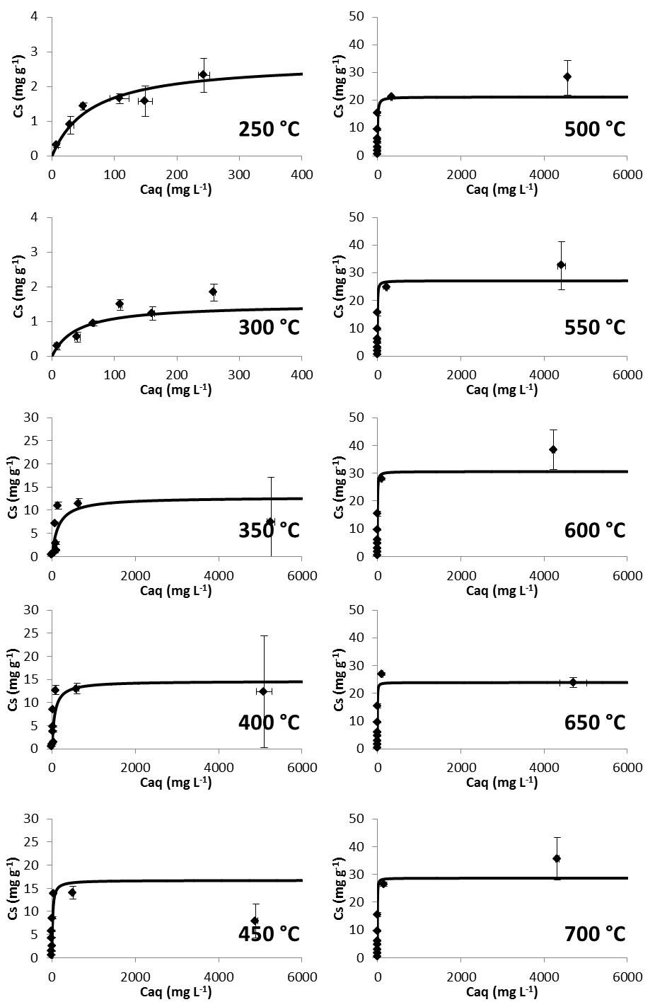
Fig. SI-1 Cu sorption isotherms for biochars 250-700 °C fitted to Langmuir isotherms. Each data point is the average of three replicate measurements, error bars are standard errors of the mean
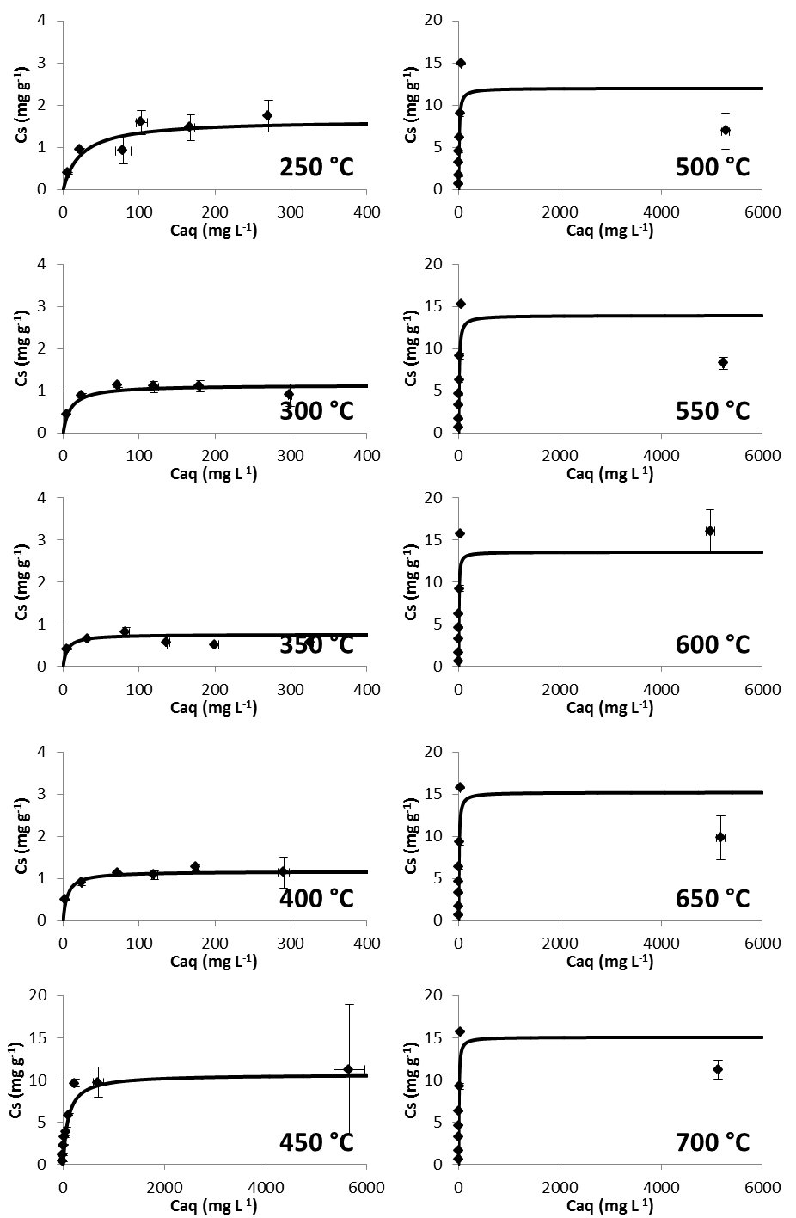
Fig. SI-2 Zn sorption isotherms for biochars 250-700 °C fitted to Langmuir isotherms. Each data point is the average of three replicate measurements, error bars are standard errors of the mean
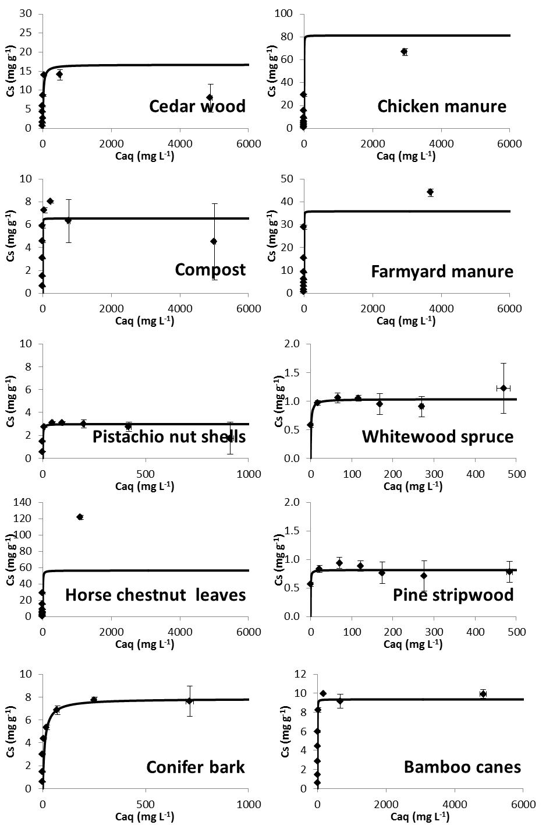
Fig. SI-3 Cu sorption isotherms for biochars from the different feedstock materials fitted to Langmuir isotherms. Each data point is the average of three replicate measurements, error bars are standard errors of the mean
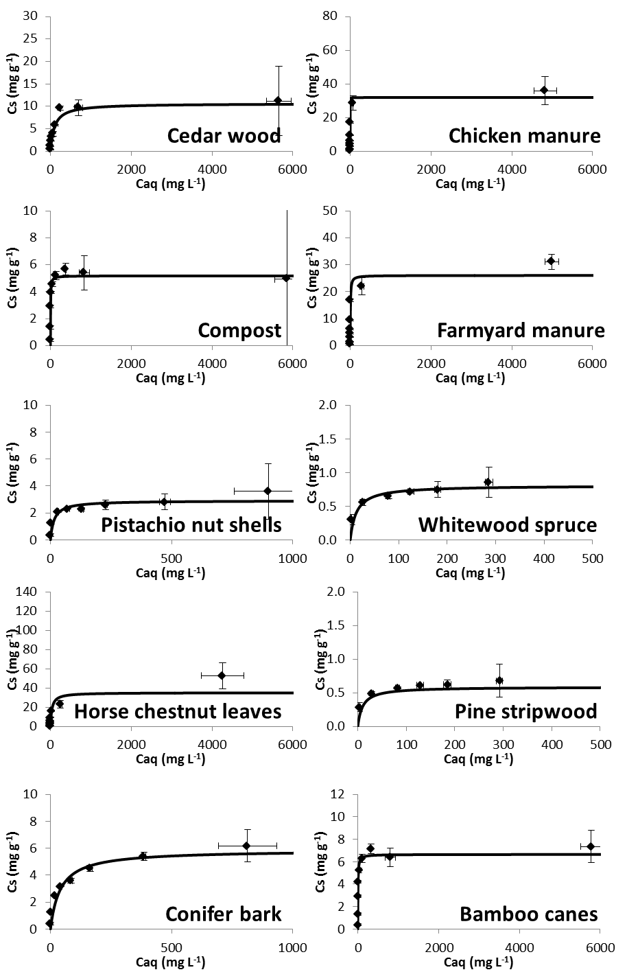
Fig. SI-4 Zn sorption isotherms for biochars from the different feedstock materials fitted to Langmuir isotherms. Each data point is the average of three replicate measurements, error bars are standard errors of the mean

