Supplementary Fig. 1
SDS-PAGE protein profiles of shoot extracts of Callitriche cophocarpa treated with 1 mM chromate for 72 h (Cr).
C, control (untreated plant); ST, protein standard markers.
Letters (a), (b), (c) indicate the individual gels obtained upon three independent physiological experiments
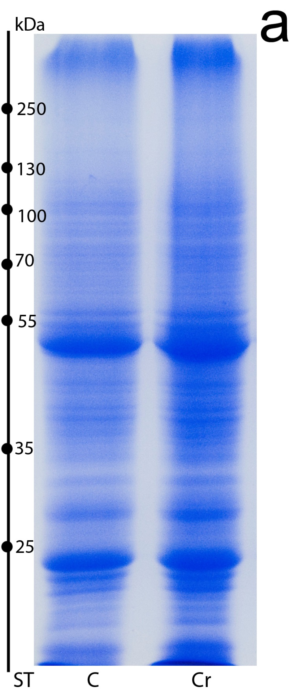
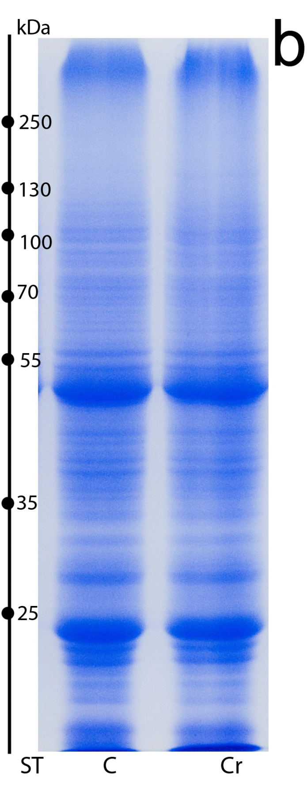
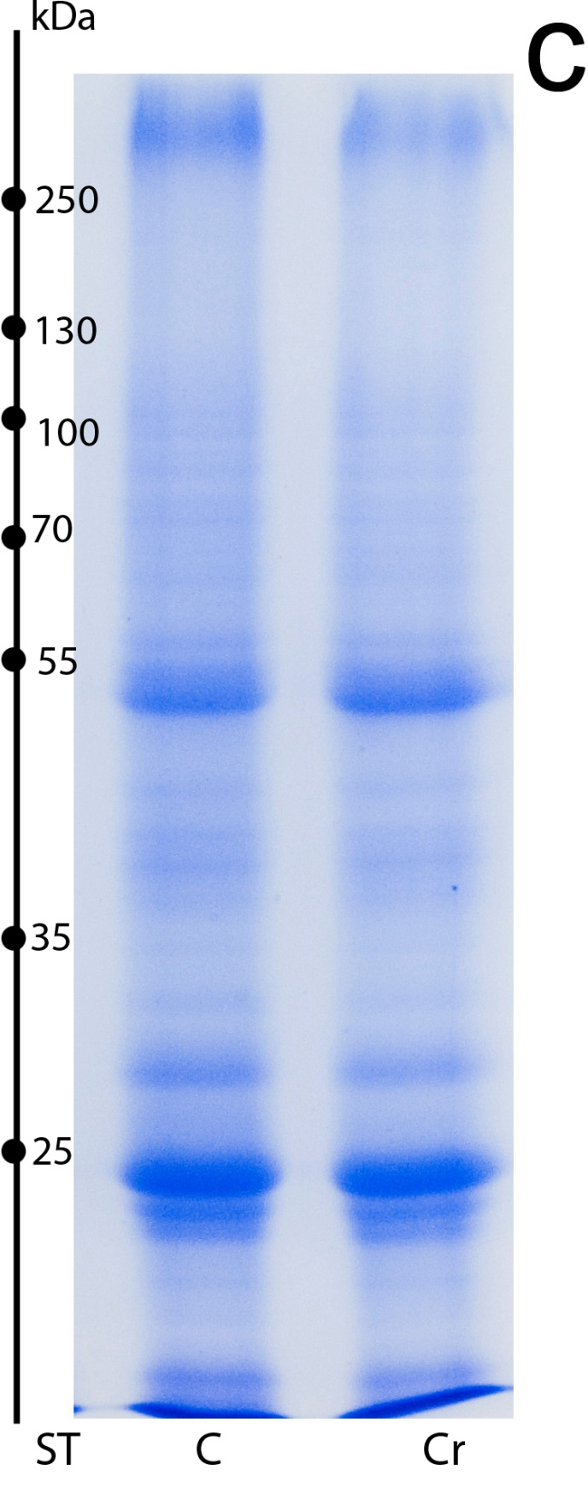

Supplementary Fig. 2
Two-dimensional (2DE) proteome mapping of C. cophocarpa shoots after treatment with 1 mM potassium chromate
for 72 h (gel 2, right) as compared to the untreated controls (gel 1, left). The isoelectric focusing (IEF) step was performed at pI range 3-10. The differentiating spots are numbered consecutively and marked with circles; spots no. 1, 2 represent the Cr(VI)-induced proteins (green circles), spots no. 3, 4, 5 indicate the down-regulated proteins (red circles).
Letters (a), (b), (c) indicate the individual gels obtained upon three independent physiological experiments
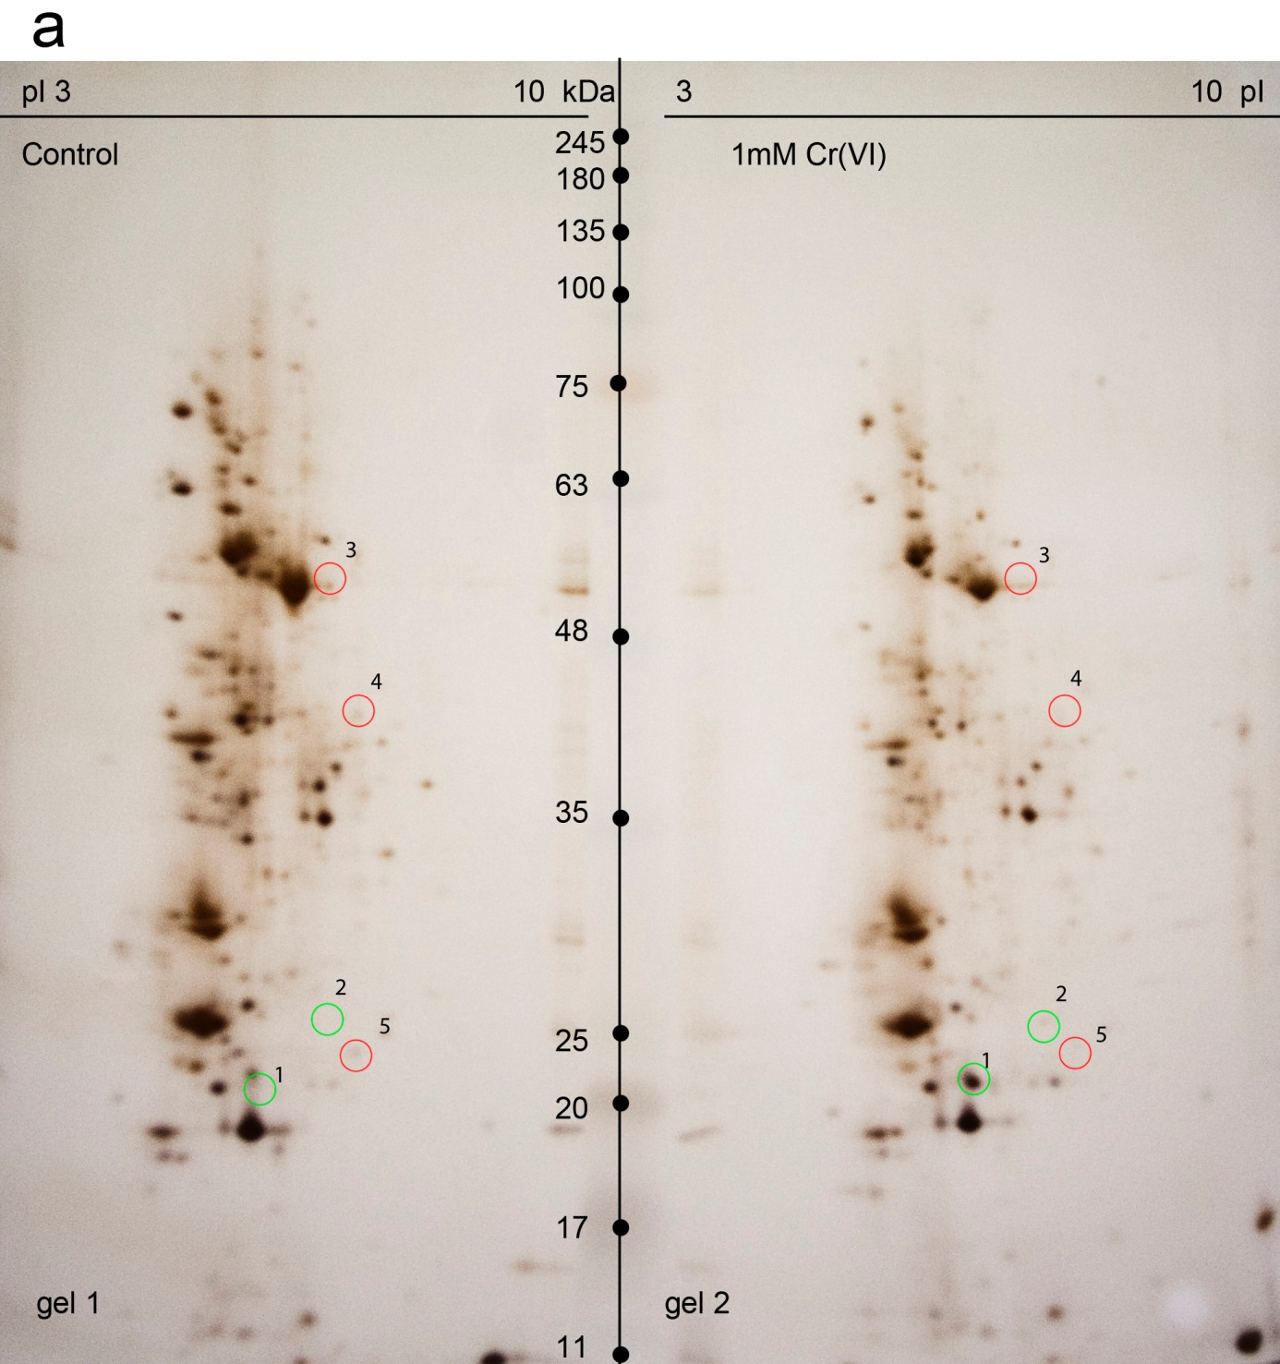

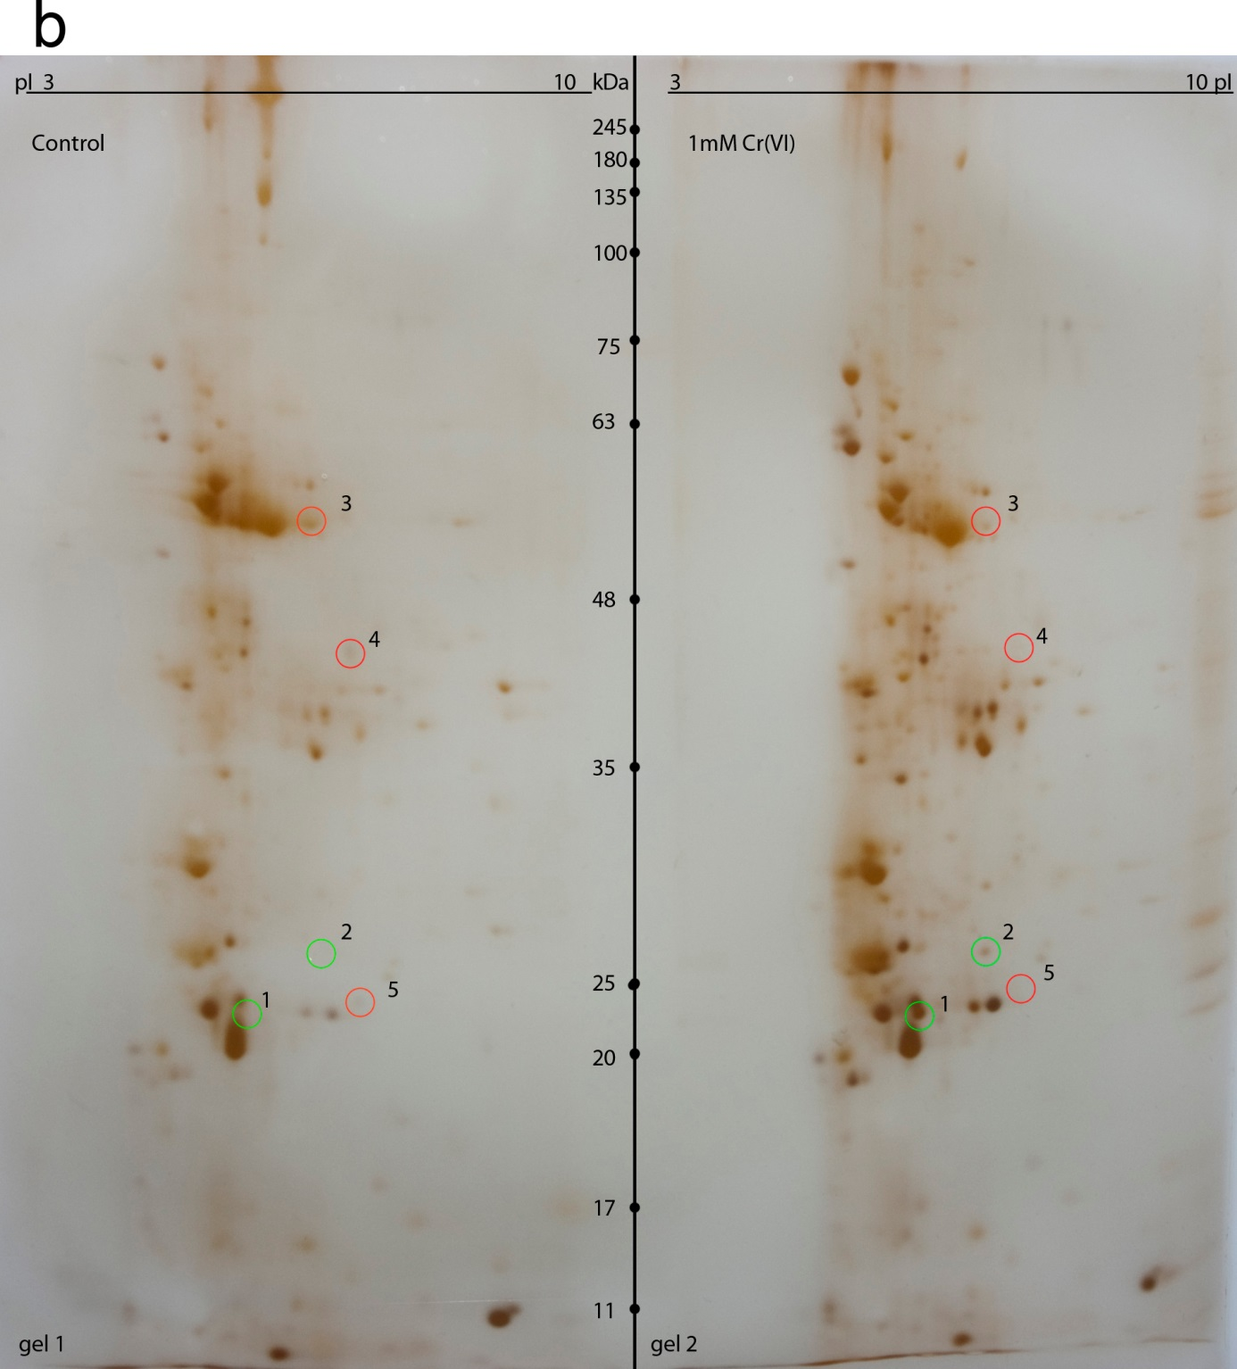

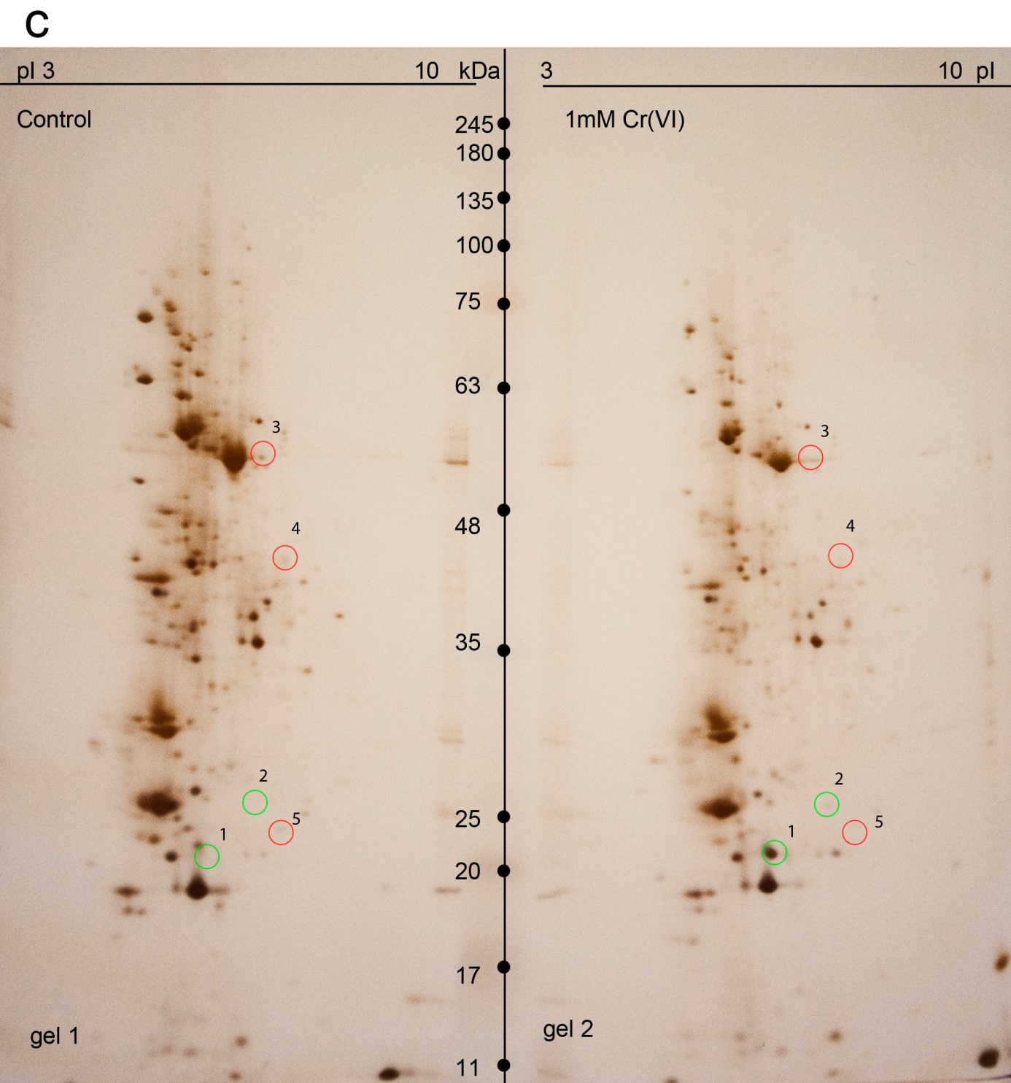

Supplementary Fig. 3
Two-dimensional (2DE) proteome mapping of C. cophocarpa shoots after treatment with 1 mM potassium chromate
for 72 h (gel 2, right) as compared to the untreated controls (gel 1, left). The isoelectric focusing (IEF) step was performed at pI range 5-8. The differentiating spots are numbered consecutively and marked with circles; spots no. 1, 2 represent the Cr(VI)-induced proteins (green circles), spots no. 3, 4, 5 indicate the down-regulated proteins (red circles).
Letters (a), (b), (c) indicate the individual gels obtained upon three independent physiological experiments

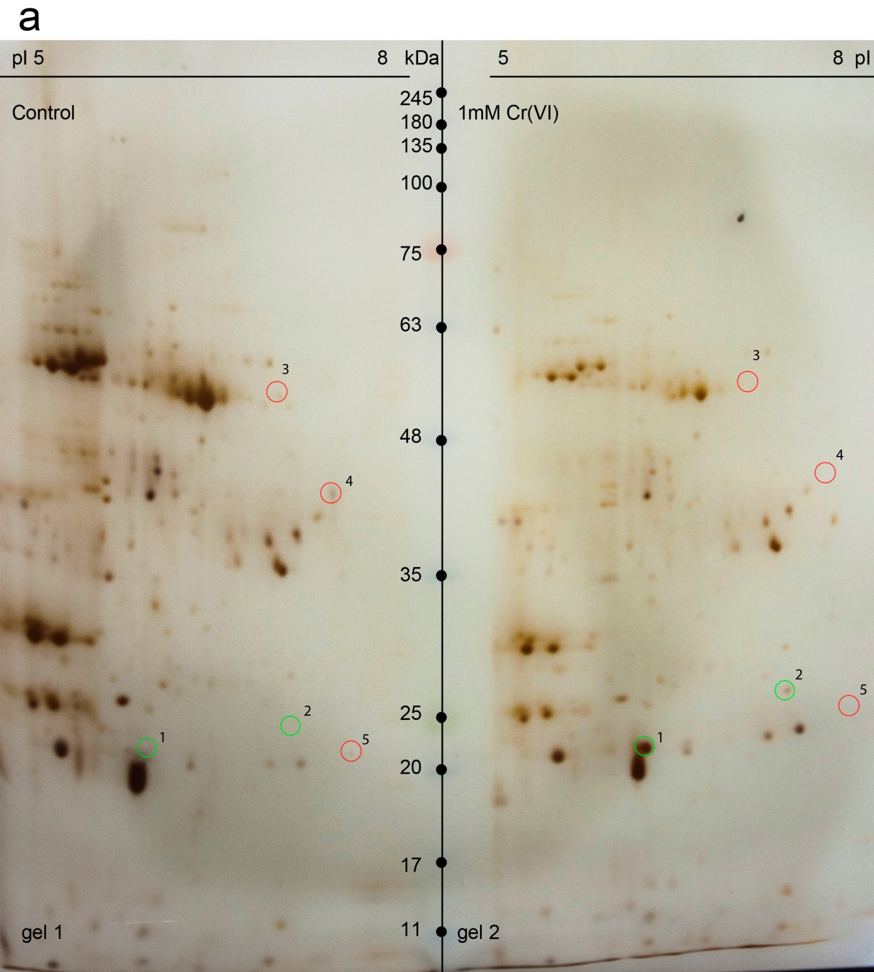

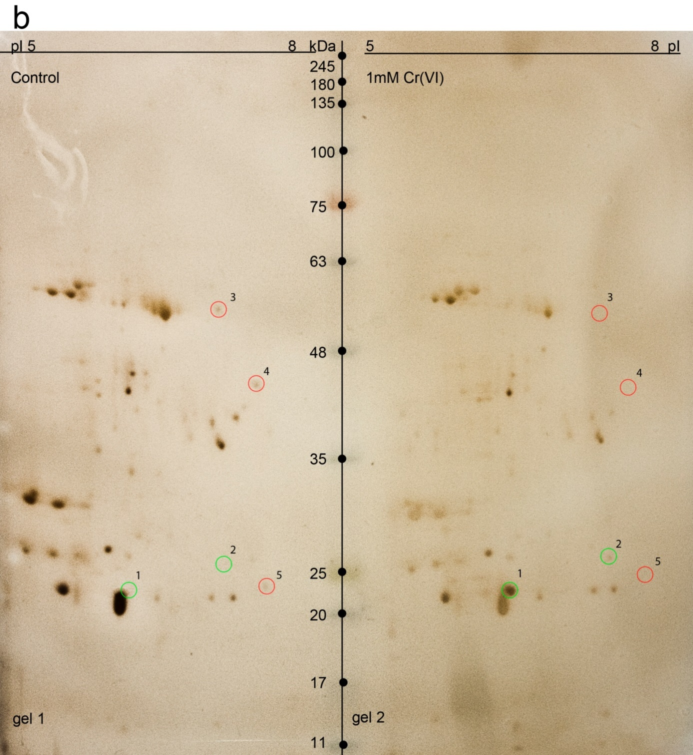

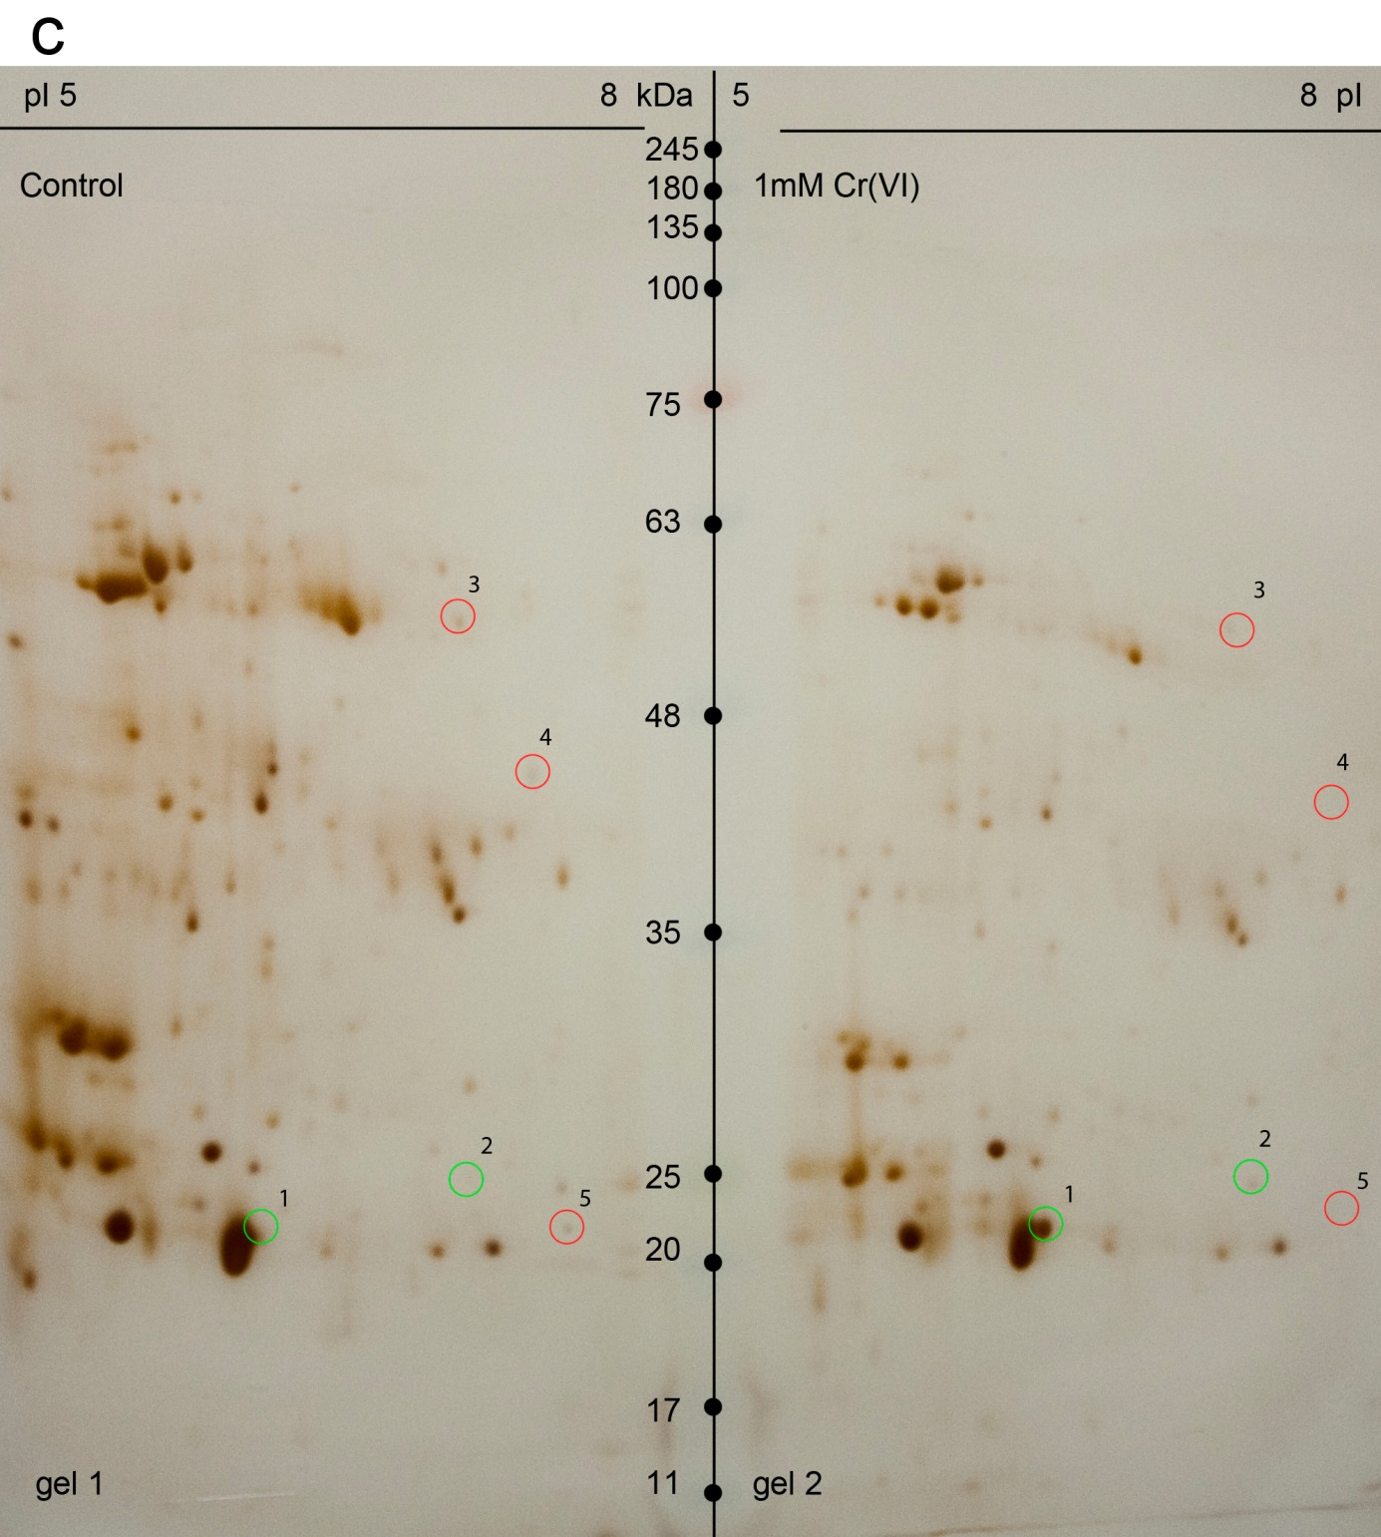

Supplementary Fig. 4
Zymographic analyses of shoot protein extracts of Callitriche cophocarpa treated with 1 mM Cr(VI) for 72 h. Enzymatic staining with a menadione substrate was done to reveal production of a novel quinone reductase activity as indicated by an arrow. C, control
Letters (a), (b), (c) indicate the individual zymograms obtained upon three independent physiological experiments

