Supporting information for
Treatment of wastewater containing pharmaceuticals in microcosm constructed wetlands: the occurrence of integrons (int1-2) and associated resistance genes (sul1-3, qacEΔ1)
Monika Nowrotek^{1,2*}, Ewa Kotlarska³, Aneta Łuczkiewicz⁴, Ewa Felis^{1,2}, Adam Sochacki^{1,2,5}, Korneliusz Miksch^{1,2}
¹Silesian University of Technology, Environmental Biotechnology Department, ul. Akademicka 2, 44-100 Gliwice, Poland
²Silesian University of Technology, Centre for Biotechnology, ul. B. Krzywoustego 8, 44-100, Gliwice, Poland
³Institute of Oceanology Polish Academy of Sciences, Department of Genetics and Marine Biotechnology, ul. Powstanców Warszawy 55, 81-712 Sopot, Poland
⁴Gdansk University of Technology, Department of Water and Wastewater Technology, ul. Narutowicza 11/12, 80-233 Gdańsk, Poland
⁵Czech University of Life Sciences Prague, Faculty of Environmental Sciences, Department of Applied Ecology, Kamýcká 129, 165 00 Prague, Czech Republic

*Corresponding author: monika.nowrotek@polsl.pl
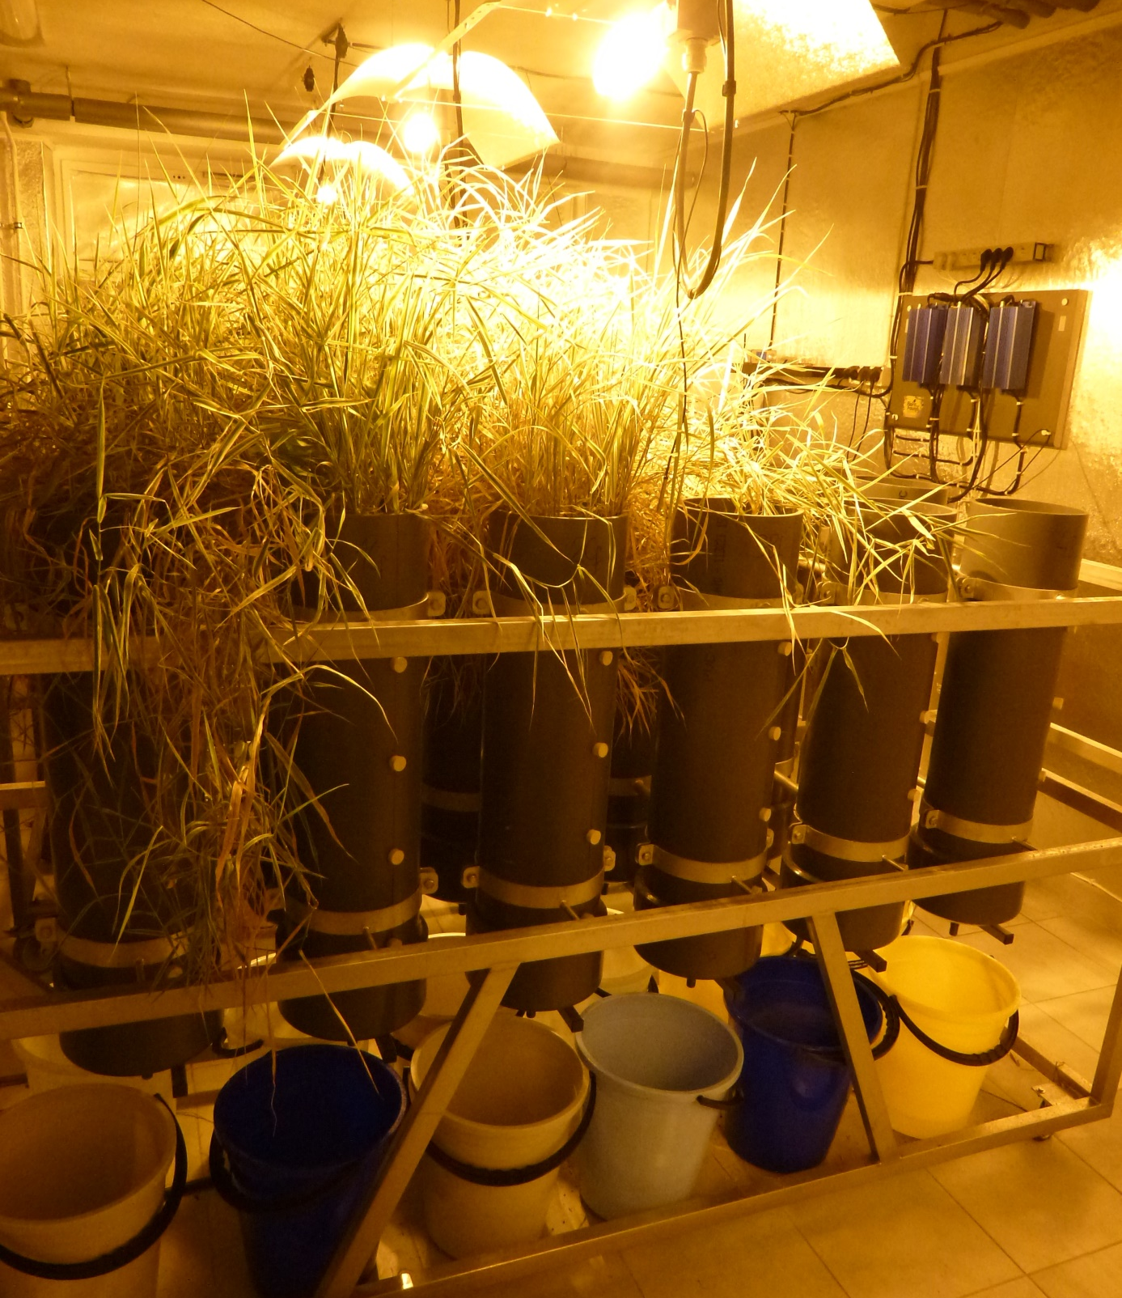
Figure S1 Photo of the experimental system: a rig supporting 12 columns; the remaining 12 columns were mounted to an identical rig.

Table S1. The detailed information on the composition of the raw wastewater used in the study (based on Nowrotek et al. (2016)
Component* | Concentration, mg/L | Concentration of metal cation, mg/L
urea | 208.76 | -----
NH₄Cl | 62.45 | -----
yeast extract | 264.00 | -----
skim milk powder | 118.00 | -----
sodium acetate | 510.40 | -----
peptone | 40.00 | -----
KH₂PO₄ | 41.37 | -----
KCr(SO₄)₂∙12H₂O | 0.96 | 0.100
CuSO₄∙5H₂O | 0.781 | 0.200
MnSO₄∙H₂O | 0.108 | 0.035
NiSO₄∙7H₂O | 0.359 | 0.075
PbCl₂ | 0.100 | 0.075
ZnCl₂ | 0.208 | 0.100
MgSO₄∙7H₂O | 4.408 | 0.430
*The influent was prepared in tap water by dissolving the following components

Table S2. Primers used in PCR experiments
Target | Primer sequences (5’-3’) | PCR product size (bp) | PCR annealing temperature (°C) | Reference
int1 | int1AF: CCT CCC GCA CGATGATC  int1AR: TCC ACG CAT CGT CAG GC | 280 | 55 | Kraft et al. (1986)
int2 | int2AF: TTATTG CTG GGATTA GGC  int2AR: ACG GCT ACC CTC TGT TAT C | 233 | 50 | Goldstein et al. (2001)
qacEΔ1 | qacF: ATC GCA ATA GTT GGC GAA GT  qacR: CAA GCT TTT GCC CAT GAA GC | 225 | 55 | Stokes and Hall (1989)
sul1 | sul1F: ATG GTG ACG GTG TTC GGC ATT CTG A  sul1R: CTA GGC ATG ATC TAA CCC TCG GTC T | 800 | 55 | Grape et al. (2003)
sul2 | sul2-F GAATAAATCGCTCATCATTTTCGG  sul2-R CGAATTCTTGCGGTTTCTTTCAGC | 722 | 50 | Toleman et al. (2006)
sul3 | sul3-F GAGCAAGATTTTTGGAATCG  sul3-R CATCTGCAGCTAACCTAGGGCTTTGGA | 792 | 51 | Perreten and Boerlin (2003)

Table S3. The occurrence the analysed genes (sul1-3, int1-2 and qacEΔ1) in the column replicates at various stages of the CW experiment
Column | Replicate | PhCs in the feed
Column | Replicate | Day 7 | Day 22 | Day 47
Upper layer of substrate
 | I | sul2 | sul1, sul2, int1, qacEΔ1 | sul1
 | II | sul1, sul2, int1 | sul1, int1, qacEΔ1 | sul1
PhCs-P | III | sul2 | sul1, sul2, int1, qacEΔ1 | nd.
 | IV | nd. | sul1, sul2, int1, qacEΔ1 | sul1, sul2, int1
 | V | sul1, sul2, int1 | sul1, sul2, int1, qacEΔ1 | sul1
 | VI | nd. | sul1, sul2, int1, qacEΔ1 | sul1
 | I | sul2 | nd. | nd.
 | II | sul2 | sul2 | nd.
noPhCs-P | III | sul2 | sul1, sul2, int1 | sul1
 | IV | nd. | nd. | nd.
 | V | nd. | nd. | nd.
 | VI | sul1, sul2, int1 | sul1, sul2, int1 | sul1
 | I | nd. | nd. | nd.
 | II | nd. | sul1, sul2, int1, qacEΔ1 | nd.
PhCs-U | III | nd. | sul1, int1, qacEΔ1 | nd.
 | IV | sul2, int1 | sul1, sul2, int1, qacEΔ1 | sul1
 | V | nd. | sul1, sul2, int1, qacEΔ1 | sul1
 | VI | sul1, sul2, int1 | sul1, sul2, int1, qacEΔ1 | sul1, int1
 | I | nd. | nd. | nd.
 | II | nd. | nd. | nd.
noPhCs-U | III | nd. | nd. | nd.
 | IV | nd. | sul2 | nd.
 | V | nd. | nd. | nd.
 | VI | sul2, int1 | sul1 | nd.
CW effluents
PhCs-P  effluent | I | nt. | sul1, sul2, int1, qacEΔ1 | nt.
PhCs-P  effluent | II | nt. | sul1, sul2, int1, qacEΔ1 | nt.
PhCs-P  effluent | III | nt. | sul1, sul2, int1, qacEΔ1 | nt.
PhCs-P  effluent | IV | nt. | sul1, sul2, int1, qacEΔ1 | nt.
PhCs-P  effluent | V | nt. | sul1, sul2, int1, qacEΔ1 | nt.
PhCs-P  effluent | VI | nt. | sul1, sul2, int1, qacEΔ1 | nt.
PhCs-U  effluent | I | nt. | sul1, sul2, int1, qacEΔ1 | nt.
PhCs-U  effluent | II | nt. | sul1, sul2, int1, qacEΔ1 | nt.
PhCs-U  effluent | III | nt. | sul1, sul2, int1, qacEΔ1 | nt.
PhCs-U  effluent | IV | nt. | nd. | nt.
PhCs-U  effluent | V | nt. | sul1, int1, qacEΔ1 | nt.
PhCs-U  effluent | VI | nt. | sul1, int1, qacEΔ1 | nt.
*⁾nd – not detected, **⁾nt – not tested
References
Goldstein C, Lee MD, Sanchez S, Hudson C, Philips B, Register B, Grady M, Liebert C, Summers AO, White DG, Maurer JJ (2001) Incidence of class 1 and 2 integrases in clinical and commensal bacteria from livestock, companion animals, and exotics. Antimicrob Agents Chemother 45:723–726. doi: 10.1128/AAC.45.3.723-726.2001
Grape M, Sundström L, Kronvall G (2003) Sulphonamide resistance gene sul3 found in Escherichia coli isolates from human sources. J Antimicrob Chemother 52:1022–1024. doi: 10.1093/jac/dkg473
Kraft CA, Timbury MC, Platt DJ (1986) Distribution and genetic location of Tn7 in trimethoprim-resistant Escherichia coli. J Med Microbiol 22(2):25–131.
Nowrotek M, Sochacki A, Felis E, Miksch K (2016) Removal of diclofenac and sulfamethoxazole from synthetic municipal waste water in microcosm downflow constructed wetlands: Start-up results. Int J Phytoremediation 18(2):157-163. doi: 10.1080/15226514.2015.1073669.
Perreten V, Boerlin P (2003) A new sulfonamide resistance gene (sul3) in Escherichia coli is widespread in the pig population of Switzerland. Antimicrob Agents Chemother 47(3):1169-1172.
Stokes HW, Hall RM (1989) A novel family of potentially mobile DNA elements encoding site-specific gene-integration functions: integrons. Mol Microbiol 3:1669–1683.
Toleman MA, Bennett PM, Walsh TR (2006) ISCR elements: novel gene-capturing systems of the 21st century? Microbiol Mol Biol Rev 70(2), 296-316.

