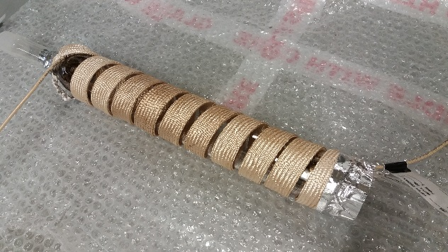
Supplementary Figure. The quartz tube reactor with heating tape wrapped around its exterior (before the application of insulation).

