Supplementary material
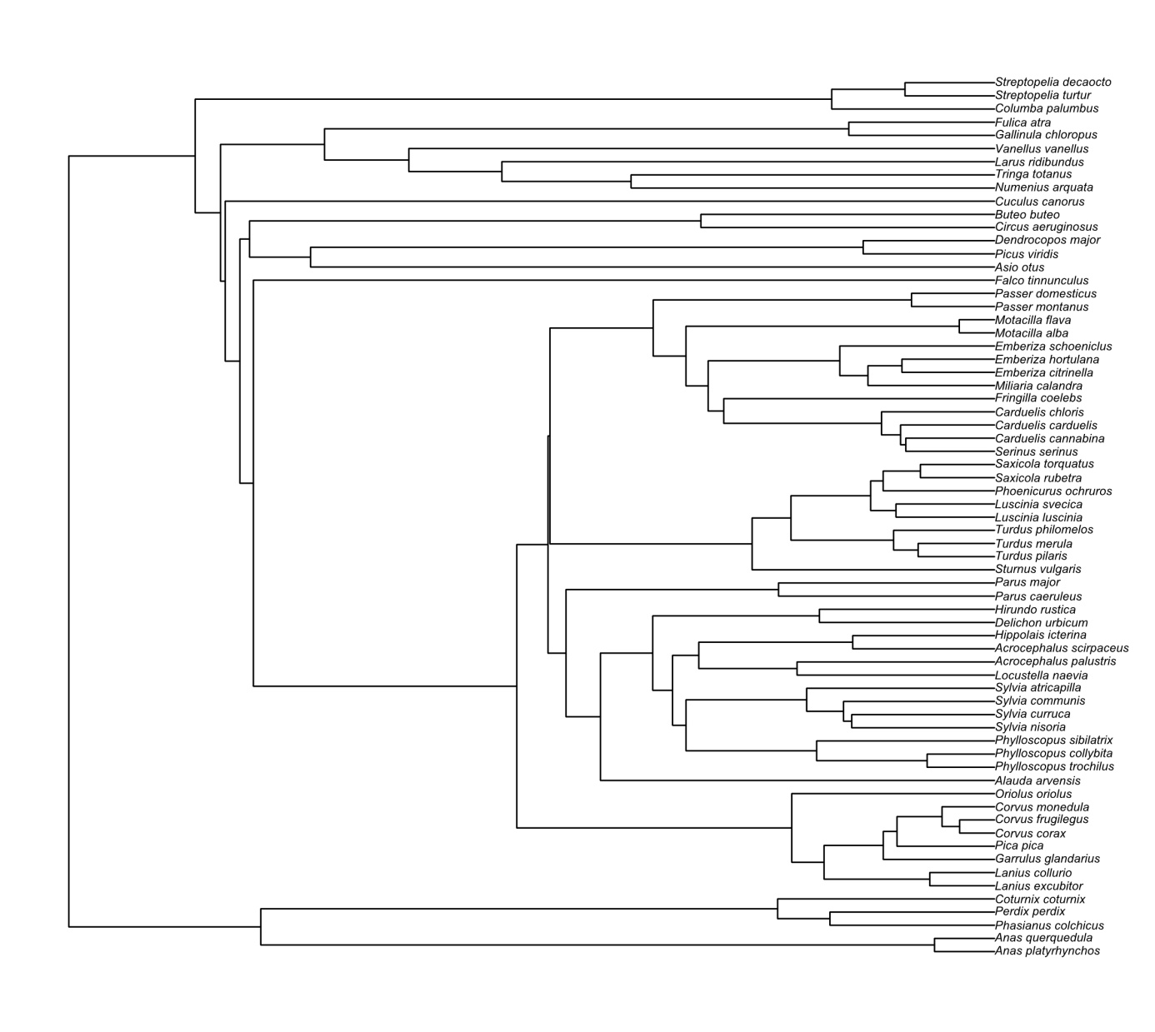
Fig. S1. Phylogenetic tree that was used in analyses.

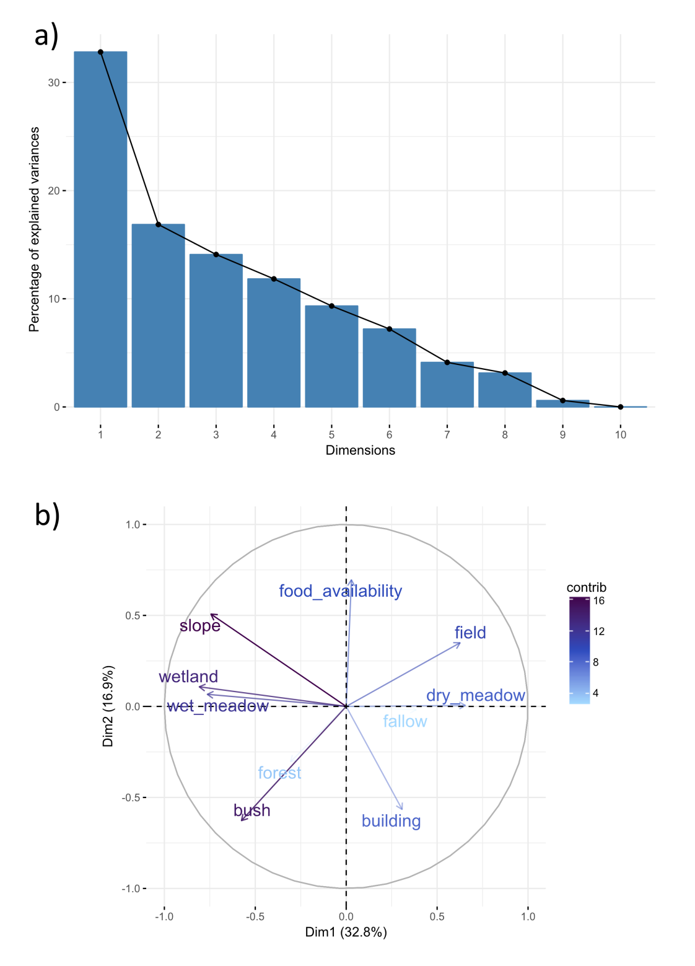
Fig. S2. Results of the principal component analysis (PCA) of continuous environmental explanatory variables used in the analysis of bird diversity indices along railway transects. The variance explained by principal components (a) and correlations between variables along the first two PCA axes (b) are shown. The colours of the environmental variables in the lower panel are scaled based on their percent contribution to the PCA.

Table S1. List of traits with the considered data type and levels of the variable used in functional diversity calculations.
No | Trait | Type(levels) | Description
1 | Brain_mass_g | Continuous | Brain mass [g]
2 | Body_mass_g | Continuous | Body mass [g]
3 | Sexual_dimorphism | Categorical (0 - no, 1 - yes) | Differences between males
4 | Clutch_MEAN | Continuous | Mean clutch size
5 | Broods_per_year | Continuous | Number of broods per year
6 | Egg_MASS | Continuous | Egg mass [g]
7 | Incubation_period | Continuous | Longetivity of incubation period [days]
8 | Fledging_period | Continuous | Longetivity of fledging period [days]
9 | Age_of_first_breeding | Continuous | Age at first reproduction [years]
10 | Life_span | Continuous | Life span [years]
11 | Sedentary | Categorical (0 - no, 1 - yes) | Migration mode: sedentary
12 | Facultative_migrant | Categorical (0 - no, 1 - yes) | Migration mode: facultative migrant (some individuals sedentary)
13 | Short_distance_migrant | Categorical (0 - no, 1 - yes) | Migration mode: short distance migrant
14 | Long_distance_migrant | Categorical (0 - no, 1 - yes) | Migration mode: long distance migrant
15 | Folivore_Y | Categorical (0 - no, 1 - yes) | At least 10% of diet throughout the year composed of grass, leaves, small plants etc.
16 | Frugivore_Y | Categorical (0 - no, 1 - yes) | At least 10% of diet throughout the year composed of fruits
17 | Granivore_Y | Categorical (0 - no, 1 - yes) | At least 10% of diet throughout the year composed of grains, seeds and nuts
18 | Arthropods_Y | Categorical (0 - no, 1 - yes) | At least 10% of diet throughout the year composed of arthropods
19 | Other_invertebrates_Y | Categorical (0 - no, 1 - yes) | At least 10% of diet throughout the year composed of invertebrates except for arthropods
20 | Fish_Y | Categorical (0 - no, 1 - yes) | At least 10% of diet throughout the year composed of fish
21 | Other_vertebrates_Y | Categorical (0 - no, 1 - yes) | At least 10% of diet throughout the year composed of vertebrates except for fish
22 | Carrion_Y | Categorical (0 - no, 1 - yes) | At least 10% of diet throughout the year composed of carrion
23 | Omnivore_Y | Categorical (0 - no, 1 - yes) | Diet throughout the year composed of similar amount of plants and animals
24 | Folivore_B | Categorical (0 - no, 1 - yes) | At least 10% of diet throughout the breeding season composed of grass, leaves, small plants etc.
25 | Frugivore_B | Categorical (0 - no, 1 - yes) | At least 10% of diet throughout the breeding season composed of fruits
26 | Granivore_B | Categorical (0 - no, 1 - yes) | At least 10% of diet throughout the breeding season composed of grains, seeds and nuts
27 | Arthropods_B | Categorical (0 - no, 1 - yes) | At least 10% of diet throughout the breeding season composed of arthropods
28 | Other_invertebrates_B | Categorical (0 - no, 1 - yes) | At least 10% of diet throughout the breeding season composed of invertebrates except for arthropods
29 | Fish_B | Categorical (0 - no, 1 - yes) | At least 10% of diet throughout the breeding season composed of fish
30 | Other_vertebrates_B | Categorical (0 - no, 1 - yes) | At least 10% of diet throughout the breeding season composed of vertebrates except for fish
31 | Carrion_B | Categorical (0 - no, 1 - yes) | At least 10% of diet throughout the breeding season composed of carrion
32 | Omnivore_B | Categorical (0 - no, 1 - yes) | Diet throughout the breeding season composed of similar amount of plants and animals
33 | Precocial | Categorical (0 - no, 1 - yes) | Breeding mode: precocial
34 | Semiprecocial | Categorical (0 - no, 1 - yes) | Breeding mode: semiprecocial
35 | Semialtrical | Categorical (0 - no, 1 - yes) | Breeding mode: semialtrical
36 | Altrical | Categorical (0 - no, 1 - yes) | Breeding mode: altrical
37 | Social_solitary | Categorical (0 - no, 1 - yes) | Sociality during breeding season: teritorial solitary
38 | Social_semi_col | Categorical (0 - no, 1 - yes) | Sociality during breeding season: semi-colonial
39 | Social_colonial | Categorical (0 - no, 1 - yes) | Sociality during breeding season: colonial

Table S2. Bird species and individuals recorded along railway and field control transects. Species recorded only along railway transects are in bold, and species found only along field control transects are in italics. The conservation status according to IUCN (LC – species of least concern; NT – near threatened species; VU – vulnerable species) coded into the corresponding Category value and the population trend for each species are given.
Species | Species abbreviation | Railway | Field (control) | Total | IUCN status | Category |  | Population trend
Sturnus vulgaris | Stu.vul | 193 | 97 | 290 | LC | 3 |  | decreasing
Alauda arvensis | Ala.arv | 44 | 149 | 193 | LC | 3 |  | decreasing
Sylvia communis | Syl.com | 61 | 11 | 72 | LC | 1 |  | increasing
Hirundo rustica | Hir.rus | 38 | 31 | 69 | LC | 3 |  | decreasing
Motacilla flava | Mot.fla | 24 | 44 | 68 | LC | 3 |  | decreasing
Emberiza citrinella | Emb.cit | 36 | 23 | 59 | LC | 3 |  | decreasing
Miliaria calandra | Mil.cal | 28 | 30 | 58 | LC | 3 |  | decreasing
Saxicola torquatus | Sax.tor | 50 | 5 | 55 | LC | 2 |  | stable
Lanius collurio | Lan.col | 39 | 11 | 50 | LC | 3 |  | decreasing
Passer domesticus | Pas.dom | 17 | 32 | 49 | LC | 3 |  | decreasing
Phasianus colchicus | Pha.col | 22 | 22 | 44 | LC | 3 |  | decreasing
Larus ridibundus | Lar.rid | 36 | 7 | 43 | LC | 4 |  | unknown
Delichon urbicum | Del.urb | 5 | 31 | 36 | LC | 3 |  | decreasing
Columba palumbus | Col.pal | 23 | 11 | 34 | LC | 1 |  | increasing
Turdus pilaris | Tur.pil | 23 | 11 | 34 | LC | 2 |  | stable
Carduelis cannabina | Car.can | 8 | 22 | 30 | LC | 3 |  | decreasing
Pica pica | Pic.pic | 9 | 21 | 30 | LC | 2 |  | stable
Motacilla alba | Mot.alb | 15 | 12 | 27 | LC | 2 |  | stable
Perdix perdix | Per.per | 10 | 15 | 25 | LC | 3 |  | decreasing
Carduelis carduelis | Car.car | 8 | 16 | 24 | LC | 1 |  | increasing
Sylvia atricapilla | Syl.atr | 14 | 7 | 21 | LC | 1 |  | increasing
Phylloscopus trochilus | Phy.tro | 13 | 6 | 19 | LC | 3 |  | decreasing
Sylvia curruca | Syl.cur | 11 | 7 | 18 | LC | 2 |  | stable
Buteo buteo | But.but | 5 | 12 | 17 | LC | 2 |  | stable
Oriolus oriolus | Ori.ori | 14 | 3 | 17 | LC | 2 |  | stable
Cuculus canorus | Cuc.can | 11 | 4 | 15 | LC | 3 |  | decreasing
Anas platyrhynchos | Ana.pla | 14 | 0 | 14 | LC | 1 |  | increasing
Carduelis chloris | Car.chl | 9 | 5 | 14 | LC | 2 |  | stable
Coturnix coturnix | Cot.cot | 2 | 12 | 14 | LC | 3 |  | decreasing
Falco tinnunculus | Fal.tin | 5 | 9 | 14 | LC | 3 |  | decreasing
Turdus merula | Tur.mer | 11 | 3 | 14 | LC | 1 |  | increasing
Fringilla coelebs | Fri.coe | 11 | 2 | 13 | LC | 1 |  | increasing
Vanellus vanellus | Van.van | 8 | 5 | 13 | NT | 5 |  | decreasing
Luscinia luscinia | Lus.lus | 7 | 4 | 11 | LC | 2 |  | stable
Phylloscopus collybita | Phy.col | 11 | 0 | 11 | LC | 1 |  | increasing
Emberiza schoeniclus | Emb.sch | 9 | 0 | 9 | LC | 3 |  | decreasing
Saxicola rubetra | Sax.rub | 5 | 4 | 9 | LC | 3 |  | decreasing
Acrocephalus palustris | Acr.pal | 6 | 2 | 8 | LC | 2 |  | stable
Lanius excubitor | Lan.exc | 4 | 4 | 8 | LC | 3 |  | decreasing
Parus caeruleus | Par.cae | 7 | 1 | 8 | LC | 1 |  | increasing
Streptopelia decaocto | Str.dec | 6 | 2 | 8 | LC | 1 |  | increasing
Corvus monedula | Cor.mon | 7 | 0 | 7 | LC | 2 |  | stable
Parus major | Par.maj | 6 | 1 | 7 | LC | 1 |  | increasing
Passer montanus | Pas.mon | 0 | 7 | 7 | LC | 3 |  | decreasing
Phoenicurus ochruros | Pho.och | 4 | 3 | 7 | LC | 1 |  | increasing
Emberiza hortulana | Emb.hor | 4 | 2 | 6 | LC | 3 |  | decreasing
Sylvia nisoria | Syl.nis | 6 | 0 | 6 | LC | 2 |  | stable
Turdus philomelos | Tur.phi | 6 | 0 | 6 | LC | 1 |  | increasing
Circus aeruginosus | Cir.aer | 0 | 4 | 4 | LC | 1 |  | increasing
Corvus frugilegus | Cor.fru | 0 | 3 | 3 | LC | 3 |  | decreasing
Gallinula chloropus | Gal.chl | 3 | 0 | 3 | LC | 2 |  | stable
Garrulus glandarius | Gar.gla | 0 | 3 | 3 | LC | 2 |  | stable
Hippolais icterina | Hip.ict | 3 | 0 | 3 | LC | 3 |  | decreasing
Anas querquedula | Ana.que | 2 | 0 | 2 | LC | 3 |  | decreasing
Phylloscopus sibilatrix | Phy.sib | 2 | 0 | 2 | LC | 3 |  | decreasing
Picus viridis | Pic.vir | 2 | 0 | 2 | LC | 1 |  | increasing
Acrocephalus scirpaceus | Acr.sci | 0 | 1 | 1 | LC | 2 |  | stable
Asio otus | Asi.otu | 0 | 1 | 1 | LC | 3 |  | decreasing
Corvus corax | Cor.cor | 1 | 0 | 1 | LC | 1 |  | increasing
Dendrocopos major | Den.maj | 1 | 0 | 1 | LC | 1 |  | increasing
Fulica atra | Ful.atr | 1 | 0 | 1 | LC | 1 |  | increasing
Locustella naevia | Loc.nae | 0 | 1 | 1 | LC | 2 |  | stable
Luscinia svecica | Lus.sve | 1 | 0 | 1 | LC | 2 |  | stable
Numenius arquata | Num.arq | 0 | 1 | 1 | NT | 5 |  | decreasing
Serinus serinus | Ser.ser | 0 | 1 | 1 | LC | 3 |  | decreasing
Streptopelia turtur | Str.tur | 1 | 0 | 1 | VU | 6 |  | decreasing
Tringa totanus | Tri.tot | 1 | 0 | 1 | LC | 4 |  | unknown
Species sum |  | 58 | 50 | 68 | - | - | -
Abundance total |  | 923 | 721 | 1 644 | - | - | -

