Supplementary table S1. Weekly measurements of ammonium (HN₃-N, mg L⁻¹), nitrite (NO₂-N, mg L⁻¹), nitrate (NO₃-N, mg L⁻¹), sulfate (SO₄²⁻, mg L⁻¹), alkalinity (mg L⁻¹), pH, and turbidity (FNU) in the rearing tank water. Systems with a small side-loop: A1, A2, large side-loop: A6, A7, and controls without a side-loop A3, A8.
A1
Week | TAN, mg/L | NH₃-N, mg/L | NO₂-N, mg/L | NO₃-N, mg/L | SO_{4,} mg/L | Alkalinity, mg/L | pH | Turbidity, FNU
1 | 1.02 | 0,000 | 0.339 | 45.1
2 | 1.07 | 0,011 | 0.245 | 52.6 | 20 | 82.1 | 7.61 | 8.60
3 | 1.01 | 0,000 | 0.218 | 56.6 | 17 | 87.1 | 7.69 | 7.12
4 | 0.85 | 0,006 | 0.180 | 54.6 | 20 | 82.1 | 7.34 | 6.53
5 | 0.98 | 0,005 | 0.173 | 56.4 | 20 | 93.0 | 7.36 | 7.48
6 | 0.82 | 0,007 | 0.197 | 54.4 | 20 | 76.6 | 7.38 | 3.66
7 | 0.90 | 0,004 | 0.166 | 65.2 | 24 | 99.5 | 7.28 | 3.91
8 | 1.14 | 0,005 | 0.193 | 71.6 | 33 | 99.7 | 7.29 | 6.84
9 | 1.26 | 0,005 | 0.182 | 67.6 | 27 | 82.3 | 7.21 | 9.58
10 | 1.14 | 0,006 | 0.182 | 69.8 | 27 | 78.6 | 7.25 | 9.45

A2
Week | TAN, mg/L | NH₃-N, mg/L | NO₂-N, mg/L | NO₃-N, mg/L | SO₄, mg/L | Alkalinity, mg/L | pH | Turbidity, FNU
1 | 1.04 | 0,000 | 0.336 | 40.0
2 | 1.17 | 0,008 | 0.279 | 48.0 | 16 | 72.3 | 7.46 | 12.7
3 | 1.21 | 0,000 | 0.252 | 51.0 | 18 | 91.2 | 7.79 | 11.5
4 | 1.25 | 0,009 | 0.172 | 53.6 | 20 | 111.1 | 7.44 | 10.4
5 | 1.35 | 0,005 | 0.191 | 55.0 | 18 | 68.1 | 7.12 | 14.1
6 | 1.14 | 0,007 | 0.151 | 55.4 | 19 | 57.2 | 7.25 | 7.25
7 | 0.96 | 0,007 | 0.108 | 67.6 | 25 | 115.6 | 7.36 | 6.41
8 | 1.12 | 0,008 | 0.129 | 70.4 | 26 | 141.5 | 7.48 | 7.34
9 | 0.92 | 0,008 | 0.155 | 67.6 | 26 | 134.0 | 7.40 | 7.24
10 | 0.66 | 0,008 | 0.141 | 65.2 | 24 | 142.8 | 7.50 | 2.84

A3
Week | TAN, mg/L | NH₃-N, mg/L | NO₂-N, mg/L | NO₃-N, mg/L | SO₄, mg/L | Alkalinity, mg/L | pH | Turbidity, FNU
1 | 0.91 | 0,000 | 0.325 | 38.1
2 | 0.90 | 0,006 | 0.239 | 46.1 | 16 | 68.0 | 7.36 | 7.32
3 | 0.95 | 0,000 | 0.187 | 45.4 | 14 | 65.6 | 7.63 | 9.18
4 | 0.94 | 0,004 | 0.162 | 58.6 | 17 | 63.1 | 7.22 | 9.44
5 | 1.07 | 0,004 | 0.149 | 47.2 | 17 | 59.2 | 7.15 | 11.4
6 | 0.95 | 0,005 | 0.148 | 44.8 | 15 | 50.2 | 7.26 | 8.17
7 | 0.92 | 0,006 | 0.120 | 53.6 | 16 | 97.6 | 7.35 | 9.98
8 | 0.79 | 0,005 | 0.123 | 56.8 | 16 | 73.9 | 7.28 | 6.50
9 | 0.76 | 0,002 | 0.118 | 47.2 | 14 | 43.1 | 6.93 | 5.74
10 | 0.75 | 0,004 | 0.111 | 45.0 | 13 | 73.7 | 7.25 | 6.19

A6
Week | TAN, mg/L | NH₃-N, mg/L | NO₂-N, mg/L | NO₃-N, mg/L | SO₄, mg/L | Alkalinity, mg/L | pH | Turbidity, FNU
1 | 0.59 | 0,000 | 0.194 | 41.4
2 | 0.75 | 0,004 | 0.209 | 51.0 | 15 | 67.3 | 7.43 | 7.87
3 | 0.84 | 0,000 | 0.151 | 51.8 | 19 | 72.9 | 7.77 | 6.66
4 | 0.89 | 0,005 | 0.114 | 59.0 | 22 | 78.5 | 7.32 | 6.83
5 | 1.07 | 0,005 | 0.106 | 53.8 | 22 | 73.8 | 7.31 | 11.8
6 | 0.94 | 0,007 | 0.095 | 62.2 | 25 | 71.0 | 7.39 | 7.08
7 | 0.91 | 0,005 | 0.097 | 78.6 | 32 | 61.1 | 7.29 | 6.60
8 | 1.16 | 0,005 | 0.118 | 88.8 | 36 | 73.2 | 7.27 | 8.71
9 | 0.94 | 0,002 | 0.128 | 83.8 | 36 | 30.1 | 6.86 | 8.01
10 | 0.84 | 0,005 | 0.134 | 84.4 | 33 | 66.4 | 7.27 | 5.67

A7
Week | TAN, mg/L | NH₃-N, mg/L | NO₂-N, mg/L | NO₃-N, mg/L | SO₄, mg/L | Alkalinity, mg/L | pH | Turbidity, FNU
1 | 1.34 | 0,000 | 0.202 | 41.3
2 | 1.41 | 0,010 | 0.200 | 45.1 | 16 | 81.3 | 7.43 | 14.3
3 | 1.41 | 0,000 | 0.148 | 47.8 | 18 | 89.5 | 7.75 | 15.5
4 | 1.45 | 0,007 | 0.169 | 59.0 | 24 | 83.1 | 7.27 | 15.5
5 | 1.43 | 0,008 | 0.156 | 56.4 | 26 | 84.0 | 7.32 | 22.4
6 | 1.07 | 0,010 | 0.102 | 62.0 | 26 | 67.8 | 7.38 | 8.85
7 | 1.18 | 0,005 | 0.122 | 77.2 | 35 | 82.2 | 7.24 | 9.98
8 | 1.24 | 0,010 | 0.152 | 89.2 | 35 | 104.0 | 7.47 | 9.69
9 | 1.06 | 0,006 | 0.169 | 83.7 | 34 | 78.6 | 7.23 | 9.13
10 | 1.01 | 0,005 | 0.183 | 84.8 | 34 | 64.0 | 7.20 | 8.27

A8
Week | TAN, mg/L | NH₃-N, mg/L | NO₂-N, mg/L | NO₃-N, mg/L | SO₄, mg/L | Alkalinity, mg/L | pH | Turbidity, FNU
1 | 0.59 | 0,000 | 0.295 | 38.6
2 | 0.67 | 0,003 | 0.304 | 48.8 | 16 | 52.0 | 7.23 | 2.41
3 | 0.67 | 0,000 | 0.215 | 46.6 | 14 | 58.8 | 7.59 | 3.13
4 | 0.79 | 0,003 | 0.176 | 53.2 | 18 | 53.3 | 7.16 | 6.61
5 | 0.99 | 0,003 | 0.141 | 50.2 | 20 | 53.0 | 7.19 | 10.0
6 | 0.66 | 0,006 | 0.113 | 49.8 | 16 | 52.3 | 7.33 | 5.15
7 | 0.82 | 0,002 | 0.147 | 56.6 | 18 | 44.1 | 7.04 | 5.16
8 | 0.70 | 0,005 | 0.151 | 57.6 | 18 | 55.6 | 7.35 | 4.50
9 | 0.79 | 0,003 | 0.218 | 54.6 | 16 | 48.5 | 7.13 | 5.11
10 | 0.74 | 0,003 | 0.267 | 49.6 | 15 | 39.6 | 7.10 | 5.57

Table S2. Level of detection (LOD), level of quantification (LOQ), and linearity (R²) of standard solutions (1-100 mg L⁻¹) used in the IC analysis.
Anion | LOD | LOQ | Linearity, R²
Cl⁻, mg L⁻¹ | 0.093 | 0.176 | 0.9996
NO₂⁻, mg L⁻¹ | 0.365 | 0.476 | 0.9973
NO₃⁻, mg L⁻¹ | 0.219 | 0.243 | 0.9980
SO₄²⁻, mg L⁻¹ | 1.042 | 1.157 | 0.9988
PO₄³⁻, mg L⁻¹ | 0.097 | 0.102 | 0.9991

Table S3. Interday (n=5) and intraday (n=5) precision (RSD, %) of high (100 mg L⁻¹) and low (10 mg L⁻¹) concentrations of standard solutions used in the IC analysis.
 | RSD (%) Intraday | RSD (%) Interday |  | RSD (%) Intraday | RSD (%) Interday
Anion | Low concentration |  | High concentration
Cl⁻, mg L⁻¹ | 0.7 | 0.7 |  | 0.3 | 1.0
NO₂⁻, mg L⁻¹ | 0.3 | 1.1 |  | 0.5 | 1.2
NO₃⁻, mg L⁻¹ | 3.3 | 3.4 |  | 2.5 | 2.9
SO₄²⁻, mg L⁻¹ | 1.0 | 4.9 |  | 1.1 | 1.6
PO₄³⁻, mg L⁻¹ | 1.0 | 2.8 |  | 0.4 | 0.5

Table S4. Method accuracy: spiked concentrations of selected anions (mg L⁻¹) in circulating water matrix, and their recoveries (%)in the IC analysis.
Anion | Spiked concentration, mg L⁻¹ | Recovery, %
Cl⁻, mg L⁻¹ | 6.1-24.6 | 99.5-100.7
NO₂⁻, mg L⁻¹ | 7.2-28.9 | 97.5-104.8
NO₃⁻, mg L⁻¹ | 8.6-34.4 | 94.8-104.7
SO₄²⁻, mg L⁻¹ | 20.9-83.6 | 100.9-103.3
PO₄³⁻, mg L⁻¹ | 9.3-37.2 | 100.4-102.4

Table S5. Level of detection (LOD), level of quantification (LOQ), and linearity (R²) in the ICP-MS analysis, listed for aluminium (Al²⁷), cadmium (Cd¹¹¹), cobalt (Co⁵⁹), copper (Cu⁶³), manganese (Mn⁵⁵), nickel (Ni⁶⁰), and lead (Pb²⁰⁶), µg L⁻¹.
Analyte | LOD (µg L⁻¹) | LOQ (µg L⁻¹) | R²
Al²⁷ | 0.15 | 2.8 | 0.9979
Cd¹¹¹ | 0.12 | 0.40 | 0.9999
Co⁵⁹ | 0.27 | 0.92 | 0.9997
Cu⁶³ | 0.02 | 0.07 | 0.9999
Mn⁵⁵ | 0.03 | 0.11 | 0.9999
Ni⁶⁰ | 0.15 | 0.50 | 0.9999
Pb²⁰⁶ | 0.06 | 0.22 | 0.9999

Table S6. Level of detection (LOD), quantification (LOQ), and linearity (R²) in the ICP-OES analysis, listed for calcium (Ca), potassium (K), magnesium (Mg), phosphorous (P), and sulfur (S), mg L⁻¹.
Analyte (nm) | LOD (mg L⁻¹) | LOQ (mg L⁻¹) | R²
Ca (315.887) | 0.29 | 1.3 | 0.9999
K (766.490) | 1.6 | 7.2 | 0.9993
Mg (279.077) | 0.59 | 2.5 | 0.9999
P (177.50) | 2.2 | 8.5 | 0.9991
S (182.563) | 0.80 | 2.8 | 0.9999

Table S7. Luminescent bacteria test based on standard ISO 11348-3.2007 (inhibition, %) for the inlet water from Lake Peurunka, systems with a small side-loop (A1, A2), a large side-loop (A6, A7), and controls (A3, A8).
Sample | Inhibition, %
Inlet water | 2.6
Inlet water | -1.2
A1 | -11.9
A1 | -12.9
A2 | -9.7
A2 | -10.0
A3 | -13.4
A3 | -14.2
A6 | -13.2
A6 | -12.8
A7 | -5.6
A7 | -4.8
A8 | -3.5
A8 | -4.3

Table S8. Acute toxicity test modified from the standard ISO 6341 (immobility, %) for the inlet water from Lake Peurunka, systems with a small side-loop (A1, A2), a large side-loop (A6, A7), and controls (A3, A8).
Sample | Immobility, %
Test control | 40
Inlet water | 4
A1 | 0
A2 | 84
A3 | 81
A6 | 28
A7 | 100
A8 | 64

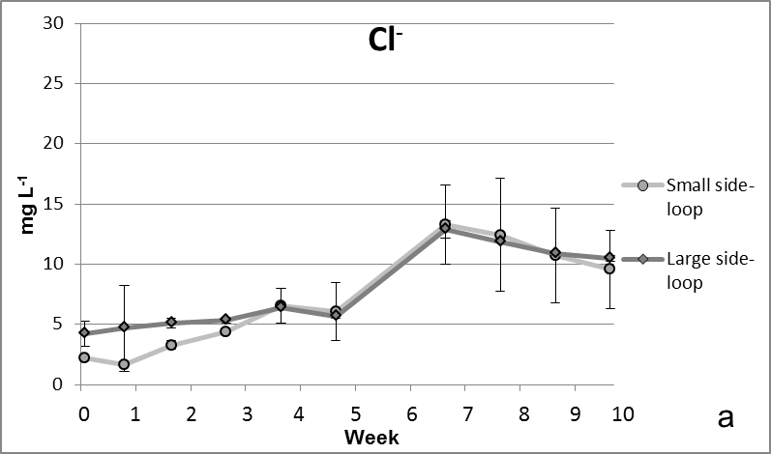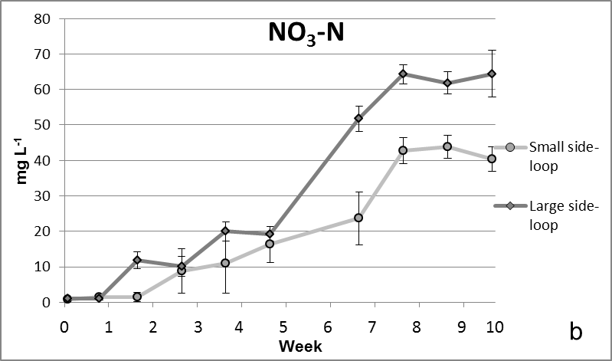
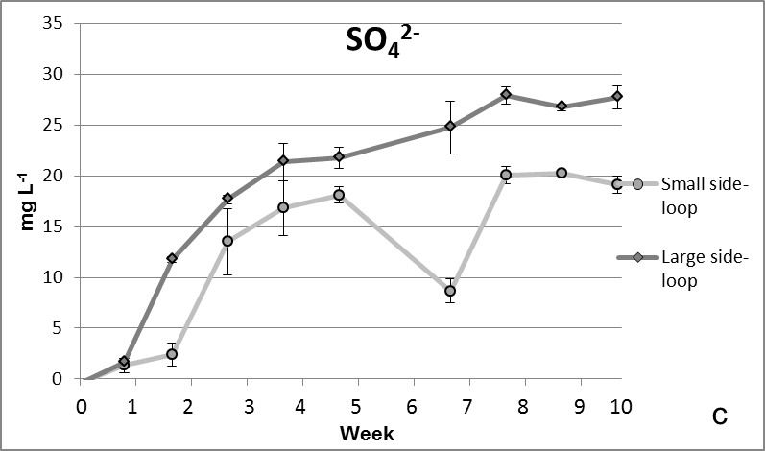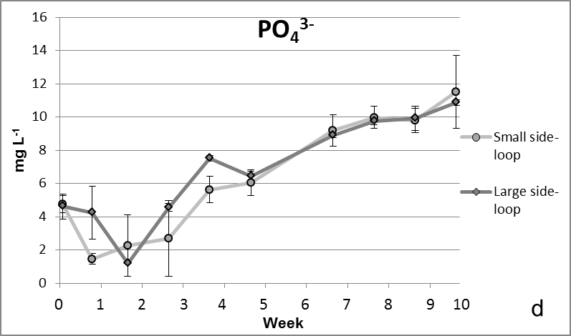
Fig. S1. Concentrations of chloride (Cl⁻, a), nitrate-N (NO₃-N, b), sulfate (SO₄²⁻, c), and phosphate (PO₄³⁻, d) (mg L⁻¹, ± SD, n=4) in circulating water after the sand filter during the 10 weeks of the experiment.

