Supplementary information to
The quantification of bisphenols and their analogues in wastewaters and surface water by an improved solid-phase extraction-gas chromatography/mass spectrometry method
Magda Caban*, Piotr Stepnowski

Department of Environmental Analysis, Faculty of Chemistry, University of Gdansk, ul. Wita Stwosza 63, 80-308 Gdańsk, Poland

*Corresponding author: Phone (+48 58) 523 5208; E-mail address: magda.caban@ug.edu.pl

Section S1. Fragmentation of TMS derivatives of bisphenols
The fragmentation pattern of silyl derivatives of bisphenols follows the general schema for TMS derivatives, which were presented in Fig. 1 and Fig. 2. The M^{+.} molecular ion is observable with moderate intensity. The other pattern found is the breakdown of the band in the beta position to the aromatic ring. The M-15 signal came from the release of a methyl group. In the case of deuterated BPA (IS), M-18 was present, which suggests the release of a methyl group is another beta-fragmentation, rather than a fragmentation of the TMS group. The 73 m/z signal comes from the TMS group, and was the most intense or one of the most intense. This fact means that the TMS group is easily ionized and can be a reason for better TIC intensity of TMS-derivatives compared to underivatized bisphenols.

Table S1. Basic characteristic of the target bisphenol A, its analogues and internal standard
No | Name [abbreviation] | Molar mass [g/mol]  Molecular formula  CAS | logP
1 | Bisphenol E [BPE]  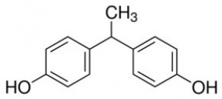 | 214.26  CH₃CH(C₆H₄OH)₂  2081-08-5 | 3.9
2 | Bisphenol C [BPC]  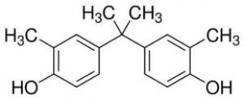 | 256.34  (CH₃)₂C[C₆H₃(CH₃)OH]₂  79-97-0 | 4.7
3 | Bisphenol A dimethacrylate  [BPA-DMC]  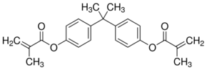 | 364.43  [H₂C=C(CH₃)CO₂C₆H₄]₂C(CH₃)₂  3253-39-2 | 6.2
4 | Bisphenol BP [BPBP]  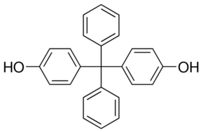 | 352.43  C₂₅H₂₀O₂  1844-01-5 | 5.6
5 | Bisphenol F [BPF]  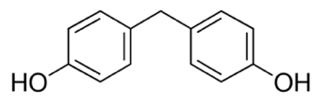 | 200.23  CH₂(C₆H₄OH)₂  620-92-8 | 2.9
6 | Bisphenol A diglycidyl ether [BPA-DGE]  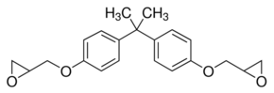 | 340.41  C₂₁H₂₄O₄  1675-54-3 | 4.0
7 | Bisphenol A diacetate, 98% [BPA-DAC]  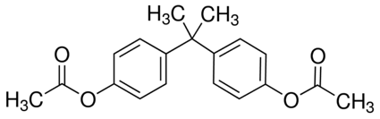 | 312.36  (CH₃CO₂C₆H₄)₂C(CH₃)₂  10192-62-8 | 4.2
8 | Bisphenol Z [BPZ]  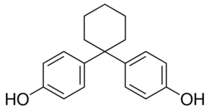 | 268.35  C₆H₁₀(C₆H₄OH)₂  843-55-0 | 5.4
9 | Bisphenol FL [BPFL]  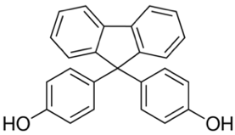 | 350.41  C₂₅H₁₈O₂  3236-71-3 | 6.0
10 | Bisphenol AF [BPAF]  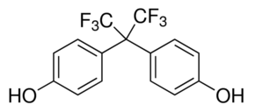 | 336.23  (CF₃)₂C(C₆H₄OH)₂  1478-61-1 | 4.5
11 | Bisphenol S [BPS]  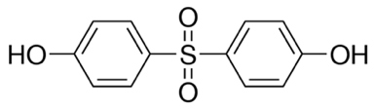 | 250.27  O₂S(C₆H₄OH)₂  80-09-1 | 1.9
12 | Bisphenol A [BPA]  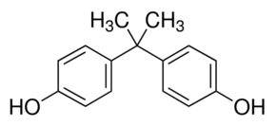 | 228.29  (CH₃)₂C(C₆H₄OH)₂  80-05-7 | 3.32  120 mg/L
13 | Internal standard: Bisphenol A-D16 [BPA-D16]  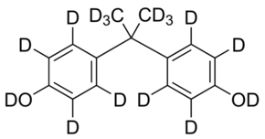 | 244.38  (CD₃)₂C(C₆D₄OD)₂  96210-87-6 | -
(log P – pubchem.org database, mostly calculated)

Table S2. The GC/MS(SIM) instrumental calibration parameters
Analyte  Qualitative/  Reference m/z | Retention time  [min] | Instrumental / method correlation coefficient (R²) | Precision (RSD)  Instrumental / method [%] | Instrumental trueness  (C_{found/}C_{nominal} x100%) [%] | Instrumental quantification limit (IQL)  [ng/mL] | Instrumental detection limit (IDL)  [ng/mL]
BPAF  411/480, 465 | 12.55 | 0.9999 | 1.1-6.2 | 102-106 | 19.5 | 6.5
BPF  344/157 | 13.90 | 0.9999 | 1.1-4.7 | 99-102 | 19.5 | 6.5
BPE  343/358 | 14.81 | 0.9999 | 1.0-4.7 | 95-110 | 19.5 | 6.5
BPA  357/372 | 14.51 | 1.0000 | 1.2-3.5 | 99-104 | 19.5 | 6.5
BPC  385/400 | 15.20 | 0.9998 | 1.5-6.1 | 100-105 | 19.5 | 6.5
BPA-DAC  213/228, 270, 312 | 15.88 | 0.9985 | 1.3-8.1 | 88-101 | 78.1 | 26.0
BPZ  412/369, 343 | 17.76 | 0.9996 | 1.3-6.6 | 93-102 | 19.5 | 6.5
BPS  394/379, 182 | 18.40 | 0.9990 | 1.6-11.4 | 99-104 | 39.1 | 13.0
BPA-DMA  349/364 | 18.97 | 0.9891 | 0.9-7.8 | 98-115 | 156.2 | 52.1
BPA-DGE  325/340 | 20.25 | 0.9885 | 5.1-7.7 | 90-109 | 1250.0 | 416.7
BPBP  419/331, 496 | 22.54 | 0.9996 | 1.2-5.0 | 100-103 | 78.1 | 26.0
BPFL  494/329 | 24.45 | 0.9995 | 0.6-5.4 | 99-107 | 39.1 | 13.0

Figure S1. The peaks area (GC/MS(SIM)) of target bisphenols obtained in different temperature and time of silylation by BSTFA reagent

Figure S2. The map with four sampling points (6.01.2020) of surface water in Gdańsk (Poland)
(www.gis.gdansk.pl)

Figure S3. The mass spectra of mono-TMS derivative of the BPA-methacrylate-mono-O-TMS (BPA-MC-TMS), BPA-glycidyl ether-mono-O-TMS, and BPA-acetate-mono-O-TMS

Figure S4. Photography of Strata-X column with PSA sorbent on the top of original sorbent with visible adsorbed impurities from wastewater sample

Figure S5. The fragments of SIM chromatograms presented detection of bisphenol A (BPA) and bisphenol S (BPS) in blank sample, standard sample, and extracts of raw and treated wastewater (WWTP Gniewino) and surface water (Oruński Stream)

Figure S6. The glass fiber filters after filtration of surface water 1-4 sampled for this study

