Per-and polyfluoroalkyl substances (PFASs) in Contaminated Coastal Marine Waters of the Saudi Arabian Red Sea: A baseline study

Aasim M. Ali^{1*}, Christopher P. Higgins², Walied M. Alarif³, Sultan S. Al- Lihaibi³, Mohammed Ghandourah³, Roland Kallenborn^{1,4}

¹Faculty of Chemistry, Biotechnology and Food Sciences, Norwegian University of Life Sciences, Christian M. Falsen veg 1, NO-1432, ÅS, Norways
²Department of Civil & Environmental Engineering, Colorado School of Mines, 1500 Illinois Street, Golden, Colorado 80401, United States

³ Department of Marine Chemistry, Faculty of Marine Sciences, King Abdulaziz University, PO. Box 80207, Jeddah 21589, Saudi Arabia
⁴ Arctic Technology Department (AT), University Centre in Svalbard (UNIS), P.O. Box 156, Longyearbyen. Svalbard, Norway.
Corresponding Author: Aasim M. Al: aasimali@nmbu.no, Tel.: +4767232579

Table S1 List of target PFASs for quantitative analysis
Analyte Name | Acronym | CAS # | Formula | Structure | LogP | LogD (7.4)
PFCAs
Perfluorobutanoic acid | PFBA | 375-22-4 | F(CF₂)₃COOH |  | 3.94 | -1.13
Perfluoropentanoic acid | PFPeA | 2706-90-3 | F(CF₂)₄COOH |  | 5.29 | -0.34
Perfluorohexanoic acid | PFHxA | 307-24-4 | F(CF₂)₅COOH |  | 5.97 | 0.15
Perfluoroheptanoic acid | PFHpA | 375-85-9 | F(CF₂)₆COOH |  | 6.86 | 1.11
Perfluorooctanoic acid | PFOA | 335-67-1 | F(CF₂)₇COOH |  | 7.75 | 1.82
Perfluorononanoic acid | PFNA | 375-95-1 | F(CF₂)₈COOH |  | 8.64 | 2.84

Table S2 continue
Analyte Name | Acronym | CAS # | Formula | Structure | LogP | LogD (7.4)
PFCAs
Perfluorodecanoic acid | PFDA | 335-76-2 | F(CF₂)₉COOH |  | 9.53 | 3.62
Perfluoroundecanoic acid | PFUnDA | 2058-94-8 | F(CF₂)₁₀COOH |  | 10.42 | 4.23
Perfluorododecanoic acid | PFDoDA | 307-55-1 | F(CF₂)₁₁COOH |  | 11.31 | 4.58
Perfluorotridecanoic acid | PFTriDA | 72629-94-8 | F(CF₂)₁₂COOH |  | 12.19 | 4.97
PFSAs
Perfluorobutane sulfonic acid | PFBS | 375-73-5 | F(CF₂)₄SO₃H |  | 3.68 | -1.56
Perfluorohexane sulfonic acid | PFHxS | 355-46-4 | F(CF₂)₆SO₃H |  | 5.25 | -0.54
Perfluorooctane sulfonic acid | PFOS | 1763-23-1 | F(CF₂)₈SO₃H |  | 7.03 | 0.66
FTSAs
6:2 Fluorotelomer sulfonic acid | 6:2 FTS | 27619-97-2 | F(CF₂)₆(CH₂)₂SO₃H |  | 3.47 | -1.00

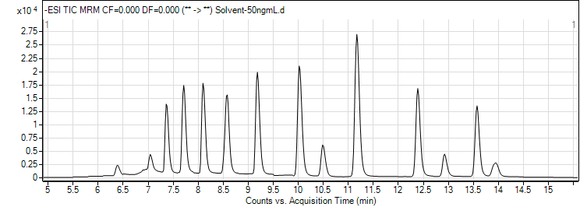
Figure S1 Total ion chromatogram of all compounds at 50pg/µL
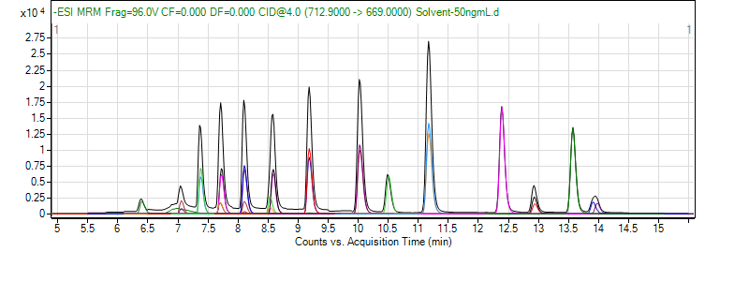
Figure S2 Extracted and Overlaid MRM of all compounds at 50pg/µL

Table S3 Agilent 6460 ionization source (JetStream) parameters
Parameter | Value
Gas Temp (°C) | 300
Gas Flow (l/min) | 5
Nebulizer (psi) | 25
SheathGasHeater | 400
SheathGasFlow | 8
Capillary (V) | -2500
VCharging | 500

Table S4 MRM transitions of target PFAS compounds
Acronym | ISTD used | Retention time  [min] | Precursor ion  (m/z) | Product ion 1 (Quantifier) (m/z) | Product ion 2  (Qualifier) (m/z) | CE1  (V) | CE2  (V) | Fragmentor  (V)
PFBA | [¹³C₄]-PFOA | 6.4 | 213 | 169 |  | 1 |  | 61
PFHxA | [¹³C₅]-PFHxA | 7.3 | 313 | 269 | 119 | 0 | 19 | 66
PFHpA | [¹³C₄]-PFHpA | 7.6 | 363 | 319 | 168.9 | 0 | 10 | 71
PFOA | [¹³C₄]-PFOA | 8.0 | 413 | 369 | 169 | 0 | 12 | 76
PFNA | [¹³C₅]-PFNA | 8.4 | 463 | 419 | 219 | 4 | 4 | 86
PFDA | [¹³C₂]-PFDA | 9.1 | 513 | 469 | 169 | 4 | 4 | 86
PFUnDA | [¹³C₅]-PFNA | 10 | 563 | 519 | 169 | 4 | 10 | 86
PFDoDA | [¹³C₅]-PFNA | 7 | 613 | 569 |  | 4 |  | 96
PFBS | [¹⁸O₂]-PFHxS | 7 | 299 | 99 | 80 | 25 | 35 | 121
PFHxS | [¹⁸O₂]-PFHxS | 7 | 398.9 | 99 | 80 | 45 | 45 | 151
Br-PFOS | [¹⁸O₂]-PFHxS | 8.3 | 499 | 99 | 80 | 61 | 61 | 200
L-PFOS | [¹⁸O₂]-PFHxS | 8.4 | 499 | 99 | 80 | 61 | 61 | 200
6:2 FTS | [¹⁸O₂]-PFHxS | 8 | 427 | 407 | 81 | 15 | 15 | 145
FOSA | [²H₃]-MeFOSA | 10.5 | 497.9 | 78 |  | 33 |  | 141

Table S5 MRM transitions of internal standards
Acronym | Retention time [min] | Precursor ion  (m/z) | Product ion 1 (Quantifier) (m/z) | CE  (V) | Fragmentor
[¹³C₈]-PFOA | 8.34 | 421 | 376 | 0 | 76
[¹³C₄]-PFBA | 6.58 | 217 | 172 | 1 | 61
[¹³C₅]-PFHxA | 7.66 | 318 | 273 | 0 | 66
[¹³C₄]-PFHpA | 7.99 | 367 | 322 | 0 | 66
[¹³C₄]-PFOA | 8.35 | 417 | 372.1 | 0 | 76
[¹³C₅]-PFNA | 8.79 | 468 | 423 | 4 | 76
[¹³C₂]-PFDA | 9.34 | 515 | 470 | 4 | 86
[¹³C₂]-PFUnDA | 9.94 | 565 | 520 | 4 | 96
[¹³C₂]-PFDoDA | 10.86 | 615 | 570 | 4 | 96
[¹⁸O₂]-PFHxS | 7.97 | 403 | 84 | 49 | 146
[¹³C₄]-PFOS | 8.74 | 503 | 80 | 61 | 180
[²H₃]-MeFOSA | 9.34 | 515 | 169 | 25 | 136

Table S6 Levels of PFAS in Selected Sites in the Eastern Coastal Waters of the Red Sea
Sample | PFHxA | PFHpA | PFOA | PFNA | PFDA | PFBS | PFHxS | PFOS | 6:2 FTS | FOSA | ∑₁₀PFASs
Arb1-A | 0.026 | <LOQ | <LOQ | <LOQ | <LOQ | <LOQ | <LOQ | <LOQ | <LOQ | <LOQ | 3.20
Arb1-B | 24.5 | 3.09 | 6.26 | 1.74 | Nd | 5.51 | 29.89 | 1.36 | 63.0 | 0.243 | 135
Arb2-A | 157 | 12.5 | 36.8 | 2.24 | Nd | 50.8 | 245 | 0.083 | 45.0 | 0.482 | 956
Arb2-B | 198 | 54.1 | 66.0 | 15.6 | 5.62 | 18.1 | 147 | 34.5 | 325 | Nd | 865
Arb3-A | 84.7 | 9.86 | 11.4 | 5.04 | 2.56 | 10.11 | 94.4 | 21.4 | 43.5 | Nd | 283
Arb3-B | 13.4 | <LOQ | 3.67 | <LOQ | <LOQ | <LOQ | <LOQ | <LOQ | 2.56 | Nd | 21.7
Arb4-A | 62.2 | 5.79 | 10.3 | 4.02 | Nd | 13.4 | 73.1 | <LOQ | 28.4 | 0.843 | 198
Arb4-B | 53.3 | 10.1 | 28.6 | 5.85 | Nd | 7.57 | 64.81 | 7.83 | 59.4 | Nd | 237
Shab1 | 1.21 | 0.415 | 0.826 | <LOQ | Nd | <LOQ | <LOQ | <LOQ | 0.796 | Nd | 4.38
Shab2-A | 7.55 | 1.42 | 3.53 | 3.84 | Nd | 2.29 | 20.1 | <LOQ | 3.74 | Nd | 42.9
Shab2-B | 8.93 | 1.31 | 3.38 | 3.80 | 0.484 | 2.74 | 19.1 | <LOQ | 4.10 | 2.00 | 46.2
Shab3-A | 14.3 | 2.63 | 5.72 | 5.95 | 1.48 | 5.55 | 32.0 | <LOQ | 14.4 | 3.18 | 85.5
Shab3-B | 15.8 | 2.99 | 7.73 | 7.02 | 1.42 | 3.62 | 37.3 | <LOQ | 12.1 | 1.15 | 89.5
Shab4-A | 12.4 | 1.66 | 3.01 | 0.92 | Nd | 4.29 | 18.1 | <LOQ | 7.32 | 12.5 | 60.5
Shab4-B | 10.5 | 1.83 | 3.36 | 0.715 | 1.30 | 7.53 | 19.9 | <LOQ | 12.0 | Nd | 57.5
Kum1-A | Nd | Nd | 0.664 | <LOQ | Nd | Nd | Nd | Nd | Nd | Nd | 0.834
Kum1-B | Nd | Nd | Nd | Nd | Nd | Nd | Nd | Nd | <LOQ | Nd | 0.816
Kum2-A | Nd | 0.285 | 0.993 | Nd | Nd | <LOQ | Nd | Nd | Nd | Nd | 1.35
Kum2-B | Nd | <LOQ | Nd | Nd | Nd | <LOQ | Nd | Nd | Nd | Nd | <LOQ
Kum3-A | Nd | Nd | 0.592 | Nd | Nd | Nd | Nd | Nd | Nd | Nd | 0.592
Kum3-B | Nd | 0.264 | 0.562 | Nd | Nd | Nd | Nd | Nd | Nd | Nd | 0.833
Kum3-C | Nd | Nd | 0.672 | Nd | Nd | Nd | Nd | Nd | Nd | Nd | 0.674
Kum4-A | Nd | Nd | 0.913 | Nd | Nd | Nd | Nd | Nd | Nd | Nd | 0.914
Kum4-B | Nd | 0.304 | 0.774 | Nd | Nd | Nd | Nd | Nd | Nd | Nd | 1.07
Obur1-A | Nd | Nd | 1.37 | Nd | Nd | Nd | <LOQ | Nd | Nd | Nd | 1.92
Obur1-B | <LOQ | Nd | 1.56 | Nd | Nd | Nd | Nd | 9.12 | 8.67 | Nd | 19.5
Obur2-A | Nd | 0.293 | 0.585 | Nd | Nd | Nd | Nd | Nd | 1.28 | Nd | 2.15
Obur2-B | Nd | 0.273 | 0.824 | Nd | Nd | Nd | Nd | Nd | Nd | Nd | 1.09
D. freq % | 57.0 | 75.0 | 96.4 | 57.1 | 28.6 | 60.7 | 57.1 | 57.167.9 | 76.0 | 28.6 | -

Table S6 Concentrations (ng/L) of selected PFASs in coastal and open ocean water samples from international studies
Location | PFBS | PFOS | PFHxS | PFNA | PFOA | Reference
Tokyo Bay | - | 0.338-57.7 | 0.017-56.0 | 0.163-71.0 | 1.80-192 | (Yamashita et al. 2005)
The German Baltic Sea | <MDL -0.430 | <MDL -0.180 | <MDL-0.480 | <MDL-0.21 | 0.200-0.700 | (Joerss et al. 2019)
Surface seawater from China | 0.189–2.66 | <MDL | 0.181–2.66 | - | (0-061–0.471 | (Zheng et al. 2017)
Coastal area of China | - | 0.023-9.68 | <0.005-1.36 | 0.002-0.692 | 0.243-15.3 | (Yamashita et al. 2005)
Coastal area of Korea | - | 0.039-2.53 | <0.005-1.39 | 0.015-0.518 | 0.239-11.353 | (Yamashita et al. 2005)
Western Pacific Ocean | - | 0.054-0.078 | 0.002-0.003 | - | 0.136-0.142 | (Yamashita et al. 2005)
Central to Eastern Pacific Ocean (surface water) | - | 0.001-0.02 | 0.0001-0.0016 | 0.001-0.016 | 0.015-0.062 | (Yamashita et al. 2005)
Central to Eastern Pacific Ocean (deep water; 4000–4400 m) | - | 0.003-0.0034 | 0.0004-0.0006 | - | 0.045-0.062 | (Yamashita et al. 2005)
North Atlantic Ocean | - | 0.008-0.036 | 0.0041-0.0061 | 0.015.0.036 | 0.160-0.338 | (Yamashita et al. 2005)
Mid Atlantic Ocean | - | 0.037-0.073 | 0.0026-0.012 | - | 0.100-0.439 | (Yamashita et al. 2005)
NW Mediterranean Sea (in Catalonia) - effluent water from municipal WWTP | 0.355–2.03 | 2.79–72.1 | 5.80–25.3 | 1.87–14.1 | 3.47–61.9 | (Sánchez-Avila et al. 2010)
Svalbard, Norwegian Arctic seawater | 0.035 | 0.100 | 0.210 | <0.020 | <0.030 | (Skaar et al. 2019)
Jeddah coast, Red Sea, KSA | n.d.-50.00 | n.d.-340 | n.d.-245 | n.d.-15.0 | n.d.-66.2 | This study

Table 7 List of the used instruments and software

Item | Specification | Producer | Supplier
MS | 6460 series  triple quadrupole LC/MS | Agilent  Technologies, Santa  Clara, CA, USA | Matriks AS, Oslo,  Norway
HPLC | Agilent 1200 series with  auto sampler, binary pump and column oven | Agilent  Technologies, Santa  Clara, CA, USA | Matriks AS, Oslo,  Norway
Software | MassHunter, Quantitative analysis for  QQQ, Versjon B.07.00/Build 7.0.457.0 | Agilent  Technologies, Santa  Clara, CA, USA | Matriks AS, Oslo,  Norway
Software | MassHunter, Qualititative analysis for  QQQ, Versjon B.06.00/Build 6.0.633.10 | Agilent  Technologies, Santa  Clara, CA, USA | Matriks AS, Oslo,  Norway
Evaporator | Reacti-Vap III™ Evaporator | Thermo Scientific,  Waltham, MA, USA | VWR  International AS,  Oslo, Norge
Vortex | MS 3 basic | IKA-Werke GmbH & Co, KG.  Wilmington, N.C, USA

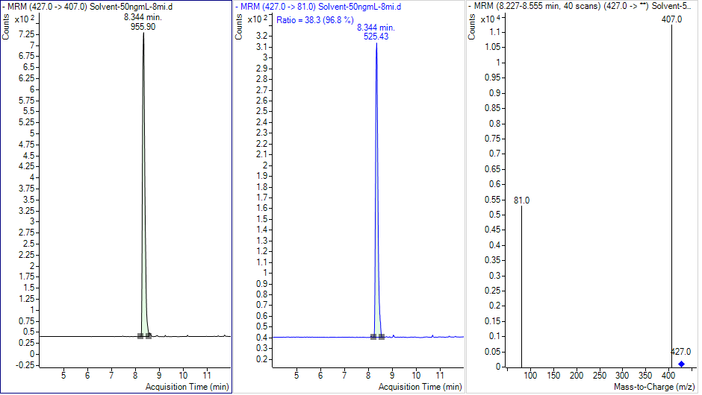
Figure S3 6:2 FTSA standard
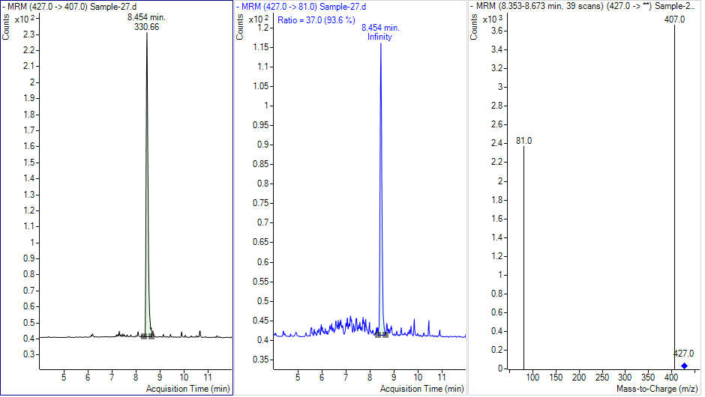
Figure S4 6:2 FTSA detected in sample
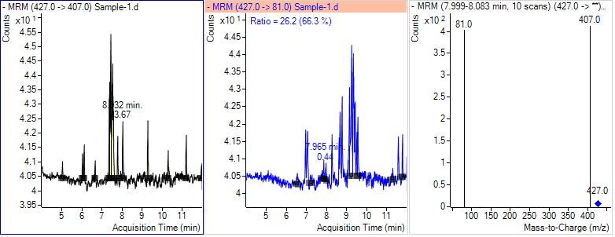
Figure S5 6:2 FTSA detected in field blank sample

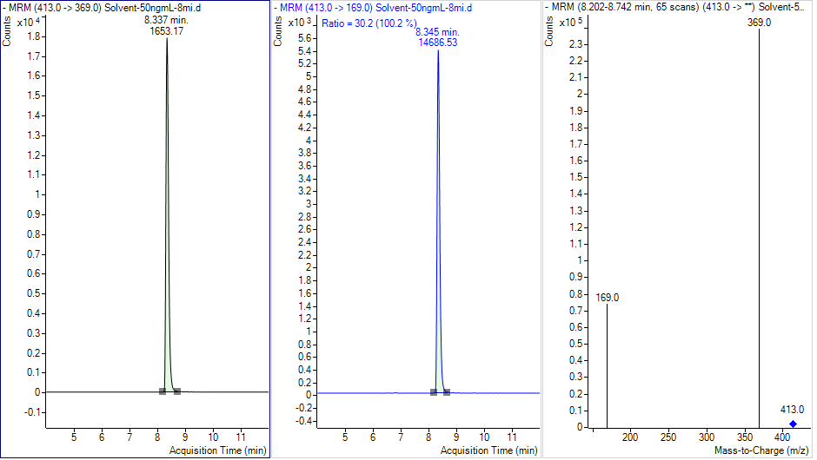
Figure S6 FOSA standard

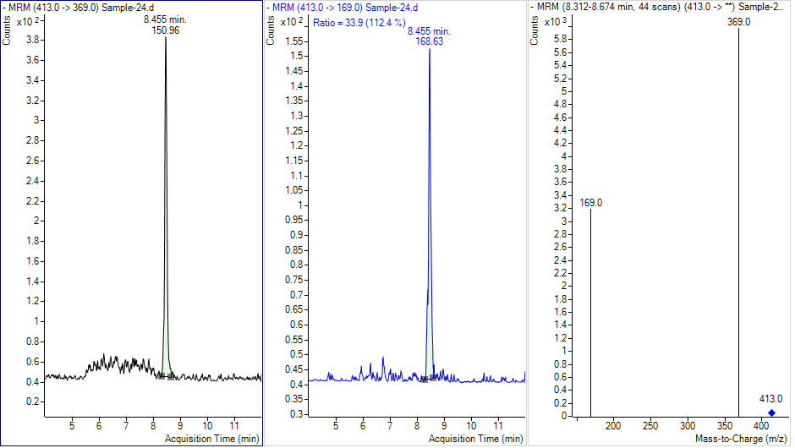
Figure S7 FOSA in Sample
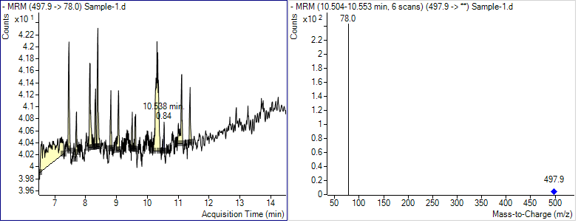
Figure S8 FOSA in blank sample

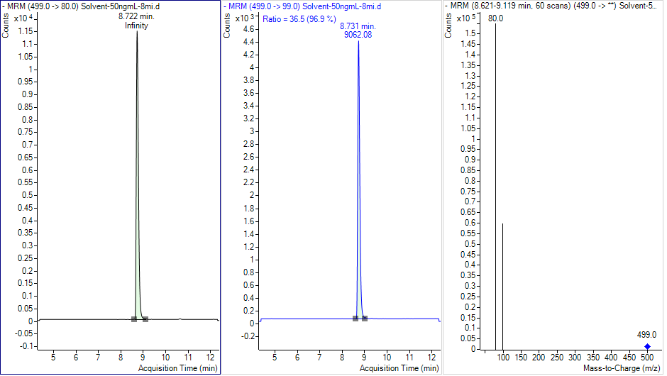
Figure S9 L-PFOS standard
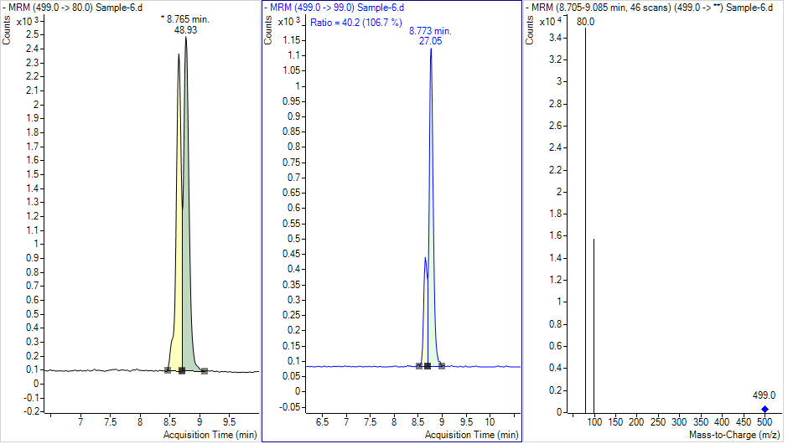
Figure S10 L-PFOS in sample
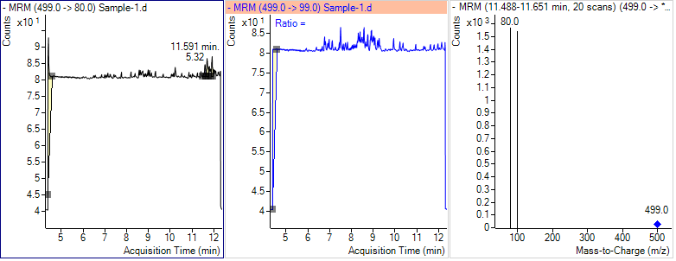
Figure S11 L-PFOS in field blank sample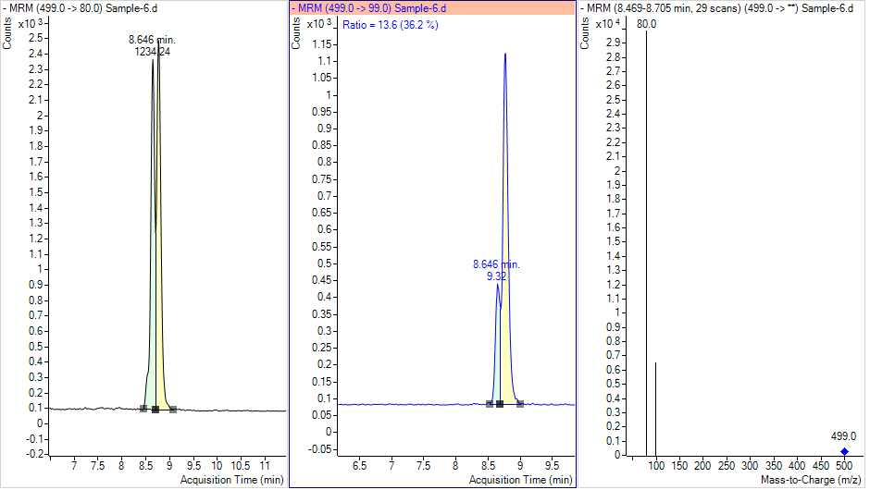
Figure S12 Br-PFOS in sample

Figure S13 Br-PFOS in field blank sample

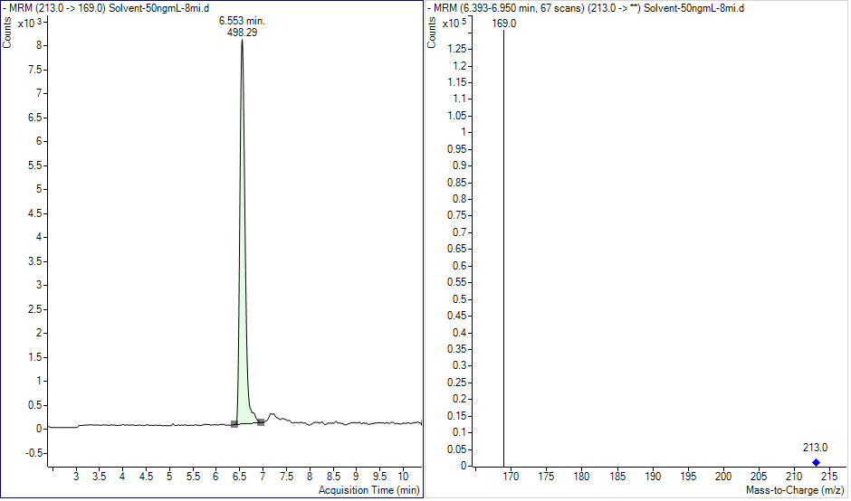
Figure S14 PFBA standard

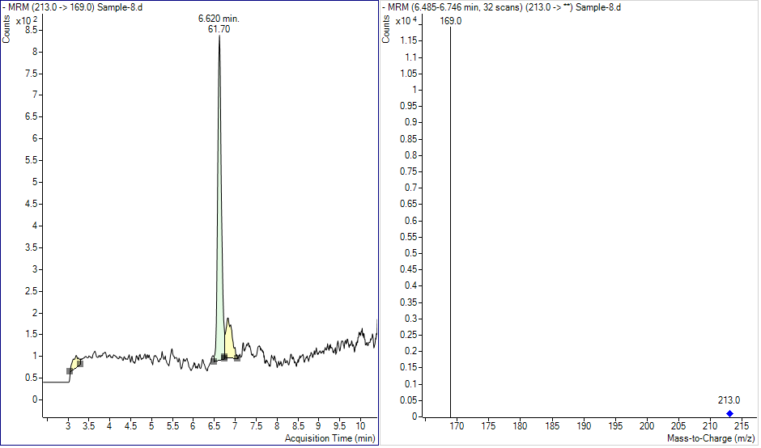
Figure S15 PFBA in sample

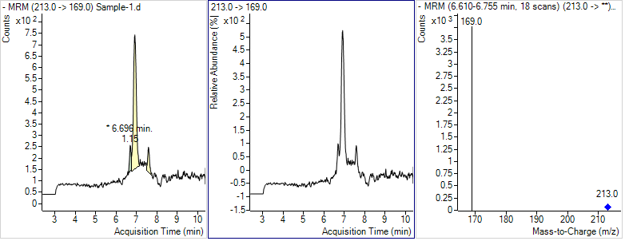
Figure S16 PFBA in field blank

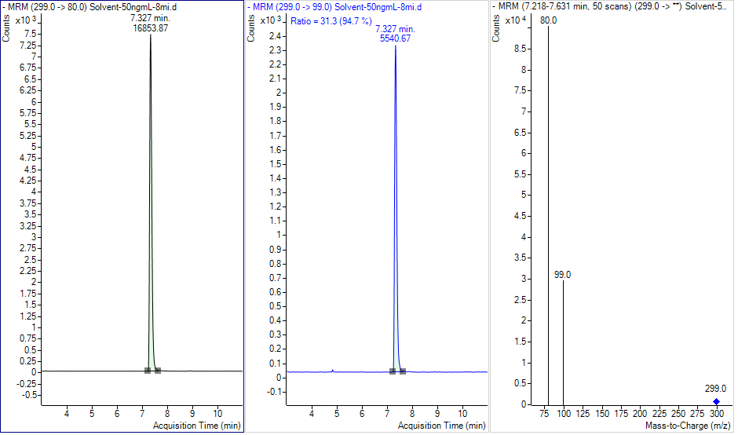
Figure S17 PFBS standard

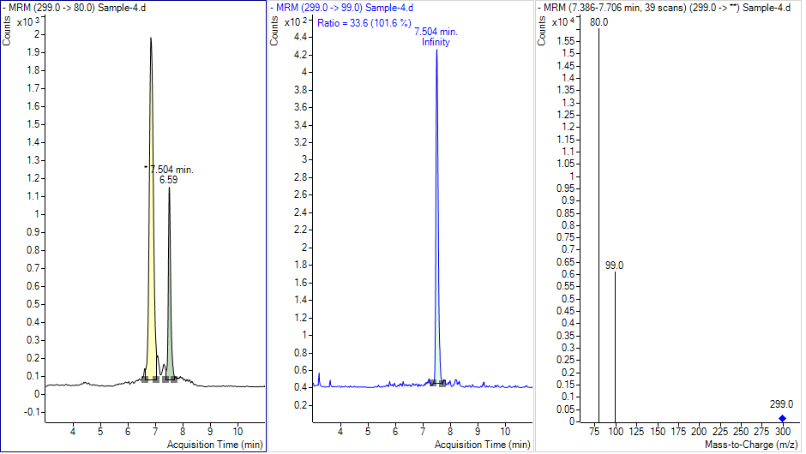
Figure S18 PFBS in sample

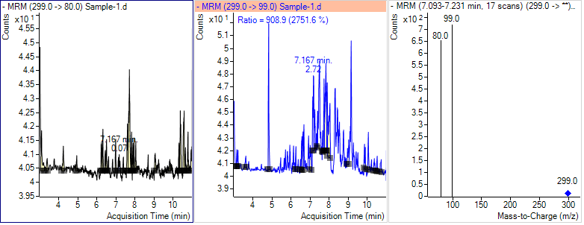
Figure S19 PFBS in field blank
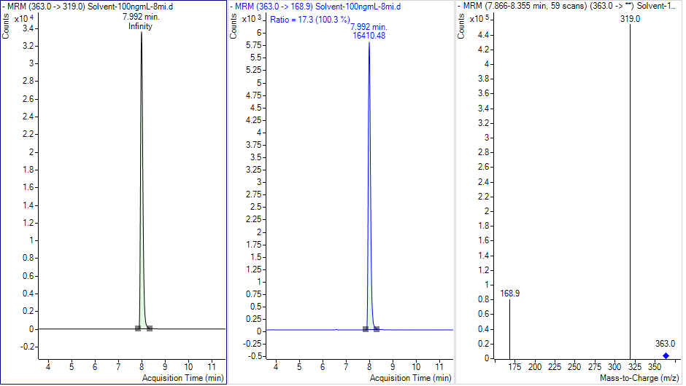
Figure S20 PFHpA standard

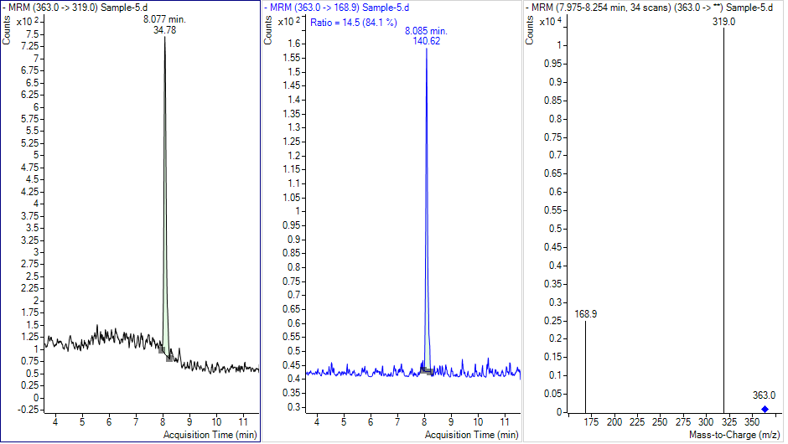
Figure S21 PFHpA in sample

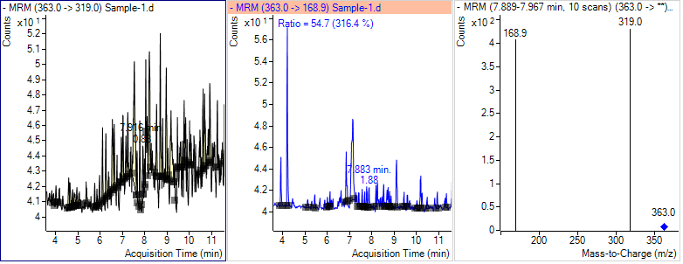
Figure S22 PFHpA in field blank
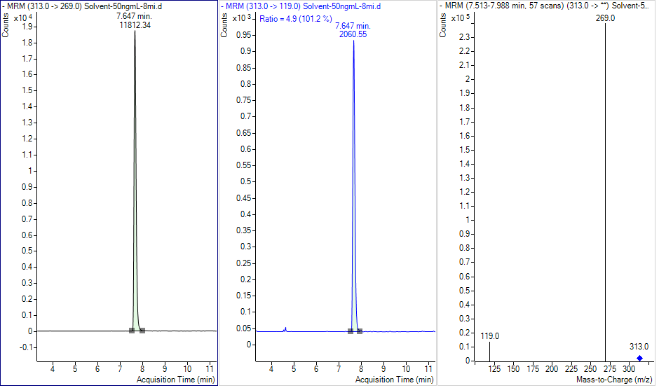
Figure S23 PFHxA standards
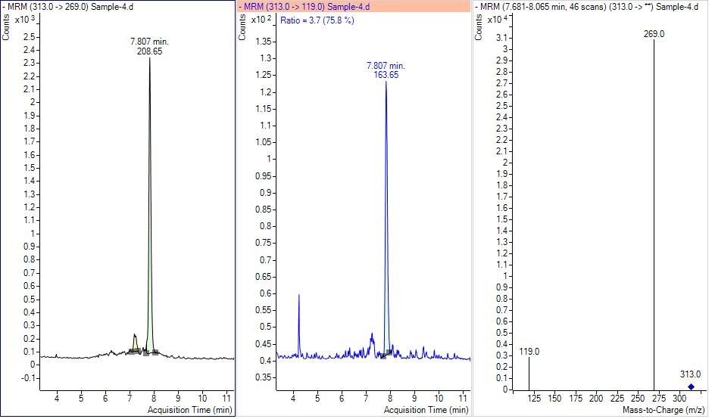
Figure S24 PFHxA in sample
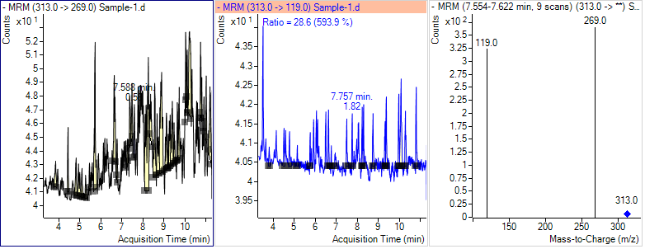
Figure S25 PFHxA in field blank
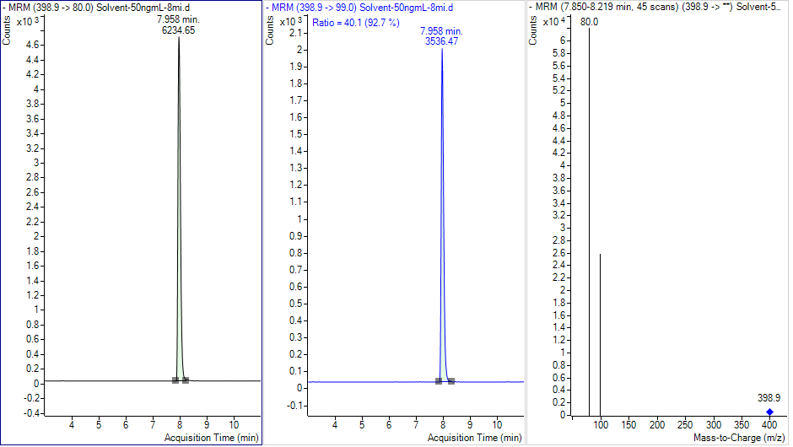
Figure S26 PFHxS standard
Figure S27 PFHxS in sample
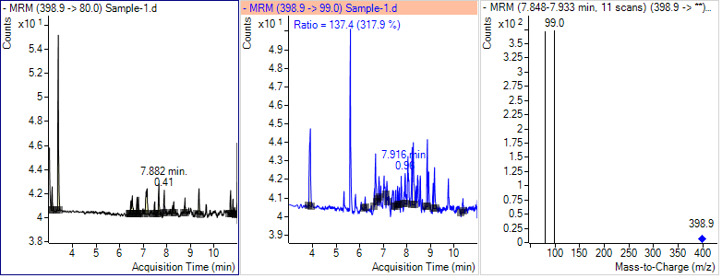
Figure S28 PFHxS in field blank

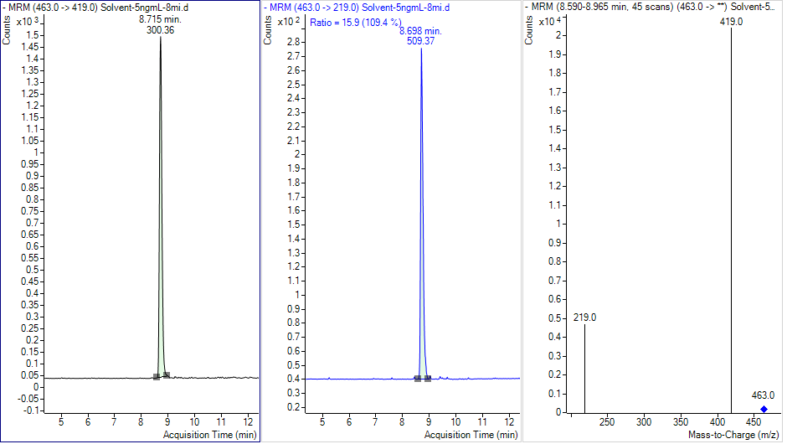
Figure S29 PFNA standard

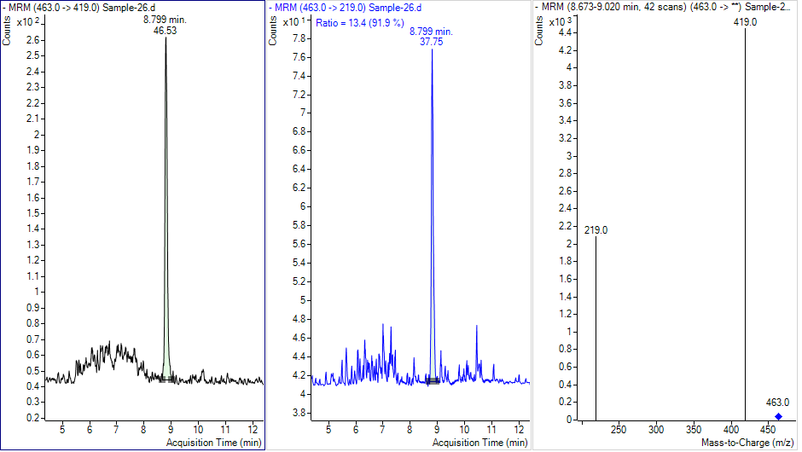
Figure S30 PFNA Sample
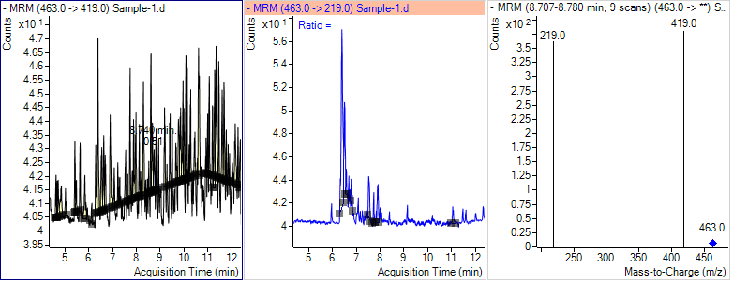
Figure S31 PFNS in field blank

References
Joerss H, Apel C, Ebinghaus R (2019) Emerging per-and polyfluoroalkyl substances (PFASs) in surface water and sediment of the North and Baltic Seas Sci Total Environ 686:360-369
Sánchez-Avila J, Meyer J, Lacorte (2010) Spatial distribution and sources of perfluorochemicals in the NW Mediterranean coastal waters (Catalonia, Spain) Environ Poll 158:2833-2840
Skaar JS, Ræder EM, Lyche JL, Ahrens L, Kallenborn R (2019) Elucidation of contamination sources for poly-and perfluoroalkyl substances (PFASs) on Svalbard (Norwegian Arctic) Environ Sci Poll Res 26:7356-7363
Yamashita N, Kannan K, Taniyasu S, Horii Y, Petrick G, Gamo T (2005) A global survey of perfluorinated acids in oceans Mar Poll Bull 51:658-668
Zheng H, Wang F, Zhao Z, Ma Y, Yang H, Lu Z, Cai Z, Cai M (2017) Distribution profiles of per-and poly fluoroalkyl substances (PFASs) and their re-regulation by ocean currents in the East and South China Sea Mar Poll Bull 125:481-486

