SUPLEMENTARY MATERIAL
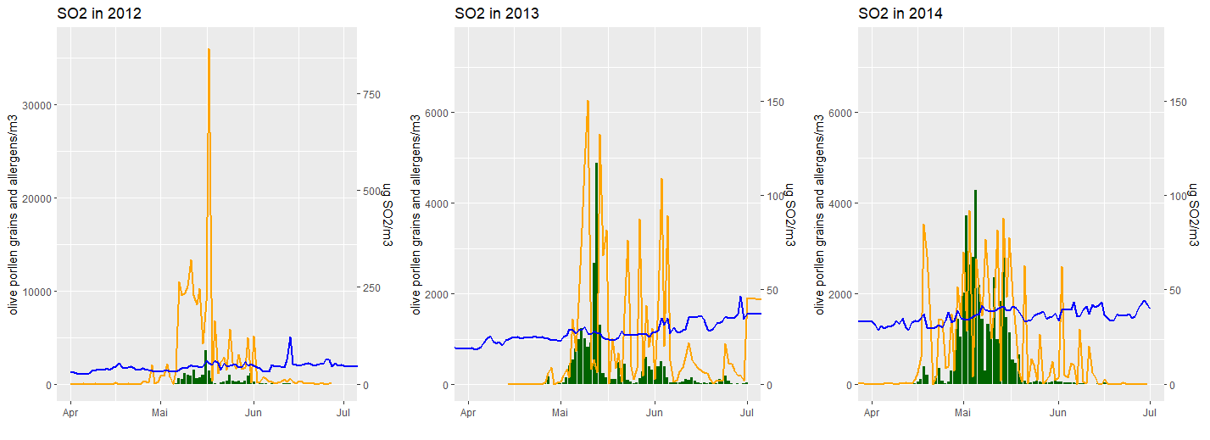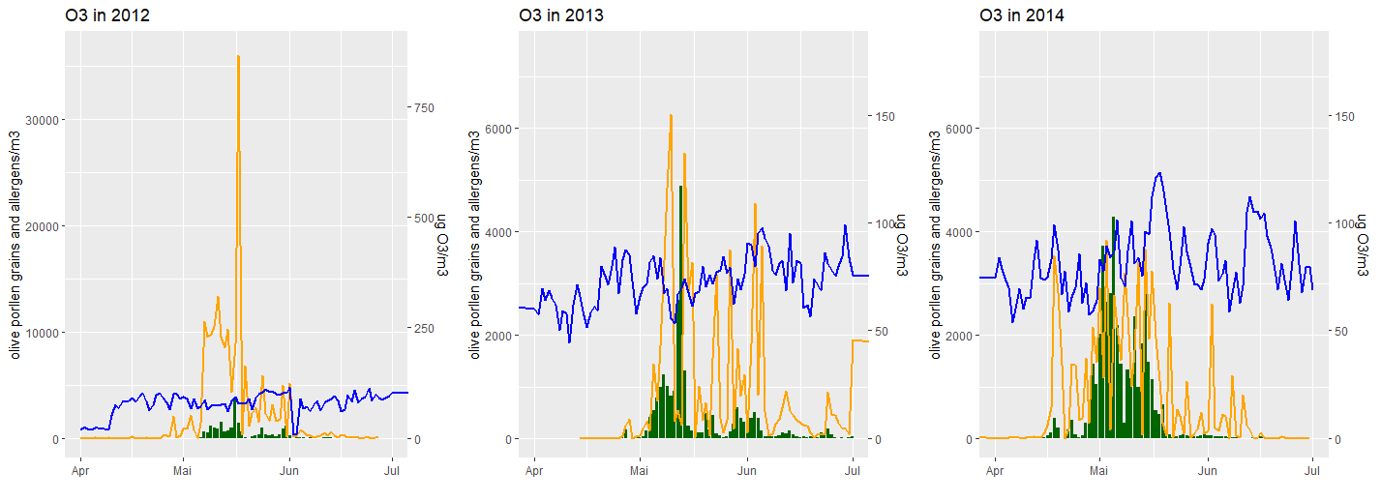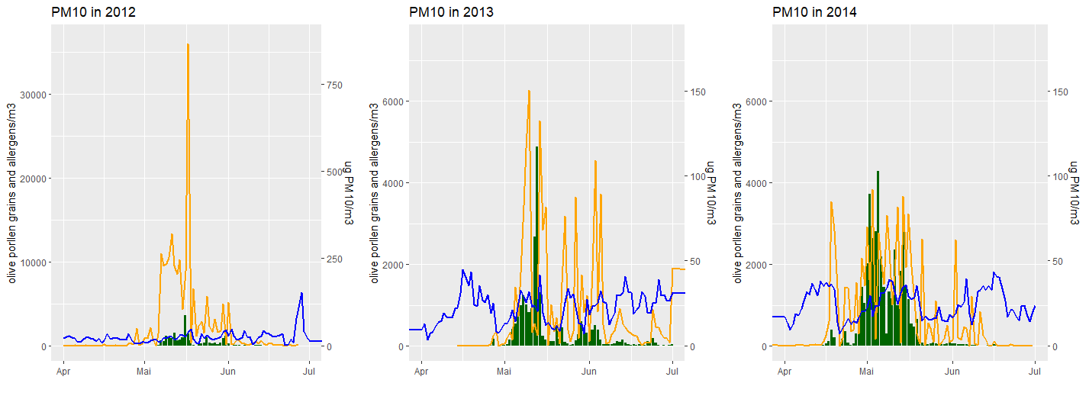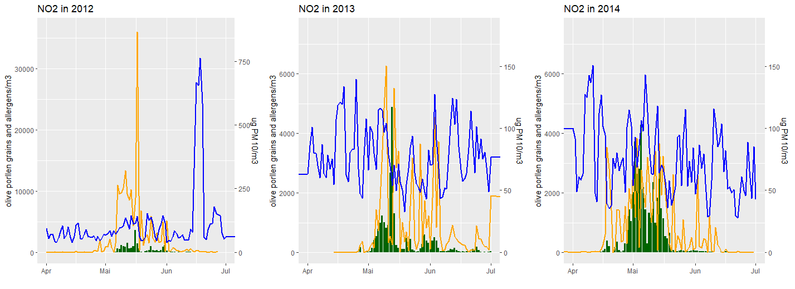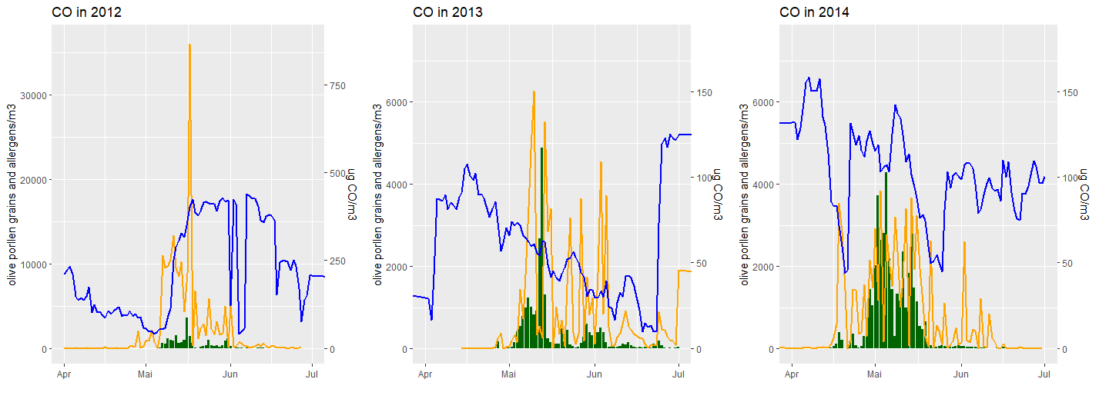
Figure A. Olea Pollen (grains/m³) in green, Ole e 1 concentration in orange and SO_{2,} O_{3,} PM₁₀, NO₂ and CO pollutants concentration (in blue) during the studied period in Córdoba

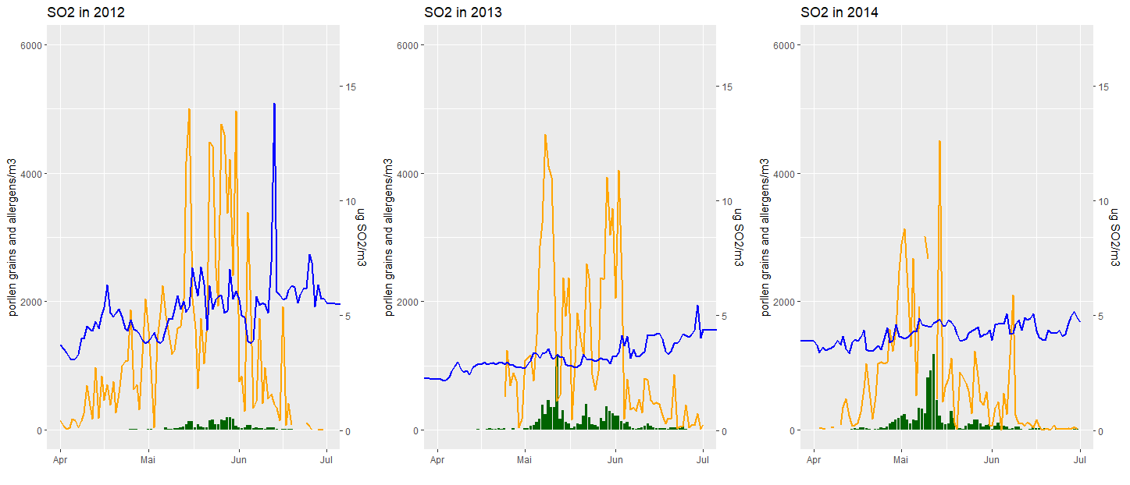

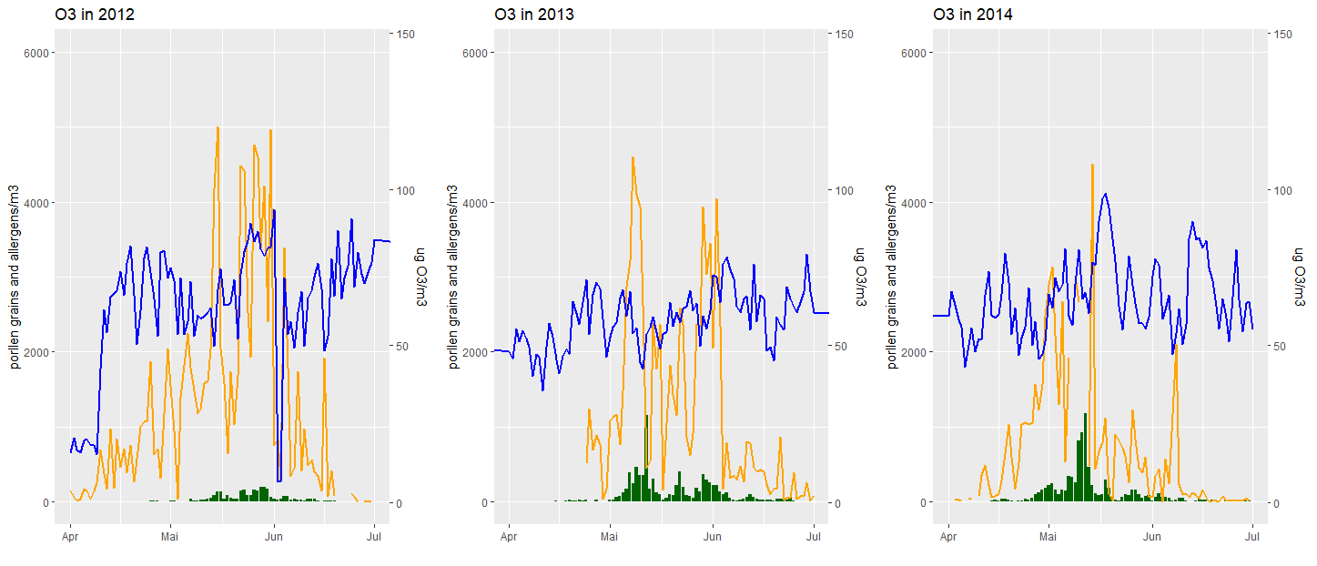
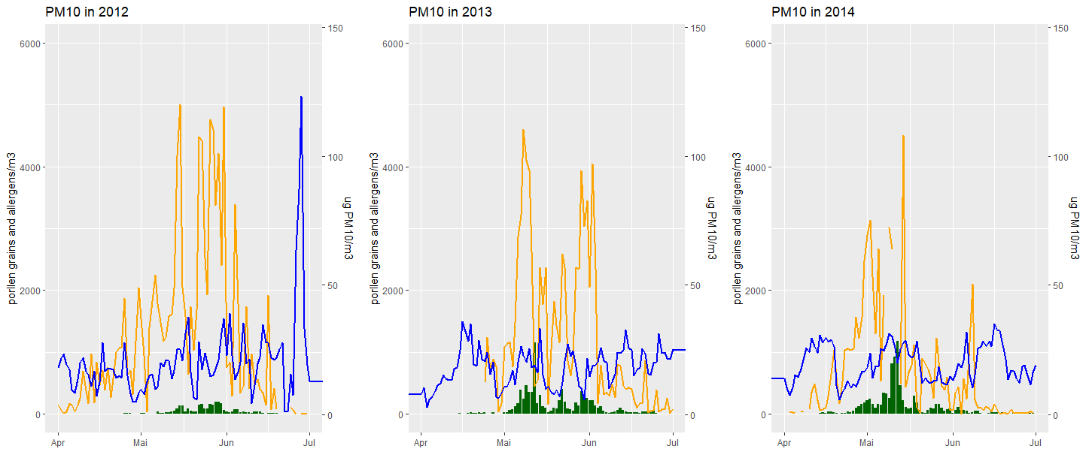

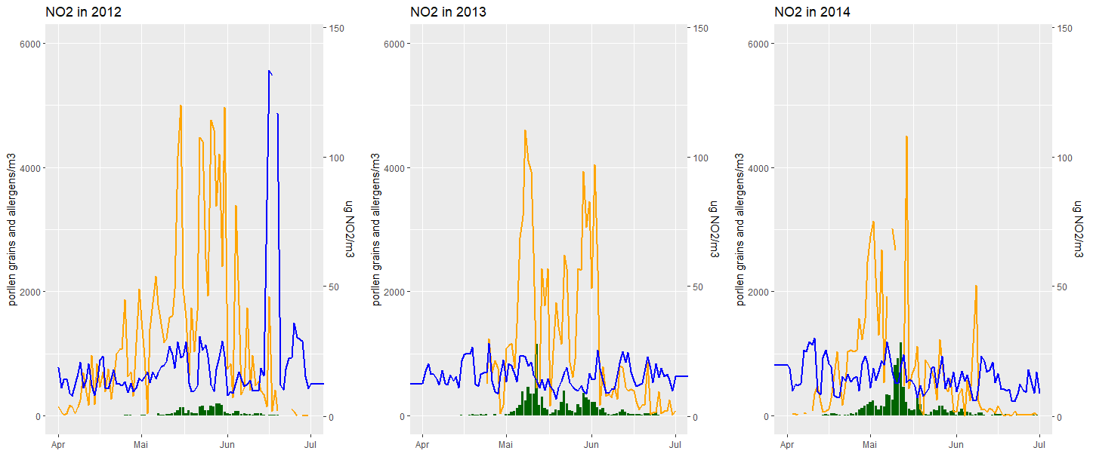
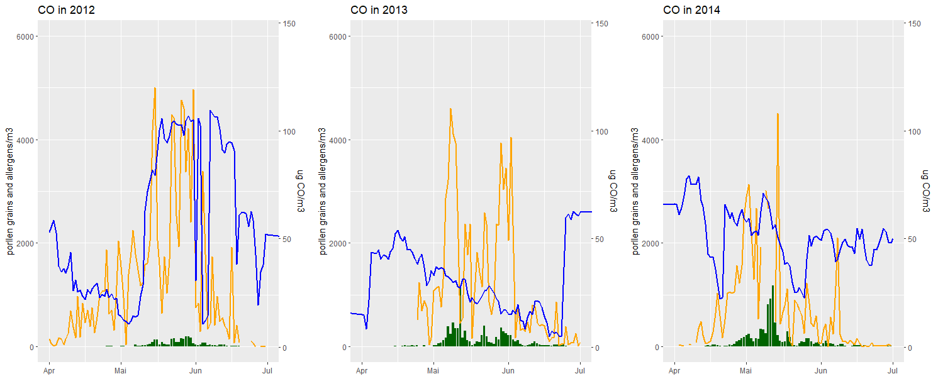
Figure B. Poaceae Pollen (grains/m³) in green, Phl p 5 concentration in orange and SO_{2,} O_{3,} PM₁₀, NO₂ and CO pollutants concentration (in blue) during the studied period in Córdoba

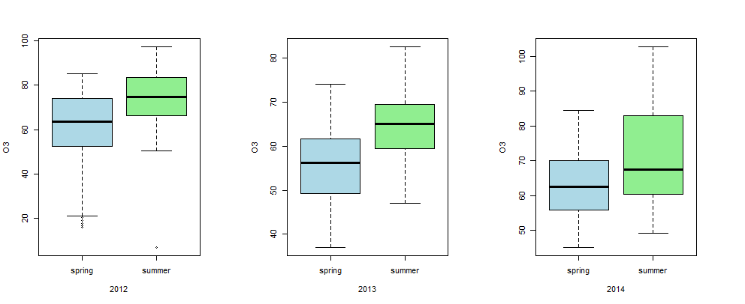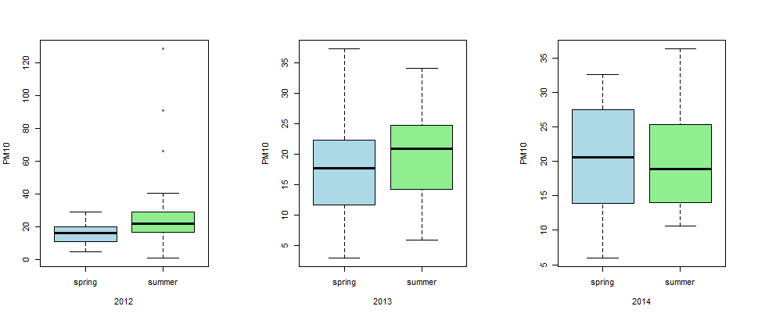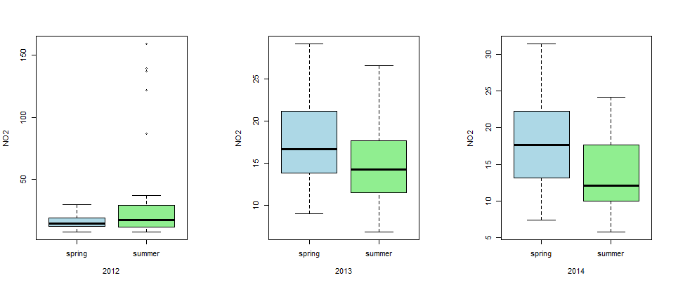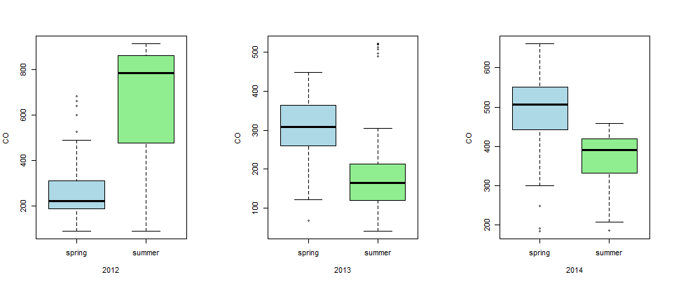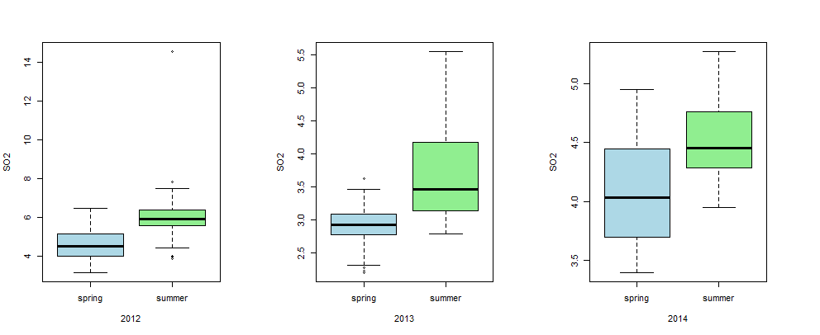
Figure C. SO_{2,} O_{3,} PM10, NO2 and CO pollutants concentration according to the dates coincide with spring from 04-01 to 05-15) or early summer (from 05-16 to 07-01) during the three studied years.

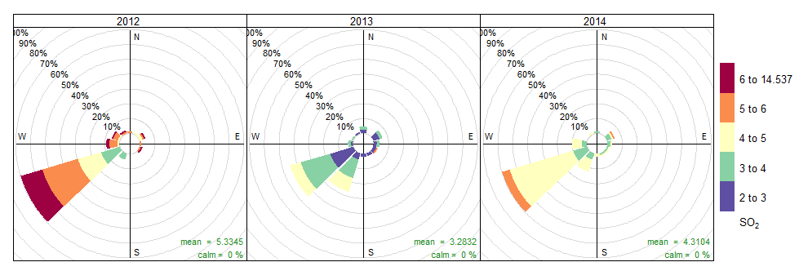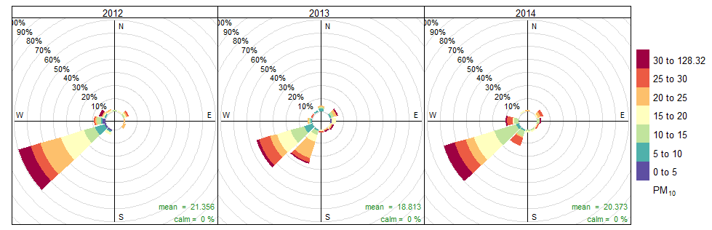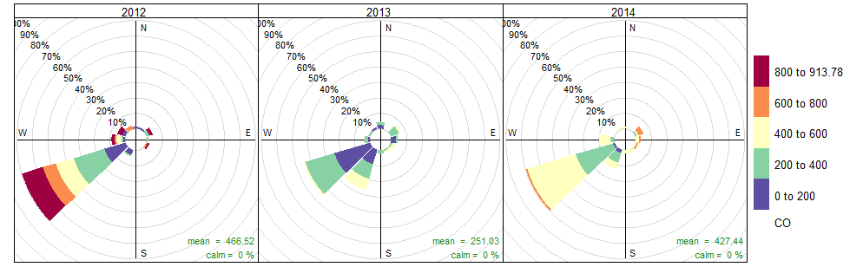
Figure D. Frequency of days with the highest percentage of pollutants SO₂, PM₁₀ and CO, for each year and the prevailing wind direction.

