Appendices

Appendix A – Mineral nutrient composition

Table 7 Mean nutrient concentrations for the reproductive and vegetative DM of the different fertilizer treatments.
 | Nutrient concentration in fruit DM |  |  |  | Nutrient concentration in shoot DM
Nutrient | NPK | CRO | S+V | AUR | NPK | CRO | S+V | AUR
 | [mg kg⁻¹] |  |  |  | [mg kg⁻¹]
N | 29179 ± 1719 a | 18799 ± 1070 b | 24148 ± 454 ab | 25391 ± 1132 a | 35954 ± 1412 ns | 29994 ± 2941 ns | 31169 ± 1466 ns | 36156 ± 1516 ns
P | 6010 ± 180 a | 5004 ± 65 b | 4863 ± 142 b | 5475 ± 109 a | 4496 ± 31 b | 7011 ± 221 a | 5964 ± 230 ab | 7413 ± 1055 a
K | 52543 ± 1020 a | 47741 ± 360 ab | 40588 ± 1729 c | 44225 ± 934 bc | 50616 ± 2993 ab | 52261 ± 1163 ab | 40708 ± 2892 b | 55032 ± 1176 a
Ca | 918 ± 128 a | 945 ± 35.2 a | 961 ± 41.7 a | 562 ± 36.5 b | 37906 ± 230 a | 35770 ± 870 a | 33953 ± 2347 a | 19387 ± 1194 b
Mg | 1900 ± 114 a | 1386 ± 37.2 b | 1342 ± 82.8 b | 1326 ± 51.5 b | 4215 ± 298 b | 6286 ± 148 a | 4835 ± 459 ab | 3764 ± 285 b
S | 2326 ± 52.8 ns | 2189 ± 42.8 ns | 1972 ± 35.7 ns | 2063 ± 73.9 ns | 19479 ± 1198 b | 30625 ± 536 a | 15423 ± 1639 b | 17963 ± 919 b
Mn | 14.6 ± 0.77a | 11.1 ± 0.16 b | 10.6 ± 0.70 b | 10.5 ± 0.46 b | 97.5 ± 15 ab | 106 ± 2.1 a | 67.8 ± 3.24 ab | 58.6 ± 3.3 b
Zn | 21.7 ± 1.38 ns | 14.5 ± 0.62 ns | 17.7 ± 3.27 ns | 17.4 ± 0.88 ns | 96.1 ± 9.9 ab | 98.1 ± 2.5 a | 65.5 ± 3.1 b | 77.8 ± 6.8 ab
Fe | 56.3 ± 1.65 ns | 43.0 ± 1.22 ns | 38.8 ± 2.10 ns | 42.9 ± 5.42 ns | 89.4 ± 5.1 ab | 152.4 ± 12.2 a | 84.1 ± 4.1 b | 100.6 ± 4.4 ab
B | 13.4 ± 0.34 a | 12.8 ± 0.10 a | 10.5 ± 0.36 b | 12.0 ± 0.30 ab | 68.0 ± 4.0 ab | 83.9 ± 3.2 a | 57.3 ± 2.7 b | 85.5 ± 5.5 a
Cu | 9.32 ± 0.33 ns | 7.94 ± 0.30 ns | 7.62 ± 0.27 ns | 7.93 ± 0.13 ns | 9.5 ± 0.2 ns | 19.3 ± 2.7 ns | 13.7 ± 2.5 ns | 21.3 ± 2.3 ns
Na | 302 ± 31.8 bc | 446 ± 16.2 ab | 252 ± 23.6 c | 562 ± 35.9 a | 600 ± 14 b | 1616 ± 84 a | 648 ± 57 b | 2225 ± 190 a
All results are expressed as mean ± SE. Different letters within rows indicate significant differences as evaluated by Tukey HSD variance of means test (α = 0.05). No statistical significance = ns. NPK = mineral control (n = 3); CRO = ‘Crop’ treatment (n = 4); S+V = Struvite & Vinasse treatment (n = 4); AUR = ‘Aurin’ treatment (n = 4)

Table 8 Optimal ranges of nutrient sufficiency for N, P, K, Ca, & Mg found in vegetative DM (shoot/leaves) of tomato plants.
Nutrient | Optimal ranges | Deficiency
[mg kg⁻¹ ]
N | 28000 – 60000 | < 20000
P | 3000 – 7000 | < 2000
K | 27000 – 55000 | < 15000
Ca | 10000 – 30000 | < 10000
Mg | 3600 – 8500 | < 3000
Optimal ranges represent highest and lowest values from established literature sources (Adams 1986; Campbell 2000; Sainju et al. 2003; Jones Jr. 2007; Sonneveld and Voogt, 2009; Hochmuth 2012; Marschner 2012).

Appendix B – Nutrient solution & analysis
Table 9 Desired nutrient solution (NS) recipe for hydroponic greenhouse cultivation of tomatoes with optimal ranges for molar concentration of nutrients, EC & pH, as described by (De Kreij et al., 1997).
NS component | Unit | Optimal range | Desired | 5th truss formation  [+/- mmol L⁻¹]
NO₃⁻-N | mmol L⁻¹ | 15-31 | 23 | –
NH₄⁺-N | mmol L⁻¹ | 0.1-0.5 | 0.1 | –
K | mmol L⁻¹ | 5.3-10.6 | 8 | + 3.5
P | mmol L⁻¹ | 0.7-1.3 | 1 | –
Mg | mmol L⁻¹ | 3-6 | 4.5 | - 0.5
SO₄ | mmol L⁻¹ | 4.5-9 | 6.8 | 0
Ca | mmol L⁻¹ | 6.6-13.3 | 10 | - 1.25
Fe | µmol L⁻¹ | 13-38 | 25 | –
Mn | µmol L⁻¹ | 2-7.5 | 5 | –
Zn | µmol L⁻¹ | 3.5-10.5 | 7 | –
B | µmol L⁻¹ | 25-75 | 50 | –
Cu | µmol L⁻¹ | 0.4-1.1 | 0.75 | –
Mo | µmol L⁻¹ | 0.3-0.8 | 0.5 | –
Na | µmol L⁻¹ | 1000-12000 | >12000 | –
EC ﻿ | dSm⁻¹ | 2.5 – 4.0 | 3.7 | –
pH | pH | 5 – 6.5 | 5.6 | –

Table 10 Solubility analysis of Struvite, Vinasse, Struvite & Vinasse, and S+V nutrient solution, measured on day 1 after mixing (1st analysis) and 3 days later (2nd analysis), (n=2).
 | P [mg L⁻¹] |  |  | K [mg L⁻¹] |  |  | Mg [mg L⁻¹]
 | Theoretical values | 1st analysis | 2nd analysis | Theoretical value | 1st analysis | 2nd analysis | Theoretical values | 1st analysis | 2nd analysis
S+V NS | 62.2 | 18.2 | 13.8 | 317 | 207 | 151 | 108 | 38.5 | 43.8
Struvite | 62.2 | 7.1 | 9.0 | 5.1 | 7.6 | 7.8 | 108 | 7.5 | 9.0
Vinasse | - | 0.9 | 0.9 | 311 | 321 | 345 | 53.9 | 1.1 | 1.1
Struvite & Vinasse | 62.2 | 3.8 | 6.1 | 317 | 304 | 321 | - | 6.1 | 9.6

Figure 5 Average values for pH and EC dS m⁻¹ for the duration of the experiment monitored biweekly and adjusted as necessary for ideal growth conditions for hydroponic greenhouse cultivation of tomatoes, as described by (De Kreij et al., 1997).

Appendix C – Climatic conditions

Figure 6 Average internal temperature and Photosynthetic active radiation (PAR) for the duration of experimental cultivation for both greenhouse cabins.

Figure 7 Average internal relative humidity (%) for the duration of experimental cultivation (17.04.2019 – 11.04.2019) for both greenhouse cabin.

Appendix D – GHG Emissions
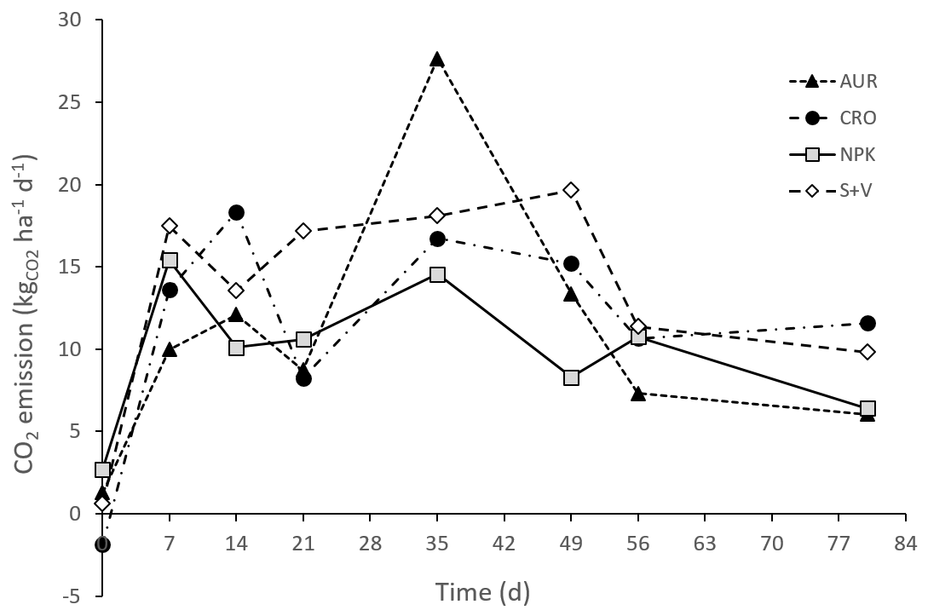

Figure 8 CO₂ fluxes during the experiment, expressed as mean daily CO₂ emissions for the different fertilizer treatments (n = 3) over eight gas sampling measurements.

NPK = mineral control; CRO = ‘Crop’ treatment; S+V = Struvite & Vinasse treatment; AUR = ‘Aurin’ treatment

Appendix E – Equipment and Experiment
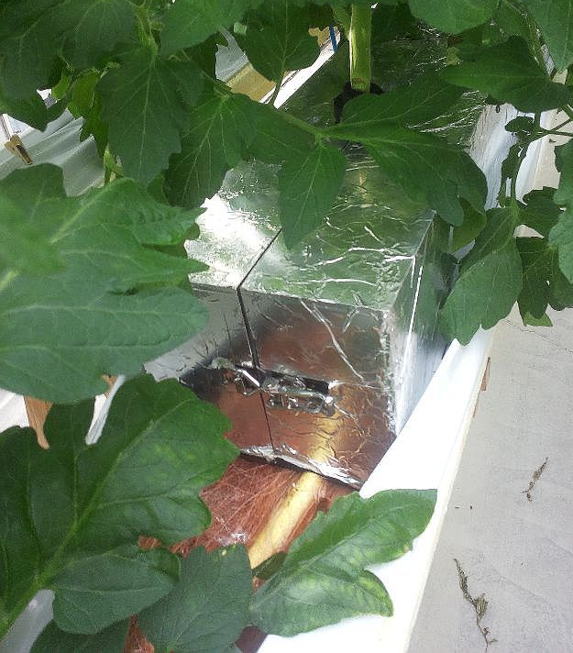
Figure 9 Gas flux chamber set-up.

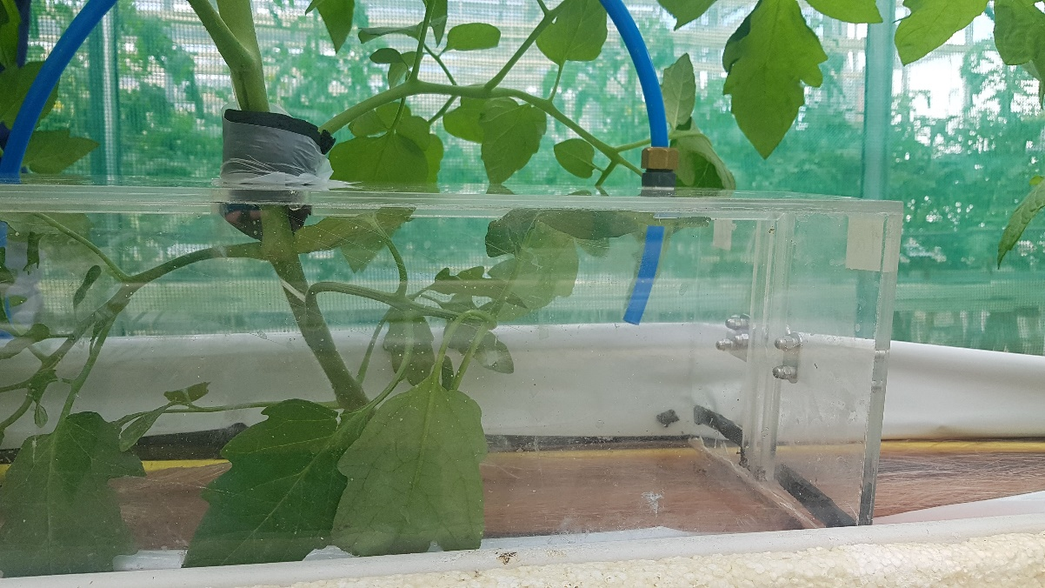
Figure 10 Gas flux chamber set up without foil covering.

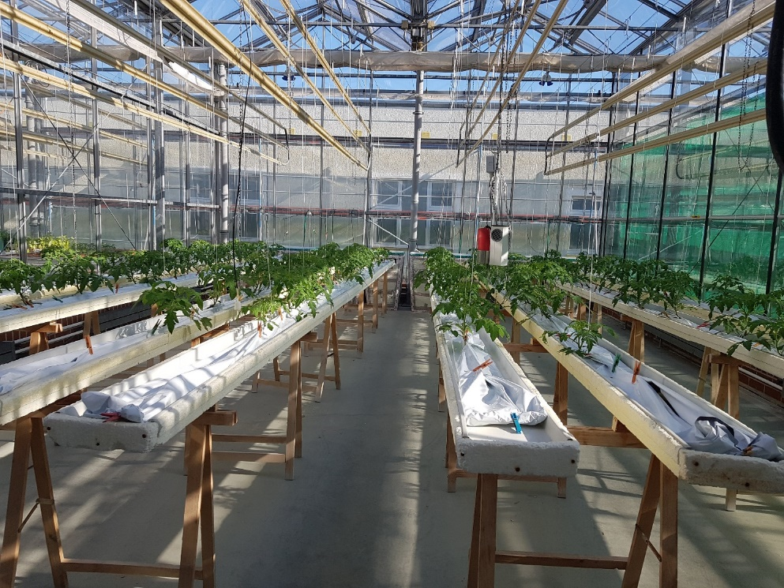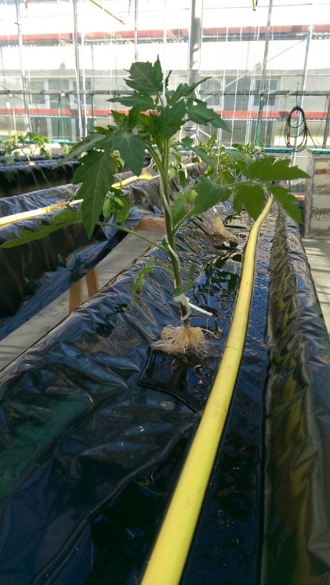
Figure 11 Left: Experimental set-up in one of the greenhouse cabins with 8 NFT troughs. Right: transplanting of tomato plants.

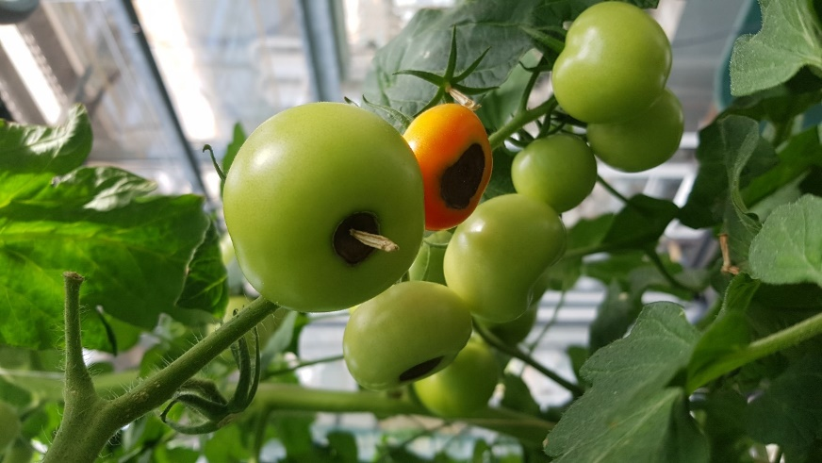
Figure 12 AUR treatment with blossom-end-rot affected tomato fruit

Appendix F – Fertilizers tested

The novel RF and NUF product ‘Crop’, was provided by the project Combined Regenerative Organic Food Production (C.R.O.P.) of the Institute of Aerospace Medicine (Deutsche Zentrum für Luft- und Raumfahrt e.V., DLR) in Cologne, Germany. C.R.O.P. aims at engineering a process to capture nutrients from solid and liquid organic wastes to be re-used in soilless cultivation systems in extended spaceflights or extra-terrestrial living (DLR 2019). Therefore, microbial trickling filters are used to degrade and mineralize the organic matter into inorganic plant nutrients. The C.R.O.P. process, as described in detail by Bornemann et al. (2018), is a fully biological process based on a fixed-bed biofiltration unit for urine degradation by nitrification (Figure 11). Mussel-shells are added to increase the buffering capacity of the solution. This buffered system allows that up to 100 % of the N contained in the soil is captured as NO₃⁻-N in the product.
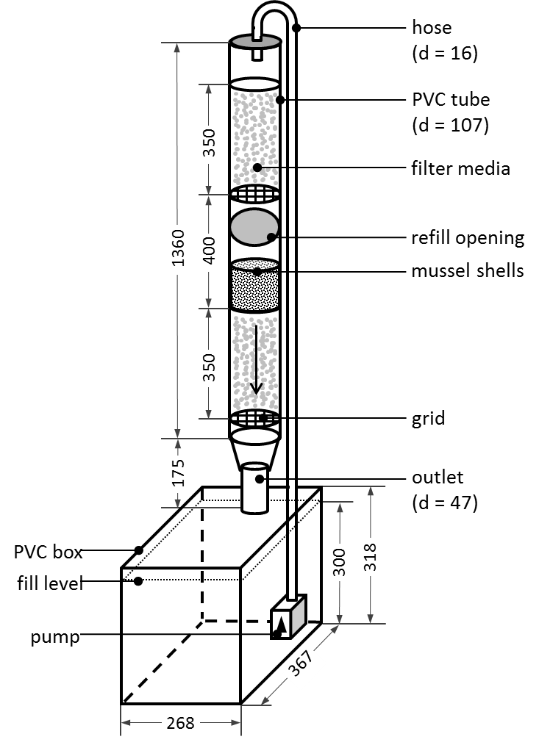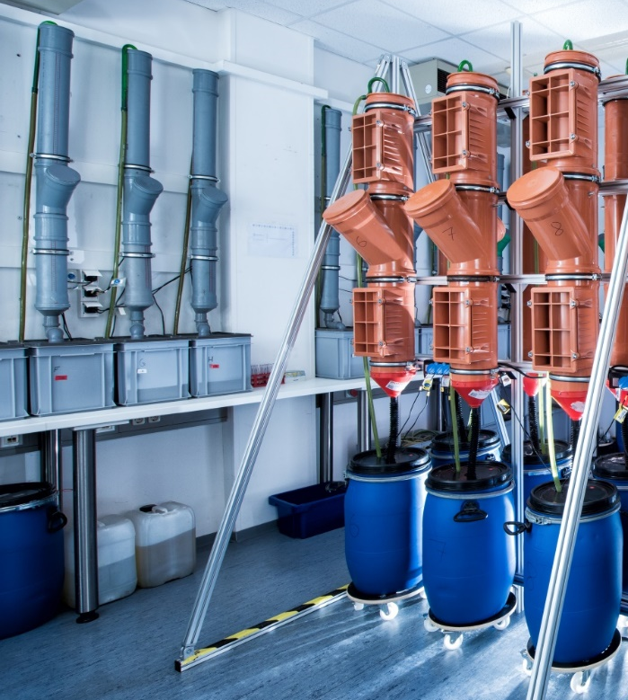
Figure 13: Left: Schematic representation of a C.R.O.P. filter unit of Bornemann et al. (2018) with dimensions given as internal dimensions [mm]; d=diameter; Right: picture of a C.R.O.P. trickling filter by Gerhild Bornemann, DLR, 2018.

When we received ‘Crop’ from DRL, the C.R.O.P. process was still tested with synthetic urine. The synthetic urine used to produce ‘Crop’ is based on the recipe of Gordon (1982) as presented by Feng & Wu (2006). In sum, 1000 ml of synthetic urine contain 0.5 g CaCl₂·2H2O, 4.12 g K₂HPO₄, 0.47 g MgCl₂·H₂O, 0.29 g KCl, 4.83 g NaCl, 1.55 g NH₄Cl, 2.37 g Na₂SO₄, 13.34 g urea, 1.0 g creatinine and 0.65 g sodium citrate (pH 6.8). After processing ‘Crop’ has a NH₄⁺: NO₃⁻ ratio of 1:2 (Table 1 main text). Due to the addition of mussel-shells, ‘Crop’ has a high Ca content (ibid).

The novel RF and NUF product ‘Aurin’ The Swiss Federal Institute of Aquatic Science and Technology (Eawag) developed a process and technology for processing human urine aiming at efficient and safe nutrient recycling (Fumasoli et al. 2016). In 2016, the company Vuna Ltd was founded based on the outcomes of Eawag’s research on urine processing. In the Vuna process, source-separated human urine is firstly stabilised by nitrification, i.e. the biological transformation of NH₄⁺ into NO₃⁻. Afterwards the nitrified urine is purified by treating it with an activated carbon filter that safely eliminates all pharmaceuticals and hormones. Then, through vaporization, the solution is distilled to remove pathogens, reduce the liquid volume and increase the overall nutrient concentration of the liquid fertilizer. The liquid NUF product ‘Aurin’ is licensed for horticultural use in Switzerland and Liechtenstein, including fertilization of ornamentals and vegetables (Vuna GmbH 2019). Due to distillation, the concentration of the ‘Aurin’ RF is about 10 fold higher than the ‘Crop’ RF, resulting in a NH₄⁺: NO₃⁻ ratio of 1:1 (Table 1 main text).

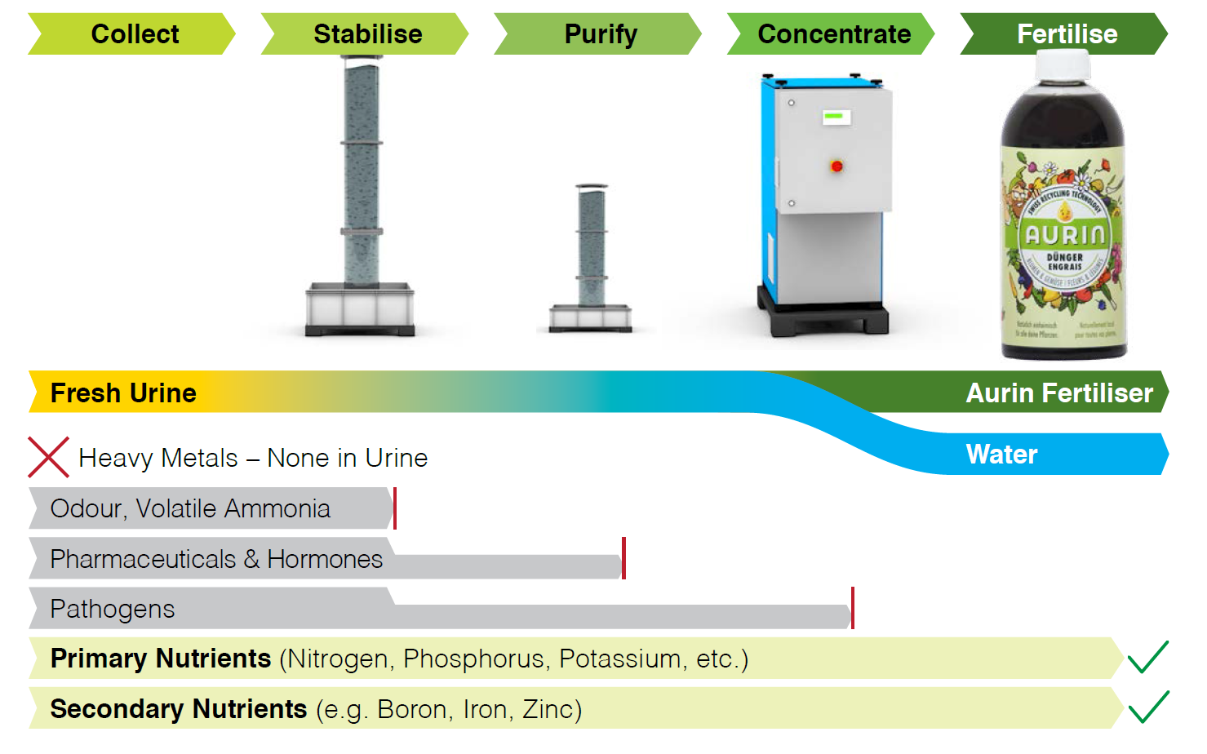
Figure 14: The Vuna process to produce the NUF product ‘Aurin’ (source: http://vuna.ch/content/verfahren_E.png).

