Supplementary to Tamminga et al. 2021: Microplastic concentrations, characteristics, and fluxes in water bodies of the Tollense catchment, Germany, with regard to different sampling systems

Catchment | Area (km²) | Area (ha)
Wustrower Bach | 9.33 | 933
Nonnenbach | 218.97 | 21897
Gaetenbach | 148.28 | 14828
Tollense at Neubrandenburg | 532.7 | 53270
Tollense at Woggersin | 917.7 | 91770
SI 1 Size of investigated catchments

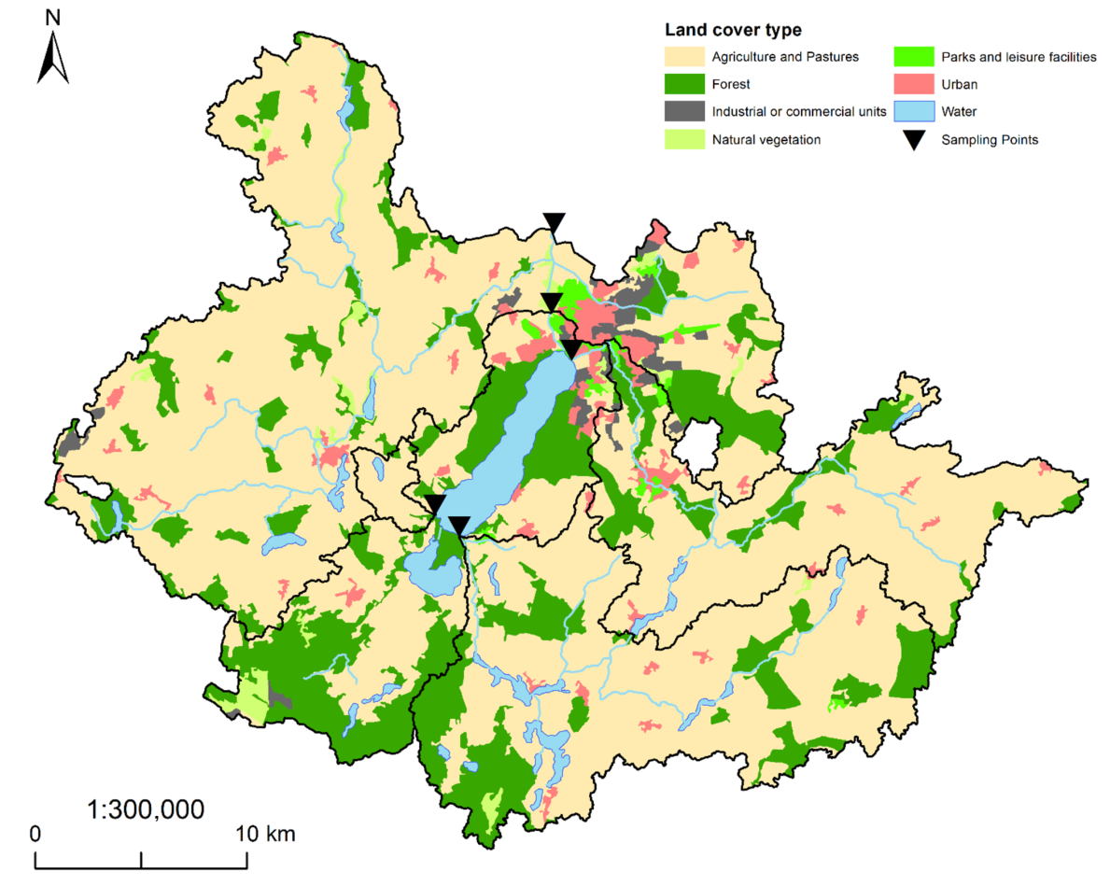
SI 2 Landcover within the study area based on the CORINE land cover data set (EEA 2021, LUNG 2021)

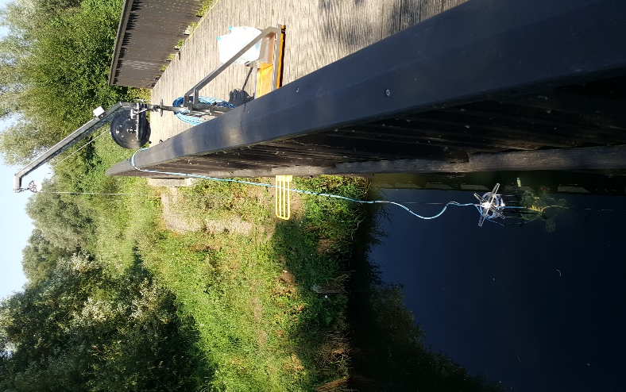
SI 3 Set-up of the 20 µm-system in the field
Sampling station | Mar. 2018 | Mar. 2019 | Sep. 2019* | Mar. 2020
Gaetenbach | 990 (97) | 1069 (75) | 1000 | 1163 (183)
Nonnenbach | 1066 (321) | 1043 | 1000 (700) | 1152
Wustrower Bach | 417 | - | - | -
Tollense NB | 1027 (786) | 1836 | 1000 | 1228
Tollense WO | - | 1305 | 1000 | 1260
Lake Tollense | - | - | 1000 | -
SI 4 Sample volumes (in liter) by sampling stations and sample time, numbers in brackets give sample volumes for the finest sieves, if clogging hindered the filtrations of 1,000 l,
*20 µm-system

SI 5 Digestion protocol applied in this study according to Hengstmann et al. 2018 and Tamminga et al. 2018, 2019
For digesting biogenic organic matter, the sample material was recovered from brown glass jars and transferred into glass beakers via rinsing with little ultrapure water. At first, hydrogen peroxide (H⁠₂O⁠₂, 30%, Merck, 60 ml per 50 ml sample volume) was added to the sample. The beaker was covered with a watch glass and incubated for seven days at room temperature. Subsequently, the hydrogen peroxide was removed by pouring the beaker content through an analytical sieve (63 µm or 20 µm) and rinsing with little ultrapure water. After transferring the sample into the beaker again by rinsing with little ultrapure water, the sample was treated with 16.7 ml sodium hypochlorite solution per 50 ml sample volume (NaClO, 6–14% active chlorine, Merck Emplura). The samples were then incubated for 24 h at room temperature to remove the residual organic matter that was not digested by hydrogen peroxide. In the following, the sample was relocated to a stainless-steel vacuum filtration system via rinsing with little ultrapure water (Satorius Stedim, 500 ml funnel capacity). After filtration, filters were placed into glass petri dishes and covered with a watch glass until further analysis.
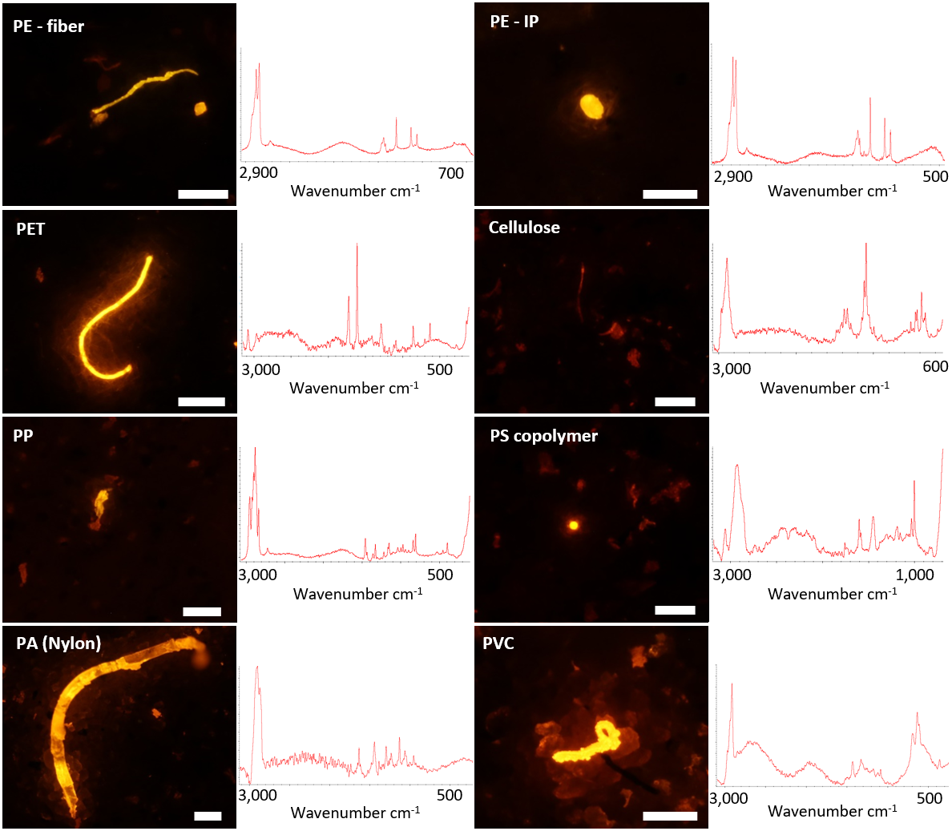
SI 6 Stained microplastic particles, a cellulose fiber, and associated Raman spectra, white scale bars indicate 200 µm
 |  |  | Abundance (number) per size class (µm)
Campaign | Shape | Value | >63-200 | >200-300 | >300-1000 | >1000-5000
Mar. 2018  (n=3) | IP | Mean | 0.0 | 0.0 | 0.0 | 0.0
Mar. 2018  (n=3) | IP | SD | 0.0 | 0.0 | 0.0 | 0.0
Mar. 2018  (n=3) | Fiber | Mean | 0.7 | 0.3 | 0.3 | 0.0
Mar. 2018  (n=3) | Fiber | SD | 0.6 | 0.6 | 0.6 | 0.0
Mar. 2019  (n=10) | IP | Mean | 1.5 | 0.5 | 0.1 | 0.0
Mar. 2019  (n=10) | IP | SD | 2.6 | 0.5 | 0.3 | 0.0
Mar. 2019  (n=10) | Fiber | Mean | 0.0 | 0.1 | 0.4 | 0.1
Mar. 2019  (n=10) | Fiber | SD | 0.0 | 0.3 | 0.5 | 0.3
Mar. 2020  (n=5) | IP | Mean | 1.2 | 0.4 | 0.0 | 0.0
Mar. 2020  (n=5) | IP | SD | 2.2 | 0.5 | 0.0 | 0.0
Mar. 2020  (n=5) | Fiber | Mean | 0.0 | 0.0 | 1.6 | 0.8
Mar. 2020  (n=5) | Fiber | SD | 0.0 | 0.0 | 1.5 | 0.4
 |  |  | >20-50 | >50-300 | >300-1000 | >1000-5000
Sep. 2019*  (n=20) | IP | Mean | 2.0 | 8.3 | 0.3 | 0.0
Sep. 2019*  (n=20) | IP | SD | 2.8 | 6.7 | 0.6 | 0.0
Sep. 2019*  (n=20) | Fiber | Mean | 0.0 | 1.0 | 0.6 | 0.5
Sep. 2019*  (n=20) | Fiber | SD | 0.0 | 1.2 | 1.0 | 0.8
SI 7 Number of microplastics detected in procedural laboratory blanks by shape, size class and sampling campaign, *20 µm-system
 | Discharge (m³/s)
Sampling station | Mar. 2018 | Mar. 2019 | Sep. 2019 | Mar. 2020
Gaetenbach | 0.907 | 0.27 | 0.084 | 0.647
Nonnenbach | 0.633 | 0.116 | 0.013 | 0.313
Wustrower Bach | 0.069 | - | - | -
Tollense NB | 3.38 | 1.58 | 0.711 | 3.282
Tollense WO | - | 2.583 | 0.936 | 6.509
Mean | 1.25 | 1.14 | 0.44 | 2.69
SD | 1.46 | 1.17 | 0.46 | 2.87
SI 8 Discharge measured in the field using the ADC device by sampling station and sampling campaign
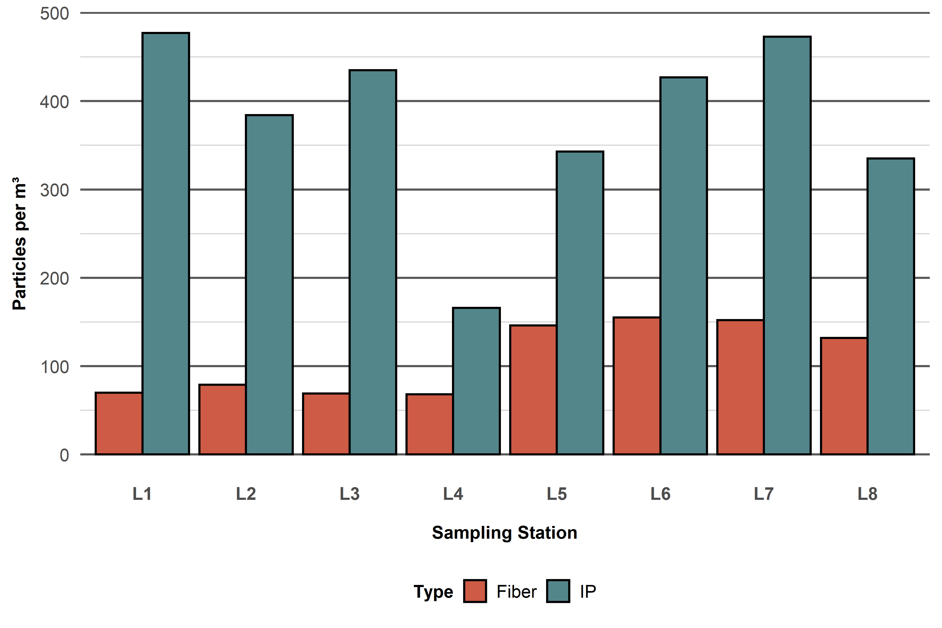
SI 9 Microplastic concentrations within surface water of Lake Tollense in Sep. 2019 by sampling station and particle shape
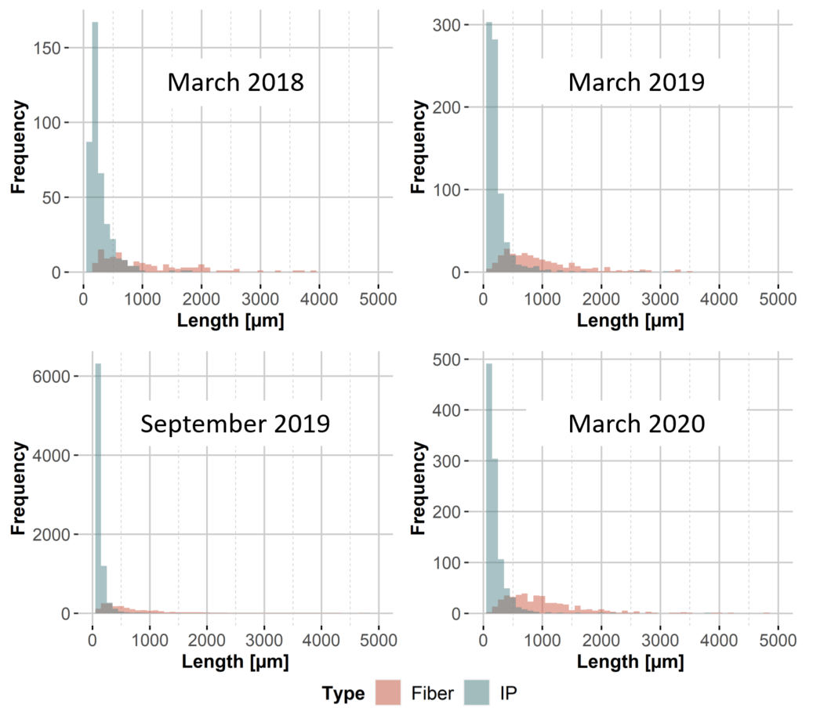
SI 10 Particle size distributions by sampling campaign and particle shape
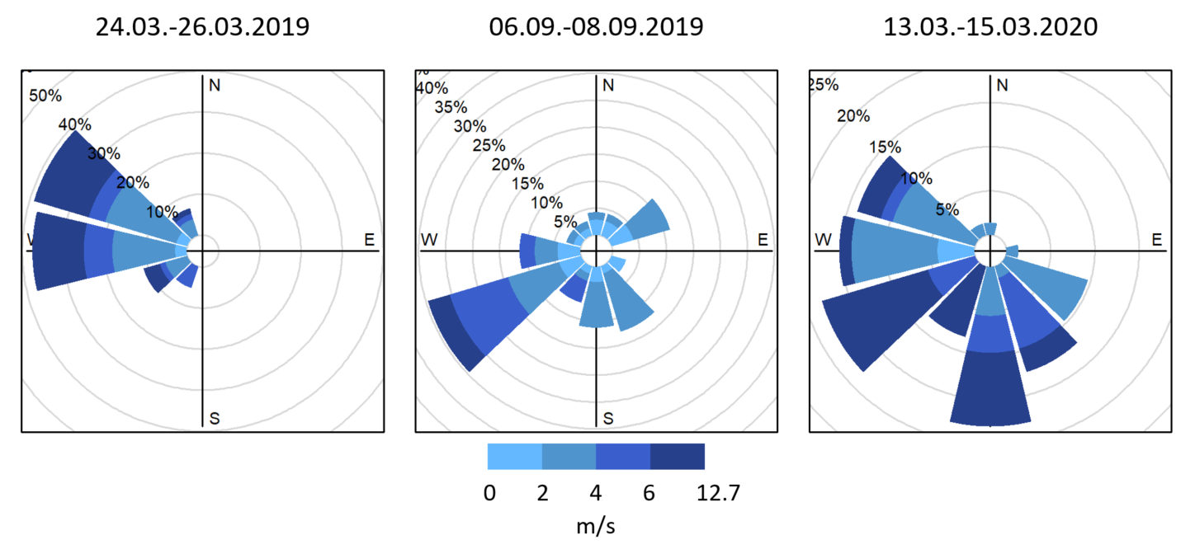
SI 11 Wind speed and direction at Trollenhagen airport averaged over sampling (at Gaetenbach) days and the two days before (DWD 2021)

Supporting Information References
Deutscher Wetterdienst (DWD), 2021. Wind Speed and Wind Direction for Climate Station 5109. Trollenhagen.
European Union, Copernicus Land Monitoring Service, European Environment Agency (EEA) 2021, f.ex. in 2018: “© European Union, Copernicus Land Monitoring Service 2018, European Environment Agency (EEA)"
Hengstmann, E., Tamminga, M., vom Bruch, C., Fischer, E.K., 2018. Microplastic in beach sediments of the Isle of Rügen (Baltic Sea) - Implementing a novel glass elutriation column. Marine Pollution Bulletin 126, 263–274. https://doi.org/10.1016/j.marpolbul.2017.11.010
Landesamt für Umwelt, Naturschutz und Geologie Mecklenburg-Vorpommern (LUNG) 2021: Gewässer des digitalen Gewässernetzes M-V (DLM25W). https://www.umweltkarten.mv-regierung.de/atlas/script/index.php
Tamminga, M., Hengstmann, E., Fischer, E.K., 2018. Microplastic analysis in the South Funen Archipelago, Baltic Sea, implementing manta trawling and bulk sampling. Marine Pollution Bulletin 128, 601–608. https://doi.org/10.1016/j.marpolbul.2018.01.066
Tamminga, M., Stoewer, S.-C., Fischer, E.K., 2019. On the representativeness of pump water samples versus manta sampling in microplastic analysis. Environmental Pollution 254, 112970. https://doi.org/10.1016/j.envpol.2019.112970

