Supplementary Material

For

Mixture toxicity of six pharmaceuticals towards Aliivibrio fischeri, Daphnia magna and Lemna minor

Anna Białk-Bielińska¹, Łukasz Grabarczyk¹, Ewa Mulkiewicz^{1*}, Alan Puckowski¹, Stefan Stolte², Piotr Stepnowski¹

¹University of Gdańsk, Faculty of Chemistry, Department of Environmental Analysis, ul. Wita Stwosza 63, 80-308 Gdańsk, Poland
²Technische Universität Dresden, Institute of Water Chemistry, 01062 Dresden, Germany

*Corresponding author:
Ewa Mulkiewicz, ewa.mulkiewicz@ug.edu.pl, +48 58 523 51 90

Mathematical forms of the model associated with concentration-response curves (https://cran.r-project.org/web/packages/drfit/drfit.pdf)
The logistic model is widely used for sigmoidal dose response curves. For logistic model the four-parameter logistic function given by the formula (1) is used:
$$f\left(x,\left(b,c,d,e\right)\right)=c+\frac{d-c}{1+exp⁡\{b\left(\log\left(x\right)-\log\left(e\right)\right)\}} (1)$$
with four parameters b, c, d, e. The parameter e is also denoted EC₅₀ and it is the dose producing the response half-way between the upper limit, d, and lower limit, c. The parameter b denotes the relative slope around e.
When the lower limit is fixed at 0 (c=0) and the upper limit is fixed at 1 (d=1) the two-parameter logistic function is obtained and the equation (1) has the form:
$$f\left(x,\left(b,e\right)\right)=\frac{1}{1+exp⁡\{b\left(\log\left(x\right)-\log\left(e\right)\right)\}} (2)$$
The equation (2) is used in logit fit.

The description of parameters obtained for the dose-response curves:
sigma - the square root of the estimated variance of the random error
a - this is the EC₅₀ for the logit model.
b - this is the parameter b from equation (1) and (2).

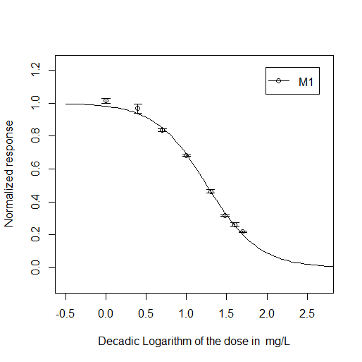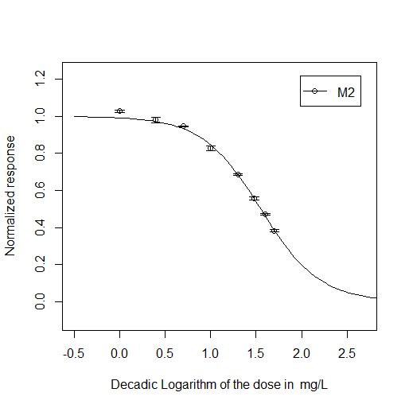
Fig. 1S. Dose-response curves obtained for studied mixtures of pharmaceuticals in A. fischeri luminescence inhibition assay

Table 1S. Parameters describing the dose-response curves obtained in A. fischeri luminescence inhibition assay
Mixture | M1 | M2
Model type | logit | logit
logEC₅₀ | 1.255 | 1.551
2.5% | 1.239 | 1.538
97.5% | 1.270 | 1.564
sigma | 0.023 | 0.019
a | 1.255 | 1.551
b | 0.321 | 0.323

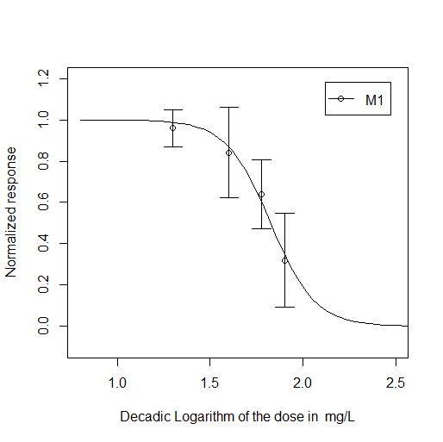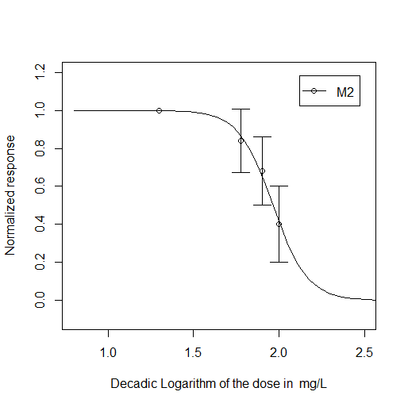
Fig. 2S. Dose-response curves obtained for studied mixtures of pharmaceuticals in D. magna acute immobilization test

Table 2S. Parameters describing the dose-response curves obtained in D. magna acute immobilization test
Mixture | M1 | M2
Model type | logit | logit
logEC₅₀ | 1.827 | 1.966
2.5% | 1.777 | 1.926
97.5% | 1.887 | 2.031
sigma | 0.156 | 0.151
a | 1.827 | 1.966
b | 0.119 | 0.101
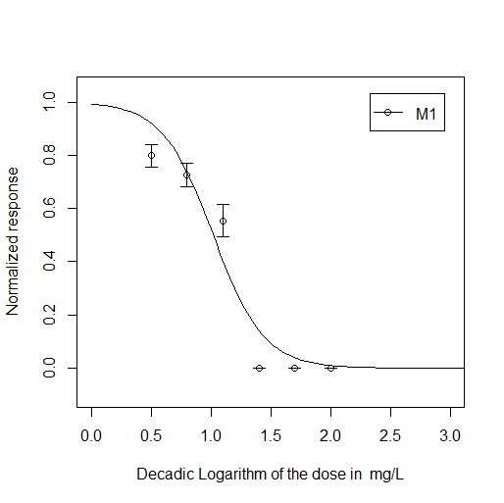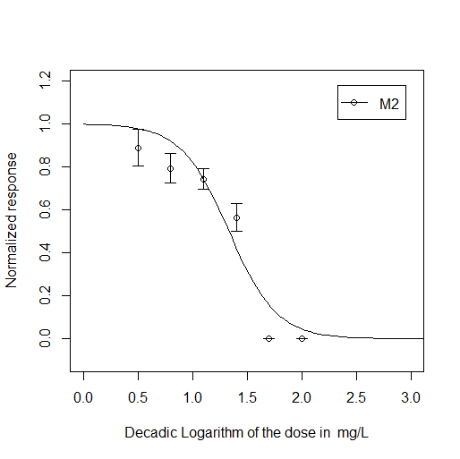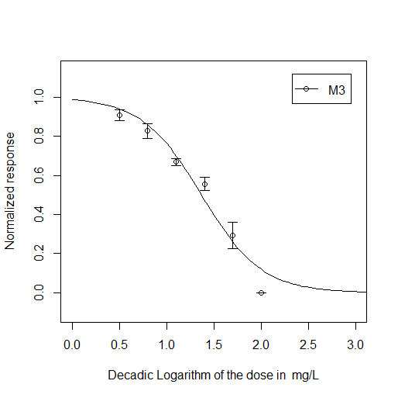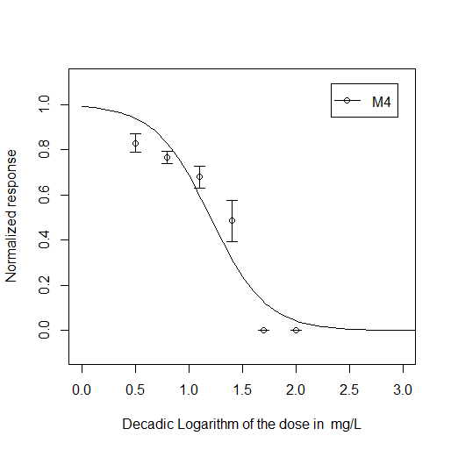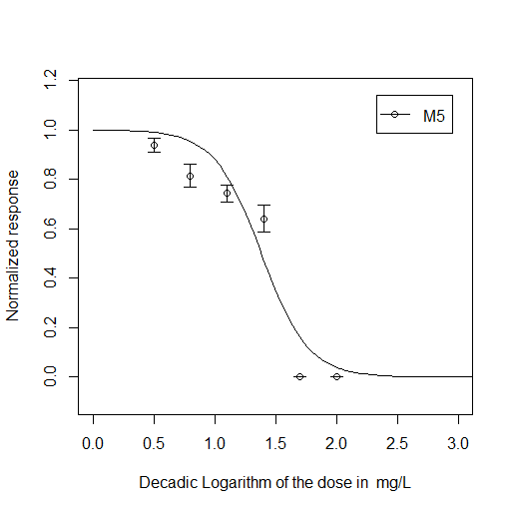
Fig. 3S. Dose-response curves obtained for studied mixtures of pharmaceuticals in L. minnor growth inhibition test

Table 3S. Parameters describing the dose-response curves obtained in L. minnor growth inhibition test
Mixture | M1 | M2 | M3 | M4 | M5
Model type | logit | logit | logit | logit | logit
logEC₅₀ | 1.015 | 1.330 | 1.367 | 1.201 | 1.380
2.5% | 0.953 | 1.258 | 1.318 | 1.132 | 1.269
97.5% | 1.074 | 1.398 | 1.416 | 1.270 | 1.481
sigma | 0.105 | 0.123 | 0.075 | 0.105 | 0.127
a | 1.015 | 1.330 | 1.367 | 1.201 | 1.380
b | 0.212 | 0.219 | 0.318 | 0.258 | 0.193

Table 4S. The concentrations of individual components of the mixture and the effects caused by them calculated in the R program used for the calculation of predicted EC₅₀ (IA).
Organism | Mixture | DIC | IBU | NAP | SMZ | CRB | TRA | Σ/  EC₅₀, IA
A. fischeri | M1 [%]  [mg L⁻¹] | 22%  3.87 | 29%  5.10 | 49%  8.62 |  |  |  | 100%  17.59
A. fischeri | Calculated effect | 0.142 | 0.283 | 0.185
A. fischeri | M2 [%]  [mg L⁻¹] | 11%  3.50 | 15%  4.78 | 24%  7.65 | 50%  15.94 |  |  | 100%  31.87
A. fischeri | Calculated effect | 0.124 | 0.272 | 0.162 | 0.067
D. magna | M1 [%]  [mg L⁻¹]  Calculated effect | 32%  43.37  0.179 | 27%  36.59  0.216 | 41%  55.56  0.226 |  |  |  | 100%  135.52
D. magna | M2 [%]  [mg L⁻¹]  Calculated effect | 20%  37.53  0.093 | 17%  31.90  0.174 | 25%  46.91  0.156 | 14%  26.27  0.149 |  | 24%  45.03  0.073 | 100%  187.64
L. minor | M1 [%]  [mg L⁻¹]  Calculated effect | 33%  9.78  -0.072 | 26%  7.70  0.342 | 41%  12.14  0.292 |  |  |  | 100%  29.62
L. minor | M2 [%]  [mg L⁻¹]  Calculated effect | 16%  4.92  -0.059 | 13%  4.00  0.202 | 20%  6.15  0.140 | 3%  0.93  0.176 | 48%  14.77  0.166 |  | 100%  30.77
L. minor | M3 [%]  [mg L⁻¹]  Calculated effect |  | 20%  4.39  0.219 |  | 5%  1.1  0.218 | 75%  16.46  0.183 |  | 100%  21.95
L. minor | M4 [%]  [mg L⁻¹]  Calculated effect | 31%  6.33  -0.074 | 25%  5.10  0.248 | 38%  7.75  0.180 | 6%  1.22  0.246 |  |  | 100%  20.40
L. minor | M5 [%]  [mg L⁻¹]  Calculated effect | 16%  6.46  -0.075 | 13%  5.25  0.253 | 21%  8.48  0.199 |  | 50%  20.20  0.221 |  | 100%  40.39

