Supplementary material
  - 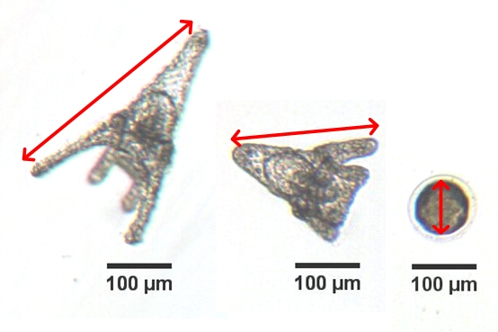
B
A
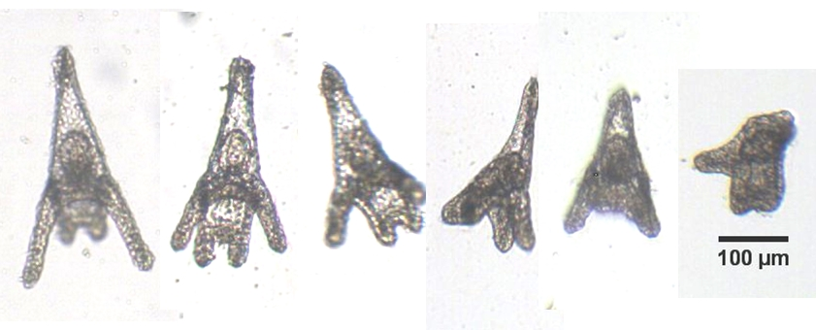
Figure S1. Measurement of maximum dimension in P. lividus larvae and embryos (A) and alterations in larval growth in P. lividus larvae resulting from exposed fertilized eggs.

Table S1. Summary of the parametric estimates and confidence intervals (α = 0.05) obtained by fitting Eq. (2) to the activity of glutathione S-transferase (GST) and glutathione reductase (GR) of sea urchin larva exposed to chlorpyrifos. Statistical values of adjusted coefficient of multiple determination (adj. R²) and p-values from Fisher’s F-test (α = 0.05) are also summarized.
Parameter | GST | GR
Base | 61.3±22.3 | 41.5±3.7
Amplitude | 31.9±29.7 | 31.4±8.5
Mean | 69.2±36.6 | 104.5±6.7
SD | 44.1±42.6 | 40.2±14.6
adj. R² | 0.618 | 0.978
p-value | 0.147 | 0.009

Table S2. Estimate of the parameters of the multiple linear regression models and its significance (0 ‘***’, 0.001 ‘**’, 0.01 ‘*’, 0.05 ‘.’, 0.1 ‘ ’, 1). Statistical values of adjusted coefficient of multiple determination (adj. R²) and p-values from Fisher’s F-test (α = 0.05) are also summarized.
Parameter | Chlorpyrifos | Triphenyl phosphate | Bisphenol A
Intercept | 0.9197*** | 0.5627** | 1.2060***
GST | 0.0004 | 0.0018 | -0.0010
CAT | 0.0042 | -0.0459 | -0.0457*
GR | 0.0028* | 0.0002 | -0.0004
AChE | -0.0014 | 0.0110** | 0.0018
Concentration | -0.0013*** | -0.0004*** | 0.0000
Adj. R² | 0.9039 | 0.8914 | 0.2741
p-value | 0.0013 | 0.0000 | 0.1120

